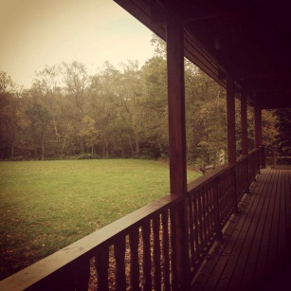
On the 18th and 19th August we took the approximately 20 young people to the Rough Close log cabin in Berkswell. The day trips were organised by the Participation team who have a key objective to support the development of looked after young people.

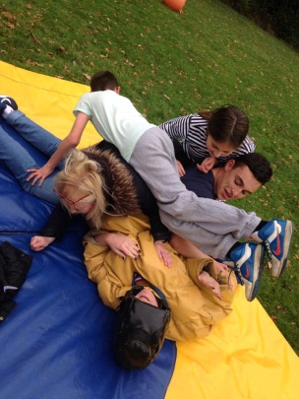
This day was planned to look at recruiting new members for our Voices of Care Council group. It has recently been decided to split VOC, due to its large numbers, into three separate age groups, primary, secondary and seniors. To gain new members, each group of the three groups were taken on a trip to see if they might be interested in joining, this gave them an opportunity to find out some information about the VOC, and the opportunity to get to know each other and The Participation team members. The aim of the two day trip was to provide activities and developmental opportunities such as team building, confidence building and essential skills training. This was done in a relaxed atmosphere with other the young people where they could develop new skills, find out about the VOC and make new friends whilst having a nice two day break within their term time.

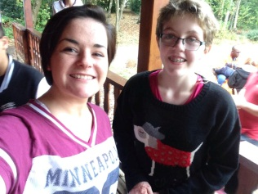
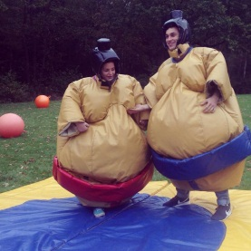
Each of the two days had different activities for the young people to take part in. On the first day we had a surf simulator, life size board games, sumo wrestler suits and large bouncers to keep the young people entertained. The Participation Team lead the group through each of these activities giving them all the opportunity to get to know each other and gave the team a chance to get to know them. They then had large take-away pizza lunch together in the cabin whilst talking to them about what the VOC Council do and whether or not they would like to get involved. All of the young people seemed eager to find out more about the group and come along to the meetings.

On the second day the young people returned and engaged in activities ran by the workers at Rough Close. They lead the group in archery, before taking them to a Go-Karting course. They then had a second lunch together with the young people and one last discussion before letting them know about the next follow up meeting with our new recruited members of VOC.

