

Coventry Partnership
Drug Strategy
01 April 2015 – 31 March 2017

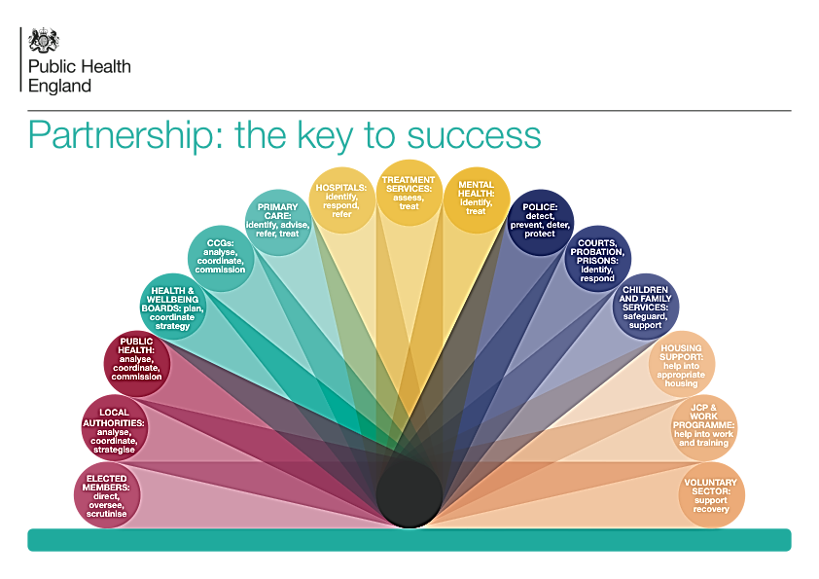
CONTENTS

Foreword 3

1. Vision for Coventry 4

2. Policy and Evidence 5

3. Current Position 7

4. Our Response 9

5. Governance 14

6. Outcomes 15

Foreword

Whilst most people do not use drugs, drug misuse can be found across all communities in society. From heroin and crack use among adults, to cannabis use amongst young people, to the use of novel psychoactive substances (“legal highs”) by clubbers, drugs are available and misused by a wide range of people.
Drug misuse is a significant issue for individuals, families and communities alike. Public Health England estimates the annual cost of drug-related harm in England to be £15.4 billion.
The harms caused by drugs are wide-ranging. Drug misuse may cause or exacerbate existing problems, its harms may be acute or chronic, and issues may arise from recreational use as well as dependency or problematic use.
Drug misuse is strongly related to crime, but harms are not just related to crime. Substance misuse can be found amongst homeless populations and those with mental health problems. Problematic drug use is associated with unemployment, domestic abuse, poor living conditions, ill-health and safeguarding concerns.
Some drug concerns are familiar and long-standing – for example inter-generational substance misuse and the negative impact of parental drug use on children – however there are new concerns as well, especially around young adults and the purchasing of drugs over the internet.
We consulted with partners and the messages we got back were clear. People want to see a holistic approach that looks at the whole person and whole family, not just the individual. People want to see a wide range of harms addressed and for us to empower individuals and communities to build resilience and strength.

Tackling drugs and drug misuse reflects the commitments made in the Council Plan ‘Coventry open for business: our vision and priorities for the next 10 years’ where Coventry stated its vision to be ‘locally committed’, to ‘make communities safer together with the police, to reduce crime’ and to ‘improve the health and wellbeing of local residents… …especially for our most vulnerable residents’.

This vision will be achieved by working closely with our partners, residents and recovery community.

[SIGNATORIES]

Vision for Coventry

The Coventry vision is to reduce the harms caused by drug misuse and make Coventry a safer and healthier place to live, where fewer drugs are consumed and where professionals are confident and well-equipped to challenge behaviour and support change. The harms associated with drug misuse are not evenly spread across the country. As an urban, industrial city with more poor areas than affluent ones, the harms of drug misuse are likely to be greater here than in other areas. However, our aims are ambitious and we want to be a high performing area.
We consulted with partners and stakeholders and their views are reflected in this document. Partners stressed the importance of taking a holistic approach, one that considered the family, employment status, mental health and housing of an individual, and not just their drug use.
Coventry’s vision is to:
- Take a holistic approach that focuses on the whole person and whole family
- Support people to choose not to take drugs
- Reduce the impact of drug use on others
- Empower individuals and communities to have resilience and strength
- Focus on diversion, early intervention and treatment
- Identify, challenge and prevent substance misuse where possible
- Provide treatment and help for people when they want it
- Help people recover fully and rebuild healthy, positive lives
As a cross-cutting issue, drug misuse affects a number of agencies and local government teams. This strategy therefore takes account of a number of other strategies and policies, including:
- Council Plan, Coventry Open for Business (2014)
- Arden Health Protection Strategy (2013)
- West Midlands Police Drug Strategy (2013)
- Coventry Housing and Homelessness Strategy (2013)
- Coventry Sustainable Community Strategy: The Next 20 Years (2011-14)
- Coventry and Warwickshire Clinical Commissioning Groups’ Strategic Plan (2014-19)
- Coventry Mental Health Crisis Care Concordat (2015)
By tackling drug use and misuse, we believe we can effect wide-ranging positive developments in Coventry and improve the lives of individuals, families and communities.
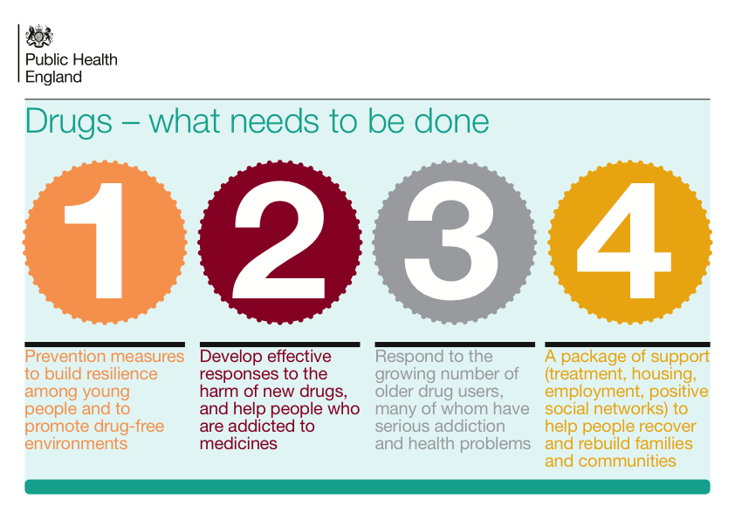 Source: Public Health England

Policy and Evidence

Public Health England took responsibility of drug and alcohol treatment in 2012 and their work builds on the work of the National Treatment Agency, which spent ten years building the evidence base for treatment in the UK. With data collected via the National Drug Treatment Monitoring System (NDTMS), the UK now has a robust evidence base for treatment and interventions.
Treatment in the UK is underpinned by clinical advice and quality standards provided by NICE (National Institute for Health and Care Excellence) in a number of key documents:
- Drug misuse: psychosocial interventions (CG51)
- Drug misuse: opioid detoxification (CG52)
- Interventions to reduce substance misuse among vulnerable young people (PH4)
- Needle and syringe programmes (PH52)
- Drug misuse – naltrexone (TA115)
- Drug misuse – methadone and buprenorphine (TA114)
- Drug use disorders (QS23)

The Cost to Society
The economic costs to society from drug misuse are high and there is a strong invest-to-save argument for providing drug treatment.
Cost to UK
- Overall annual cost to society £15.4bn
- Annual cost of drug-related crime £13.9bn
- Annual cost of deaths related to substance misuse £2.4bn
- Annual cost to NHS £488m

Other costs – such as emotional distress, family breakdown and fear in the community – are just as high and good reasons for taking action.
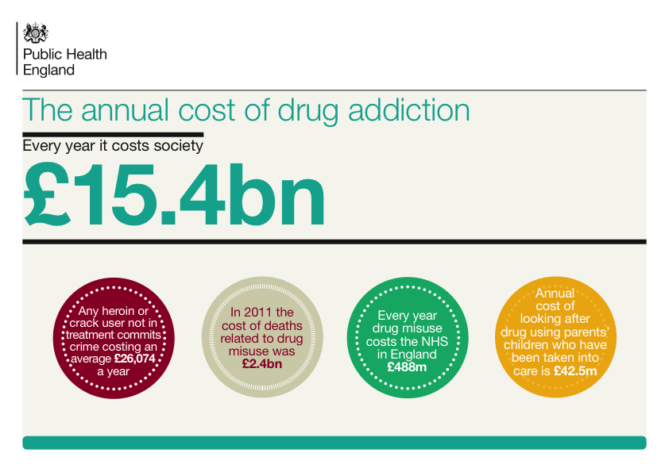Source: Public Health England
The National Drug Strategy, published in 2010, outlined the ambition to provide recovery-focused treatment in the UK rather than a maintenance programme focused on harm minimisation as previously advocated. It also strengthened the focus on families, carers and communities.
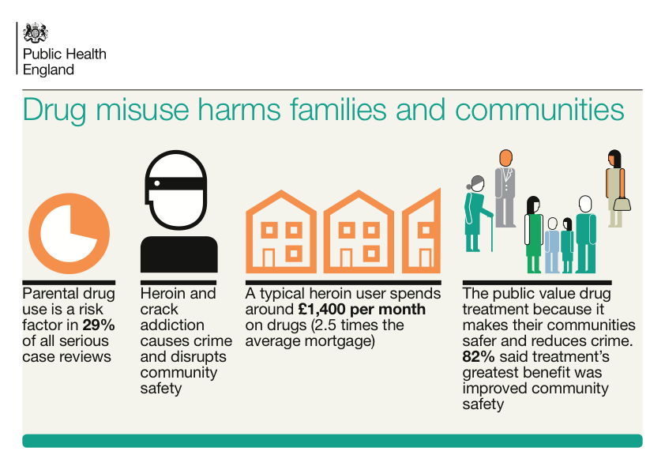 Source: Public Health England

The focus on recovery sits comfortably alongside other local policy goals, such as asset-based community development and community integration.
Finally, a number of trends have emerged in recent years, which require a response from local agencies:
- An ageing opiate population with chronic health and social care needs
- A growing awareness of how drugs are involved and a feature of child sex abuse
- A slowly growing market of novel psychoactive substances (NPS) sometimes known as ‘legal highs’. NPS are substances which mimic the effects of illicit drugs and their effects vary; some mimic the effects of cannabis, some mimic the effects of amphetamines, some mimic ‘downers’/tranquilizer-type drugs, and some mimic hallucinogenic drugs. They are legal to purchase and labelled “not for human consumption”. There have been hospitalisations and deaths linked to NPS. Due to their recent emergence, there is a lack of data on NPS.
- An increase in the number of people misusing medicines such as Gabapentin and Pregabalin

Current Position

Figures from Public Health England show fewer people in drug treatment but more people completing treatment.
Key National Treatment Statistics for 2013-14 (NDTMS)
- 193,198 people were in drug treatment during 2013/14 – down from down from 193,575 in 2012-13 and continues the trend in falling numbers in treatment that began in 2009-10
- 29,150 (45%) successfully completed their treatment
- Opiate and crack use remain the dominant reasons why people seek treatment
- The most common route into treatment was self-referral (44%)
- Opiates/opioids (i.e. heroin/morphine; methadone; other opiates/opioid analgesics), alone or in combination with other drugs, account for majority of drug-related deaths
Studies such as the British Crime Survey show drug misuse to be declining nationally.
Key National Features for 2013-14 (Crime Survey for England and Wales)
NB: Interviews for the CSEW took place over 12mths: April 2013-March 2014. Interviewees were asked about their drug use in ‘the last year’. For those interviewed at the start, that meant drug use from Apr 2012 –Apr 2013. For those interviewed at the end, ‘the last year’ referred to March 2013-March 2014.
- Around 1 in 11 (8.8%) adults aged 16 to 59 reported taking an illicit drug (excluding mephedrone) in the last year, which equates to around 2.7 million people. This proportion was an increase compared with 2012/13 (8.1%) but is back to the same level as in 2011/12;
- Overall trend in the proportion of adults taking an illicit drug has been essentially stable at between 8% and 9% per cent since 2009/10 following a period of decreasing rates from a peak in 2003/04. (Prior to 2003/04 the proportion remained broadly flat at around 12%);
- The proportion of adults aged 16 to 24 taking any drug in the last year, was double the proportion in the 16 to 59 age group, at 18.9%. This was an increase compared with 2012/13 (16.2%) but around the same level as in 2011/12 (19.2%).
Nationally, opiates and crack remain the key drugs for which people seek treatment and therefore this cohort is still the main focus of treatment services.
Primary drug use of all clients in treatment 2013-14 by main drug
Drug Group | n | %
Opiates Only | 91,560 | 47
Opiates & Crack | 61,353 | 32
Cannabis | 17,229 | 9
Cocaine (excl. Crack) | 10,610 | 5
Crack Only | 4,097 | 2
Amphetamines (excl. Ecstasy) | 3,862 | 2
Benzodiazepines | 1,312 | 1
All others (Prescription Drugs , Hallucinogens, Ecstasy, Solvent, Major Tranquilisers, Anti-depressants, Barbiturates) | 3,049 | 2
Misuse free/unknown | 126 | 0
Total | 193,198 | 100
Source: National Drug Treatment Monitoring System

Key Local Features
There are some positive trends locally.
Coventry’s prevalence estimate for opiate and crack users (OCUs) has come down slightly (see table below), and decreased dramatically in the 15–24 age group. This evidences that fewer young people are starting opiate and crack use and reflects the ageing OCU population. Coventry’s overall OCU prevalence rate is also lower than West Midlands average, though higher than England average, which is to be expected for an urban area.
Estimated number of Opiate and Crack Users, 2009 – 2012

 | 2009/10 | 2010/11 | 2011/12
Coventry | 2,003 | 2,124 | 1,935
Source: National Drug Treatment Monitoring System
NB: The National Treatment Agency (NTA), a Special Health Authority which oversaw drug treatment in England and Wales from 2001-2013, established prevalence rates for local authorities. Public Health England now publishes this data, with the next estimate due in 2015.
Despite that positive news, there are still too many people using drugs recreationally, and too many people experiencing problematic drug use.
In the last few years, Coventry has seen a slight decline in the number of opiate/crack users seeking treatment (-1%) and a significant rise in the number of non-opiate/crack users seeking treatment (up 32%). In terms of those completing treatment, Coventry is above national average rates for opiate users successfully completing treatment, and below national averages for non-opiate users successfully completing treatment.
% Clients successfully completing treatment, Q2 2014/15
 | Coventry Baseline | Coventry Q2, 2014/15 | National Average
Opiate drug users | 7.0% | 7.9% | 7.7%
Non-opiate drug users | 31% | 33% | 38%
Source: National Drug Treatment Monitoring System
The picture among young people is that the majority (88%) of young people do not use drugs (Coventry Children Survey, 2013). However, 750 schoolchildren have reported taking an illicit drug at some point. Of those that had used an illicit drug:
- A third had only tried drugs ‘once or twice’ and were therefore not regular users
- The majority had tried cannabis
- A few (1%) had tried cocaine, glues, aerosols, legal highs and ecstasy
Compass, the local young person’s treatment service, receives 250 referrals a year with 140 starting treatment/support. Cannabis is the main drug young people need help with.

Our Response

Much has changed since Coventry’s last Drug Treatment Plan, published in 2012. Some of the key successes of that plan included:
- Commissioning new, recovery-oriented services
- Re-commissioning of the Service User Involvement Scheme
- Commissioning an Independent Living Service for people with drug and alcohol issues
- A growing recovery community, developed through Service User Involvement Scheme
- Maintaining focus on harm reduction through support for elements like needle exchange and BBV (blood borne virus) screening, testing and referral
- Producing a Directory of Services (‘Getting Better, 2013’) to advertise services available

As a result of the above activities, our recovery community has grown, with the local forum now attracting 15-20 people in recovery at every meeting, volunteers giving 150 hours of volunteering time per month, more non-opiate users feeling they can access our services and greater diversity in where we deliver services from. Outreach and co-location now happens in schools, in the Referral and Assessment Service, in children’s care homes, in MIND day centres, at Church’s on Saturday mornings, etc.
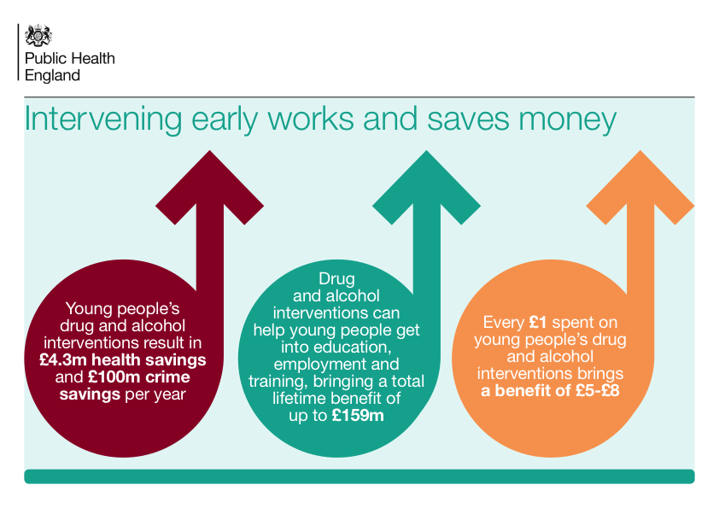
Source: Public Health England
Priority Themes
Building on the success of the previous plan, in accordance with the principles of the Marmot Review which stress peer support and asset-based development, and in line with the Coventry alcohol strategy, the Coventry drug strategy prioritises three key themes:
- Providing effective prevention and recovery-focused treatment
- Changing and challenging attitudes and behaviour
- Controlling supply and promoting drug-free environments

To reflect the changes to Council structures and to take a better life-course approach to drug use and misuse this strategy brings together young people and adults for the first time.

THEME 1: Providing effective prevention and recovery-focused treatment

Targeted prevention and accessible, recovery-focused, evidence-based treatment services are central to the Coventry approach. Providing information to those at risk of drug use and providing high quality services to those who need help tackling their drug use will ensure that Coventry limits and reduces the harms caused by drug misuse. Treatment and support will be available to any young person or adult who needs it.
Services will offer a range of psychosocial, pharmacological and wraparound support and be available throughout the week in a variety of settings that can appeal to different groups of people. Interventions will be of varying intensity and length, depending on the needs of different individuals.
Services will deliver cost-effective, evidence-based, recovery-oriented treatment as recommended by National Institute for Health and Care Excellence (NICE) and Public Health England and will be registered with the Care Quality Commission where applicable.
The Coventry approach is to:
- Support the creation of a recovery-orientated workforce that is focused on all elements of recovery - housing, employment, mental health, family life - and not just medical treatment
- Build skills among frontline workers so that any professional can have a conversation about drugs with a resident
- Involve (ex)service users as to what services and interventions they find helpful or useful, utilising the Recovery Forum, feedback forms and individual comments
- Strengthen links between drug services and other services in Coventry, including primary care, mental health services, criminal justice services, through multi-agency meetings, partnership forums, clearer information sharing protocols, better promotion of services to other teams, joint events, etc.
- Tackle dual diagnosis - patients who have both substance misuse and mental health problems, working in partnership with new services such as the Mental Health Street Triage Team
- Encourage all providers and staff to make best use of local services, both statutory and voluntary agencies, as well as community groups and faith organisations, so that individuals are aware of and can access a full range of local support
- Facilitate peer support and mutual aid networks so communities become empowered and individuals who have exited services can continue to receive support that enables them to sustain their recovery

THEME 2: Changing and challenging attitudes and behaviour

There is a sense in Coventry that some drug use, cannabis use in particular, is not challenged as robustly as it should be and that the city has a culture in which cannabis use at home and cannabis use in public is not being tackled. Referrals from early intervention, social care, mental health and some youth services are also sometimes perceived to be disproportionately low considering the cohorts of people they are working with and the needs those people often have.
To reflect the holistic approach that Coventry will take, individuals will be challenged not only on their drug consumption, but on their attitudes, relationships, offending behaviour, overall health, and attitudes to education, employment and work. Cannabis use by young people will be challenged in particular, as it has been shown that regular cannabis use at a young age can have a negative impact on mental health.
Organisational and staff attitudes also need to be reformed. Silo working by agencies will be addressed and agencies who do not refer appropriately to other services will be questioned. Agencies and teams will be challenged by senior staff, strategic leads and commissioners, and drug services will be challenged on their accessibility and willingness to promote themselves and co-operate with other agencies across Coventry.
The Coventry approach is to:
- Take a whole systems approach, and challenge individuals in treatment on a range of issues including training, employment, housing, family relationships, etc. so that recovery is not simply perceived of as ‘coming off drugs’ or ‘exiting treatment’
- Create a Tier 1 workforce that can recognise the risks of cannabis use, particularly in young people, and have a challenging conversation with individuals about drug use
- Provide education and information for targeted groups, e.g. Troubled Families, offenders, children on Looked After Child caseload, in an effort to reduce, divert or stop potential drug use
- Support schools in their efforts to challenge young people’s attitudes to drugs
- Recognise the importance of early intervention and intensive support for young people and families where there is drug misuse, and provide appropriate support and help to those who need it, in times and places which suit individuals
- Encourage agencies, staff and managers to have a ‘dare to share’ ethos, so they are willing to positively work with other agencies and share information, thereby improving experiences and services for individuals, e.g. by reducing the need for repeat assessments
- Ensure that long-term support is there for those who require on-going help, e.g. on-going psychological help or counselling to help individuals with childhood trauma

THEME 3: Controlling supply and promoting drug-free environments

Drug-dealing blights communities and often goes hand in hand with other types of offending, e.g. anti-social behaviour, theft, robbery, violence, fraud and intimidation though to more serious types of offending such as kidnap and murder.
Coventry has had recent success in tackling drug-dealing and drug production but more needs to be done. Typically the removal of one organised criminal gang triggers the arrival of another gang who see a power vacuum and an opportunity for their business to take over the market, and therefore controlling supply is an on-going task.
Tackling drug-dealing and promoting drug-free environments requires a multi-agency approach. From housing and hostel providers to nightclub owners and community safety officers, a range of agencies can help in the effort to reduce the availability of drugs in the city.

“A gang based in Coventry who distributed millions of pounds of drugs around the country have been jailed for nearly 100 years. The wholesale drug dealers shipped in huge amounts of cocaine, amphetamine and ketamine during an 18 month operation.”

Coventry Evening Telegraph
September 4th 2014
The Coventry approach is to:
- Take an early intervention approach to divert those at risk of becoming involved with drug-related crime
- Work with primary care to ensure that prescription drugs and over-the-counter medicines are not misused or causing patients problems
- Engage with communities to build strength and resilience at a local level, supporting those who are trying to keep their neighbourhoods healthy and drug free
- Protect vulnerable residents by providing local housing which is safe and drug-free
- Share intelligence and analysis in order to better target services or schemes, focusing on those in greatest need
- Work in partnership to tackle supply and drug-dealing in Coventry, particularly in the city’s deprived areas, including working with businesses in the night-time economy to take a zero-tolerance approach to drug use on premises
- Tackle criminal gangs and drug-dealing, especially in priority areas, and undertake robust offender management of those who have committed drug-related crime

Priority Groups
While efforts to reduce the harms caused by drug use must be delivered across the whole population, interventions must be targeted on those who need it most (‘proportionate universalism’).
Intervening early, with at-risk groups and when people are in greatest need of support is critical. 'At risk' groups include a diverse range of individuals who are particularly susceptible to drug use and are more likely than others to experience adverse outcomes and would include: children from households where there is drug use, Looked After Children, offenders, people with mental health problems and people from deprived neighborhoods.
It is well-known that while drug use can affect anyone, problematic heroin and opiate use is concentrated in areas of deprivation, where residents tend to have lower levels of recovery capital (supportive friends, family, educational qualifications, mental strength, money, employment, and so on).
Because of this, the following main groups will be prioritised across all three of the strategy's priority themes:
- Children and young people
- Opiate and crack users
- Residents of priority (most deprived) neighbourhoods
- Families involved in the 'Troubled Families' programme
In addition to the above, Coventry will also look to focus efforts and resources to the following:
- Adults with complex health and social problems
- Dual diagnosis patients (mental health problems and substance misuse problems)
- Offenders
- Vulnerable individuals, including rough sleepers and the homeless
- Young adults (18 – 24)

Governance

Drugs and substance misuse remains a cross-cutting theme that requires an on-going, joined-up partnership response.
The delivery of the drug strategy is the responsibility of the multi-agency Drug and Alcohol Steering Group which is chaired by an elected member from the City Council.
Members of the group include:
- Coventry City Council (Licensing, Public Health, Bid Team and Community Safety)
- Coventry and Rugby Clinical Commissioning Group
- Aquarius Service User Involvement and Advocacy
- Members of the Recovery Community
- Primary Care
- Coventry and Warwickshire Partnership Trust (Community Services and UHCW)
- West Midlands Police
- Coventry Probation
- Youth Offending Service
- Healthwatch
The group is accountable to the Health and Wellbeing Board, but also works closely with the Police and Crime Board and Young People's Strategic Partnership.
A multi-agency Implementation Plan will sit underneath the drug strategy and provide a detailed breakdown of the actions that partners will undertake to deliver the strategy. This plan will be the work plan of the Drug and Alcohol Management Group, a sub-group of the Steering Group.
Quarterly reporting will track progress against outcomes and indicators with remedial action being taken by partners in areas where there is under-performance or blockages.

Outcomes

The public health outcomes framework contains a number of indicators which will reflect progress made in addressing drug misuse.
A performance dashboard has been developed to monitor the impact of this strategy, and include the following measures:

Outcomes and Indicators
The overall success of this strategy will be measured through the achievement of a number of high-level performance indicators, including:
- Increases in number of young people leaving treatment with reduced drug use or drug free
- Increase in number of young people leaving treatment with reduced risky behaviours
- Increase in proportion of adult opiate & crack users exiting treatment successfully without representing (Public Health Outcomes Framework)
- Increase in proportion of adult non-opiate and crack users exiting treatment successfully and not representing (Public Health Outcomes Framework)
- Decrease in number of burglary (dwellings)
- Increase referrals from drug treatment to Coventry Domestic Violence & Abuse Support Services (CDVASS)

The multi-agency Drug and Alcohol Steering Group will monitor performance against outcomes and take remedial action where improvement is needed.

March 2015

