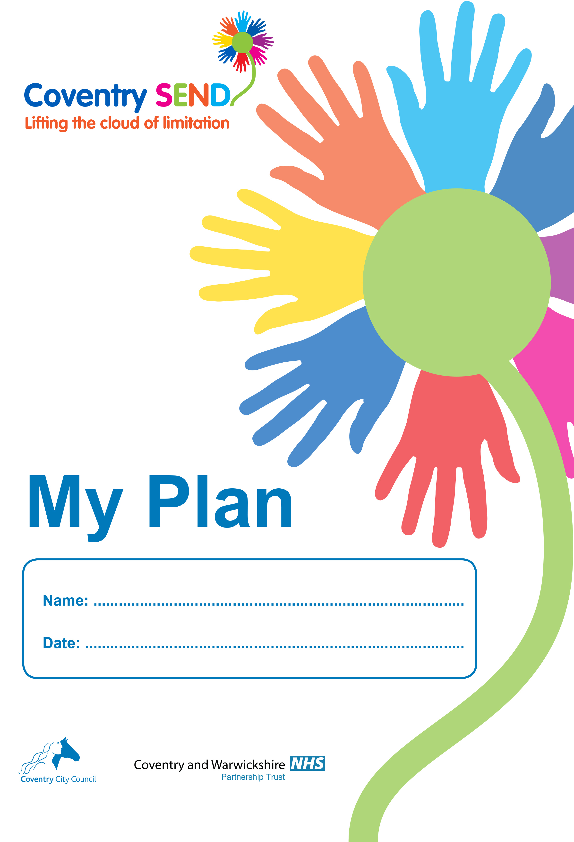

What everybody needs to know about me

My strengths, interests, Passions and Skills | Things that are important to me now
What I want for my future | What my parents want for my future
Other things I’d like people to know | Other things my parents would like people to know

My Team
People in my Family
_{Name} | _{DOB} | _{Gender} | _{Relationship} | _{Address} | _{Contributed to My Plan} | _{Parental responsibility}  _{Y/N}

Professionals supporting me and my family
Name | Role | Supporting | Contributed to My Plan | Agency | address/contact details

My Progress

Area of Learning | Attainment at previous review  (if applicable) | Current Attainment | If current attainment is below age expectations please identify potential barriers to learning.

My Special Educational Needs, Desired Outcomes and Provision

Summary of my SEN
My Diagnoses and Conditions
My Health Care Provision (If applicable)
My Social Care Provision (if applicable)

My Physical and Sensory Needs
Please provide details of the young person’s needs.

To be completed at the plan writing meeting |  | To be completed at the Review Meeting
Outcomes Sought | Educational provision to meet my outcomes | Was the agreed support fully implemented? | Has the outcome been achieved?

My Independence and Care Needs
Please provide details of the young person’s needs.

To be completed at the plan writing meeting |  | To be completed at the Review Meeting
Outcomes Sought | Educational provision to meet my outcomes | Was the agreed support fully implemented? | Has the outcome been achieved?

My Education and Learning Needs
Please provide details of the young person’s needs.

To be completed at the plan writing meeting |  | To be completed at the Review Meeting
Outcomes Sought | Educational provision to meet my outcomes | Was the agreed support fully implemented? | Has the outcome been achieved?

My Communication and Interaction Needs
Please provide details of the young person’s needs.

To be completed at the plan writing meeting |  | To be completed at the Review Meeting
Outcomes Sought | Educational provision to meet my outcomes | Was the agreed support fully implemented? | Has the outcome been achieved?

My Emotional and Behavioural Needs
Please provide details of the young person’s needs.

To be completed at the plan writing meeting |  | To be completed at the Review Meeting
Outcomes Sought | Educational provision to meet my outcomes | Was the agreed support fully implemented? | Has the outcome been achieved?

My needs with regard to friendships and being part of the community
Please provide details of the young person’s needs.

To be completed at the plan writing meeting |  | To be completed at the Review Meeting
Outcomes Sought | Educational provision to meet my outcomes | Was the agreed support fully implemented? | Has the outcome been achieved?

Changes to support
To be completed at the review meeting
Details of outcome NOT achieved | Reason(s) why outcome was NOT achieved | Details of additional provision (if needed) | How will the additional provision be funded?

Please use the information in this table to complete a revised My Plan
Personal Details and Consent

Name of Pupil |  | Sex | School Year
 |  | Date of Birth
Is the pupil a Looked After Child/Young Person?  Yes No  Is the young person in receipt of Pupil Premium?  Yes No |  | Attendance for current term  Actual/Possible
Home Language | Ethnic Category  Bangladeshi □ Black Other □ Pakistani □  Black African □ Chinese □ White □  Black Caribbean □ Indian □ Other □
Address

Please sign below to indicate that you:
- Have contributed to the development of the My Plan.
- Understand the support that will be provided through the My Plan.
- Agree to a photo of the young person being used on the cover of their plan
- Agree to a copy of the plan being stored in the School’s and Local Authority’s SEN files.
- Consent to a copy of the plan being shared with the people listed in the ‘My Team’ section of this plan and with a Local Authority SEN Officer, if necessary.

……………………………………………………………………Young Person (if appropriate)

……………………………………………………………………Parent/Carer

……………………………………………………………………School representative / Plan author

……………………………………………………………………Date

