Parents’ Guide
Applying for a school place online

Online Admissions
Before starting your application, please make sure you have the following to hand:
- Your Home Postcode
- If you are going to apply for a Catholic School, you will need to supply the baptismal certificate direct to the school. If you do not have this information speak to the parish priest or to the school direct. Please note: If your child is not baptised you will be considered under a lower admissions criteria.
- Your Council Tax customer reference number
- Have read the ‘Making a realistic application’ section of the admissions website/2023 booklet
- Somewhere to make note of the email and password you use to create an account
To log into the Coventry Education Services Portal page, please click this link or copy and paste the address into your browser: https://emsonline.lea.coventry.sch.uk/CitizenPortal_LIVE/en
Registration
If you are accessing the Education Services portal for the first time you will need to register to create an account. Please select the register button as below to get you started, you will then see the following screen;
Click on register an account

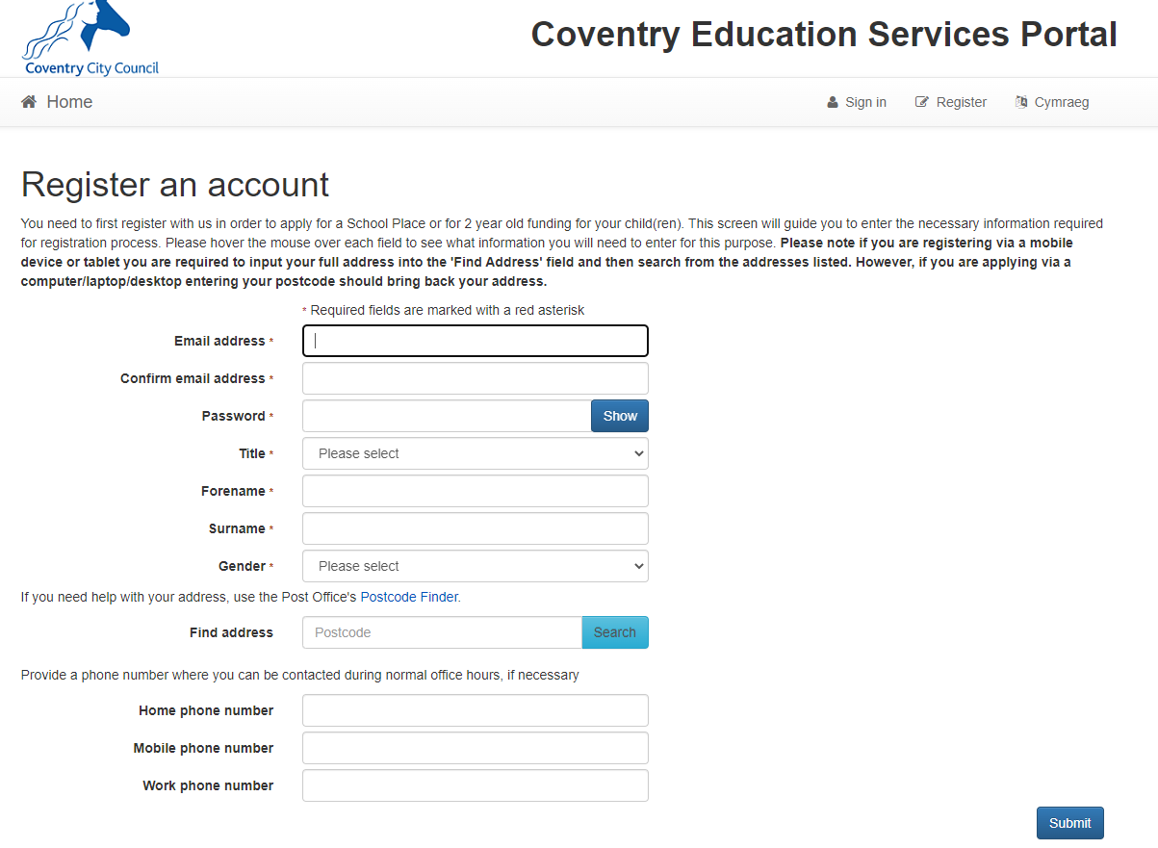
Complete your security and personal details and select submit at the bottom of the page
Once you have submitted this registration form you will receive a verification email (please allow 10 minutes for this to be received). This email will contain a link verifying your account and will take you back to the log in page to complete the process and complete your application for a school place in September.

Once you have followed the link from your email this is the page you will see. You can now log in as you will already be registered. Please use the same email and password you have created for this account.

Select the sign in button to enter the account
HOME PAGE
To apply for a school place select the School Places Blue button
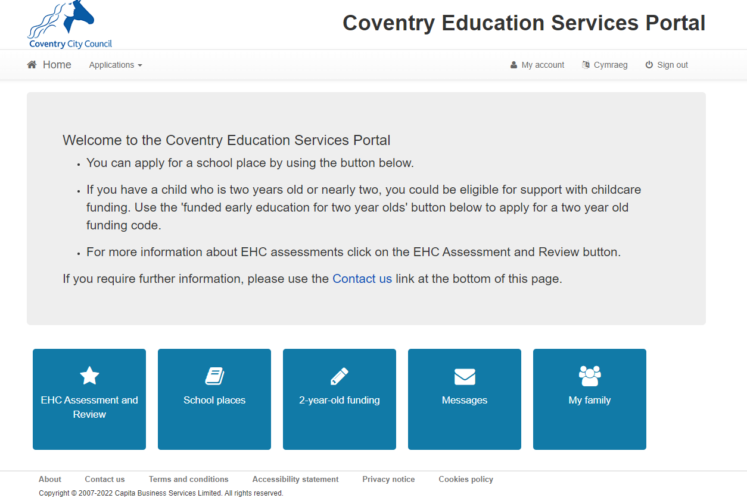

Important Information
You will see this page. Please ensure that you read this page before starting your application. This page contains details on the application process.
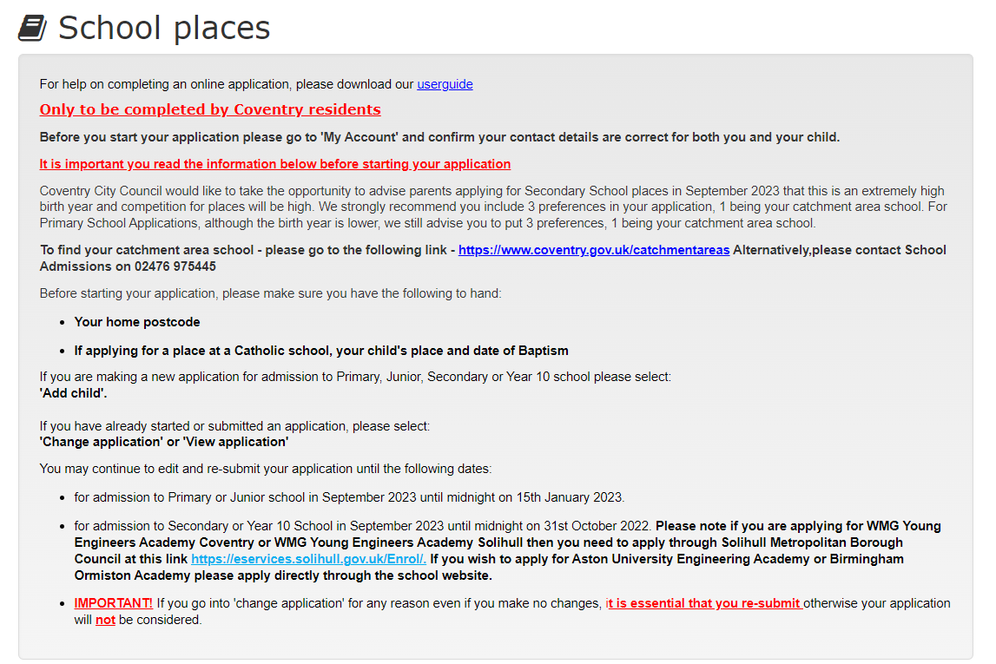
There is a button at the bottom of the page to add a child.
Adding a child
Please input your child’s details, include your relationship with them. To proceed to the next page, you will also need to click on the address.
If you are applying for multiple children you will need to complete this for each child.

ADDING AN APPLICATION
For each child, there will be blue box with their name.
Click on start new application then click on the blue box that appears showing the relevant transfer group.
Additional Child Details
Please input any details if your child has an Education, Health & Care Plan (EHCP) or has been looked after. The Council tax information is not mandatory but would be useful.

Moving To A New House
If you are moving to a new house during the admissions process this is your opportunity to tell school admissions. It is your responsibility to inform school admissions once you have moved to your new address.

Additional Questions
School Admissions can only communicate, to the individual who is making the application, this screen is the opportunity to nominate another person (Spouse, parent, guardian, social worker) who may wish to contact school admissions also.
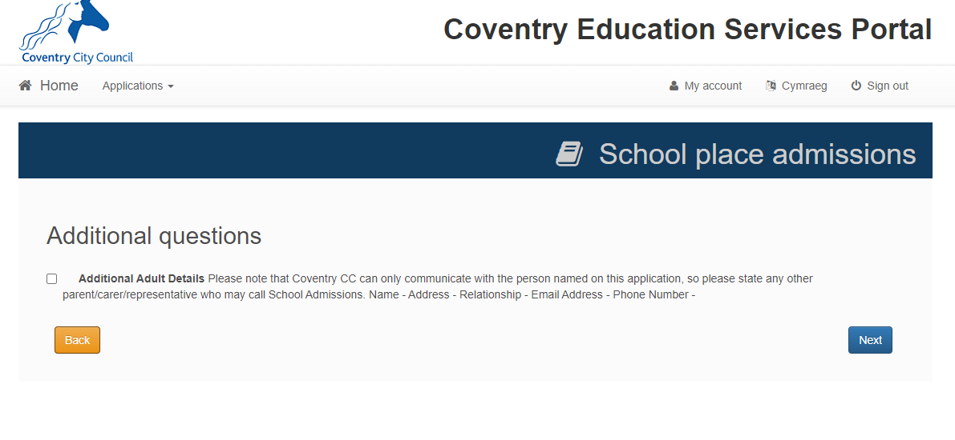
Current School
If you are applying for a Reception School place, this field is not mandatory, however if you are applying for a Year 7 Secondary School place, you cannot proceed without inputting the Primary school your child is currently attending.
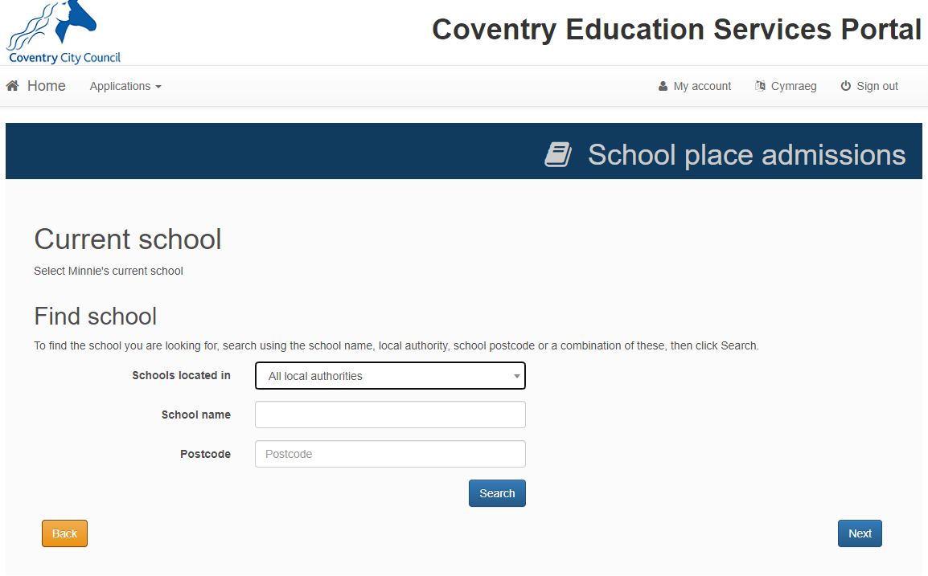
You can narrow down your search to the current school by selecting the Local Authority the school is in.
Choosing your Preference Schools
It is important you read the information on this page. This will provide details on the school preferences being made.
You can narrow down your search to the current school by selecting the Local Authority the school is in.
Preference Schools
The following pages will be dependant upon which school you put down as a preference. For example, if you are applying for a Catholic school, you will be asked to confirm your faith, if any siblings attend the school, if your child attends a feeder school, or if you are a member of staff at the school. However, if applying for Sidney Stringer, you will be asked to confirm if any siblings attend the school, or if you are a member of staff.

Other Reasons
Only you have completed the details required by each school, there is a free text box, allowing you the opportunity to put in any other relevant details that you feel may be important in coordination with the schools admissions policy. Please note any information not relevant to the school’s admissions arrangements will be discounted.

When you click the next button, you will be shown the school you have placed as a preference. To add more schools, click the add preferred school button and follow the same process as on previous page. Coventry City Council advise you place 3 schools as preference, with 1 being your catchment school. Details on how to find your catchment school are here. www.coventry.gov.uk/catchmentareas
Once you have completed 3 preferences your application will look like this and the add preferred school’s button will be greyed out.
When you click the next button, you will be shown the final page for submitting your application. This includes the terms and conditions, the privacy notice, and how you would like to receive your school offer. Please note the default is via email. Please use this opportunity to also preview your application and confirm all the information is correct before submission.
Once you have clicked on submit you will receive an email confirmation with your school choices. If there is any school choices/preference missing please edit your application to add further preferences on your application. Please do not forget to re-submit any changes made to the online application.
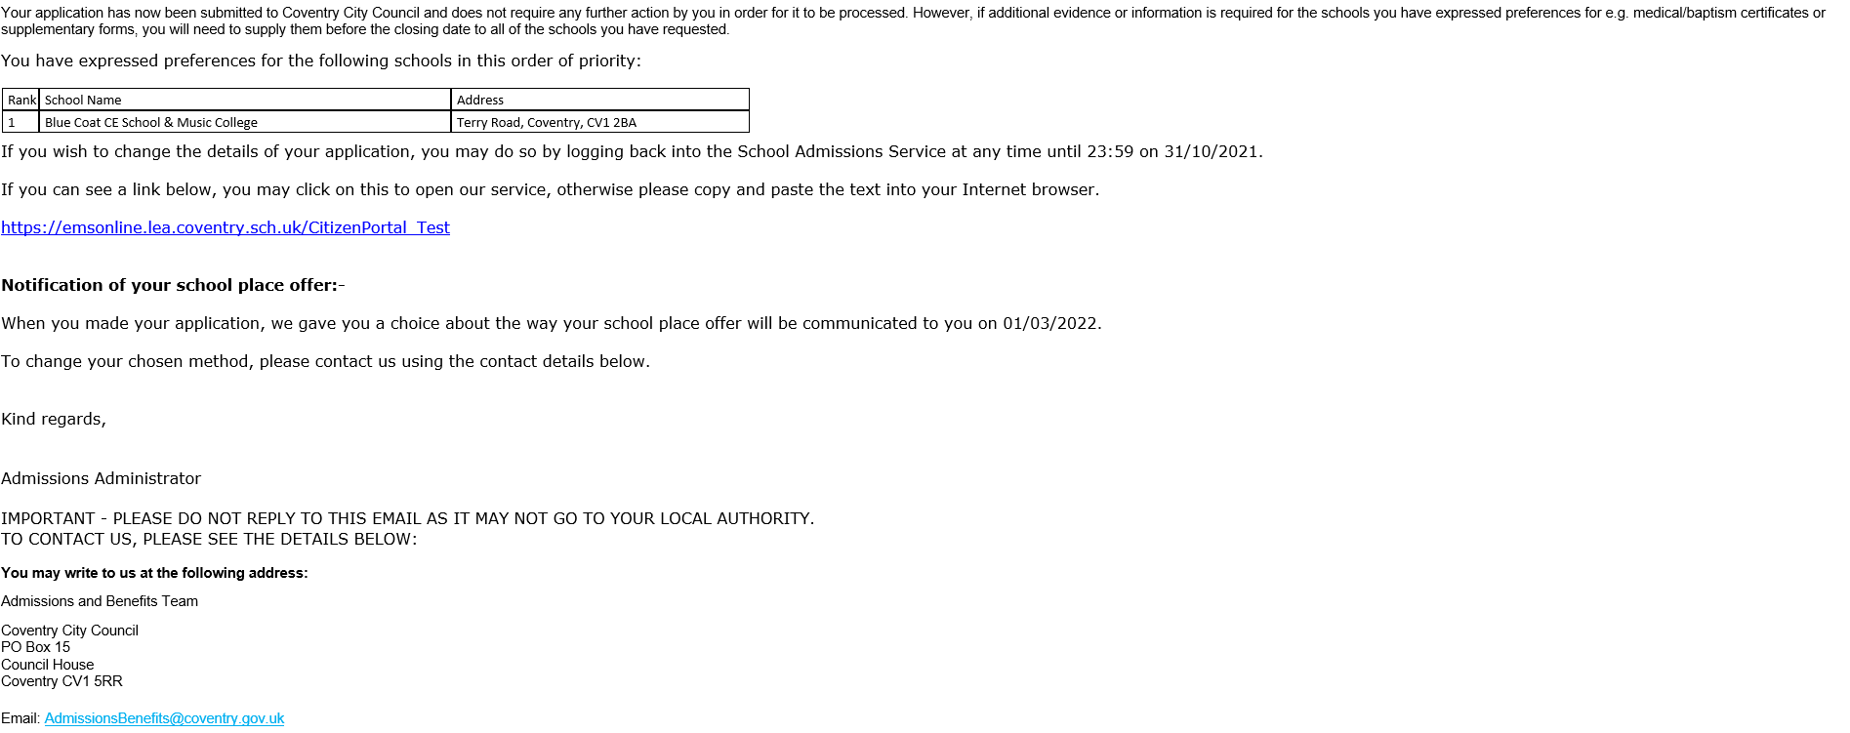

What Happens Next?
You can return to the Coventry Education Services Portal and at any time and change your application up until the closing date. Please do not forget to re-submit any changes made to the online application.
- For Secondary/Year 10 places the closing date is 31st October.
- For Primary/Junior places the closing date is 15th January.

An email will be sent on the dates below informing you of the decision that has been made on your application. You will also be able to log into your portal account to view the outcome.
- For Secondary/Year 10 places the national offer date is 1st March*.
- For Primary/Junior places the national offer date is 16th April*.

*Or the next working day

Useful Links
Please ensure you read the following
- Ensure that you include 3 different preferences on your application – There is no advantage in listing fewer than three schools or including the same school more than once; in fact, by not including 3 realistic preferences, it could result in your child being allocated a school some distance away
- You must include your catchment area school if you want to apply for a place at that school as there is no guarantee you will get this later in the process. Information regarding the catchment area for your address can be found at www.coventry.gov.uk/catchmentareas
- Look at the oversubscription criteria for your preferred schools to work out which priority would be given to your application. Policy details can be found by school.
- Compare your priority and distance with how places have been offered in previous years this will give you an indication of how successful your application might be. There are further details on how places were allocated for each individual school in the Primary and Secondary Admissions 2023 booklet.
- The School Admissions Team are always available to help if you have not been through this process before or need some expert advice or call 02476975445

