Family Matters Meetings in EHM
Guidance Notes

Coventry City Council Business Systems & Continuous Improvement

Contents

Document Control
Source Document Stored: Business Systems Team, LCS Useful Links
Document Distribution:
Version | Date | Place of Distribution | Place of Distribution Owner
1.0 | 26/04/2021 | EHM Useful Links | Karyn Bacon

Responsible Children’s Services Officer:
Name | Job Title
Karyn Bacon | Business Systems Manager (Children’s)

Version History:
Revision Date | Summary of Changes | Version
30/04/2021 | Additional Guidance Added by Ashley Hubball | 1.1

Contents

Heading | Link to Page
Background | Page 4
Starting a Family Matters Episode | Page 5
Organising a Family Matters Meeting | Page 7
Recording the Meeting Notes | Page 9
Finalising a Family Matters Meeting | Page 15
Closing a Family Matters Episode | Page 16
Process Maps | Page 20
Key Contacts | Page 21

Background
Previously, the Family Matters process including meetings was recorded outside of the EHM system. This process had its limitations as partners were not able to see the meetings within the EHM system and MASH had no visibility of Family Matters in EHM apart from a case note.
This new process enables Family Matters to be recorded within a workflow in EHM. Both current and previous meetings are there for review at any time and the episodes placed within each Family Hub’s Family Matter’s Tray form the agenda from which partners could gather their information in preparation for the upcoming meeting.

This guidance has been produced to assist the Professional Support Service as they arrange and record Family Matters Meetings within EHM.

Starting a Family Matters Episode
All Family Hubs hold their Family Matters Meetings at different times throughout the working week. However, each Family Hub has a deadline in which cases are confirmed as needing to come to Family Matters. If you are unsure of the deadline within your Family Hub, please speak to the Team Leader within your Family Hub.
The Request for Help form the Family Hub receive should be uploaded onto the Child(ren)’s record as a document. Members of the Family Matters Meeting will be able to access this document to ascertain the needs to the Family and the reasons they’ve been brought to Family Matters.
For each Child’s record, you’ll see a link on the right-hand side of the record called “Start a Family Matters Episode.”
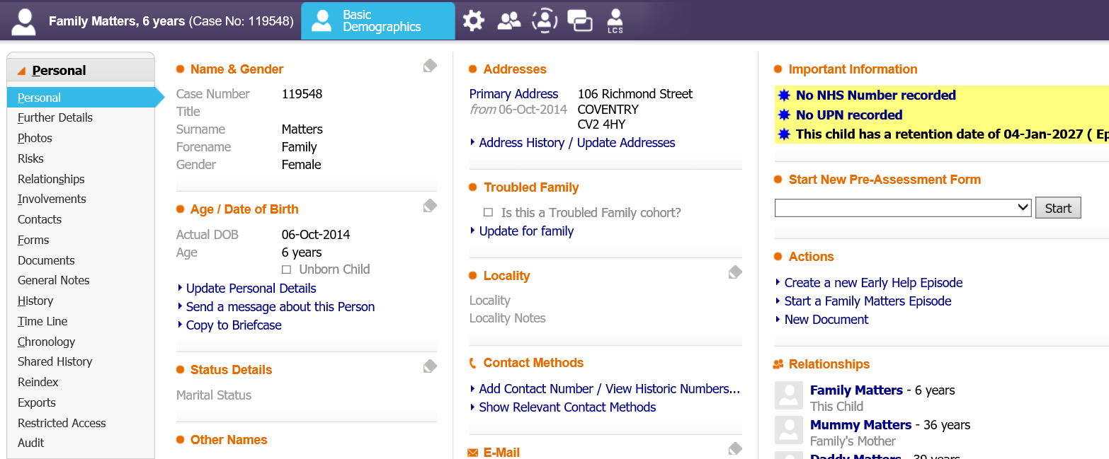
This link will trigger the Family Matters workflow and create an Active Family Matters Task in your EHM work tray. The system will ask you if you’re sure you want to start a Family Matters Episode. Click OK to confirm. The system will then ask you who you need to include in this episode. Currently we only include the Children in the Family. In our demonstration Family there are two young sisters, so we’ll make sure both of those are included:
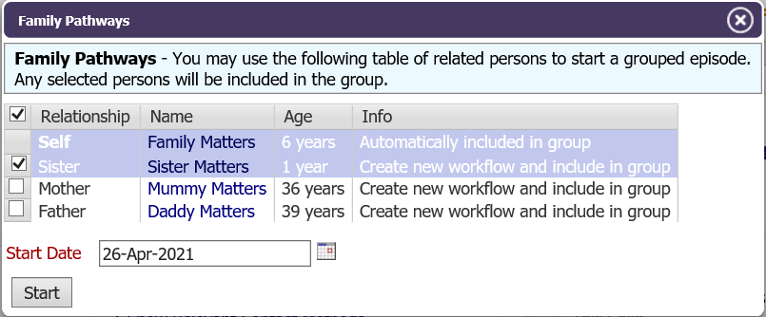
The start date of the episode should be the date the decision was made to discuss the Family at Family Matters. Once you’ve done this you’ve started your Family Matters Episode:
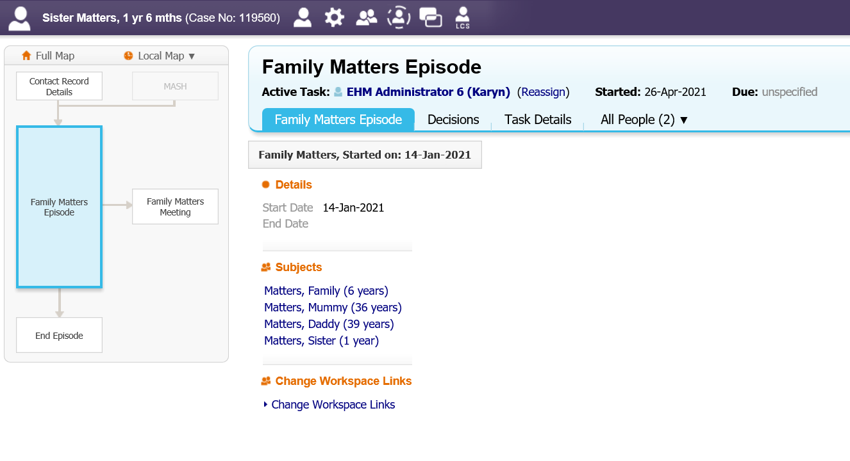
You can check who you’ve included in the Family Matters Episode by clicking on the Decisions Tab.

Organising a Family Matters Meeting

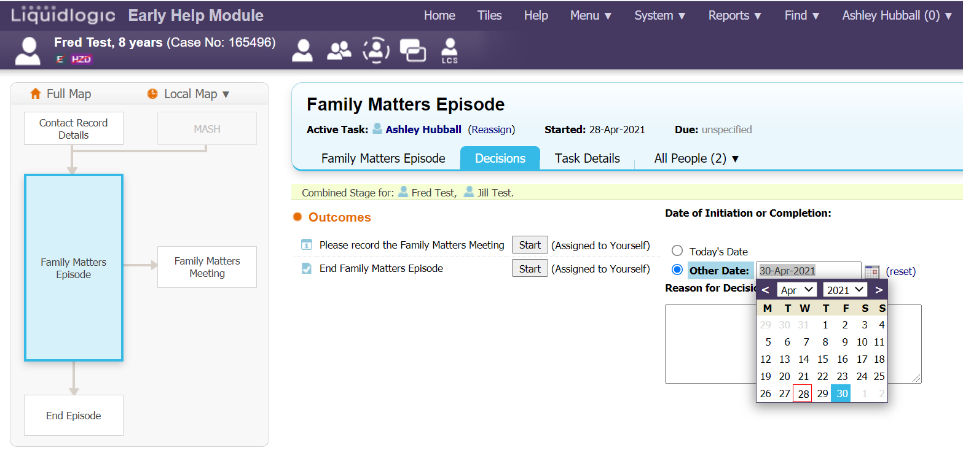
Now you are on the decisions tab, you can set a date for the Family Matters meeting. This date can be set in advance in preparation for the following week’s meeting:

Each Family Hub has their own Family Matters work tray within EHM. It is important that once a family matters episode has been opened, and a date has been set, to reassign this to the correct Hubs work tray. The Hubs work trays affectively act as an agenda, allowing the panel to view all the families to be discussed along with the families completed Request for Help form.
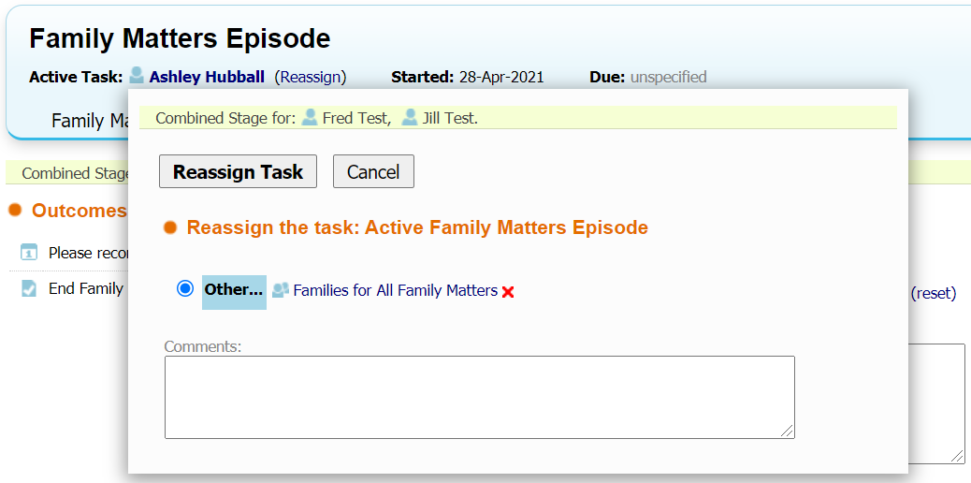
To reassign the family matters episode, click “reassign”, which is located next to your name and just above the decisions tab. From there, enter the appropriate Family Hubs name in the search bar before selecting it and clicking “reassign”:

Whilst the episode is no longer in your tray, you will not have access to make any amendments to the episode.
In order to make any changes you will need to click the green “pickup” icon, which will move the episode from the family matters work tray back into your own. This shouldn’t be something you need to do till you start typing your notes, at the beginning of the family matters discussion.
Your family matters workflow should now look like the image below:
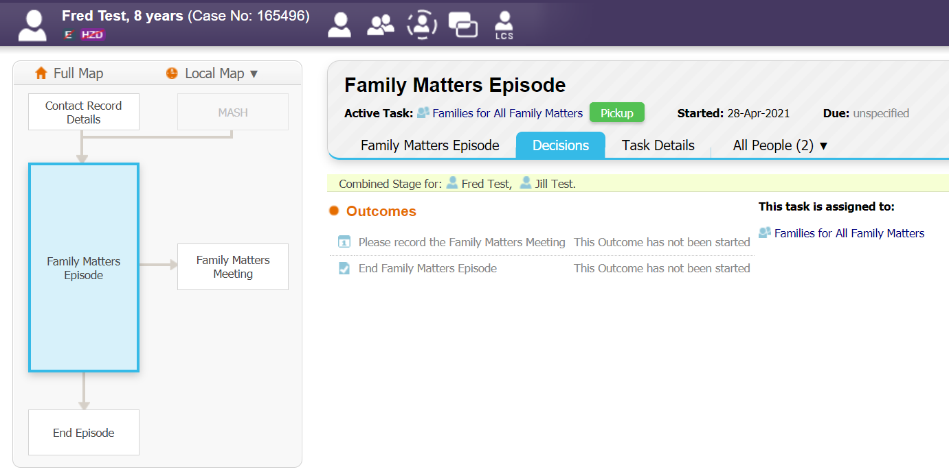

The meeting is now successfully set up and ready. You can view all your families due to be discussed by going into the appropriate hubs work tray. Which is located at the left-hand side of the home tab/screen:
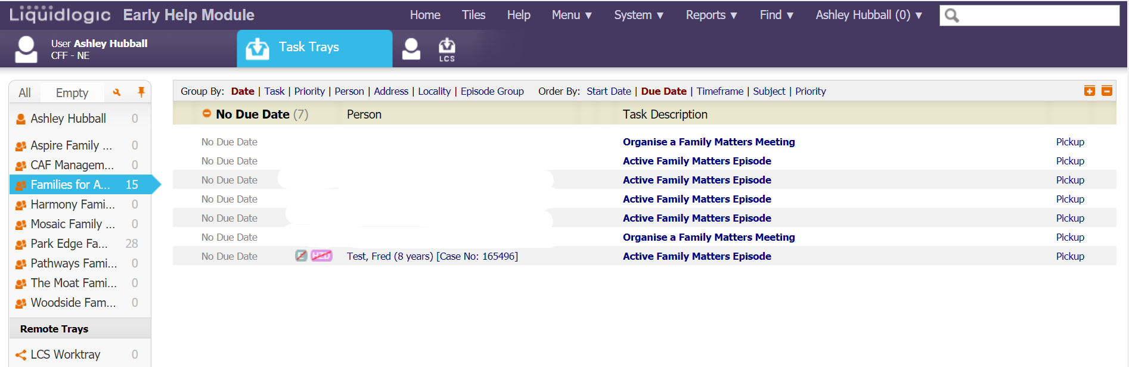

Recording the Meeting Notes

Please Note: As this is a new process in EHM, you may not feel confident typing the notes whilst the meeting is happening. This is perfectly fine. If you feel more confident typing or writing your notes as you normally do then you can do this and record the meeting notes into EHM following the meeting.

Begin your family matters meeting by navigating to the Family Matters work tray. Wait for the chair to start the meeting and click “pickup” on the first family that is about to be discussed (as shown below). This will navigate you to the family matters workflow:

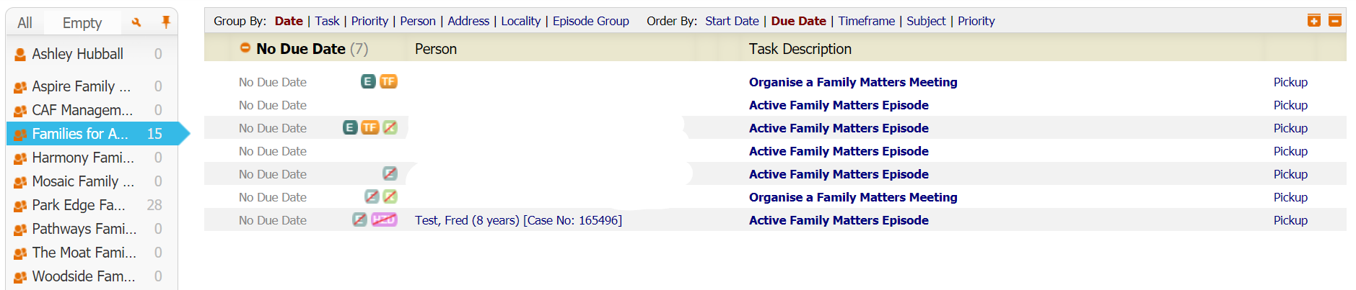

Click the “start” button, located next to “please record the family matters meeting”. This page you must confirm that the date and the child(ren)’s to be discussed are correct. Once you have checked, click “confirm”. As shown below:

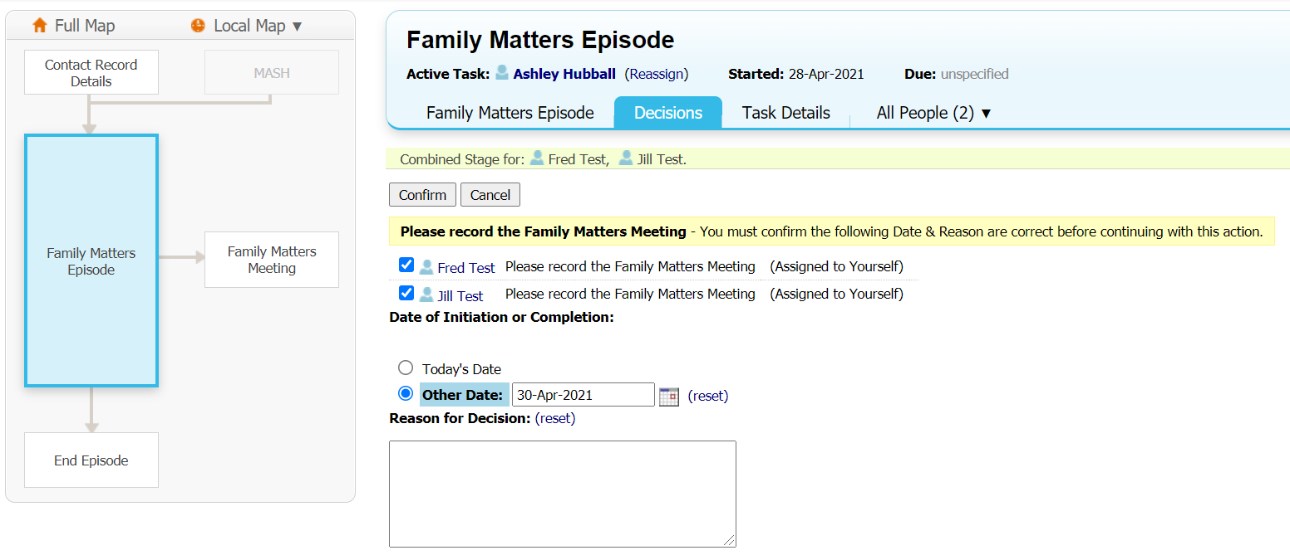

This will now direct you to the Family matters meeting section of the workflow. The diagram on the left of the page will highlight blue depending on what section of the workflow you are currently working on.
A red exclamation mark should appear to warn you a date and time for the meeting has not yet been set. To progress from here, click the “update meeting details and scheduling” option below:
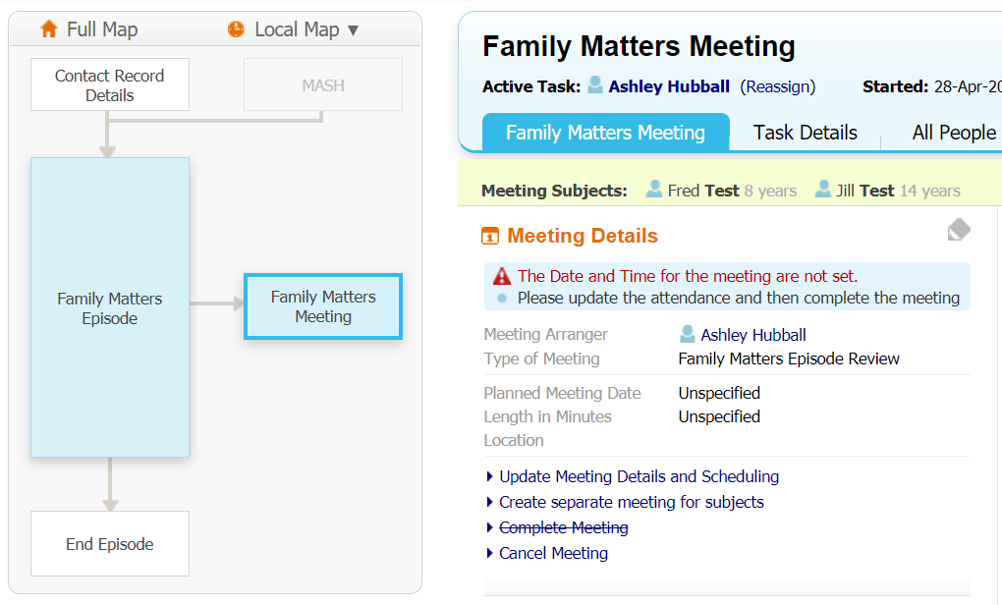

Ensure the date is correct and state how long the discussion will take in minutes (approximately). As an example, the below print screen says 60 minutes. For the location simply put your hubs name. Meetings are currently being completed via MS teams, so I have also involved that into the location.

Once this has been checked and completed, click “update” located at the top left of the page:
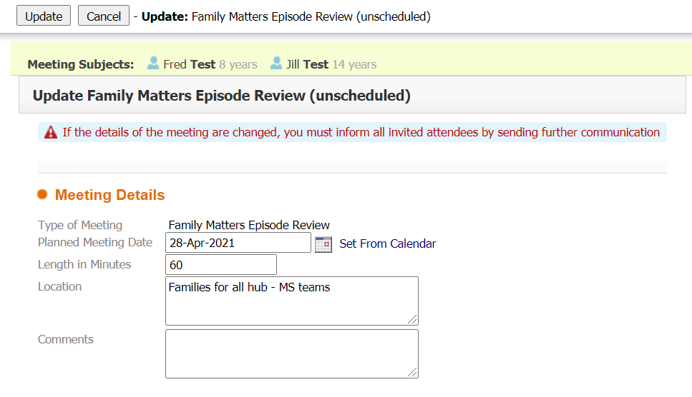
Click “meeting held – write up outcomes”. Located on the right-hand side of the meeting screen. You will be prompted to confirm that the meeting has been completed and the attendance has been updated. Click “ok”:
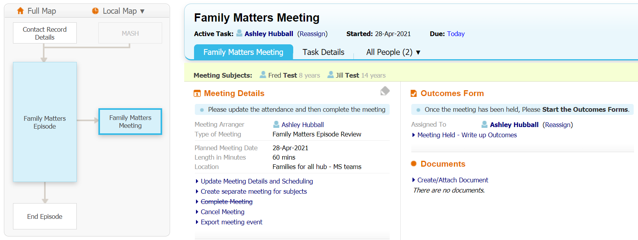

Confirm the date of the meeting and click “update” located in the top left corner:
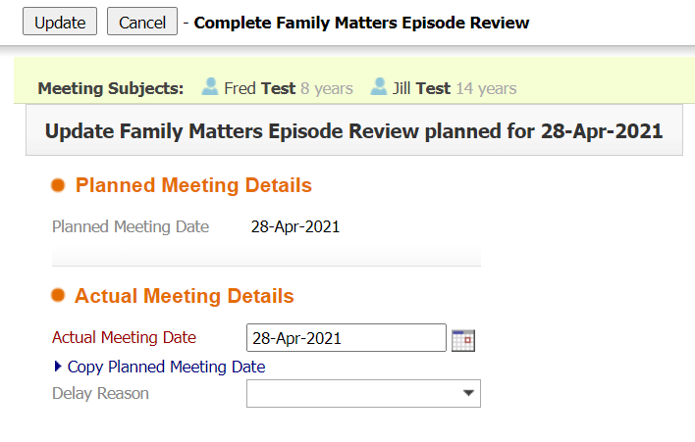

For this next page of the form you will be given the option of “copy forward selected” or “start blank”. Clicking either of the two options will navigate you to the same screen regardless.
Copy forward selected – this option only applies if the family are being discussed for a review. Clicking this will prepopulate the meetings attendees as it was the previous discussion. You will need to tick the boxes next to the child(ren)’s names before. This option will not be available if a it is a families first discussion for family matters.
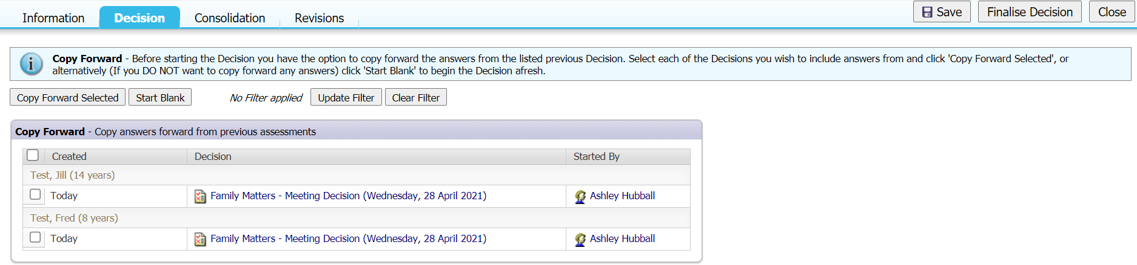
Start blank – this option can be used for a new discussion and for a review. If this is a families first family matters discussion, you will only have this option available to you.

This is now the form where you will type your attendees, discussion and the agreed outcomes. If you selected the “copy forward” option, your attendees will be the same as the previous discussion and you can make quick amendments for your convenience. If not, you will have to fill it in yourself. See an example image below.
If you feel this is taking too much time during the meeting, you can always copy and paste your attendee list for each discussion. If you need to take a moment to type it the first time, please inform the chair of the meeting:
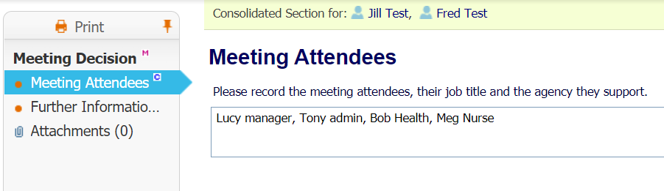

Please Note: It’s vital to only include the people who have attended the meeting to discuss this Child or Children. So if you have a partner from a school, for example, who is only attending Family Matters to discuss one Child or one Family then please ensure that the attendee list reflects that they attended for that Family only and not other Families who the school is not involved with.

Click into the further information section, located just above the meeting attendees section. Here you will type your discussions and agreed outcomes into the top textbox, labelled “details of meeting”.
You must tick one of the two boxes provided for suggested outcomes;
- Start next family matters meeting – this box is selected when the request for help needs another family matters discussion (also known as a review).
- Continue with current process – this box is selected when the request for help can be removed from family matters and no review is needed (i.e. the Family Matters Episode can close).
In the “reason for suggested outcomes” textbox, you will need to write a justification as to why you have selected which box. If you are unsure you can confirm this with the chair. I have attached an example image below.
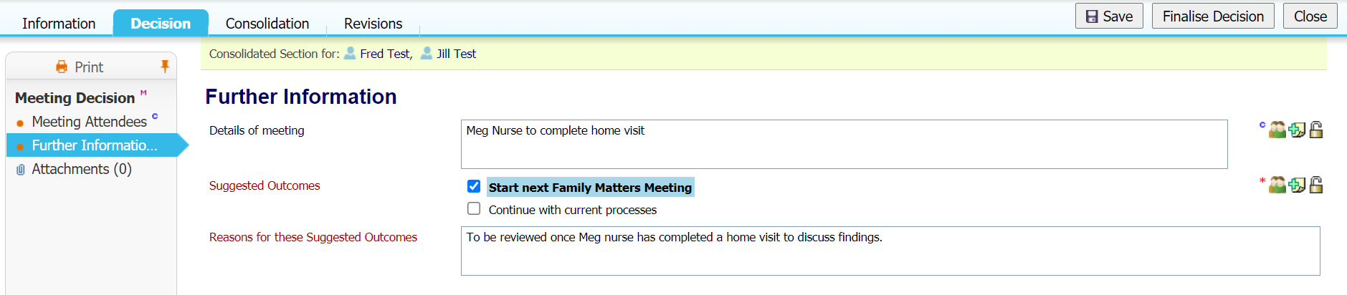
You can save your notes at any time by clicking save in the top right, these can be revisited and amended at any point until you click finalise. Do not click finalise until you have checked your note taking with the chair:

Once you have saved your notes. You are now able to navigate back to the family matters work tray, by clicking the home tab and repeat these steps for the next family discussed.

Finalising a Family Matters Meeting

Bringing a case back for a review;
If a Family needs discussing for a review at a future family matters meeting, make sure you have selected the “start next family matters meeting” box.
Once the chair has confirmed that you can finalise your notes, click the “finalise” button on the top right corner of the form. This will prompt you to click “ok”.
Please skip to the section Closing a Family Matters Episode for steps regarding closing a family matters episode.

Click into the “family matters meeting” section of the workflow visual on the left-hand side of the form. From here, click “complete meeting”:
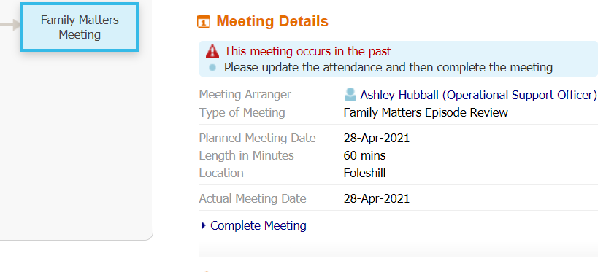
This will complete the meeting and trigger the outcome recorded within the form (i.e. start next Family Matters Meeting or Continue with current process)

Now that your meeting is finalised, you must arrange the meeting date for the next meeting. Click “start next family matters meeting”. This will navigate you back to the meeting screen where you arrange your family matters meeting. If you need a refresh, please refer to the section on Organising a Family Matters Meeting and repeat the steps from there.

Closing a Family Matters Episode

Once you have completed your notes from the family matters meeting, and the decision has been made to close the family matters episode. Ensure you have the “continue with the current process” box ticked, before saving or finalising your meeting using the options displayed in the top right of the form, as shown below:

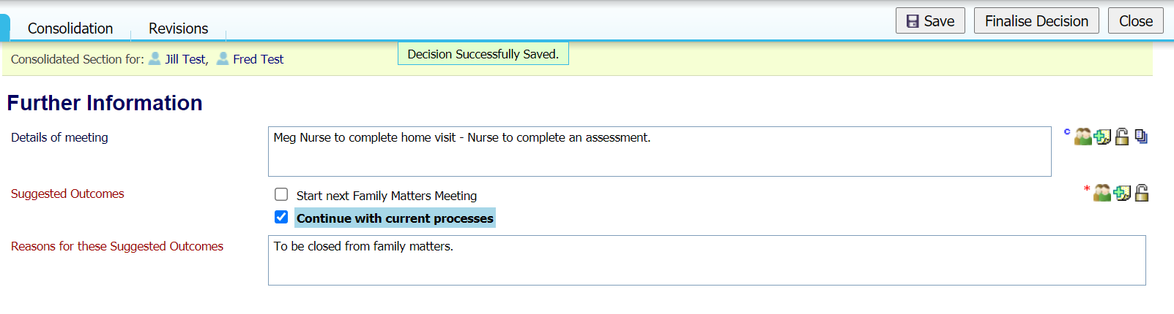

Select “complete meeting” from the meeting screen:
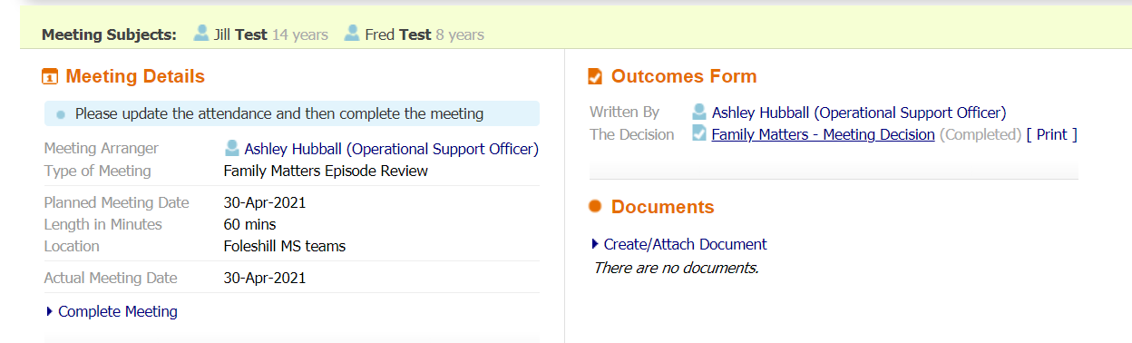

Now start the “continue with current process” decision:
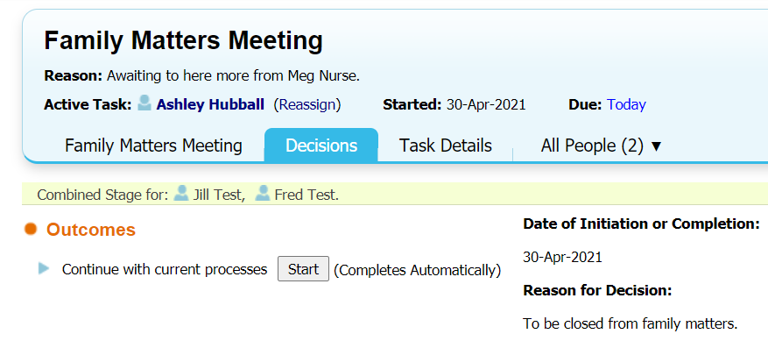

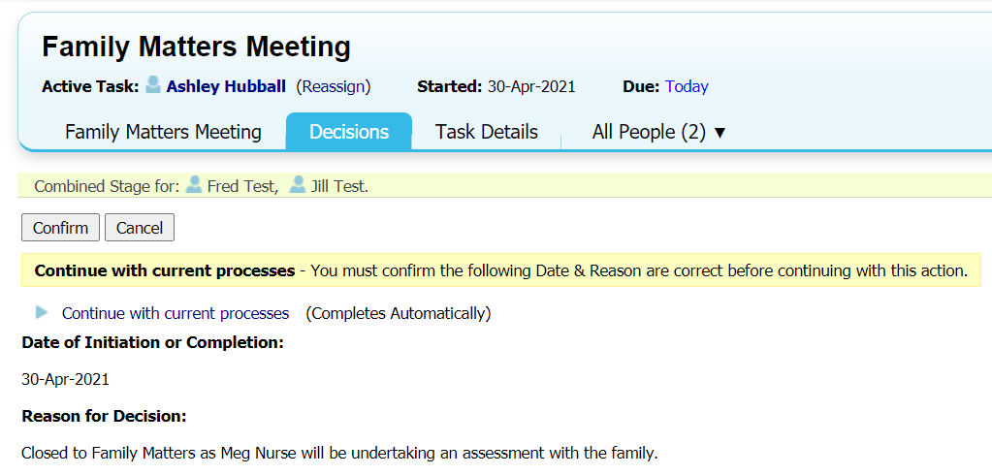
Select “confirm” as shown below:

Make sure you are now in the Family Matters episode section of the workflow and start the family matters closure by selecting “start” next to “end family matters episode:
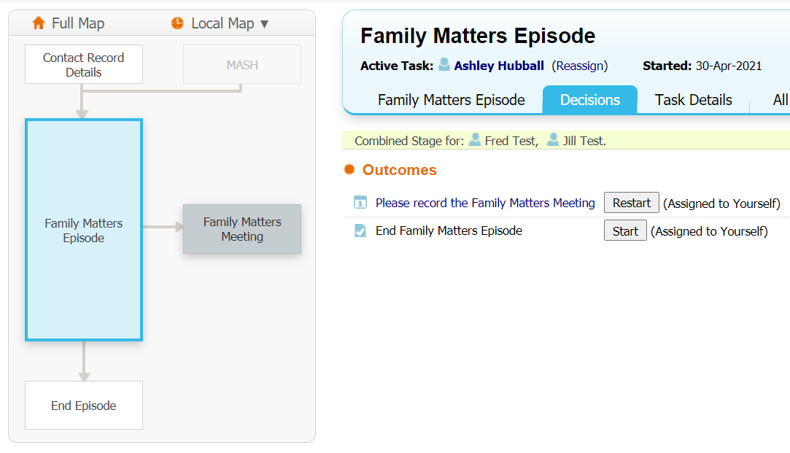

Next, put the date of the family matters closure and click “confirm”:
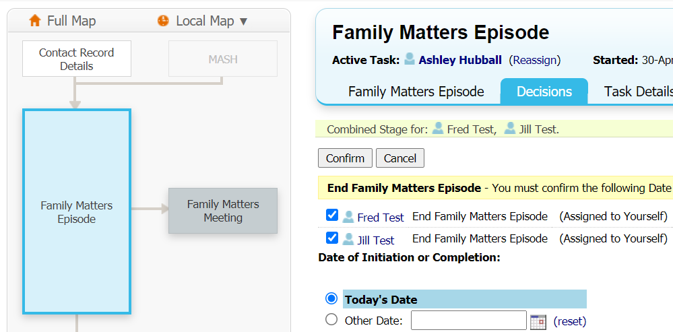

Now you are in the “end episode” section of the workflow visual. Proceed by clicking “start family matters episode closure”:
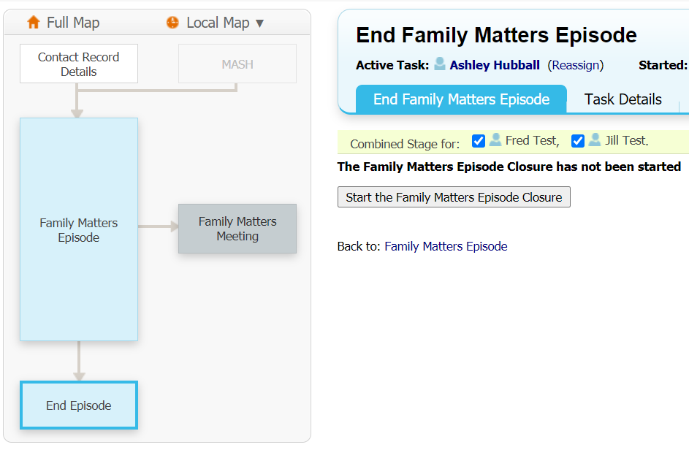

On the form you must confirm the dates of the episode closure and select a justification for the closure using the drop-down menu. The drop-down menu has 2 options;
- No further action required.
- Other.
If you select other, a text box will appear asking you to write a short sentence as to why the closure has taken place. An example could be “allocated to Meg Nurse to complete an assessment.”
Once you have completed these steps, you can save or finalise the assessment using the options provided at the top right of the form:
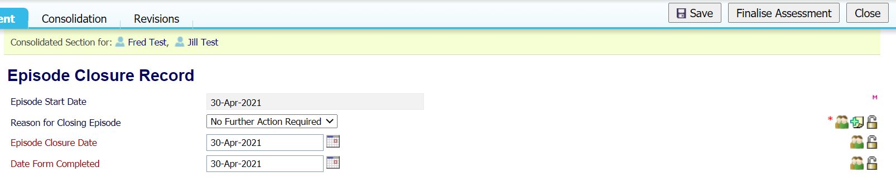

This concludes your involvement for a family matters episode. If you want to check that the family matters episode has been successfully closed, check both your own and your family hubs work tray to make sure the family is no longer in it.

Process Map
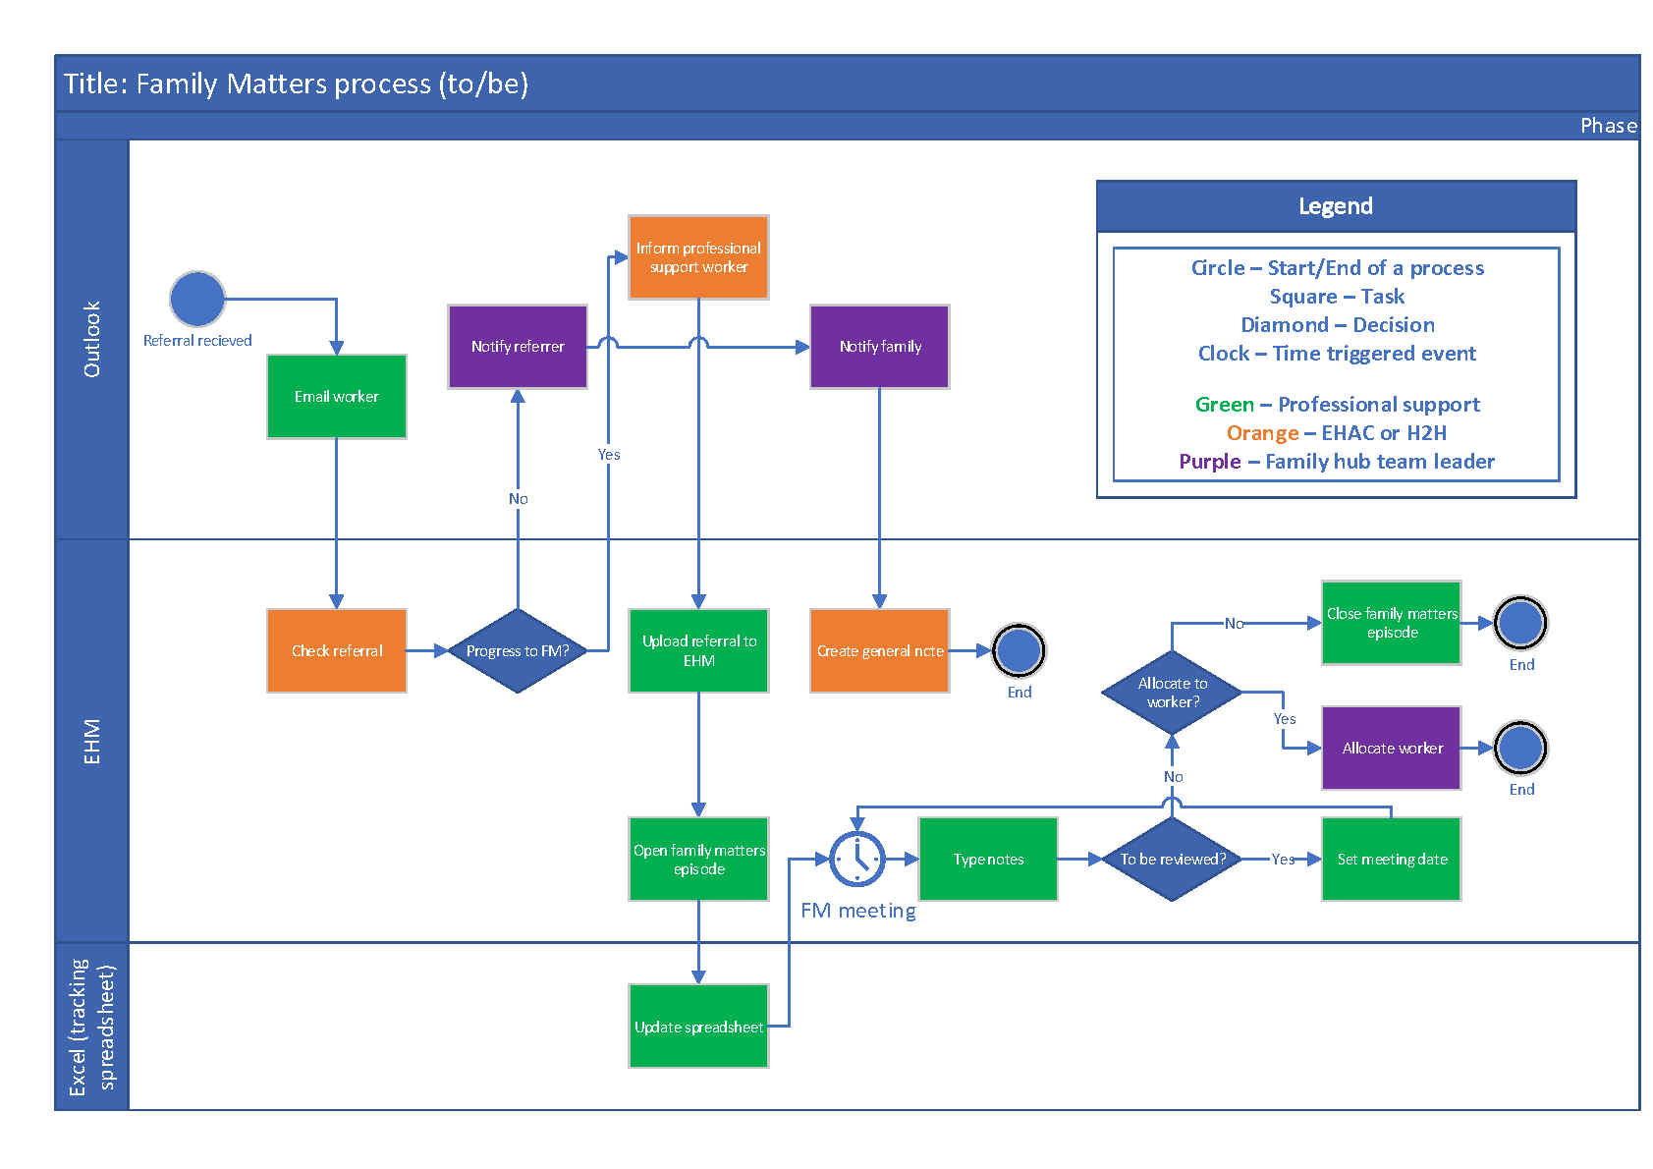

Key Contacts

For system-based issues and queries:

EHM Help Desk
EHMHelp@coventry.gov.uk

Steven Turner
EHM Co-ordinator
Steven.turner@coventry.gov.uk

Ashley Hubball
Family Matters Champion
Ashley.Hubball@coventry.gov.uk

For practice and recording issues please speak to your Team Leader or Early Help Manager within your Family Hub.

