Please specify the area(s) in which you wish to carry out your Street Collection:
LOCATION | YES / NO
All Areas Named Below, OR
Precinct Crossover
Upper Precinct
Smithford Way
Market Way (adjacent to Crossover)
Shelton Square
Dresden Place
Hertford Street
Other: (please specify)

NB (a) Street Collections may be conducted in Shelton Square from Monday to Friday, but on a Saturday this area is reserved for entertainment.
(b) Sale of articles for the benefit of charitable purposes may be conducted in Dresden Place only.
(c) Street Collections and events are not permitted in Broadgate without prior permission from the
City Centre Markets Team. Please contact: 024 7622 4927 before applying for a street collection in Broadgate.
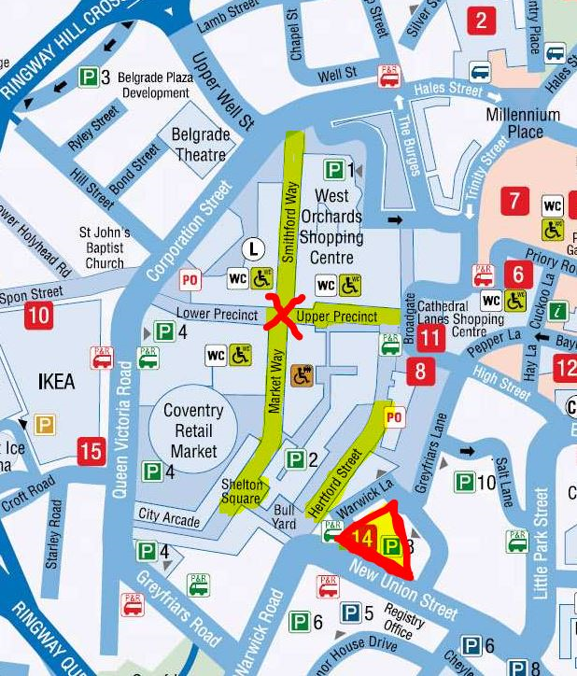
Precinct Crossover Dresden Place

