Supporting care home residents in England and Wales to register to vote

This document provides key information about the voter registration system in England and Wales.
It provides guidance on how you can support those in your care to register to vote.

Applying to register to vote
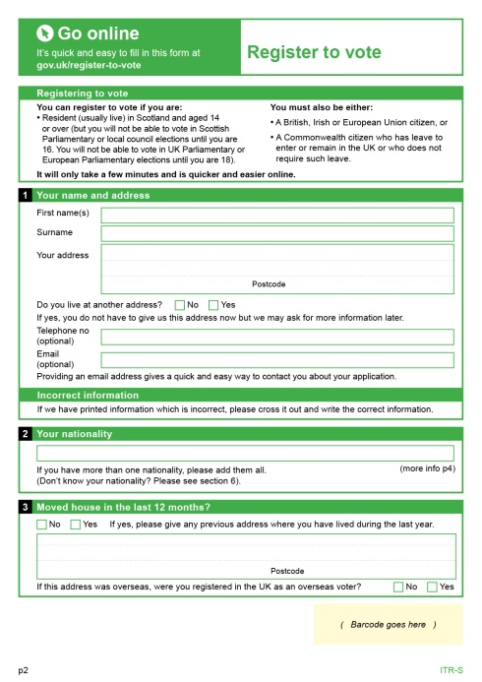
Any new application to register must be made individually.
Applications can be made online at www.gov.uk/register-to-vote or by completing a ‘Register to vote’ form. Some Electoral Registration Officers will also offer the possibility of making registration applications by telephone. You should contact your local electoral registration office for more information. You can find their details at www.electoralcommission.org.uk/i-am-a/voter.
To make the registration system more secure, applicants must provide identifying information (date of birth and national insurance number) as part of their application. These details will be checked against official records to verify the identity of the person making the application.
Where this identifying information cannot be provided, applicants must give the reason why they cannot provide the information. They will then be contacted and required to provide documentary evidence of their identity.
The online registration system and the paper form both contain guidance notes to help with completing the application.
The application requires the person who is applying to declare that the information provided is true (a ‘declaration of truth’).
On the paper form, the applicant must make the declaration by signing or making their usual mark. On the online application, the applicant must confirm that the information is correct. Alternatively, a person who has an appropriate power of attorney may make the declaration on behalf of the applicant.
A postal vote application form may also be requested by ticking a box on the ‘Register to vote’ form. A postal vote application can only be completed on a paper form since a signature is required. If a person is unable to sign or to provide a consistent signature they may contact their local electoral registration office to request an application for a signature waiver. See the FAQ on page 7 for further information.

Annual canvass
Pre-populated | Blank
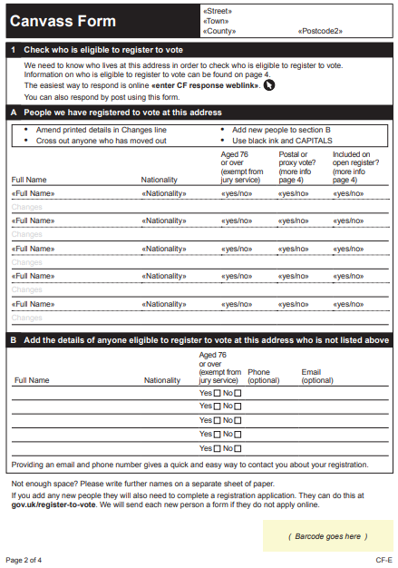 | 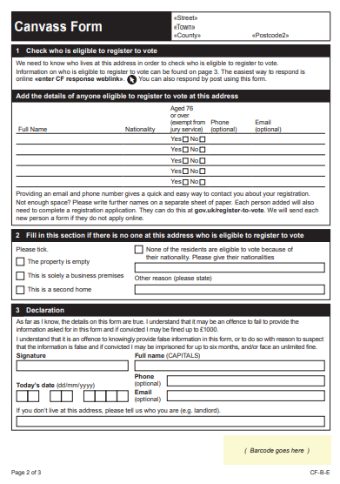
From 2020, Electoral Registration Officers will conduct the annual canvass of care homes in one of two ways.
- they may contact a responsible person, and request that they provide a list of the residents at the care home and other required information, or
- they may send a canvass form to the property
The purpose of the annual canvass is simply to capture information on who lives at the property to show who should and shouldn’t be registered to vote – a person cannot register to vote via a canvass communication.
A person in charge of the premises must provide the required information ensuring that all eligible people are listed. The form explains who is eligible to vote.
The canvass form may be sent blank or may be pre-printed with the names of people who are currently listed on the electoral register at that address.
- If the form is blank, the details of everyone eligible to register to vote must be added. Use their full names, e.g. ‘Elizabeth’ not ‘Bessie’. Include all residents even if they are physically or mentally frail. Once the form is processed, the local electoral registration office will send those people included on the form a ‘Register to vote’ form.
- If the form is pre-printed it will list the names of the people who are currently on the electoral register at that address. It will also indicate whether these individuals have an existing postal or proxy vote, their open register preference (See the FAQs for further information) and whether they are aged 76 or over (required for jury service purposes). Any person who is no longer resident should be crossed through, and anyone not listed who is eligible should be added. Once the form is processed, the local electoral registration office will send any new people a ‘Register to vote’ form.

Principles
- Everybody who is eligible should be registered irrespective of any illness or disability they may have

- There should be a presumption that a person has capacity to register to vote

- Only the applicant, or a person to whom they have given power of attorney, can make the required declaration as part of an application for registration

How can I help the people in my care?
It is important that you do not make an assumption about an individual’s capacity to register or to vote or apply a “one size fits all” approach to all residents. Everyone, regardless of their capacity, should be registered to vote. It is important that vulnerable people do not lose their right to vote.
You may provide assistance but the applicant must make the declaration of truth by signing or making their usual mark (in the case of the paper form) or confirm that the information is correct (for an online registration). Alternatively, a person who has an appropriate power of attorney may make the declaration on behalf of the elector.
If an elector has a physical disability that means they cannot write or type, a person can assist them to register online by doing the typing on their behalf, as long as the elector is present and can communicate that the information provided on the application is true.
As the application asks for the individual’s date of birth and National Insurance number, you may need to make extra effort to obtain this information. For example, where this information is not immediately available, you may need to speak to a relative to obtain it.
Most people will have a National Insurance number, but if the applicant does not have one, this fact will need to be stated (there is space on the application for this) and the electoral registration office may contact the applicant to ask for evidence or alternative information to help confirm their identity.
You may be supporting some residents who are using your service for a respite stay. In that case, you should check if they would like support to register to vote or find out if they have made alternative arrangements to register to vote at their home address.
Suggested actions:
- Ensure that any forms received are completed and returned promptly to avoid reminders.
- Contact the local electoral registration office in the event of a resident’s death or if new residents move in or residents move out.
- Provide information and assistance on the different ways in which residents may register and vote. Anyone who is registered will receive a poll card before an election is due to take place, telling them when the poll is, and where their polling station is or when to expect to receive their postal vote (depending on how they have chosen to vote).
- Provide scheduled transportation, if possible and appropriate, to and from polling stations.
- Assign a member of staff as a single point of contact or ‘registration champion’.

How can I help those voting by post?
You must ensure that residents with postal votes have privacy while they are marking their ballot paper. It is very important that the resident marks their own ballot paper.
The postal ballot paper will be accompanied by a postal vote statement on which the resident must provide their signature and date of birth. You can help with this, but the resident must sign the postal vote statement themselves (unless they have been granted a waiver). You can help place the ballot paper (without looking at how it has been marked) into the correct envelope ensuring that their vote remains secret.

Power of attorney
Although you may provide assistance to a resident to help them to register themselves you cannot make the declaration of truth on their behalf. However, a person with an appropriate power of attorney may complete a registration application and make the declaration of truth on behalf of an incapacitated person.

Frequently asked questions

What if the date of birth or National Insurance number is not known?
Every effort should be made to provide both personal identifiers.
The National Insurance number can be found on official paperwork such as letters from the Department for Work and Pensions or HM Revenue & Customs. The details may also be known by relatives.
Where this identifying information cannot be provided, applicants must give the reason why they cannot provide the information. They may then be contacted and required to provide documentary evidence of their identity.
In Wales, a person under 16 years old is not required to provide their National Insurance number.

What if a signature cannot be provided?
Registering to vote – an application to register requires a declaration of truth from the applicant that the information provided is true. On a paper form, the applicant must make the declaration by signing or making their usual mark; however, where they are unable to do so, the ERO can accept a declaration made in some other way (for example, by telephone or in person) as long as they are satisfied that the declaration is being made by the applicant and is genuine and true. On the online application, the applicant must confirm that the information is correct. Alternatively, a person who has an appropriate power of attorney may make the declaration on behalf of the applicant.
Postal vote – a person who is applying to vote by post or already votes by post and who is unable to sign or to provide a signature in a consistent way, can apply for a ‘signature waiver’ by contacting their local electoral registration office. You can find their details at www.electoralcommission.org.uk/i-am-a/voter
Enquiries may be made to ensure that the request for a waiver is genuine and not being used to avoid postal vote security measures.

Can you provide information in another format (Braille, large print, etc.)?
Some information is available in alternative formats. The online registration form at www.gov.uk/register-to-vote works with assistive technologies such as screen readers. Large print and ‘easy read’ versions of the individual registration form are available on the Electoral Commission’s website.

What if a person does not register?
They will not be able to vote in elections or referendums. Since the electoral register is used by credit reference agencies, they could also have difficulty in obtaining credit or a mobile phone contract, for example.
If the forms are not completed, the Electoral Registration Officer (ERO) is required to send reminders and these would be followed by a personal visit from council staff. A person who still does not register could then be sent a requirement to register. Continued failure to respond could result in a fine of £80.
It is also a legal requirement to provide the information asked for on the canvass form, and failure to respond could result in a fine of up to £1,000.
In practice, the legislation does not take account of the sensitivities that may arise around issues such as mental capacity. Legally, the ERO must go through the required steps (reminders / personal visit) where no response is received (unless they are they are satisfied that the person is not entitled to be registered or, is registered at a different address). However, it is recognised that in cases where an individual lacks mental capacity, the reminder letters with the threat of a fine and a personal visit to encourage registration could be distressing for the individual and those caring for them.
For example, where an invitation to register/ register to vote form is returned and is marked to indicate that the person invited lacks mental capacity to register, the ERO should make further enquiries and explain the purpose of registration and the help that can be given to assist the person to make an application to register (for example, information being taken in person or by phone – depending on the options offered by the ERO – or the application being made by a person with an appropriate power of attorney).
If the ERO is satisfied that the person is not able to register – i.e. the person lacks mental capacity and their condition will not improve or is degenerative – the ERO will need to consider whether it is appropriate, taking into account all of the particular circumstances, to continue with the follow-up processes at that time.
You should contact the local electoral registration office if you have concerns. You can find their details at www.electoralcommission.org.uk/i-am-a/voter

What is the open register?
Using information received from the public, registration officers keep two registers – the electoral register and the open register (also known as the edited register).
The electoral register lists the names and addresses of everyone who is registered to vote in public elections. The register is used for electoral purposes, such as making sure only eligible people can vote. It is also used for other limited purposes specified in law, such as: detecting crime (e.g. fraud), calling people for jury service, and checking credit applications.

The open register is an extract of the electoral register, but is not used for elections. It can be bought by any person, company or organisation. For example, it is used by businesses and charities to confirm name and address details. Your name and address will be included in the open register unless you ask for them to be removed. Removing your details from the open register does not affect your right to vote.

In Wales, if you are aged 14 or 15: If you are aged 14 or 15, you will not be included on the open register. You will be included on the electoral register, but only Electoral Registration Officers and their staff can usually see the details you provide. Your details will not be included in any register that is published. About six weeks before an election certain people need details of everyone who can vote in that election. If you will be 16 on the date of a Welsh Parliament your name and address will be given to people who run the elections, and to candidates who want to provide information to voters.

You can find more information about both registers and how they may be used at www.gov.uk/register-to-vote.

An elector can ask for their details not to be included in the open register (i.e. they can choose to ‘opt out’). This can be done on the ‘Register to vote’ form when registering to vote, or at any other time by telephoning, emailing or writing to their local electoral registration office.

What are the different ways to vote?
There are three ways of voting:
In person – polling stations are open from 7am to 10pm on polling day. Registered electors will receive a poll card telling them where their polling station is.
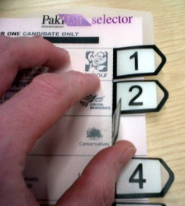 There will be large print versions of the ballot paper on display and a ‘tactile’ voting device to help blind and partially sighted voters complete their ballot paper at all polling stations.
If residents need help with the process of voting, they can take a companion with them to assist them, or ask the polling station staff for help.
By post – an elector can apply to have their ballot paper sent to them in the post for:
- A particular election (i.e. a poll on a specific date)
- A definite period (i.e. between specific dates)
- An indefinite period (i.e. until further notice)

In all cases, the application deadline is 5pm, eleven working days before the poll.
Application forms are available from www.electoralcommission.org.uk/i-am-a/voter or from the local electoral registration office. Unlike applications to register, postal vote applications cannot be made online. Applications must be sent to the person’s local electoral registration office (not to the Electoral Commission).
The applicant must provide their signature and date of birth. When ballot papers are sent out for an election, a postal vote statement must be completed when the ballot paper is returned. Full instructions on how to do this are included with the postal ballot pack. The signature and date of birth on the returned postal voting statement is compared against the signature and date of birth previously provided by the elector as a security check.
A person who is applying to vote by post or who already votes by post and who is unable to sign or to provide a signature in a consistent way can apply for a ‘signature waiver’ by contacting their local electoral registration office.
By proxy: an elector can appoint someone they trust to vote on their behalf for:
- A particular election (i.e. the poll on a specific date)
- A definite period (i.e. between specific dates)
- An indefinite period (i.e. until further notice)

An application for a definite or indefinite period can only be made in specific circumstances and a supporting statement (or ‘attestation’) may be needed. Those who are registered blind by the local authority or who are in receipt of the higher rate of the mobility component of the Personal Independence Payment do not need an attestation.
The application deadline is 5pm, six working days before an election. If, however, a person becomes unexpectedly ill or incapacitated after this time or becomes aware, after the application deadline, of reasons relating to their occupation, service or employment which mean they are unable to vote in person, they can apply for an emergency proxy up until 5pm on the day of the election.
Application forms can be obtained from www.electoralcommission.org.uk/i-am-a/voter or by contacting the local electoral registration office. Unlike applications to register, proxy vote applications cannot be made online.
About the proxy
The person appointed as proxy can only act as proxy if they are 18 or over (16 or over in Welsh Parliament elections or local elections in Wales) and they are (or will be) registered and are entitled to vote in the type of poll they are appointed for.
A proxy can cast the proxy vote either in person at the polling station or by post (a postal proxy).
A person cannot be a proxy for more than two people at any one election unless they are a close relative. Care home staff should avoid acting as proxy for a resident unless there is no other person who could perform this function.

Section 1 of the Mental Capacity Act 2005.
No charge should be made for providing an attestation.
In this context, a close relative is the spouse, civil partner, parent, grandparent, brother, sister, child or grandchild of the elector.

