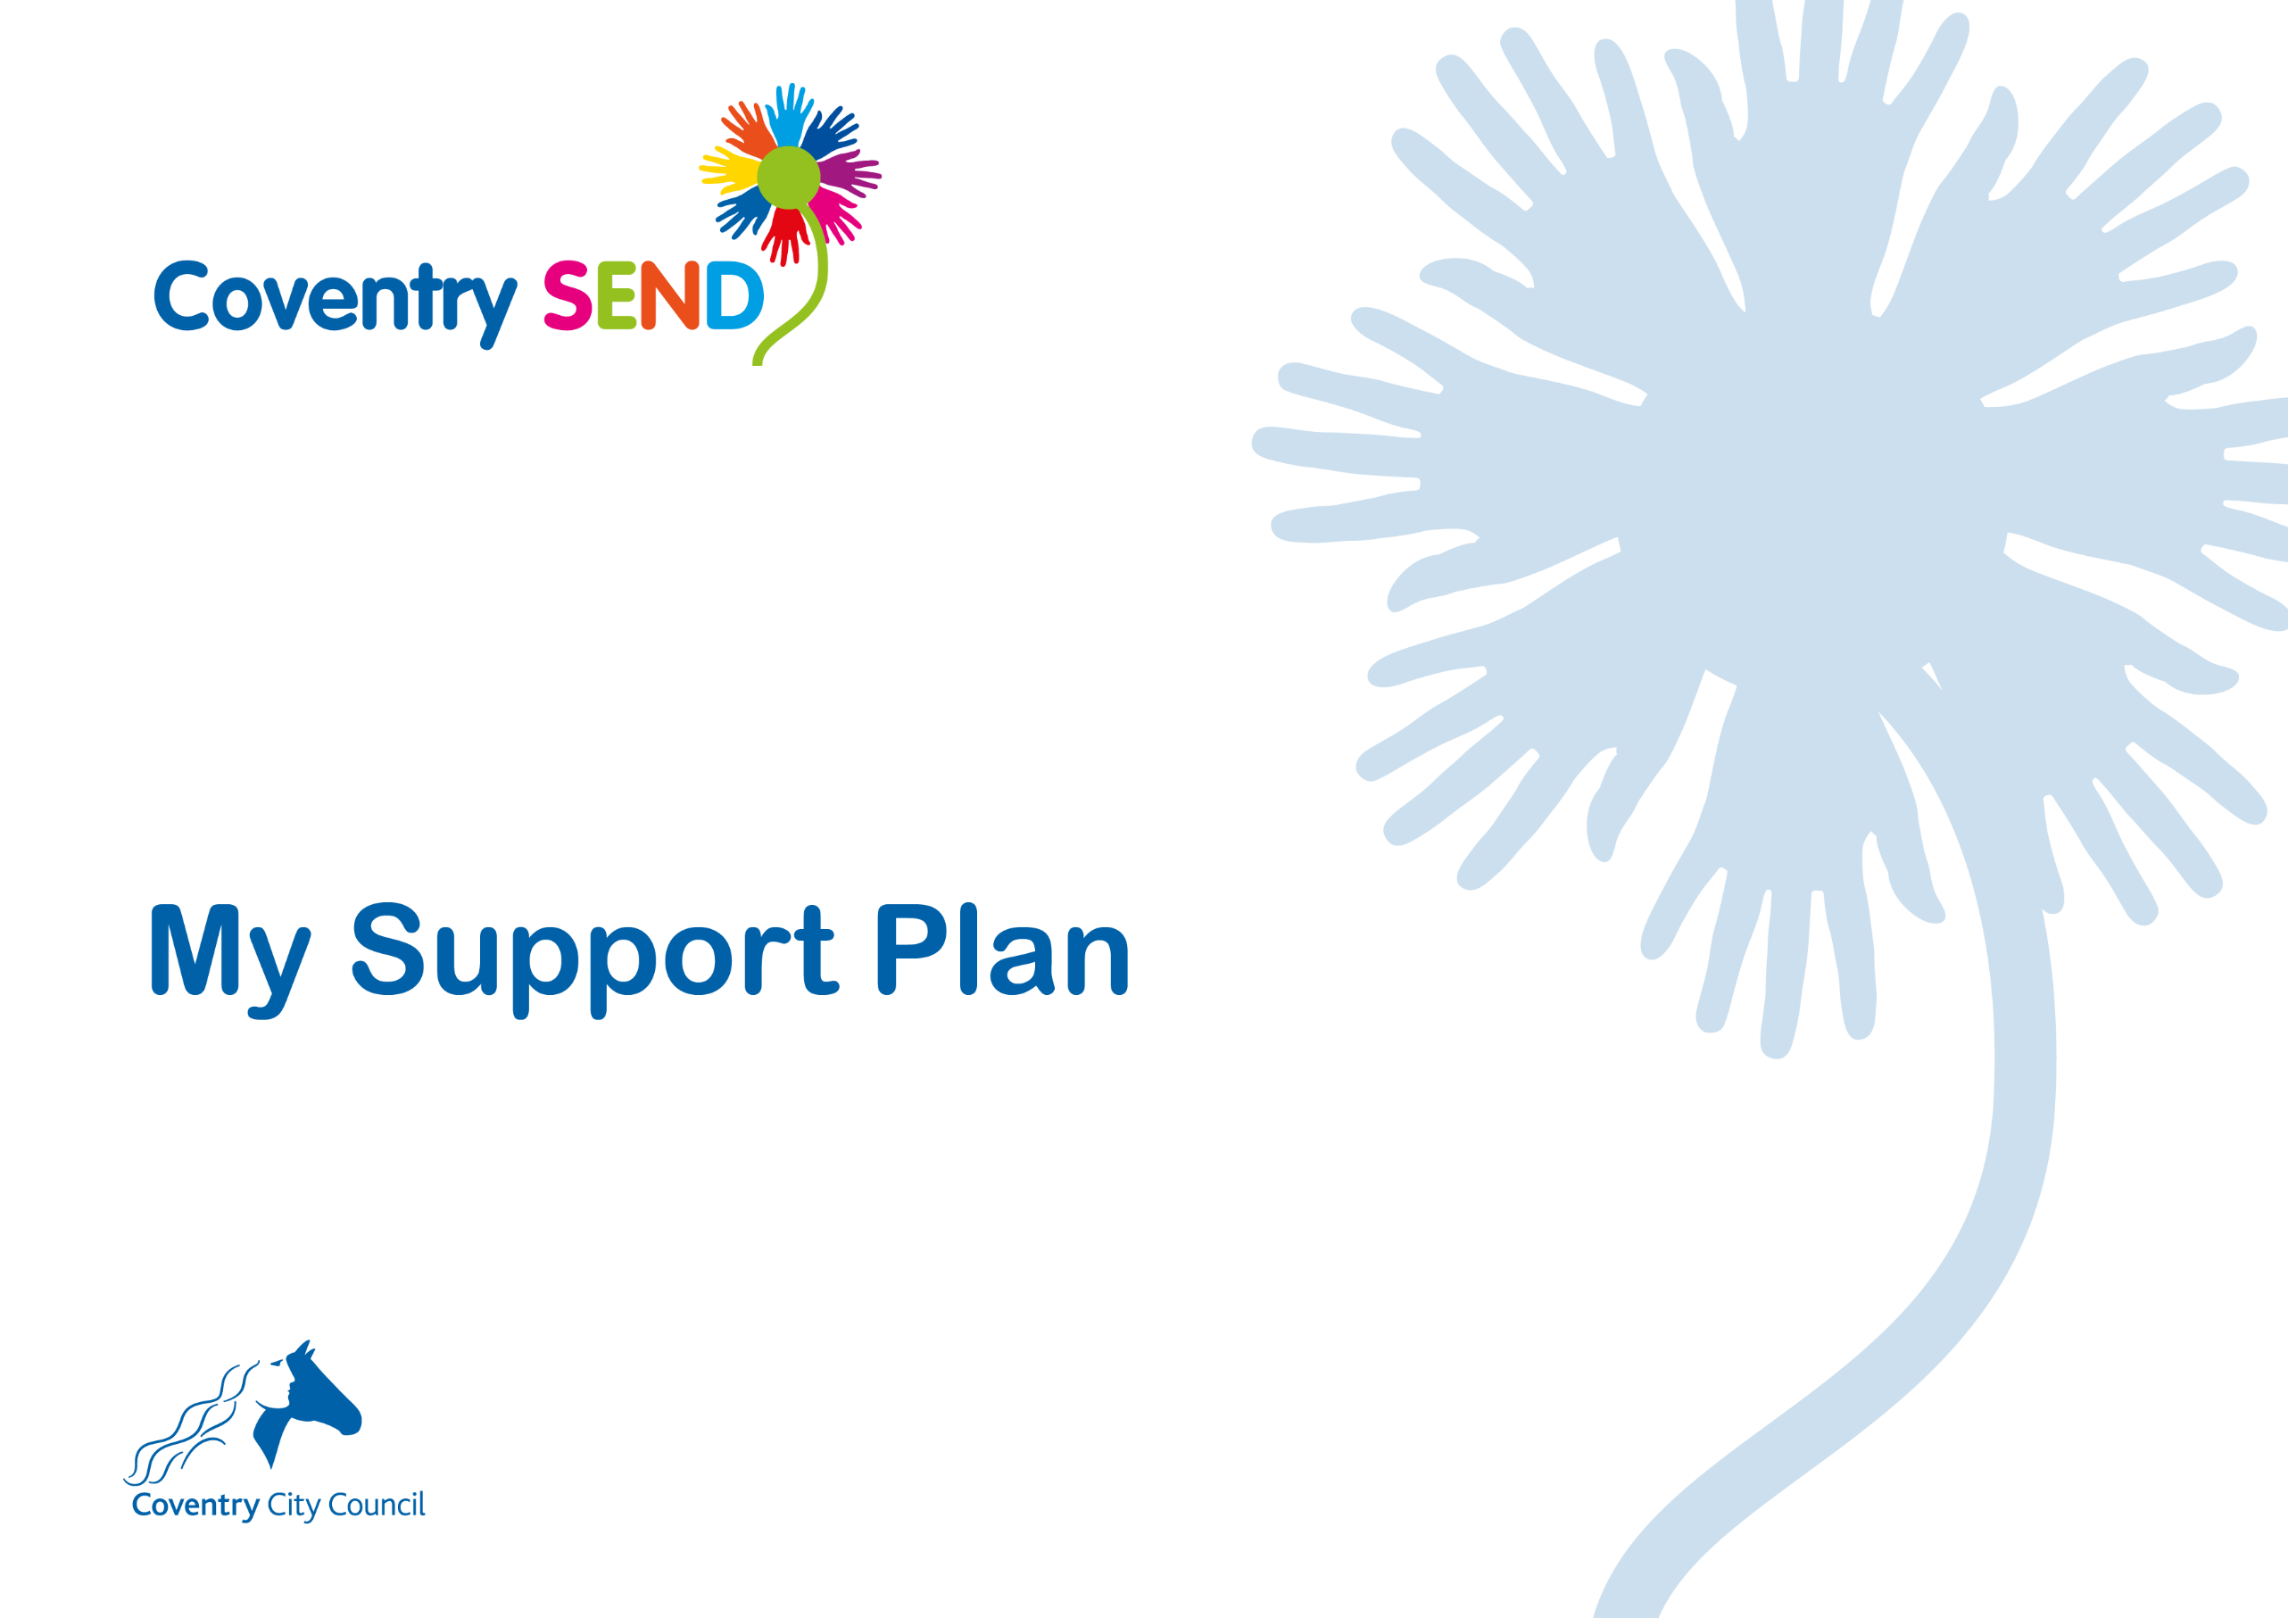
Name
Setting
Plan number
Plan start date
Plan review date

Early Years Foundation Stage
My Views My Family’s Views
This section was written on my behalf by the people who know me best.  I am happy when:  I don’t like it when: | Our priority for our child is:  This is what is working well for them at the moment:  This is what would improve things for them:  It is important for you to know these things about our family:

My Team
People in my family
_{Name} | _{Relationship} | _{Parental responsibility?} | _{Contributed to My Plan?} | Contributed to review?

Professionals supporting me and my family
Name | Role | Agency | Contributed to My Plan? | Contributed to review?

My Health Needs
Diagnosis/ Disability/ Health Need | Diagnosed by | Is medication taken for disability/diagnosis? | Is it taken at setting?
Other health issues/ referrals made
My Social Care Needs
Social Care Processes in operation:
Local authority responsible:
Other plans:

My Progress
Please use the table below to provide information about the child’s level of attainment. We recommend referring to the ‘Birth to 5 Matters’ non statutory guidance and, in partnership with parents, making an informed professional decision about which range best describes the child’s attainment in each area.

Area of Learning | Attainment at the beginning of this  My Support Plan  (chronological age XX months = range X) | Attainment when this My Support Plan was reviewed  (chronological age XX months = range X)
Personal, Social and Emotional Development | Making relationships - range  Sense of self - range  Understanding emotions - range | Making relationships - range  Sense of self - range  Understanding emotions - range
Communication and Language | Listening and attention - range  Understanding - range  Speaking - range | Listening and attention - range  Understanding - range  Speaking - range
Physical Development | Moving and handling - range  Health and self-care - range | Moving and handling - range  Health and self-care - range

My Strengths and Needs
Personal, Social and Emotional Development
Communication and Language
Physical and Sensory Development
Cognition and Learning

My Outcomes and Provision
To be completed during the plan writing meeting |  | To be completed during the plan review meeting
Outcomes Sought | Educational provision | Review Notes
The provision was fully/partially/not implemented.
The outcome was fully/partially/not achieved.
Comments:

The provision was fully/partially/not implemented.
The outcome was fully/partially/not achieved.
Comments:

The provision was fully/partially/not implemented.
The outcome was fully/partially/not achieved.
Comments:

The provision was fully/partially/not implemented.
The outcome was fully/partially/not achieved.
Comments:

The provision was fully/partially/not implemented.
The outcome was fully/partially/not achieved.
Comments:

