Task 1:
Look carefully at the four sources on the issues of Elizabethan poverty and make a list of everything you can infer about:
- the life of vagrants
- how vagrants were treated.
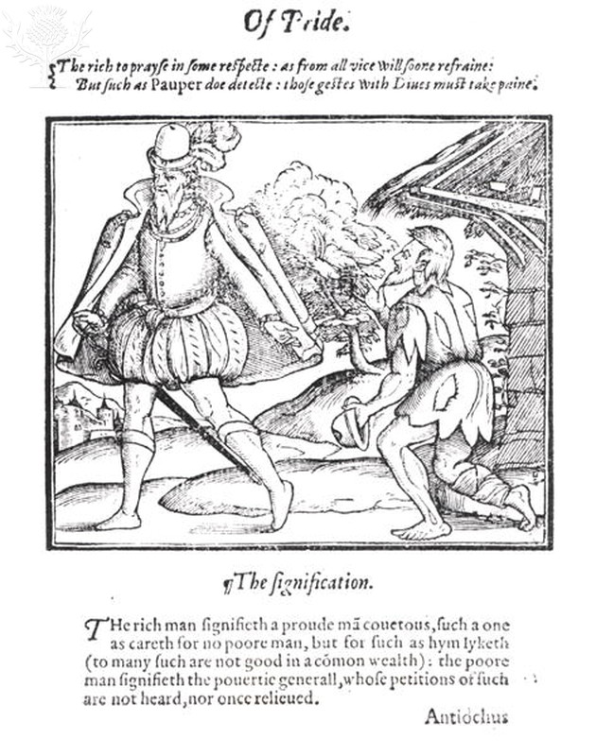 |  | 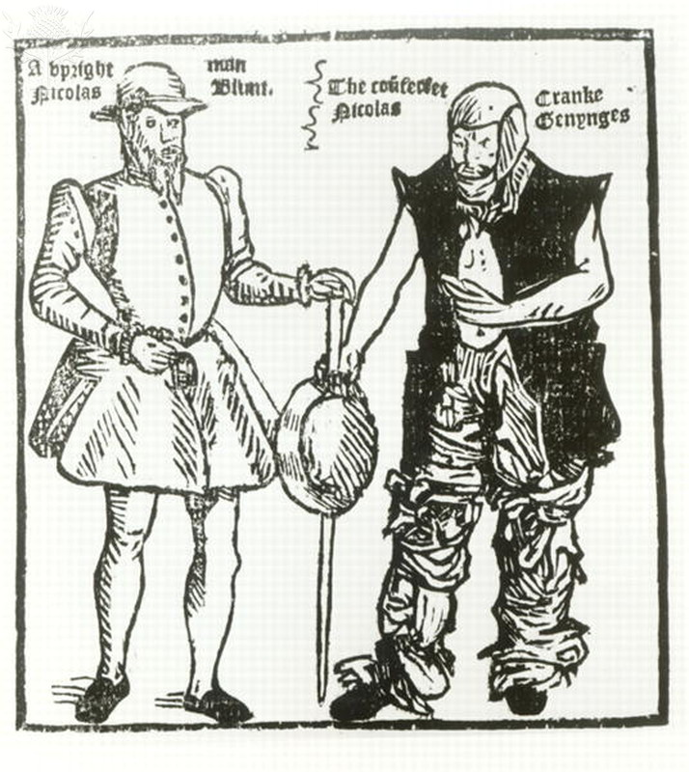
Source 1: A rich man spurns a beggar |  | Source 2: Nicholas Jennings in the guise of both a cripple and a gangleader.
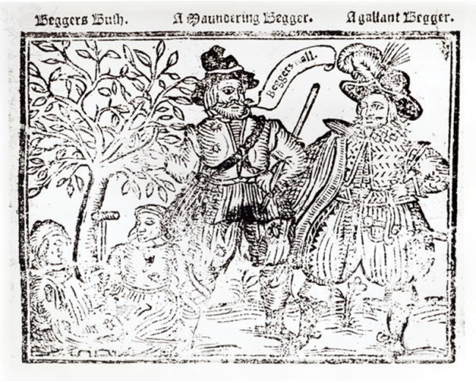 |  | 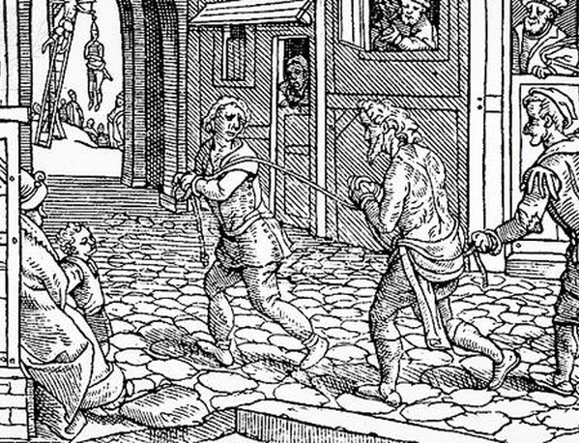
Source 3: Beggars All’: Beggars Bush, a Wandering Beggar and a Gallant Beggar, title page of ‘The Praise, Antiquity and Commodity of Beggary’. |  | Source 4: A beggar is tied and whipped through the streets.

Task 2:
- Cut out the cards and put them in chronological order.
- Identify the key turning points in the way vagrants were treated.
- Put the cards into the order of the changes from most important down to the least important.
The Poor Law, 1552 Act  This was passed as there was a need to officially record the number of poor people in each parish. | The Poor Law, 1552 Act  Each parish appointed two collectors to encourage people leaving church services to give towards the relief of the poor. These alms collectors then distributed the money to those who were known to be poor. | The Poor Law, 1563 Act  Some poor were to be classified as ‘Deserving poor’. This included those who were old, young or sick and could not work. They were top be provided with some relief, e.g. clothes, food and money.
The Poor Law, 1563 Act  Some poor were to be classified as ‘Deserving unemployed’. This included those who were fit, able and willing to work but could not find employment. They were to be cared for in alms houses and appreticships were to be found for the young. | The Poor Law, 1563 Act  Some poor were to be classified as ‘Undeserving poor’. This included those who had chosed crime and begging as their way of life. They were to face harsh punishements for this, for example would be beaten through the streets until the arrived at their own parish. | The Poor Law, 1572 Vagabonds Act  For those who were found begging and were over the age of 14 a first offence would be to be whipped through the streets and have a hole bored through their ear. For a third offence they could be executed. Under 14s who were begging without a license would only be whipped.
The Poor Law, 1572 Act  It was now compulsory for everyone who owned land in the parish to contribute to the relief of the poor in their parish. The Justices of the Peace (JPs) were responsible for collecting and distributing these funds. | Poor Law, 1576 Act  Each town was now required to find work for the unemployed. The members of the parish should also provide raw materials for those who were unemployed to work with. | Poor Law, 1598 Act  The Justices of the Peace (JPs) were given more authority to collect money for the poor. A new role of ‘Overseer of the Poor’ was also created and their role was to oversee the collection and distribtuion of funds as well as supervise their parish ‘poor house’. Begging was now forbidden.
1598, Act for the Punishment of Rogues  JPs were to establish a ‘House of Correction’ for rogues. Ear boring was ended but beggars were to be whipped through the streets until they arrived at their own parish. Dangerous rogues were banished or executed. | Elizabethan Poor Law, 1601 Act  This Act formalised the previous acts and created a national system for dealing with the poor, whereas before it had all been focused on a local level.

Task 3
Prepare a speech for the Privy Council to persuade them of the importance of the 1601 Poor Law.

To the members of the Privy Council,
It has become clear that there are still issues with poverty in our country. This has been caused by

I believe that it is important to introduce the Elizabethan Poor Law because

Although our previous Acts have had some success, this will be a much stronger Act because

Image credits
- Source 1 – A Rich Man Spurns a Ragged Beggar, from 'A Christall Glass of Christian Reformation' by Stephen Bateman, 1569 / Credit: Bridgeman Art Library / Universal Images Group / Copyright © Bridgeman Art Library / For Education Use Only. This and millions of other educational images are available through Britannica Image Quest. For a free trial, please visit www.britannica.co.uk/trial
- Source 2 – Nicholas Jennings in the guise both of a cripple and a gang leader, from 'Groundworke of Conycatching' 17th century / Credit: Bridgeman Art Library / Universal Images Group / Copyright © Bridgeman Art Library / For Education Use Only. This and millions of other educational images are available through Britannica Image Quest. For a free trial, please visit www.britannica.co.uk/trial
- Source 3 – Beggars All': Beggars Bush, a Wandering Beggar and a Gallant Beggar, title page of 'The Praise, Antiquity and Commodity of Beggary, Beggars and Begging' / Copyright © Bridgeman Art Library / For Education Use Only. This and millions of other educational images are available through Britannica Image Quest. For a free trial, please visit www.britannica.co.uk/trial
- Source 4 – A beggar is tied and whipped through the streets, c.1567 / Credit: Bridgeman Art Library / Universal Images Group / Copyright © Bridgeman Art Library / For Education Use Only. This and millions of other educational images are available through Britannica Image Quest. For a free trial, please visit www.britannica.co.uk/trial

