You are a  Slave  Roughly 10% of the population of Saxon England were slaves.  They were not free and owned no land.  Slaves worked on their lord’s land or in his house as servants.  Their master dictated every aspect of their life, including the amount they worked, the food they ate, and sometimes even who they should marry.  Most slaves did get a very small wage, and a few were able to save up and buy their freedom to become a peasant.  Others could become slaves too – one of the punishments in Saxon England was making someone a slave.  However, slaves themselves were often given less severe punishments than others if they committed a crime, because no-one wanted to damage their ability to work. | You are a  Peasant  Over 70% of the population were peasants.  Peasants had to work on the lands of their lord for up to three days a week and do any job he requested, such as taking animals to market.  On other days they farmed their own rented land to grow enough food to survive (we call this subsistence farming) and pay their rent.  Rent could be paid in money or goods, like pigs, eggs or milk.  If peasants did not carry out the work their lord asked of them, they could lose their right to use their rented land.  Every male peasant could be asked by their lord to fight in wartime.
You are a  Ceorl  Pronounced ‘curl’.  Ceorls made up about 10% of the population and were also known as freemen.  They owned their own small area of farmland. They were also allowed to carry weapons.  Being free meant they did not have to work for their lord every day of the week, unlike the peasants and slaves.  All male ceorls had to serve in an army if needed.  If he was clever and had good luck, ceorls could build up their own large estate and became thegns. | You are a  Thegn  Pronounced ‘thane’.  Thegns made up less than 1% of the population. There were between 4,000 and 5,000 thegns in England in 1060.  They were nobles, but less powerful that earls.  They were primarily warriors who defended the king. In return he granted them land.  Thegns carried out local duties such as guarding tax collectors from attack and organising the repair of fortifications, roads and bridges.  They lived in manor houses with a tower and a separate church.  Thegns often had about 600 acres of land.

You are an  Earl  Earls were the most powerful lords in Saxon England and owned huge areas of land, which were called earldoms.  There were usually no more than six earls.  Earls were the king’s advisers. They ensured the king’s laws were enforced in their regions, and raised men for the king’s army.  They were expected to protect the people on their lands from attack. | You are the  King  Complete this section.

Questions

- Were people stuck being slaves forever?

- What was the main kind of work done by slaves?

- Who were the biggest section in Anglo-Saxon society?

- Were peasants always working for their lord?

- How did peasants pay their rent?

- What happened to peasants in wartime?

- What made ceorls freer than the peasants?

- Were there more ceorls than peasants?

- How were ceorls similar to peasants?

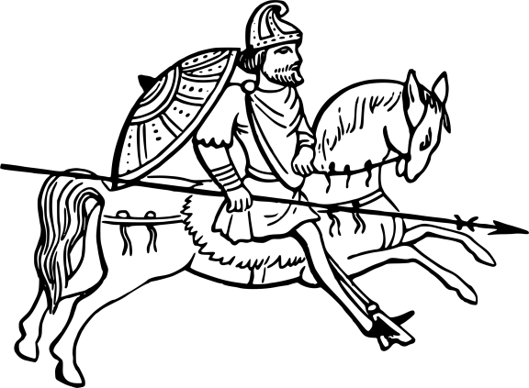
- What was the main role of the theyns?

- What did theyns get from the king in return?

- How did theyns help run their local area?

- Were there a lot of theyns?

- How many earls were there usually?

- How did earls help the king?

- What did earls do for the people living on their land?

