Rainforests occur in a belt around the Equator. They forests have a warm climate with a mean monthly temperature that is always greater than 18°C. The rainfall is never less than 168 cm and can exceed 1,000 cm in a year.

Student tasks
- Copy the sketch below of ‘A typical rainforest landscape.’
A typical rain forest landscape
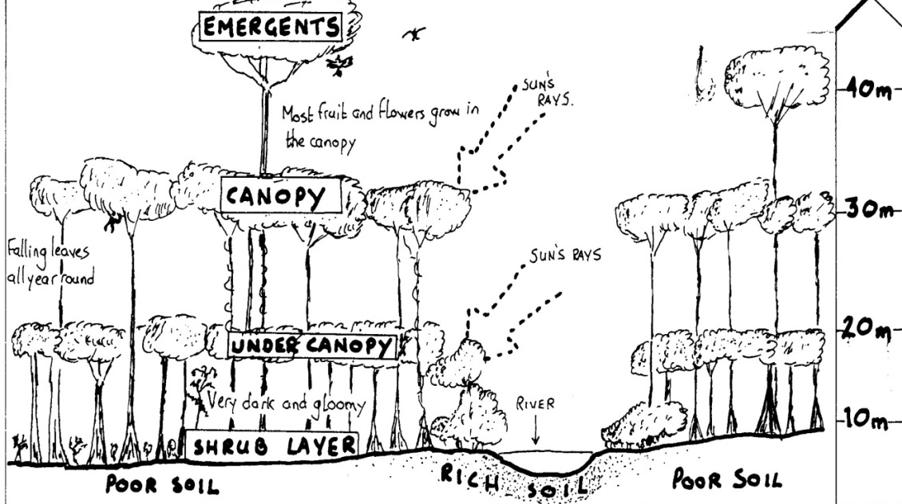
- Copy out the paragraphs below. Use the word box to fill in the blanks:

Rainforest trees
The warm and wet climate of the tropical rainforest creates perfect conditions for the growth of plants. Most of the trees are h with names like, M Teak and
Rosewood. These trees are excellent for making f and are highly sought after because of this. As there are no s in the rainforest, trees lose their leaves whenever they need to. Many sp of rainforest trees, plants, insects and animals have yet to be discovered by scientists.

How the rainforest is structured.
The rainforest is organised in distinct layers. The does not receive much sunlight as the dense canopy blocks out most of the sunlight reaching the forest floor. The trees of the under canopy grow as they do not receive much light. In an area where a canopy tree falls down, sunlight reaches the under canopy trees and they literally race each other until they close the gap in the canopy. The tallest trees are called and can reach heights of up to high.
slowly | hardwoods | 40 metres | furniture
four | shrub layer | seasons | species
suddenly | Mahogany | warm and wet | emergents

Extension tasks

Look at the image below. Use the diagram of ‘a typical rainforest landscape’ to estimate how high the walkway is off the ground.

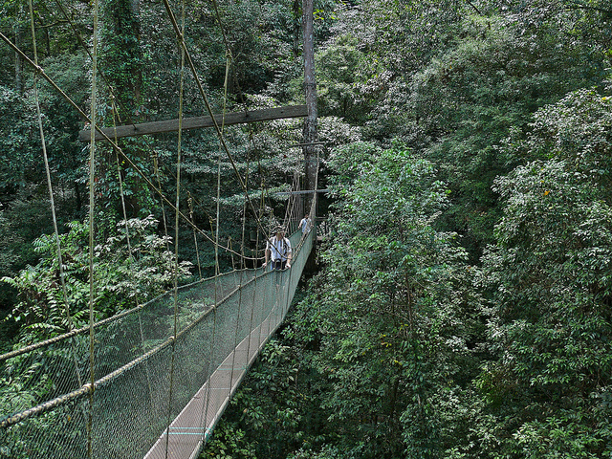
Rainforest walkway, Sarawak
© Bernard Dupont, 2007 flic.kr/p/dPNnrg
- Copy out the paragraph below. Use the word box to fill in the blanks:

Soils in the Rain Forest
The enormous supply of dead leaves, fruit and animals falling from the canopy keeps the soil
. They decay rapidly in the h conditions and add n to the poor quality soil. The rainforest soil near rivers is fertile because river water contains lots of m from the rocks contained in the rivers.

nutrients | minerals | humid | fertile

Use the diagram of ‘a typical rainforest landscape’ and the paragraph above to answer the questions:
- What is leaf litter?
- Why is the soil near the river more fertile than the other soil?
- Most of the rainforest is growing on poor soil – how does this soil keep fertile enough to allow trees to grow?

