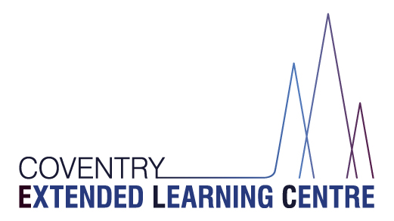

Curriculum Policy
&
Curriculum Offer
2022-2023

Table of Contents
The CELC Curriculum 3
Main Principles of the CELC Curriculum 3
Intent – Our ambitions for our students 3
Implementation – Our structure & curriculum 5
WRL / Vocational Courses 5
Qualifications and Awards 6
Impact - Our Outcomes 7
Appendix 1 – Induction Pathway 8
Appendix 2 – Curriculum Overview 8

Policy reviewed | November 2022
Next review date | September 2023
Editor | Cathy Pierce
Approver | Glenn Mellor
Approval date | 8.11.2022

The CELC Curriculum

The curriculum should be seen in its widest sense as the entire planned learning experience. This includes formal lessons as well as activities, routines, and learning that take place outside the classroom.

Within the framework of a broad and balanced education for each student, our curriculum allows for a high level of personalisation so that each student can play to their strengths, develop existing and new interests, and achieve their personal best in all that they do.

This curriculum document should be seen within the overall aims and ethos of the CELC, which are at the core of its objectives. Fundamentally, our curriculum is focused upon ‘Enhancing Futures’.

Main Principles of the CELC Curriculum

- ‘Enhancing Futures’ – maximising the potential of all our students
- Create well rounded citizens who make a positive contribution to society
- Broad, balanced and relevant.
- A personalised curriculum with a choice of routes (reintegration into mainstream school or specialist provision where possible, recognising that some students require support to successfully complete Year 11 with us and get the best opportunities for post 16 provision). Students access a wide curriculum offer tailored to needs and aspirations, including a wide range of work-related learning course at KS4.
- Sequenced and progressive.
- Meet students’ SEMH needs.
- Promotes knowledge and understanding; mastery of intellectual, physical and interpersonal skills and personal qualities, values and attitudes.
- Equality of access for all students to academic experiences.
- Choice of routes focusing on reintegration and / or post 16 provision.
- Offer a personalised curriculum including opportunities for entitlement to work related learning at KS4.
- A positive, secure and safe environment creating to enable students to learn
- Meets all statutory requirements.

Intent – Our ambitions for our students

Our students receive a broad and balanced curriculum offer which supports positive emotional, social and cognitive progress in a developmentally appropriate way. We recognise that our students attend CELC because they are, at that point in time, unable to succeed in a mainstream school. It is thus crucial that we provide a truly ‘alternative provision’ to mainstream schools to best meet our students’ needs.

CELC’s offer goes beyond what a mainstream school can provide by tailoring a personalised curriculum for each student and by intensively addressing each student’s underlying SEMH needs. We seek to identify and meet our students’ academic and SEMH needs to enable them to reintegrate into mainstream school or into special educational settings or to support students to successfully complete Year 11 with us with improved prospects and engagement for Post-16.

Our curriculum has been thoughtfully constructed to allow each student to:

- Re-engage with their education
- Be inspired and motivated to achieve the best possible outcomes, whatever their ability
- Develop the skills, behaviours and attitudes that will enable them to reintegrate to and be successful in the next phase of their education
- Make progress from their individual starting points and to have success in learning
- Focus on developing their social, emotional and mental health
- Focus on core subjects (English, Mathematics and Science)
- Explore enrichment subjects beyond the core curriculum
- Lead healthy, safe and fulfilling lifestyles
- Become responsible citizens who make a positive contribution to society
- Develop personal moral values, respect for religious values and tolerance of other races, religions and ways of life

KS3 - Our KS3 curriculum has a particular focus on reintegration into mainstream school or specialist provision. It is designed to cover all the competencies required for experiencing success in a new mainstream or special school placement. Our students receive a balance of academic and personal development sessions.

The academic lessons ensure a key focus on core subjects, engaging learners, identifying gaps in learning, and driving progress to equip students for success in their school career.

The personal development sessions enable us to do the same process of identifying gaps and driving progress, but with students’ SEMH needs – those which led them to being placed in our provision and which need addressing in order for them to move on. We provide a nurturing environment in which students’ underlying needs are identified and met.

The academic curriculum is supported by an enhanced offsite reward/enrichment session every Friday, this is delivered by Coventry Outdoor Education Service. To qualify for this students must demonstrate a positive attitude to learning, behaviour and attendance throughout the week. Those students that do not qualify for this activity remain onsite and access curriculum catch up sessions delivered by the Core curriculum subject leads.

KS4 - Our KS4 curriculum also aims to support reintegration where possible, though recognises that some students require support to successfully complete Year 11 with us. Our curriculum offer is further tailored according to needs and abilities. All our students receive a broad and balanced curriculum offer of accredited academic study, SEMH intervention and enrichment.

A good proportion of students attend the centre full time. Those that don’t, have access to 1 or 2 days Work Related Learning, which provides students’ with the opportunity to access a wide range of vocational qualifications which they can build upon during their Post16 education. The remaining 3 or 4 days are spent within the Centre, where students have access to a broad GCSE curriculum, including a range of subject option choices and additional SEMH support if required.

All students at both KS3 and KS4 are offered Quality Careers Advice, this is delivered by Prospects.

Implementation – Our structure & curriculum

Students’ attending CELC will join us having had very different experiences of education, with differing levels of engagement and varying curriculum offers. Those who are successful in being integrated into a new setting may experience yet another different curriculum. We have mixed ability classes of students, many of whom are not working at age related expectations. It is therefore important that our curriculum is flexible enough to enable us to engage all students and meet a wide range of needs and abilities.

A new robust induction pathway ensures that as much relevant information as possible is gained from all stakeholders in order to inform the support each student receives. Each student who enters CELC will be assessed on entry. Students complete baseline assessments in Maths, English and Science, allowing staff to develop a curriculum offer that fills any gaps in prior learning and engage students with differentiated learning, whatever their starting point.

Reading Wise literacy intervention will be targeted at students who have weak and below age range literacy skills. Provision is made within the school for all students with special educational needs and disabilities and those for whom English is an additional language.

Additional support is provided for students within the classroom. The student-focused provision, along with personalise pathways and differentiation, ensures that all students are stretched to meet their own potential.

Students continue to follow the requirements of the National Curriculum, whilst embarking on public examination courses leading to a range of qualifications (see below).

Our curriculum delivery is enhanced through the use of external specialists, including
Northampton Saints (physical activity and personal development sessions - Saints in the Schools community program), Coventry Outdoor Education Service and Coventry Music Service.

Our curriculum overview and the induction pathway can be found in Appendix 1 and 2.

WRL / Vocational Courses

A broad range of courses are offered to students within KS4. All courses are accredited and are sourced through Coventry Local Authority’s Work Related Learning Team.

The current offer includes the following options:

- Sports Leadership
- Construction
- Car Mechanics
- Motorbike Safety and Maintenance
- Gaming Design
- Music
- Health and Social Care
- ICT
- Boxing
- Animal Care
- Public Services

In addition to the offsite provision, there is a purpose built Hair and Beauty facility at the Herald Learning Centre site offering accredited courses in this area, which will begin during this academic year.

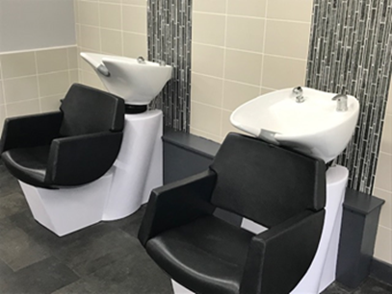
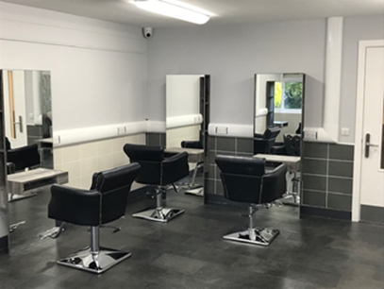

A new suite of workshops onsite at Herald Learning Centre will further enhance our vocational offer. This will allow onsite courses to include construction, music, vehicle maintenance and sport/fitness.

Qualifications and Awards

Academic Qualifications
CELC seeks to provide qualifications at a range of levels, so that students experience success and gain confidence by securing early achievements to build upon.
KS4 students are entered for Functional Skills tests in English and / or Maths when they are ready.
The Unit Award Scheme (UAS) is a unique recording of achievement scheme, rather than a qualification. It offers learners the opportunity to have their achievements formally recognised with a certificate each time a short unit of learning is successfully completed.

Vocational Qualifications
CELC offers a range of vocational qualifications through on-site and off-site Work Related Learning courses. Students experience success and gain confidence by securing early achievements which can progress to higher level qualifications for those who are able and are with us for long enough.

Impact - Our Outcomes

Our key indicator of success is not examination and test results alone but rather ‘enhancing futures’. Whilst we care greatly about ensuring that all students gain the qualifications that they are capable of, we know that enhancing futures for our students is about far more:

- Developing into a well-rounded citizen making a positive contribution to society.
- Improved wellbeing.
- Leaving us with the best possible skills and qualifications, built on the solid foundations outlined above, in order to:
  - Successfully reintegrate into a mainstream school
  - Secure a placement at a special school
  - Enter Post 16 education, employment or training.

Appendix 1 – Induction Pathway
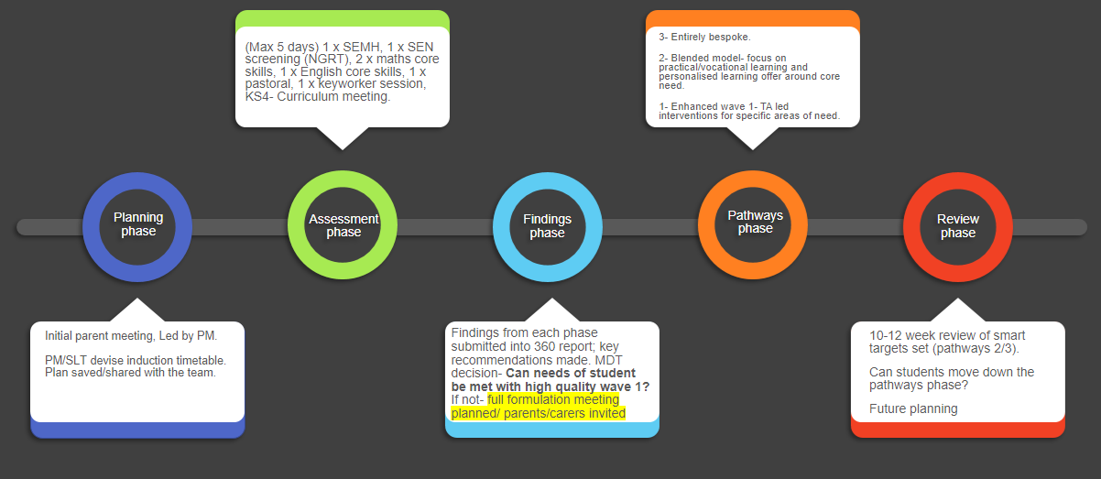

Appendix 2 – Curriculum Overview

Key Stage / Year | Group | Subject | Number of weekly lessons per subject | Total weekly  lesson time per subject
KS3 | W1 / W2 /  W3 / W4  (5 days in centre) | English | 5 | 3 ¾ hours
 |  | Maths
 |  | Science
 |  | Humanities | 3 | 2 ¼ hours
 |  | Art | 2 | 1 ½ hours
 |  | Food Tech
 |  | Sport
 |  | Enrichment
 |  | Philosophy & Ethics | 1 | 45 mins
 |  | ICT
 |  | PHSE

Key Stage / Year | Group | Subject |  | Number of weekly lessons per subject | Total weekly lesson time per subject
Year 10 | 10A  (5 days in centre) | Core Subjects | English Language | 5 | 3 ¾ hours
 |  |  | Maths
 |  |  | Double Science
 |  |  | Citizenship | 2 | 1 ½ hours
 |  |  | ICT
 |  |  | Art | 1 | 45 mins
 |  |  | Food Tech
 |  |  | Sport
 |  |  | PSHE
 |  | Option 1 | Catering | 3 | 2 ¼ hours
 |  |  | History
 |  |  | Geography
 |  | Option 2 | Art | 3 | 2 ¼ hours
 |  |  | Geography
 |  |  | Music
 | 10B  (4 days in centre) | Core Subjects | English Language | 4 | 3 hours
 |  |  | Maths
 |  |  | Double Science
 |  |  | ICT | 1 | 45 mins
 |  |  | Sport
 |  |  | PHSE
 |  | Option 1 | Catering | 3 | 2 ¼ hours
 |  |  | History
 |  |  | Geography
 |  | Option 2 | Art | 3 | 2 ¼ hours
 |  |  | Geography
 |  |  | Music
 |  | Work Related Learning |  | 1 full day off site
 | 10C  (3 days in centre) | Core Subjects | English Language | 3 | 2 ¼ hours
 |  |  | Maths
 |  |  | Double Science
 |  |  | ICT | 1 | 45 mins
 |  |  | Sport
 |  |  | PHSE
 |  | Option 2 | Art | 3 | 2 ¼ hours
 |  |  | Geography
 |  |  | Music
 |  | Work Related Learning |  | 2 full days off site

Key Stage / Year | Group | Subject |  | Number of weekly lessons per subject | Total weekly lesson time per subject
Year 11 | 11A  (5 days in centre) | Core Subjects | English Language | 5 | 3 ¾ hours
 |  |  | Maths
 |  |  | Double Science
 |  |  | ICT | 2 | 1 ½ hours
 |  |  | Citizenship
 |  |  | Art | 1 | 45 mins
 |  |  | Food Tech
 |  |  | PHSE
 |  |  | Sport
 |  | Option 3 | Art | 3 | 2 ¼ hours
 |  |  | Catering
 |  |  | Geography
 |  |  | History
 |  |  | English Literature
 |  | Option 4 | Art | 3 | 2 ¼ hours
 |  |  | Catering
 |  |  | Music
 |  |  | Geography
 |  |  | History
 | 11B  (4 days in centre) | Core Subjects | English Language | 4 | 3 hours
 |  |  | Maths
 |  |  | Double Science
 |  |  | Citizenship | 2 | 1 ½ hours
 |  |  | ICT | 1 | 45 mins
 |  |  | Sport
 |  |  | PHSE
 |  | Option 3 | Art | 3 | 2 ¼ hours
 |  |  | Catering
 |  |  | Geography
 |  |  | History
 |  |  | English Literature
 |  | Option 4 | Art | 3 | 2 ¼ hours
 |  |  | Catering
 |  |  | Music
 |  |  | Geography
 |  |  | History
 |  | Work Related Learning |  | 1 full day off site

Key Stage / Year | Group | Subject |  | Number of weekly lessons per subject | Total weekly lesson time per subject
Year 11 | 11C  (3 days in centre) | Core Subjects | English Language | 3 | 2 ¼ hours
 |  |  | Maths
 |  |  | Double Science
 |  |  | Citizenship | 2 | 1 ½ hours
 |  |  | ICT | 1 | 45 mins
 |  |  | PHSE
 |  |  | Sport
 |  | Option 3 | Art | 3 | 2 ¼ hours
 |  |  | Catering
 |  |  | Geography
 |  |  | History
 |  |  | English Literature
 |  | Work Related Learning |  | 2 full days off site

