Progress
and
Assessment Policy
2022

Purpose of the Progress and Assessment Policy:
CELC puts the progress of students at the heart of all we do. Our mission is to be an outstanding provider for, and because of, our students and staff. To achieve our vision, we deliver a high quality, personalised and engaging programme of learning for students and staff alike.
CELC serves a student community that has had difficulty in accessing the provision of a mainstream school and who have a broad social diversity and range of abilities in terms of academic achievement. Nonetheless we provide an exceptional standard of education for all students so that they can engage with education, access learning opportunities, make excellent progress and succeed. We further enhance their futures by supporting their social, moral, spiritual and cultural progression. At the CELC we provide an excellent educational experience for all our students so that they progress in the following ways:
• Academic progress - we provide a high quality education for all our students, tailored to their needs. We recognise and promote the achievements of each individual child and develop their personal abilities and aptitudes to the full.
• Learner progress - we enable all students to develop the self-discipline and the independent learning skills required to facilitate them to become life-long learners.
• Social and emotional progress - we place a high priority on providing a caring, highly effective and secure teaching and learning environment. We develop students’ personal and social skills to enable them to approach life with confidence.
CELC expects all stakeholders to commit to and use this policy to secure progress. CELC commits to providing a high quality professional development programme for all our staff to support them to be able to follow the policy and enable them to progress their own learning and professional development towards succeeding in achieving our vision of ‘Enhancing Futures’.
Aims
Every Pupil will know: What they are learning in a lesson; why they are learning it and what they need to do to progress their learning.
Every Teacher will:
Deliver a high quality, personalised and engaging programme of learning for students that:
- Commits to classroom culture of high-quality AFL that drives the planning of learning which in turn informs the teaching techniques employed to secure good. AFL – Where each learner can answer ‘What are they learning?’ ‘Why are they learning it?’ and ‘What do they need to do next to improve?’
- Focuses on the learning intention / outcome, ‘the goal’
- Sets carefully differentiated stretching learning tasks
- Uses dialogue not monologue; less teacher talk and more teacher listening
- Structures teaching around the 3 I’s of the curriculum– Intent, Implementation and Impact

CELC Cycle of Progress
The CELC considers that progress is facilitated in the following way:

Marking
Marking is used as a means of personalising learning and to ensure students have a clear understanding of how they are progressing and how they can improve their work.
When marking a piece of work, tell the student what they have done well and what they could do to improve. The suggestion for improvement may include an ‘action’ for the student to complete; allow time to complete this action at the start or end of a lesson.
MACS: | Done by: | Explanation:
Marking | Teacher | Checking for accuracy and content of work
Action | Teacher | An action that the student needs to do, to improve or complete their work
Comments | Teacher | Providing feedback - what has been done well and what could be better
Student Response | Student | The student’s response to the action - this will mean them completing the action set by the teacher

When marking work, you will also be grading the student’s ‘Work Effort’ - this is the amount of effort they have put into the task being marked. WE grades can be used to determine detentions and/or homework. If a student has missed a large amount of a task, they can be asked to stay behind during break/lunch/at the end of school, or given the missing work to do as homework. The key to our Work Effort grades is:
WE5 | Excellent effort - the student’s best work; highly motivated and well organised
WE4 | Very good effort - a positive effort showing a keen interest
WE3 | Satisfactory effort - generally positive at an acceptable level
WE2 | Poor effort - the student is capable of much better; little motivation shown towards the work
WE1 | Unacceptable effort - there is a lot of work missing or the work needs to be redone

Teachers are not expected to mark every piece of work but should be giving a WE grade for each lesson. Each piece of extended work should be marked, marked for SPaG, and given a GCSE grade at KS4.
Outcomes of using the Marking and Assessment Policy:
- Students will be given the opportunity to redraft work or sections of work in response to teacher comments
- Time should be made within lessons to allow for this redrafting to take place
- Peer and self-assessment should be used in addition to teacher assessment where appropriate.
Useful marking prompts and comments:
A reminder prompt – this is useful for all abilities but particularly for the higher attaining student. It simply reminds the pupil of what could be improved.
e.g. “Say more about why the fire spread quickly.”
“Explain why it doesn’t react with water.”
“Explain why this does not help find the area.”
A scaffolded prompt – particularly useful for students who need more support.
This can be a question:
e.g. “Can you give a further reason for the chemical reaction you got?”
This can be a directive:
e.g. “You need to say whether you think you’ll always get these results.”
This can be an unfinished sentence:
e.g. “Romeo felt like this because…. (finish this sentence)”
An example prompt – particularly useful for lower ability students who need more support.
e.g. “The man was really angry.”
““The tall man was really angry.” I have added an adjective to provide more detail. Now you have a go and write the sentence but add two different adjectives.”
Summative assessment:
When students are receiving levels for the key assessed pieces it’s important that they are reported in a way that puts them in the context of the pupil’s targets.
e.g. “Well done, you have achieved a grade 4 for this essay because you have shown that you are able to explain several reasons clearly.”
“You are on track to reach your target of a 5 if you can more consistently explain your thinking step by step.”
SPaG Marking:
It should be recognised that whatever the subject, whoever is teaching, the basic SPaG marking principles apply to all. The teacher’s job is not to correct mistakes the students have already made, but to help them not to make that mistake next time.
Sp – Spelling mistake
P - Punctuation error
C - Capital letter needed or used incorrectly
T - Tense (tenses confused)
// - New paragraph needed
W - Wrong word (this could be a homophone error)
Phr - Phrasing (doesn’t make sense)
Exp - Explain (explain what you mean)
^ - Missed word/words
Con - Connective (add a connective)

Spelling
Incorrect spellings are to be marked with ‘Sp’ in the margin and the incorrect word underlined. Students then need to correct the spelling using a different coloured pen.

Don’t mark every misspelling - choose three and pick the ones that most need correcting, e.g. words that students should be able to spell out or key words for the unit you are studying. Allow students to look at their incorrect spellings and correct them. Time can be used within Keyworker time for students to work on spellings and learn key words.
When introducing new words, you should spend time looking at the words and how they are spelt.

Punctuation
Punctuation errors are to be marked with a ‘P’ in the margin and the error underlined.

All errors in punctuation should be marked, and guidance as to why it is incorrect. Allow students time to address their punctuation errors and where appropriate students can correct them using a different coloured pen.

If a common error is identified the teacher can address this within a starter in the next lesson.
Paragraphs
Paragraphing errors are to be indicated by using a ‘//’ where the new paragraph should have been applied.

Mark every paragraph error. New paragraphs should be started for the following reasons: change in time, place, topic or speaker. Allow students time to look at their writing. Make paragraphing explicit when reading in class.

Assessment:
When a student joins the school, they complete baseline assessments in core subjects. This data, alongside their KS2 scaled scores, informs each student’s predicted and aspirational grade. Non- core subjects will use this baseline data to set targets for students. KS3 students are expected to make two levels of progress from Y7 to the end of KS3 and KS4 students are expected to make two grades progress from Y10 to the end of KS4. Teachers set challenging but achievable End of Year targets.
Assessment data is recorded in SIMS at 3 points – Autumn, Spring and Summer. This data is informed by Written Assessments which take place during half term 2, 3 and 6 for Year 7 to Year 10 and half term 2 and 3 for Year 11. These are based on key stage appropriate questions to ascertain individual student current assessment grades and GCSE questions from past papers or exam board assessment materials. Baseline Assessments are collected for all subjects, in September or on admission to CELC. End of Year targets should take into account all factors, such as attendance, attitude to learning, behaviour for learning and prior attainment.
All student progress data is stored in SIMS enabling tracking. Waved interventions including, 1:1 sessions, will be used for students that are below target in subjects to get them back on track. The information in SIMS informs student reports which are generated twice yearly (December and July).

Baseline Grade | The grade achieved on entry after completing baseline assessments. Grade range will be Emerging, Developing, Approaching, 1-, 1, 1+ etc to 9, to mirror mainstream grades. Emerging being the lowest grade.
EOY Target Grade | The grade you think the student could achieve for the end of the academic year, considering attendance to lessons, attitude to learning, behaviour for learning, progress and achievement. This should be challenging but also achievable. The Grade range is the same as for the Baseline Grade.
Autumn/Spring/ Summer Level | The grade the student achieved:  - If the student was present and completed the assessment (or did as much as they could), the grade range is as above and should progress at the rate of one whole grade per year after the end of Y9.  Other options available:  - N/A if the student was not on roll at the time of the assessment, eg on mainstream placement  - Ab if the student missed / did not complete the assessment for any other reason than above.  - R if the student refused to complete the assessment.  - U for unclassified
Attitude for Learning and Behaviour for Learning | Descriptors for ATL and BFL are:  - Excellent  - Very Good  - Satisfactory  - Poor  - Unacceptable  - Not Seen

2022-23 Assessment Schedule
Autumn Term |  |  | Spring Term |  | Summer Term
September or on entry | HT1 | HT2 | HT3 | HT4 | HT5 | HT6
Baseline Assessments - All Subjects | Formal Assessment Week  w/c 5.9.2022  All years | Formal Assessment Week  w/c 7.11.2022  All years | Mock exams  w/c 23.1.2023  Year 11 | Spring Teacher Assessments  w/c 27.2.2023  All years | No assessments | Formal Assessment Week  w/c 19.6.2023  Year 7 to 10
 |  | Autumn Teacher Assessments  w/c 14.11.2022  All years | Mock exams  w/c 13.2.2022  Year 10
 |  |  |  | GCSE Predicted Grades  w/c 27.3.2023  Year 11 |  | Summer Teacher Assessments  w/c 26.6.2022  Year 7 to 10
 |  | Teacher Assessment Week  w/c 12.12.2022  All years | Formal Assessment Week  w/c 13.2.2022  Excl Year 10

Wellbeing
WEMWBS- A measure of perceived wellbeing. This completed upon entry and at exit. This measures progress of perceived wellbeing and can be completed on a more regular basis for specific learners. The average scoring for general wellbeing 51.6 in England.
Students significantly below this may be referred to see the clinical psychologist that CELC is purchasing time with for 1:1 sessions. This will also be used alongside the SDQ for further depth in report. At present this is conducted by keyworkers and collated/ processed by SENCO.
The on-line dimensions tool- designed by Coventry and Warwickshire Partnership Trust, enabling professionals and parents to screen a young person’s presenting mental health difficulties and secure on-line support, including fact sheets, practical advice and sign-posting. https://dimensions.covwarkpt.nhs.uk/
SDQ- The Strengths and Difficulties Questionnaire (SDQ) is an emotional and behavioural screening questionnaire for children and young people. The tool can capture the perspective of children and young people, their parents and teachers. There are currently three versions of the SDQ: a short form, a longer form with an impact supplement (which assesses the impact of difficulties on the child’s life) and a follow-up form. The 25 items in the SDQ comprise 5 scales of 5 items each. The scales include: 1) Emotional symptoms subscale 2) Conduct problems subscale 3) Hyperactivity/inattention subscale 4) Peer relationships problem subscale 5) Prosocial behaviour subscale.

Pastoral Assessments
CELC SEMH coaches will use a range of processes and standardised assessment tools to assess our students and track their progress in meeting their SEMH need and as an indicator of mainstream school readiness.

SEND Assessments
NFER- Assessment used across KS3 and 4 on entry and once every term to monitor progress with reading and comprehension. Conducted in lessons. Used to inform need for intervention.

Identifying students with SEND
On entry to CELC a combination of initial screening tools are used (WEMWBS- YARC) alongside baseline assessments for core subjects. These will be used as indicators as to whether further assessments are needed- concerns in the entry assessments may also result in further interventions being put into place by the SENCO or the class teacher being directed to incorporate the graduated approach. The CELC also delivers an ‘enhanced Wave 1 Provision’, ensuring that strategies and interventions targeted to meet SEMH needs are incorporated by default. Students that still have difficulties in accessing their education despite QFT and evidence of the graduated approach would then be referred onto the SENCO- see flowchart below.
When making a referral to SENDCo; the expectation will be evidence of the following:
- Evidence of quality first teaching.
- Evidence of managing SEMH needs through development of relationships with the students and demonstrating an understanding of the individual’s needs.
- Evidenced use of at least two rounds of interventions and differentiation in delivery, planning and resourcing. These should have been used for a minimum of half a term each, reviewed for effectiveness/impact and modified or altered.
- Evidence that My Support Plans have been used to influence interventions and differentiation.
- Evidence of poor progress made over time for reasons other than attendance. Baseline data and classroom assessment will be fine.
- Evidence of using other adults in the classroom to support learning.
- Evidence of using the ELC SEND info sheets when developing differentiation / modifications.
- Evidence of an understanding of individual students SEMH needs and the impact this can have on them as a learner.

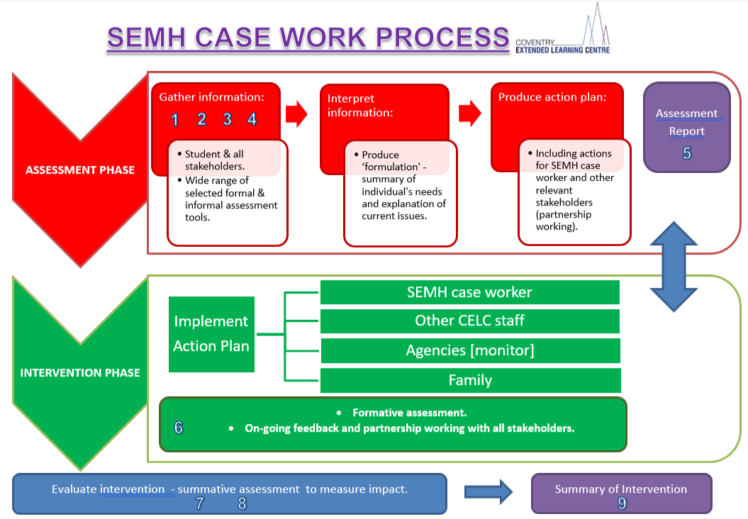
Appendix 1 – SEMH case work process
