CELC
Relationship and Sex Education
Policy and Framework

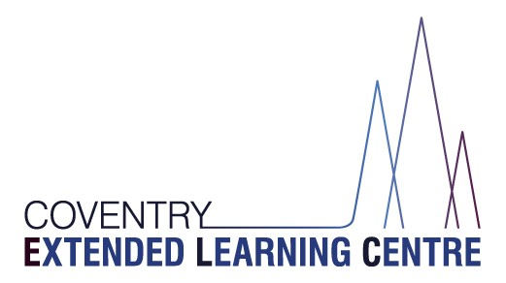

Contents
1. Aims 2
2. Statutory requirements 2
3. Policy development 3
4. Definition 3
5. Curriculum 3
6. Delivery of RSE 3
7. Use of external organisations and resources 4
8. Roles and responsibilities 4
9. Parents’ right to withdraw 6
10. Training 6
11. Monitoring arrangements 7
Appendix 1: Curriculum map 8
Appendix 2: By the end of secondary school pupils should know 9
Appendix 3: Parent form: withdrawal from sex education within RSE 12

1. Aims
The aims of relationships and sex education (RSE) at our school are to:
- Provide a framework in which sensitive discussions can take place
- Prepare pupils for puberty, and give them an understanding of sexual development and the importance of health and hygiene
- Help pupils develop feelings of self-respect, confidence and empathy
- Create a positive culture around issues of sexuality and relationships
- Teach pupils the correct vocabulary to describe themselves and their bodies
RSE supports the CELC’S RESPECT System – Respect for others, Self-respect.

2. Statutory requirements
As a maintained secondary alternative provision, we must provide RSE to all pupils under the Children and Social Work Act 2017.
In teaching RSE, we must have regard to guidance issued by the secretary of state, as outlined in section 403 of the Education Act 1996.
We must also have regard to our legal duties set out in:
- Sections 406 and 407 of the Education Act 1996
- Part 6, chapter 1 of the Equality Act 2010
- The Public Sector Equality Duty (as set out in section 149 of the Equality Act 2010). This duty requires public bodies to have due regard to the need to eliminate discrimination, advance equality of opportunity and foster good relations between different people when carrying out their activities
At Coventry Extended Learning Centre we teach RSE as set out in this policy.

3. Policy development
This policy has been developed in consultation with staff, pupils and parents. The consultation and policy development process involved the following steps:
- Review – a member of staff or working group pulled together all relevant information including relevant national and local guidance

- Staff consultation – all school staff were given the opportunity to look at the policy and make recommendations

- Parent/stakeholder consultation – parents and any interested parties were invited to attend a meeting about the policy

- Pupil consultation – we investigated what exactly pupils want from their RSE

- Ratification – once amendments were made, the policy was shared with governors and ratified

4. Definition
RSE is about the emotional, social and cultural development of pupils, and involves learning about relationships, sexual health, sexuality, healthy lifestyles, diversity and personal identity.
RSE involves a combination of sharing information, and exploring issues and values.
RSE is not about the promotion of sexual activity.

5. Curriculum
Our RSE curriculum is set out as per Appendix 1, but we may need to adapt it as and when necessary.
We have developed the curriculum in consultation with parents, pupils and staff, and taking into account the age, developmental stage, needs and feelings of our pupils. If pupils ask questions outside the scope of this policy, teachers will respond in an appropriate manner so that pupils are fully informed and don’t seek answers online.

6. Delivery of RSE
RSE is taught within the personal, social, health and economic (PSHE) education curriculum. Pupils receive one weekly 45 minute lesson in both Key Stage 3 (Wyken) and Key Stage 4 (The Herald). Biological aspects of RSE are taught within the science curriculum, and other aspects are included in weekly Philosophy and Ethics lessons. In Key Stage 4 this is also reinforced in Citizenship lessons.
As an Alternative Provision, we always consider the needs of all pupils including those with special educational needs. All resources are differentiated and presented according to needs for example large or reduced text, dual-coded and on coloured paper (as needed). Support from teaching assistants is available in every lesson, allowing for 1;1 support an/or breaks from the lesson as needed.
Appendix 1 details when the different aspects of sex education are taught throughout years 7 to 11.

RSE focuses on giving young people the information they need to help them develop healthy, nurturing relationships of all kinds including:
- Families
- Respectful relationships, including friendships
- Online and media
- Being safe
- Intimate and sexual relationships, including sexual health
For more information about our RSE curriculum, see Appendices 1 and 2.

These areas of learning are taught within the context of family life, taking care to make sure that there is no stigmatisation of children based on their home circumstances (families can include single parent families, LGBT parents, families headed by grandparents, adoptive parents and foster parents/carers, amongst other structures), along with reflecting sensitively that some children may have a different structure of support around them (for example, looked-after children or young carers).
We will also be mindful of the law and legal requirements, taking care not to condone or encourage illegal political activity, such as violent action against people, criminal damage to property, hate crime, terrorism or the illegal use of drugs.

  - Inclusivity
We will teach about these topics in a manner that:
- Considers how a diverse range of pupils will relate to them
- Is sensitive to all pupils’ experiences
- During lessons, makes pupils feel:
  - Safe and supported
  - Able to engage with the key messages
We will also:
- Make sure that pupils learn about these topics in an environment that’s appropriate for them, for example in:
  - A whole-class setting
  - Small groups or targeted sessions
  - 1-to-1 discussions
  - Digital formats
- Give careful consideration to the level of differentiation needed

  - Use of resources
We will consider whether any resources we plan to use:
  - Are aligned with the teaching requirements set out in the statutory RSE guidance
  - Would support pupils in applying their knowledge in different contexts and settings
  - Are age-appropriate, given the age, developmental stage and background of our pupils
  - Are evidence-based and contain robust facts and statistics
  - Fit into our curriculum plan
  - Are from credible sources
  - Are compatible with effective teaching approaches
  - Are sensitive to pupils’ experiences and won’t provoke distress

7. Use of external organisations and materials
We will make sure that an agency and any materials used are appropriate and in line with our legal duties around political impartiality.
The school remains responsible for what is said to pupils. This includes making sure that any speakers, tools and resources used don’t undermine the fundamental British values of democracy, the rule of law, individual liberty, and mutual respect and tolerance of those with different faiths and beliefs.
We will:
- Make appropriate checks and engage with external agencies to make sure that their approach to teaching about RSE is balanced, and it and the resources they intend to use:
  - Are age-appropriate
  - Are in line with pupils’ developmental stage
  - Comply with:
    - This policy
    - The Teachers’ Standards
    - The Equality Act 2010
    - The Human Rights Act 1998
    - The Education Act 1996
- Only work with external agencies where we have full confidence in the agency, its approach and the resources it uses
- Make sure that any speakers and resources meet the intended outcome of the relevant part of the curriculum
- Review any case study materials and look for feedback from other people the agency has worked with
- Be clear on:
  - What they’re going to say
  - Their position on the issues to be discussed
- Ask to see in advance any materials that the agency may use
- Know the named individuals who will be there, and follow our usual safeguarding procedures for these people
- Conduct a basic online search and address anything that may be of concern to us, or to parents and carers
- Check the agency’s protocol for taking pictures or using any personal data they might get from a session
- Remind teachers that they can say “no” or, in extreme cases, stop a session
- Make sure that the teacher is in the room during any sessions with external speakers
We won’t, under any circumstances:
- Work with external agencies that take or promote extreme political positions
- Use materials produced by such agencies, even if the material itself is not extreme

8. Roles and responsibilities
8.1 The governing board
The management committee will approve the RSE policy, and hold the headteacher to account for its implementation.
8.2 The headteacher
The headteacher is responsible for ensuring that RSE is taught consistently across the school, and for managing requests to withdraw pupils from non-statutory components of RSE (see section 9).
8.3 Staff
Staff are responsible for:
- Delivering RSE in a sensitive way
- Modelling positive attitudes to RSE
- Monitoring progress
- Responding to the needs of individual pupils
- Responding appropriately to pupils whose parents wish them to be withdrawn from the non-statutory components of RSE
Staff do not have the right to opt out of teaching RSE. Staff who have concerns about teaching RSE are encouraged to discuss this with the headteacher or the Humanities and PSHE lead, Rachel Kerry.

8.4 Pupils
Pupils are expected to engage fully in RSE and, when discussing issues related to RSE, treat others with respect and sensitivity.

9. Parents’ right to withdraw
Parents have the right to withdraw their children from the non-statutory components of sex education within RSE up to and until 3 terms before the child turns 16. After this point, if the child wishes to receive sex education rather than being withdrawn, the school will arrange this.
Requests for withdrawal should be put in writing using the form found in Appendix 3 of this policy and addressed to the headteacher.
A copy of withdrawal requests will be placed in the pupil’s educational record. The headteacher will discuss the request with parents and take appropriate action.
Alternative school work will be given to pupils who are withdrawn from sex education.

10. Training
Staff are trained on the delivery of RSE as part of their induction and it is included in our continuing professional development calendar.
The headteacher will also invite visitors from outside the school, such as school nurses or sexual health professionals, to provide support and training to staff teaching RSE.

11. Monitoring arrangements
The delivery of RSE is monitored by Rachel Kerry, Humanities Lead through:
- planning scrutinies,
- learning walks,
- pupil voice meetings
Pupils’ development in RSE is monitored by class teachers as part of our internal assessment systems.
This policy will be reviewed by Rachel Kerry, Humanities lead annually. At every review, the policy will be approved by the management committee.

Appendix 1: Curriculum map
Relationships and sex education curriculum map

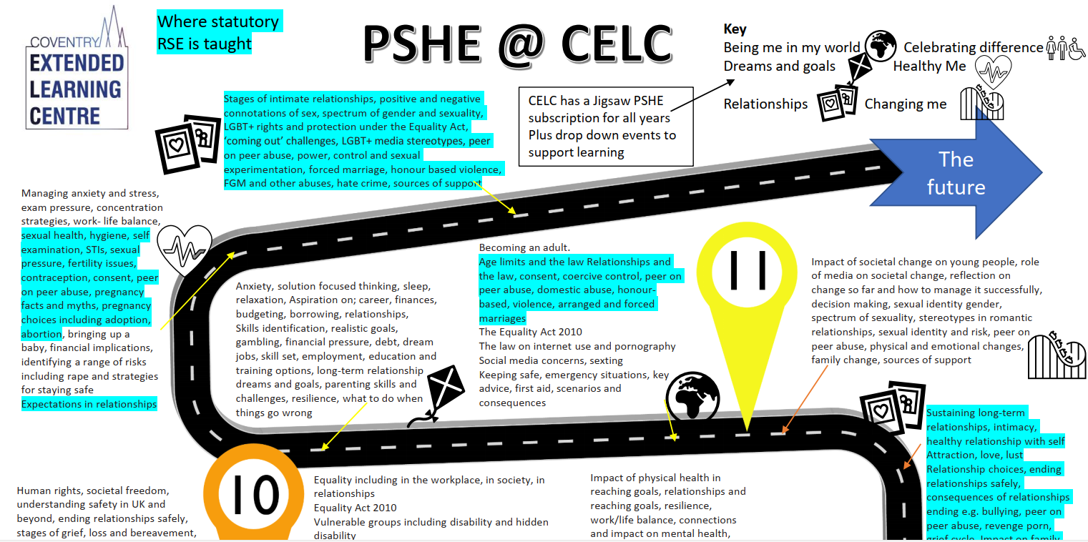
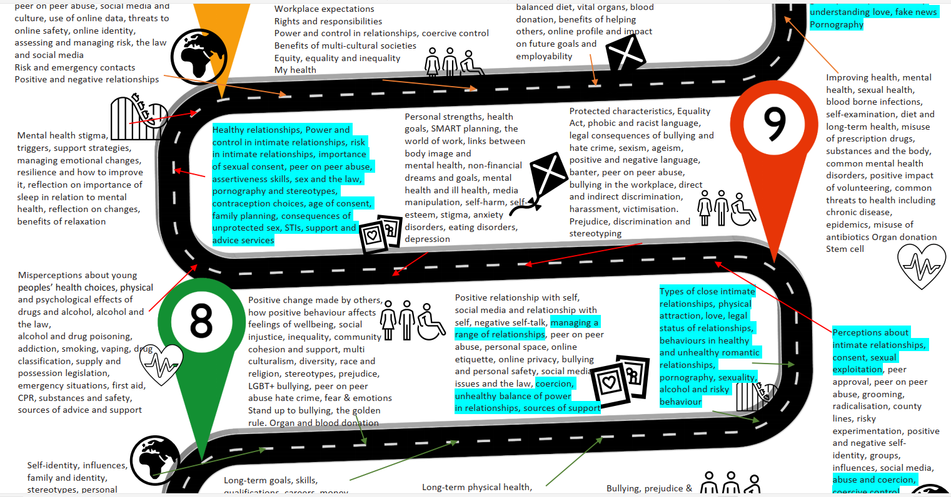

Appendix 2: By the end of secondary school pupils should know (from Statutory Guidance
Topic | Pupils should know
Families | - That there are different types of committed, stable relationships  - How these relationships might contribute to human happiness and their importance for bringing up children  - What marriage is, including their legal status, e.g. that marriage carries legal rights and protections not available to couples who are cohabiting or who have married, for example, in an unregistered religious ceremony  - Why marriage is an important relationship choice for many couples and why it must be freely entered into  - The characteristics and legal status of other types of long-term relationships  - The roles and responsibilities of parents with respect to raising of children, including the characteristics of successful parenting  - How to: determine whether other children, adults or sources of information are trustworthy: judge when a family, friend, intimate or other relationship is unsafe (and to recognise this in others’ relationships); and, how to seek help or advice, including reporting concerns about others, if needed
Respectful relationships, including friendships | - The characteristics of positive and healthy friendships (in all contexts, including online) including: trust, respect, honesty, kindness, generosity, boundaries, privacy, consent and the management of conflict, reconciliation and ending relationships. This includes different (non-sexual) types of relationship  - Practical steps they can take in a range of different contexts to improve or support respectful relationships  - How stereotypes, in particular stereotypes based on sex, gender, race, religion, sexual orientation or disability, can cause damage (e.g. how they might normalise non-consensual behaviour or encourage prejudice)  - That in school and in wider society they can expect to be treated with respect by others, and that in turn they should show due respect to others, including people in positions of authority and due tolerance of other people’s beliefs  - About different types of bullying (including cyberbullying), the impact of bullying, responsibilities of bystanders to report bullying and how and where to get help  - That some types of behaviour within relationships are criminal, including violent behaviour and coercive control  - What constitutes sexual harassment and sexual violence and why these are always unacceptable  - The legal rights and responsibilities regarding equality (particularly with reference to the protected characteristics as defined in the Equality Act 2010) and that everyone is unique and equal
Online and media | - Their rights, responsibilities and opportunities online, including that the same expectations of behaviour apply in all contexts, including online  - About online risks, including that any material someone provides to another has the potential to be shared online and the difficulty of removing potentially compromising material placed online  - Not to provide material to others that they would not want shared further and not to share personal material which is sent to them  - What to do and where to get support to report material or manage issues online  - The impact of viewing harmful content  - That specifically sexually explicit material e.g. pornography presents a distorted picture of sexual behaviours, can damage the way people see themselves in relation to others and negatively affect how they behave towards sexual partners  - That sharing and viewing indecent images of children (including those created by children) is a criminal offence which carries severe penalties including jail  - How information and data is generated, collected, shared and used online
Being safe | - The concepts of, and laws relating to, sexual consent, sexual exploitation, abuse, grooming, coercion, harassment, rape, domestic abuse, forced marriage, honour-based violence and FGM, and how these can affect current and future relationships  - How people can actively communicate and recognise consent from others, including sexual consent, and how and when consent can be withdrawn (in all contexts, including online)
Intimate and sexual relationships, including sexual health | - How to recognise the characteristics and positive aspects of healthy one-to-one intimate relationships, which include mutual respect, consent, loyalty, trust, shared interests and outlook, sex and friendship  - That all aspects of health can be affected by choices they make in sex and relationships, positively or negatively, e.g. physical, emotional, mental, sexual and reproductive health and wellbeing  - The facts about reproductive health, including fertility and the potential impact of lifestyle on fertility for men and women  - That there are a range of strategies for identifying and managing sexual pressure, including understanding peer pressure, resisting pressure and not pressurising others  - That they have a choice to delay sex or to enjoy intimacy without sex  - The facts about the full range of contraceptive choices, efficacy and options available  - The facts around pregnancy including miscarriage  - That there are choices in relation to pregnancy (with medically and legally accurate, impartial information on all options, including keeping the baby, adoption, abortion and where to get further help)  - How the different sexually transmitted infections (STIs), including HIV/AIDs, are transmitted, how risk can be reduced through safer sex (including through condom use) and the importance of and facts about testing  - About the prevalence of some STIs, the impact they can have on those who contract them and key facts about treatment  - How the use of alcohol and drugs can lead to risky sexual behaviour  - How to get further advice, including how and where to access confidential sexual and reproductive health advice and treatment

Appendix 3: Parent form: withdrawal from sex education within RSE

To be completed by parents
Name of child |  | Class
Name of parent |  | Date
Reason for withdrawing from sex education within relationships and sex education
Any other information you would like the school to consider
Parent signature

To be completed by the school
Agreed actions from discussion with parents

