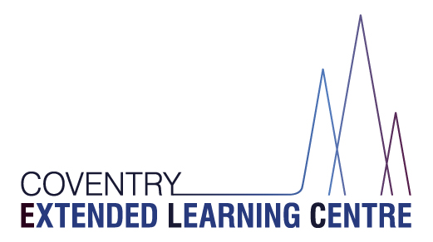

People Directorate
CELC - Herald Learning Centre
Watcombe Road
Coventry
CV2 1DJ

Email: CELC@coventry.gov.uk
Tel: 02476 978150

RE: GCSE Results Day 2022
DATE: 17 June 2022

Dear Parent/Carer,

I can confirm that GCSE results will be released to students on Thursday 25 August 2022 and Herald Learning Centre will be open from 09:30 to 11:30 on this day for students to collect their results.

CELC staff will be present on site to discuss results, together with colleagues from the careers service Prospects, who can offer advice and guidance on students’ next steps.

Any results that are not collected from school will be posted out on 25 August.

Yours faithfully,

Cathy Pierce
Attendance, Data and Exams Officer

