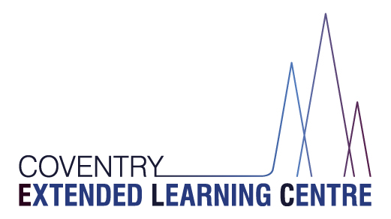

People Directorate
CELC - Herald Learning Centre
Watcombe Road
Coventry
CV2 1DJ

Email: CELC@coventry.gov.uk
Tel: 02476 978150

13th July 2022

REF: Arrangements for the end of this academic year and the start of next academic year
Dear Parent/Carer,
As we near the end of another busy and successful year, it is a privilege to write to you as the interim Headteacher of CELC. I want to thank you for your ongoing support and look forward to getting to know families and students. Many congratulations to Matt Stiles, who has been appointed as Headteacher to Worcestershire Virtual Schools. We wish him well.

Below is an outline of arrangements for the end of this academic year and the beginning of the new 2022-23 academic year.
Dates:
This academic year:
The last day of this academic year for students is Thursday 21st July 2022. All students will finish at 1:15pm on this final day. Friday 22nd July is an INSET day for staff so school will be closed for students.

Next academic year:
Monday 5th and Tuesday 6th September are INSET days for staff, so school will be closed for students
Students return on Wednesday 7th September 2022. Please note that this is a Target Setting Day for all students so they will only attend for a target setting meeting and will not attend all day. Year 10 and 11 students will also be asked to make their option choices. Your child’s keyworker will contact you regarding an appointment for Target Setting Day.

All students will return for a full school day on Thursday 8th September.

Ofsted
You may be aware that we have recently had an Ofsted inspection. The official outcome letter will follow, but I am looking forward to sharing the outcomes with you.

School Meal Vouchers
If your child is entitled to free school meals, you will be receiving a food voucher next week for the summer holidays via e mail. If you have changed your e mail address or you do not receive the voucher, please contact our administrators on the CELC office email addresses or telephone numbers (see website).

The end of year is a chance to reflect on the great things our school and young people have achieved. At the time of writing 28 young people have returned to mainstream schools or a specialist provision. We have moved into the fantastic new Herald site and are looking forward to our opening event on 7th September. More details on this will follow.

I would like to thank parents, carers and our young people for their support this year, and the fabulous team of staff at CELC who I’m lucky to lead.

We hope you have a wonderful Summer break and we look forward to another year of ‘Enhancing Futures’.
Best wishes,

Glenn Mellor
Interim Headteacher

