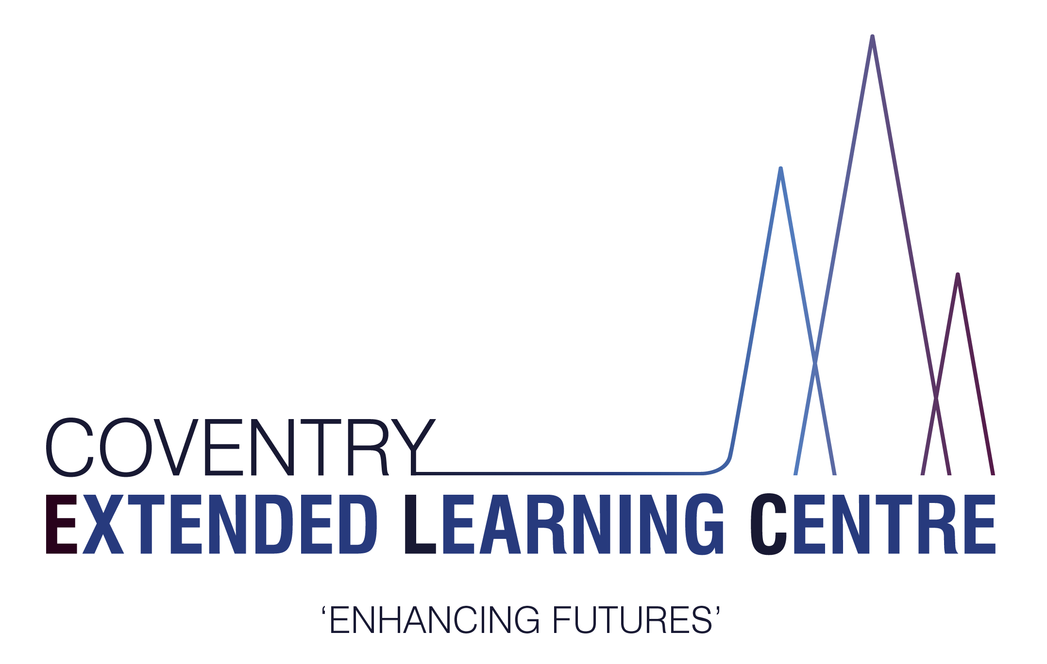

People Directorate
Coventry Extended Learning Centre (Wyken and The Herald)
5 Axholme Road
Coventry
CV2 5BD

Tel: 024 7678 7832
Email: CELC@coventry.gov.uk

18 April 2024

Dear Parent/Carer,

Coventry Alternative Provision Academy

I am writing to you today to bring you up to date with some significant developments here at the Coventry Extended Learning Centre.

You may be aware that we received an OFSTED visit in June 2022, which although it identified that leaders had a “clear vision” for the future, at the time the quality of education provided was not yet good enough.
Over the last two academic years the school has gone from strength to strength, with a significant proportion of pupils successfully returning to mainstream or specialist schools. Of the Pupils who completed GCSEs last year 92% are still in education, employment or training.

In order to continue our school improvement journey, the CELC is going to be joining the highly successful Solihull Alternative Provision Multi Academy Trust (SAPMAT) from September 2024. SAPMAT is a small but growing group of Academies that specialise in the Alternative Provision sector of Education. The governors and I believe that this will allow our dedicated team and pupils to achieve even more going forwards.

Stephen Steinhaus CEO of SAPMAT recently said that “we are so excited to have Coventry joining us from September. Our common goals, shared vision and ethos and our joint commitment to curriculum intervention with and positive destinations for our students has the real potential to significantly change the face of what alternative provision looks like and what is possible for our students across the West Midlands.

Please be assured we will maintain all of the attributes that make our school what it is. Moving forward we will be able to share resources, best practice and staff expertise to develop our curriculum and our educational offer. The SAPMAT trust will have a central focus on school improvement and professional development for our staff so that we can continually improve our teaching and learning. Each provision within SAPMAT retains its own individuality and identity alongside our shared ethos and values.

In terms of the day-to-day life of the school, there will be some differences (to the better) to that which is currently experienced by the pupils and parents/carers, but we are putting a great deal of effort to ensure continuity of service and make sure it is “business as usual” as much as possible. In particular we will be maintaining our strong identity as an Alternative Provision academy.”

The CELC will convert to Coventry Alternative Provision Academy on the first of September 2024. As we progress towards this date, I will be in touch further to keep you updated on what this will mean for the education of your child.

In the meantime, if you have any questions about this process, please do not hesitate to contact me.

Yours Sincerely

Glenn Mellor Stephen Steinhaus
Headteacher CEO SAPMAT

