www.coventry.gov.uk/connectlandlords

Click on the REGISTER NOW button
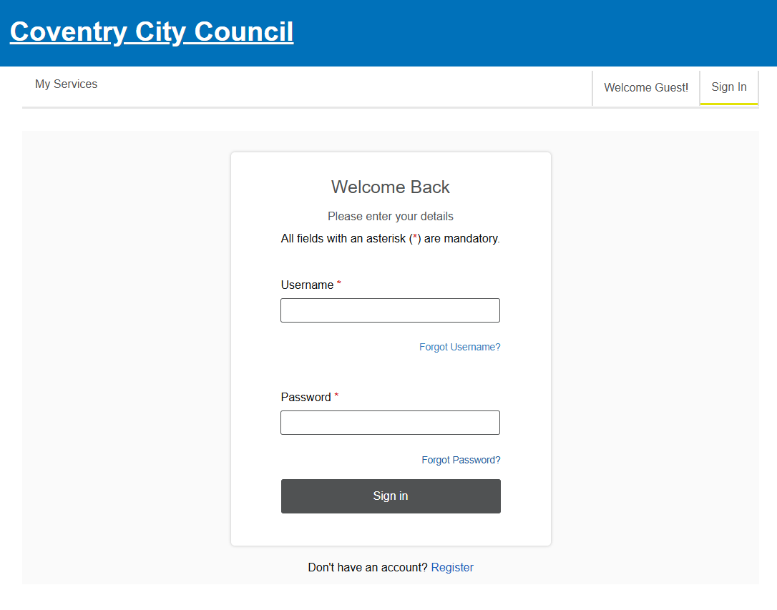
Complete the details on the following screen.

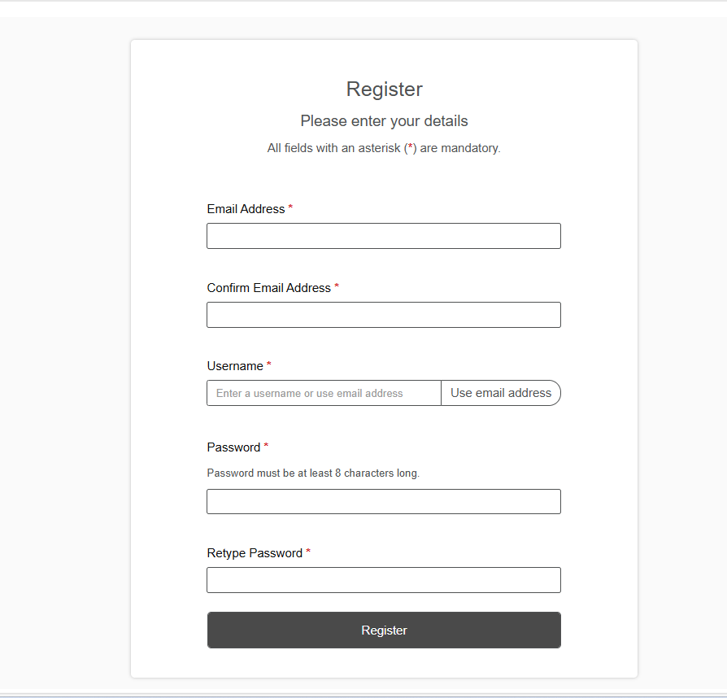

This will then show the following page:
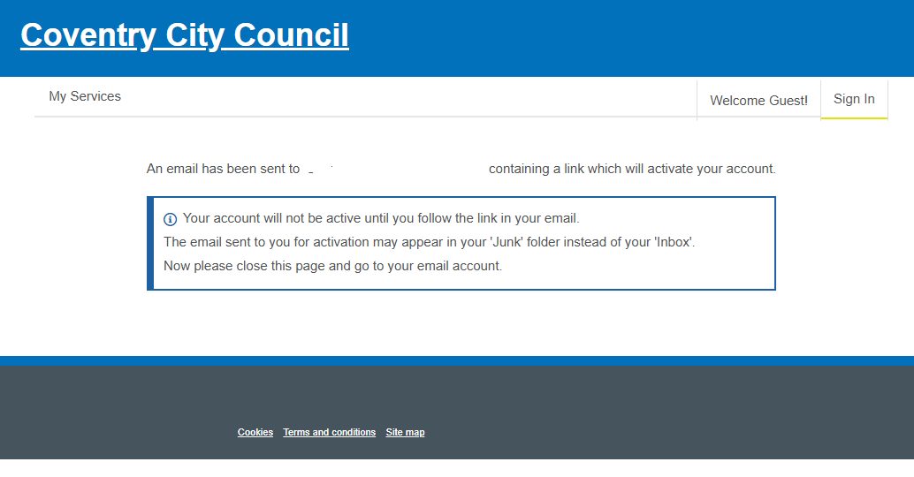

Following this an email will be sent to the email address you recorded during the registration. The email when received will have an activation weblink on it. Click on the link and this will complete the registration process

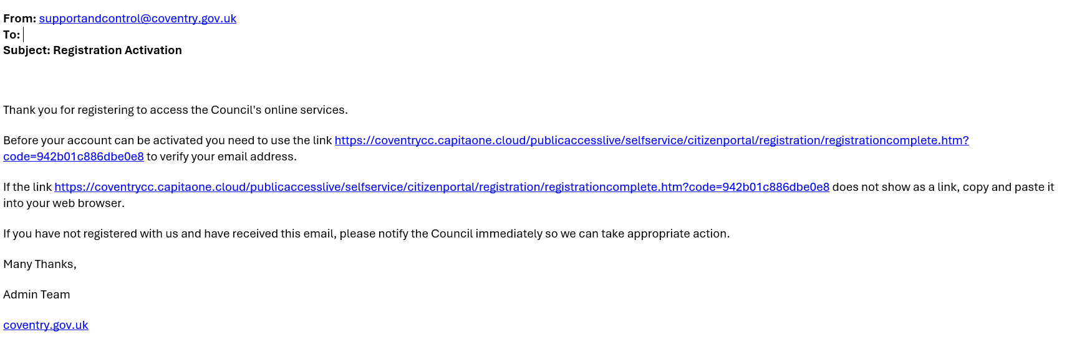

Then the following screen will appear:
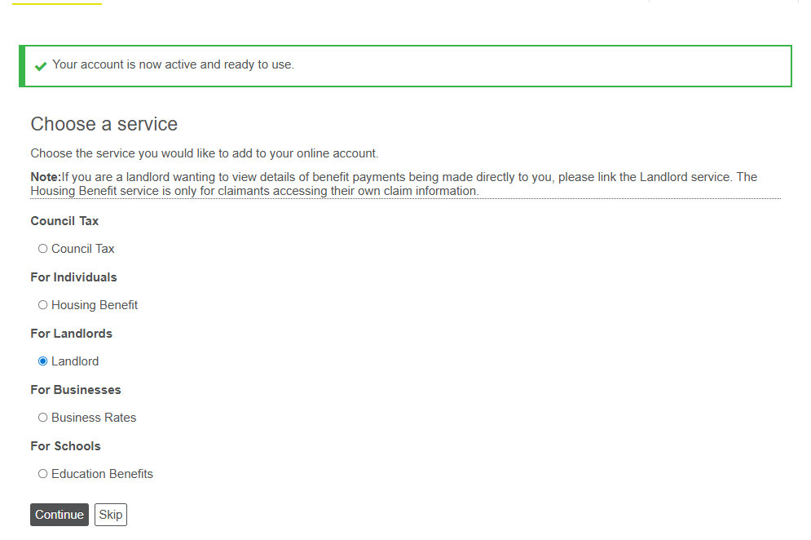
You now need to activate your landlord account, at this page you can Select the Landlord radio button and press continue.
Then at the next screen enter your landlord/creditor reference and press continue:
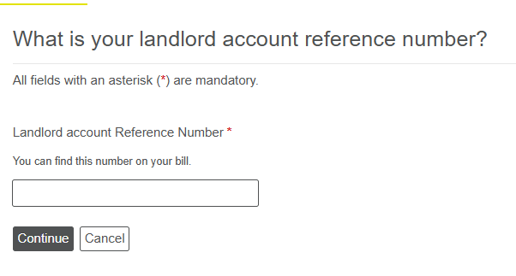
This will then enable full access to the web portal.

If you do not know your landlord/creditor reference or PIN Number:
If you do not know your landlord/creditor reference and PIN number, please email: supportandcontrol@coventry.gov.uk requesting your details.
PLEASE NOTE for security purposes you will be asked to verify details regarding any tenants, addresses, HB payments and/or bank details to confirm you are the correct landlord.

