The Celebration Event 2014
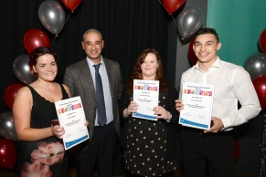
The annual looked after children celebration event went ahead on the 12th November 2014 at Sydney Stringer School. This event is to celebrate the achievements of all young people in care. They are nominated for awards by foster carers, social workers, schools or other professionals that feel their young people deserve some acknowledgment for their outstanding achievements from within the year.
The Participation team have been working hard over the last five months to make this ceremony a success. They badgered schools, social workers, carers and anyone else we could thought of to nominate young people who they feel have achieved over the last 12 months. A lot of preparation went into the planning of the event and choosing the right venue, awards, and entertainment to make the awards night enjoyable for everyone.
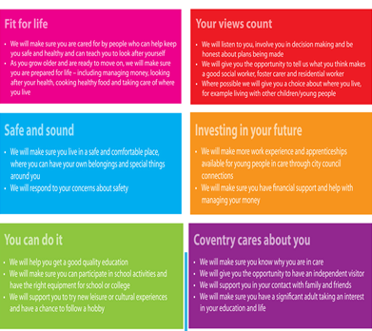
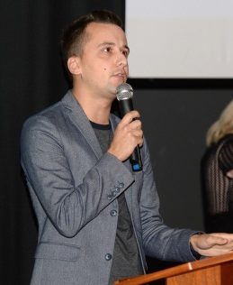
We were joined at the event by many important guests some that were asked to present awards, this included Johnny Rickard, our presenter, who is a radio DJ in Coventry and Comedian. We were also joined by many of the Coventry elected members including Councillor Ann Lucas, Councillor Julia Lepoidevin, Councillor David Kershaw, Councillor Mal Mutton & John Mutton, Yolanda & Isabel Marrifield the Assistant Directors and Bob Dhammi service manager at Route 21. And also, presenting the main award of the evening, the deputy Lord Mayor, Michael Hammon.
There are six categories for awards all based around the Coventry Pledge as shown on the left.
The Coventry Pledge is a promise from professionals within the Coventry City Council that play the role of Corporate Parents to all young people within the care system. Each category has special award winners who received customised plaques and then certificates are given to each young person nominated.
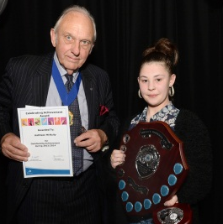
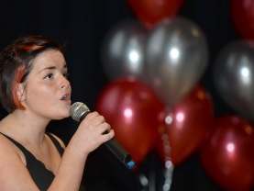
The other award of the night was the Councillor Jack Harrison Award. The Councillor Jack Harrison Outstanding Award is the biggest and final award of the night; it is awarded to the individual that received the most nominations. This award was presented by Councillor M Hammon, the deportee Lord Mayor.
Councillor Jack Harrison MBE was a Councillor for Coventry City Council for over 25 years, He was Lord Mayor from 2009-2010 during which time he raised over 100,000 for local charities. Jack was always open about the fact that he was in care himself as a child and as such had a real understanding of what it means to be looked after in Coventry. Jack was a huge supporter of looked after children and when he sadly passed away Jill, his widow dedicated this award in his memory. The winner receives the Jack Harrison plaque and is able to keep the award for the year until a new winner is chosen. Each Young Person to receive the award has their name engraved on the plaque. The last year’s winner Lucy Fripp spoke openly about how the award gave her the confidence to carry on achieving great things and how happy she was to have had the pleasure of looking after the plaque over the past 12 months.
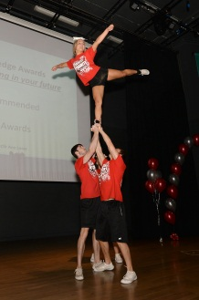
Each young person nominated was able to invite any guest of their choice. The audience consisted of foster carers, some parents, children and young people, professionals including social workers and senior staff. All of our guests were greeted and welcomed by a selection of sandwiches and cakes to indulge before the ceremony began.
We would like to say a big thank you to Sydney Stringer School for proving the venue and refreshments; also Colin Bell for providing great entertainment for the night, including a singer and DJ. As well as Coventry Dynamite Cheerleading squad for their performance on the night that wowed the audience.
This night was to celebrate the successes of our young people but we should not forget the huge amount of support given to our young people from their families, carers and staff.

