Early Years
Newsletter

Disability Access Funding (DAF)
Additional funding for children with SEND.

What is Disability Access Funding?
Additional funding paid directly to Early Year’s Providers (including schools), to support children with Special Educational Needs and Disabilities (SEND), aged three or four, who are in receipt of Disability Living Allowance (DLA) and accessing some or all, of their Early Education Entitlement.
DAF is a payment of £615 per year, for each eligible child, so it is essential that you claim as soon as possible, as some children will be eligible for a second payment, one year later.
The fund enables providers to make reasonable adjustments to support children with SEND, including accessing training, purchasing resources, fund additional sessions etc.

Who is eligible?
Children aged three or four, who are in receipt of DLA and accessing some or all, of their Early Education Entitlement. Please note: four-year olds attending a reception class are not eligible.
If a child accesses their Early Education Entitlement across two providers, the parent / carer will need to nominate which provider receives the funding. This is recorded on the Parent / Carer Agreement.
If a child leaves the nominated provider half way through the year, the funding will remain with the provider. The DAF funding is not transferable and does not follow the child.
How to submit a DAF claim?
- Ensure parents / carers complete the DAF section on the Parent / Carer Agreement.
- Obtain a copy of the child’s DLA award letter.

Then submit a DAF claim through Coventry’s Early Years Online Portal and attach a copy of the child’s DLA award letter.

Please note: DLA award letters must be returned to the parent / carer; providers are not required to keep a copy.
For further support with making a DAF claim; please refer to the Disability Access Funding Portal Guidance: http://www.coventry.gov.uk/downloads/file/25885/disability_access_fund_daf
and our ‘How to’ video clips http://www.coventry.gov.uk/eypportalhowto
If you have any questions or experience difficulty submitting a claim, please contact our team at EYCentral@coventry.gov.uk
How can providers use the funding?
It is the responsibility of the provider to identify what reasonable adaptations or resources may be required to enable the child to have equal access to the provision in the same way as another child. This should include providing basic entry into the provision.
Providers should liaise with the child’s parents/carers and engage with relevant professionals to ensure the DAF is spent appropriately. This may include the child’s Portage Worker; Educational Psychologist, SEND advisor; Physiotherapist; Occupational Therapist; Health Visitor etc.
Providers who have more than one child that will be eligible for DAF may combine the funding to support an adjustment or purchase resources that will benefit more than one child.
Phoenix Nursery at Wyken Croft Primary School have claimed DAF to support several children accessing their Early Education Entitlement. Nursery Manager, Sharon Cockerill explains how they have used the funding and provided some photographs of resources purchased:
“We looked at each child’s development and noted where they needed additional support. We also spoke to professionals involved with the children, who gave us some great ideas and advice on what resources would benefit the children and where best to make the purchases. Parents also gave us advice on children’s likes and interest.
Some of our children with a higher level of need, required a variety of resources to support their development, so their DAF was spent at the beginning of the year. Whereas for other children, we have spent throughout the year as the child’s needs develop. We used the DAF Impact Record Sheet ( supplied by Coventry Early Years Team) to monitor and track the impact of the funding.
We also used the money to buy storage for the resources and created a nurture space with the specialist equipment.
These are just some of the things we have purchased:

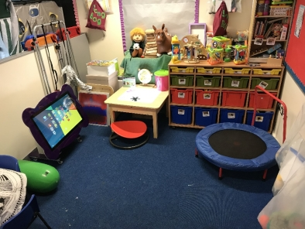
“Our nurture space with storage unit to store our fine motor/sensory specialist resources to meet children’s individual needs”
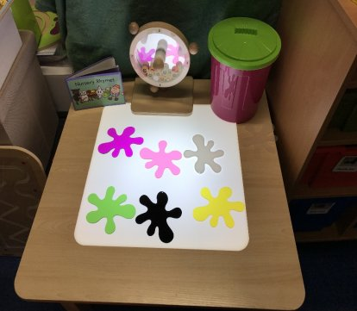
“Light up table to support visual impairment”
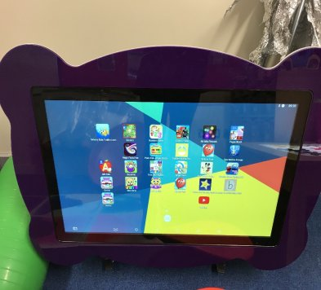
“We pooled some of the money to purchase a ‘go pro’ table. This particularly supports our non-mobile children as they can reach and participate in sensory apps”
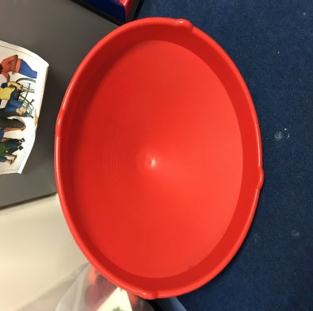

“Spinning top to support core and balance development and to relieve sensory seeking behaviour”

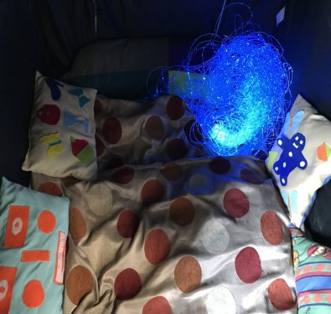

“Sensory tent with fibre optic lighting”

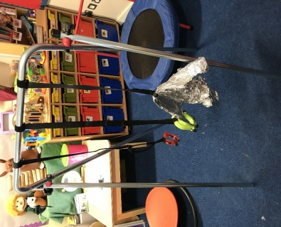

“We have children with specialist seating or cannot sit unaided so this frame allows them access to resources outside in their chairs or when lying down.”

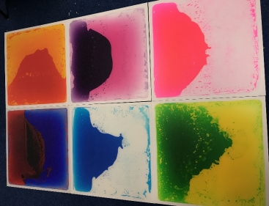

“Sensory boards to develop awareness of marks
they make or create through movement”

Any resources purchased as part of DAF remain the property of that provider and can be used to support future children to access the provision. However, if a child is moving onto

another provider, they may decide to transfer any resources that will benefit the child’s access into the new provider. This will only be possible for non-static items and is at the discretion of the provider who purchased the equipment.
Resources can be shared with parents to be used at home during weekends and holidays if it is felt it will benefit the child.
Providers are expected to spend the full £615 on the child, and if the equipment/adjustment is more than that amount, providers are expected to fund this gap.
Here are some ideas / suggestions of how the funding can be used:
Physical Access | Communication needs / ASD | Hearing needs
Gates / child gates | Feelings faces | Sign language books, cards and games
Ramps | Sensory toys | Light and sound toys Velcro story sacks
Hand rails | Sensory tent | Interactive whiteboards
Steps | Portable dividers to create different spaces | Soundfield system
Chairs / seating | Autism friendly materials; social stories book, weighted lap blankets | Talking tins
Walker / rollator | Board maker/Communicate in Print CD or iPad app | Acoustic modification, acoustic clouds
Outside equipment such as different swing seat, adapted trikes, soft play, sitting wedges, corner seats | Sound area – head phones and DVD player etc. – calming or for Speech and Language. | Audio equipment – listening checkers, listening leads, stetoclip, splitter cables etc
Soft play equipment | Communication support – Makaton symbols, choice boards | Sign and write – part of communicate in print software
Sitting wedges / corner seats | DVDs for songs, simple picture books, big / little books, story sacks, chunky books, PECS books | Listening games
Big physio balls | Chewigems | iPad  communication/pictures
Occupational Therapy equipment e.g. spinning mat, ‘bilabos’ | Mirrors for speaking, language and talking (SLT) | Visual needs
Gross motor skills equipment | Mini trampolines | Books with sound buttons, tactile  patches  Touch Braille letters
Hoists | Persona dolls | Coloured glue sticks  Giggly Wiggly balls/sensory balls  Tactile books  Story sacks
Bibs/dribble bibs | Feely bags | Musical instruments  Light and sound buzzers
Complete waterproof suits | Early language objects (doll, brush, cup etc.) | Scented playdough  Scented pens and pencils
Tough spots allowing for physical/sensory play | Key fobs | Vibrating cushions  Plate guard/plate surround  Scooping bowl
Rulers with handles | General development needs | Simple switches
Rompa helmets | Sensory toys  Large handled brushes | Dark tent/cosy cave  Dark room kit  Be Active box
Suction grab rails | Cause and effect toys | WOWee  Tactile Vibrations Sensory StarterTub
Push chair for trips | Stage-not-age toys e.g. cause and  effect, inset puzzles | Ultra Violet (UV)Dark Den Multi-Sensory Glow Kit
Self-care | Large handled brushes | Fibre Optics
Toilet access, changing table etc.,  changing mats, kneeling pads for staff,  storage, toilet frames, toilet steps, toilet  inserts, potties with arms/backs. | Musical instruments/hand bells  Light weight rattles  Peg men/spring pegs  Stacking toys with magnets  Bubbles  Switches and cause and effect toys  Sensory materials | Lightbox  iPad  Tactile letters with braille  Torches  Subscription for 3D books  Survival blanket/space blanket
Feeding materials: non-slip mats, angled  plates, cutlery, appropriate height tables.  chairs, specialist cutlery, grasp bar,  cups, mini food processor | Construction toys  Treasure baskets  Playdough  Posting boxes | Talking Tins  Wikki Sticks  Braille Maths Blocks  Braille ABC blocks  Numicom  Desk slopes  iPad stands
Please note: Providers must ensure that any equipment purchased will meet the relevant safety requirements including the required PAT testing.
Recording impact and evidence:
Providers must keep receipts and proof of what the DAF has been spent on should this be required for audit purposes.
Providers will be sent a DAF impact record when making a claim, to help record the benefit and how the funding has been spent for each child.
Why is this important?
As a childcare provider, you have a legal duty to make reasonable adjustments to ensure that children with Special Educational Needs and Disabilities (SEND) have equal access to early education under the Equality Act 2010.
Equal access and reasonable adjustments refer to:
- The means or opportunity to enter the provision of space where early education is to take place.
- The means or opportunity to engage with the Early Years Foundation Stage (EYFS).
- To ensure you are not discriminating, you must make reasonable adjustments for SEND children. This involves taking positive actions to ensure that SEND children can participate in early education and enjoy all the benefits and services offered by the provision.
- Reasonable adjustments will include provision, criteria, practices, aids, services and physical features.

If you have any further questions regarding DAF please contact Coventry Early Years Team at EYCentral@coventry.gov.uk

