r
Early Years
Newsletter

Tax-Free Childcare - Are your parents missing out?

According to figures obtained from HMRC 162 childcare providers, in Coventry, are not yet registered for a Tax-Free Childcare account. For the parents of children attending these settings, this is a potential loss of up to £2000 per child, per year or £4000 per year for a disabled child. The Tax-Free Childcare scheme supports parents and carers in reducing childcare costs and enables providers to attract new customers and sustain occupancy levels.

The Early Years team are currently in the process of creating a ‘Tax-Free Childcare’ search option on the Family Information Directory web pages. The aim of this is to help parents identify which childcare providers are registered on the scheme, when making their choice about which childcare provision best meets their needs.

Don’t miss out!
If you are one of the 162 providers who have not yet registered for a Tax-Free Childcare account, do it now! You can find more information about signing up by accessing the link below.
https://childcare.tax.service.gov.uk/ccp/signup/signupcode

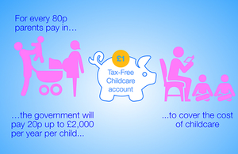

School provision
If you are a school and would like to register for a Tax-Free Childcare account, you will need a UTR number to complete the application. Contact EYCentral@coventry.gov.uk to obtain this information.

The chart 1 shows the number of providers registered to access Tax Free Childcare

Chart 1

Chart 2 shows a breakdown of the providers, by type, who are registered to take
Tax- Free Childcare

Chart 2

Further information:

The gov.uk site has produced a Tax-Free Childcare 10 things parents should know factsheet
www.gov.uk/government/news/tax-free-childcare-10-things-parents-should-know

Childcarechoices website
www.childcarechoices.gov.uk

