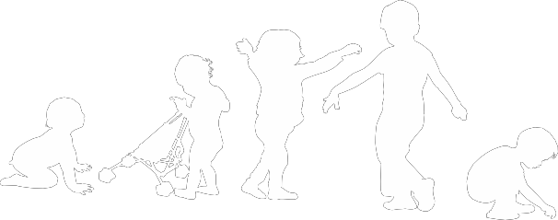You may have already received some information on ‘school readiness’ from your health visiting team, school nursing team or SEND (special educational needs and / or disability) professional. They have been visiting early years providers and schools to share information about the skills children will need to support a smooth transition into school.
Developing School Readiness

In preparation for starting school, children need to be able to do many things for themselves. The table below outlines some skills and experiences which will support children to be prepared for starting school. It may be useful to share some of these with parents.

Personal, Social and Emotional Development
- To be able to express and manage their feelings and emotions.
- To be aware of how actions can affect others.
- Share toys and resources.
- Show respect for other people and the environment.
- To understand and conform to appropriate guidance and boundaries e.g. stop.
- To know that there are things you cannot do.
- To join in at tidy up time.
- To have experience of being friends and being part of a small and large group.
- To be able to play and explore independently for short periods of time.
Physical Development
- To be able to dress and undress independently.
- To be able to gather own belongings into a pile.
- To be able to independently manage own toilet needs including wiping own bottom.
- To blow and wipe own nose when needed.
- Know when hand washing is required and wash own hands independently.
- Be able to independently access packed lunch e.g. open yoghurt pots, eating whole pieces of fruit.
- To be able to feed self, use a knife and fork.
- To have plenty of opportunities to practice mark making on a large-scale and develop pencil control.
Communication language and literacy skills.
Understanding the world Mathematics
- Recite nursery rhymes.
- Listen to and respond to simple instructions.
- To recognise own name including surname/family name and gender.
- To be able to verbalise their own needs and emotions.
- To be able to ask for help when needed.
- To be confident to converse with an adult.
- To enjoy sharing stories.
- Showing an interest in numbers and letters e.g. how old they are, numbers on street signs, car registrations etc.
- To follow an adult led activity.

A coordinated and collaborative approach between school and provider is essential for a smooth transition to take place. Keeping routines and the environment as familiar as possible will support children adjust and settle more quickly. Working in partnership with parents and professionals enables consistency and for a personalised transition to be made.

For children with a special educational need and / or disability (SEND) they may not reach the perceived expectations for school-readiness, despite early intervention and support. There will always be some children who find it more difficult to use the toilet, put on their own coats and express themselves. A carefully planned transition should allow the receiving school to find out about the child’s strengths, needs and preferences. Reasonable adjustments should be made by both Early Years providers and schools to help children to achieve their full potential and become confident individuals. Sharing information about specific interventions and programmes of support is essential to help children settle and transition more effectively.

For more helpful hints and tips on supporting a child to become ‘school ready’ please follow the link below:

https://www.pacey.org.uk/working-in-childcare/spotlight-on/being-school-ready/

