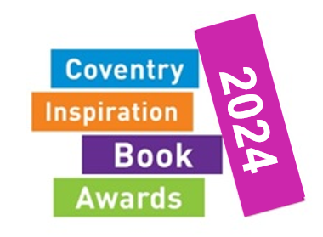
Book order form
secondary

I would like to order the following sets of books:
Category | Age | RRP | Cost | Quantity
Hooked on Books | 9-13 | £65.92 | £52.74
Simply The Book | 14+ | £68.92 | £55.14
Rapid Reads | 11-16 | £74.92 | £59.94

Books will be supplied with free protective jackets worth £2.80 per set.
Please return this order form to sls@coventry.gov.uk by Tuesday 25th July for delivery by the launch. Orders can still be placed after this time and will be delivered as soon as they are available.
School:
Contact Name:
Contact e-mail:
Budget / Finance contact:
Purchase Order No:

Please note that by returning this form you are confirming that you have permission from the budget holder to do so.

Children's book publishing is a complex process and although all books were available and in print at the time of selection, this could change at any time and we cannot guarantee supply.

