






















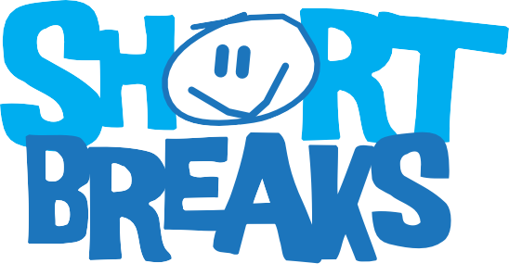

www.coventry.gov.uk

This passport belongs to

Date completed

General Introduction Please fill in this section

Hello, my name is

About me
Things I like best are:

Things I like least are:

My best friends are:

My favourite foods are:

My disability:

Important health needs/allergies and how they are treated:

More about me and my family
1
Surname: First name: DOB:

Address:

Postcode:

Parent/carer’s name:
Telephone number:

Mobile:

Siblings: Language/s:

Religion:

School/college:

Doctor: Tel No:

Surgery address:

Social Worker:

Preferred way to receive information about Short Breaks (place an x in the box):

Email:

Post:

You can also find out more information on our website:

www.coventry.gov.uk/shortbreaks

Introducing...me
This section will explain about my disability and things I like, dislike and enjoy.
2

My communication needs
This is how I like to communicate for example, picture exchange, Makaton etc.
3

My interests
These are the activities I enjoy doing over term time and during the school holidays.
4

My behavior
5
Sometimes, I may display some challenging behaviour. Here are some tips on how to manage my behaviour, what triggers this and any patterns in my behaviour.

My personal care needs
6
This will explain whether assistance is needed with personal care.

My meals
7
This section will tell you about what foods I enjoy eating and what food I don’t like. It will also inform you of foods I can’t eat due to allergies.

My mobility
Please tell us how you get around and if you require any assistance.
8

My health and medication
9
Please explain any health needs your child may have, for example epilepsy, medication etc.

Daily medication needs
Please describe what medication your child requires, even if the short break carer isn’t required to administer it, it is important we have this information in case of an emergency.

Medication name and strength | Dosage | When is it given? | What is it for? | How is the medication taken?

PTO to add more

Medication name and strength | Dosage | When is it given? | What is it for? | How is the medication taken?

Outcomes
Please describe here what you wish to be the main outcomes for your child accessing short breaks.
10

Any other information
Is there anything else we need to know about your child that we haven’t covered elsewhere in the passport? If you feel your child needs one-to-one support, please speak with the Short Breaks Development Officer before attending a short break.
11

This section must be signed

Passport written by: Signature: Parent/carer: Signature:

Young person: Signature:

OFFICE USE ONLY
A DLA letter must be provided, stating the rate for the Care Component and the rate of the Mobility Component.

Contact name:
Contact No: Rate of DLA:
DLA start date:
DLA ends:
Evidence seen by:
Date:
Care component: Mobility:
Parent/carer consent and permissions

You must fill out this section for the passport to be valid.
Place an X in the box.
Data

I, the undersigned, give consent for the information contained within this passport to be used to safeguard and promote the welfare of my child during the short break. This information will also be used to help plan and analyse the service.

Photographs
I, the undersigned, hereby grant permission to the short break provider to use/copy photographs taken during the short break activity for promotional and publicity purposes.

Off-site activities
I, the undersigned, as parent or carer do hereby give my permission for my child to participate in activities off-site with the short break provider including travel to and from these activities. In connection with these activities, it is understood that my child will be under the supervision of an adult and may travel in a vehicle driven by an adult supervisor. This is based on the understanding that the off-site activity has been risk assessed and appropriate staffing.

Yes No

Yes No

Yes No

Emergency Healthcare
I, the undersigned, as parent/carer consent to the short breaks provider organising emergency healthcare for my child should he/she suffer serious injury or exhibit symptoms of illness while participating in one of these activities and agree that this document be shared with the health services, if necessary.

Signed: Date:

Yes No

Once completed please return with a copy of a Disability Living Allowance (DLA) letter or evidence of a diagnosed disability, either by letter from a relevant professional or by confirmation from your child's school. You can email these documents to CSCCDT@coventry.gov.uk or send it to the address below.

Short Breaks
Coventry City Council,
PO Box 7097,
Coventry,
CV6 9SL.

For more information or help with completing this passport please contact the Community Short Breaks Development Officer on 024 7678 7980.

