Body Map Guidance and Recording Proforma
This booklet is designed to accompany your accident, incident and injuries on arrival records.
For further guidance relating to potential action you may need to take, please refer to the CSCP Effective Support for Children and Families in Coventry guidance, available online here: Effective Support for Children and Families in Coventry

This booklet is designed to help you accurately record injuries observed on children and young people and support you in making decisions on what actions to take on concerns raised by these injuries.
Please see guidance below. Injuries to a child could be the result of one or more types of abuse and it is important to be vigilant to all forms of abuse.

 | Definition | Signs and Symptoms
Physical Abuse | Physical abuse may involve hitting, shaking, throwing, poisoning, burning or scalding, drowning, suffocating, or otherwise causing physical harm to a child. It includes physical harm may also be caused when a parent fabricates the symptoms of, or deliberately induces illness in a child | - Injuries at different stages of healing  - Bite marks  - Burns  - Burns in the shape of an object Marks on unusual body parts  - Defence wounds (forearms, backs of legs, hands and feet)  - Bruised scalp (hair pulling)  - Bruises in the shape of an object  - Broken bones, sometimes at different stages of healing  - Scarring  - Effects of poisoning – drowsiness, vomiting, seizures | - Effects of suffocation – respiratory problems  - Flinching when approached  - Withdrawn  - Changes in behaviour Behavioural issues Being clingy or tearful  - Not wanting to go home  - Truancy  - Nightmares Drug/alcohol abuse Anxious  - Unable to explain injuries/inconsistent explanation
Neglect | Neglect is the persistent failure to meet a child's basic physical and / or psychological needs, likely to result in the serious impairment of the (unborn) child's health or development, including failure to:  - Provide adequate food, clothing and shelter (including exclusion from home or abandonment);  - Protect a child from physical and emotional harm or danger;  - Ensure adequate supervision (including the use of inadequate care-givers);  - Ensure access to appropriate medical care or treatment.  - Ensure a child's basic emotional, social and educational needs. | - Smelly  - Unwashed clothes  - Inadequate clothing (poor footwear, no winter coat)  - Seems hungry, overeats at school, doesn’t have money for lunch  - Frequent nappy rash in infants  - Untreated injuries, illness or dental problems  - Recurring illness or infections  - Lack of appropriate medication  - Missed medical appointments  - Poor muscle tone/prominent joints | - Skin issues such as sores, rashes, flea bites, scabies, ringworm  - Swollen tummy or thin  - Anaemia  - Tiredness  - Failure to thrive (e.g. not meeting developmental milestones)  - Poor language, communication or social skills  - Unsuitable home – dirty, cold  - Left alone for long periods of time  - Taking on carer role for other family members  - Hoarding food  - Frequent lateness or absence from school
Emotional Abuse | Emotional abuse is the persistent emotional maltreatment of a child such as to cause severe and persistent effects on the child's emotional development, and may involve:  - Conveying to children that they are worthless or unloved, inadequate, or valued only insofar as they meet the needs of another person;  - Imposing age or developmentally inappropriate expectations on children. These may include interactions that are beyond the child's developmental capability, as well as overprotection and limitation of exploration and learning, or preventing the child participating in normal social interaction;  - Seeing or hearing the ill-treatment of another e.g. where there is domestic abuse;  - Serious bullying, causing children frequently to feel frightened or in danger;  - Exploiting and corrupting children.  Some level of emotional abuse is involved in all types of maltreatment of a child, though it may occur alone. | - Overly-affectionate towards strangers or people they haven’t known for very long  - Lack confidence or become wary or anxious  - Not appear to have a close relationship with their parent, e.g. when being taken to or collected from nursery etc.  - Aggressive or nasty towards other children and animals.  - Use language, act in a way or know about things that you wouldn’t expect them to know for their age | - Struggle to control strong emotions or have extreme outbursts  - Seem isolated from their parents  - Lack social skills or have few, if any, friends  - Self-harm  - Fearfulness  - Behavioural or emotional changes
Abuse | Sexual abuse involves forcing or enticing a child or young person to take part in sexual activities, not necessarily involving a high level of violence, whether or not the child is aware of what is happening. The activities may involve physical contact, including assault by penetration (e.g. rape or oral sex) or non-penetrative acts such as masturbation, kissing, rubbing and touching outside of clothing. Sexual abuse includes non-contact activities, such as involving children in looking at, including online and with mobile phones, or in the production of pornographic materials, watching sexual activities or encouraging children to behave in sexually inappropriate ways or grooming a child in preparation for abuse (including via the internet).  Sexual abuse is not solely perpetrated by adult males. Women can also commit acts of sexual abuse, as can other children. | - Unexplained gifts  - Truancy or lateness to school  - Avoid being alone with people, such as family members or friends  - Frightened of a person or reluctant to socialise with them.  - Show sexual behaviour that's inappropriate for their age Sexually active at a young age  - Use sexual language or know information that you wouldn't expect them to | - Anal or vaginal soreness Unusual discharge  - Sexually transmitted infection (STI)  - Pregnancy  - Drug/alcohol abuse Self-harm  - Anxiety Behavioural issues
Extra  Familial  harm | As well as threats to the welfare of children from within their families, children may be vulnerable to abuse or exploitation from outside their families. These extra-familial threats might arise at school and other educational establishments, from within peer groups, or more from within the wider community and/or online. These threats can take a variety of different forms and children can be vulnerable to multiple threats, including: exploitation by criminal gangs and organised crime groups such as county lines; trafficking; online abuse; teenage relationship abuse; sexual exploitation and the influences of extremism leading to radicalisation. Extremist groups make use of the internet to radicalise and recruit and to promote extremist materials. Any potential harmful effects to individuals identified as vulnerable to extremist ideologies or being drawn into terrorism should also be considered. | - Poor school attendance or exclusions  - Staying out late  - Going missing  - Unexplained money/gifts  - Possesses more than 1 mobile  - Found in areas they have no connection with  - Victim of crime/assault  - Victim of child sexual exploitation  - Changes in friendship group  - Movements controlled by others

Key points:
- Body Maps should be used to document and illustrate visible signs of harm and physical injuries.
- Do not examine or photograph a child’s injuries, or ask them to undress
- Add as much detail to the recording proforma as possible
- Take immediate action if a child requires First Aid or emergency assistance
When you notice an injury to a child, try to record the following information in respect of each mark identified e.g. red areas, swelling, bruising, cuts, lacerations and wounds, scalds and burns:

- Exact site of injury on the body, e.g. upper outer arm/left cheek.
- Size of injury - in appropriate centimetres or inches.
- Approximate shape of injury, e.g. round/square or straight line.
- Colour of injury - if more than one colour, say so.
- Is the skin broken?
- Is there any swelling at the site of the injury, or elsewhere?
- Is there a scab/any blistering/any bleeding?
- Is the injury clean or is there grit/fluff etc.?
- Is mobility restricted as a result of the injury?
- Does the site of the injury feel hot?
- Does the child feel hot?
- Does the child feel pain?
- Has the child’s body shape changed/are they holding themselves differently?

Importantly the date and time of the recording must be stated as well as the name and designation of the person making the record. Add any further comments as required.

Recording Proforma: Body Map
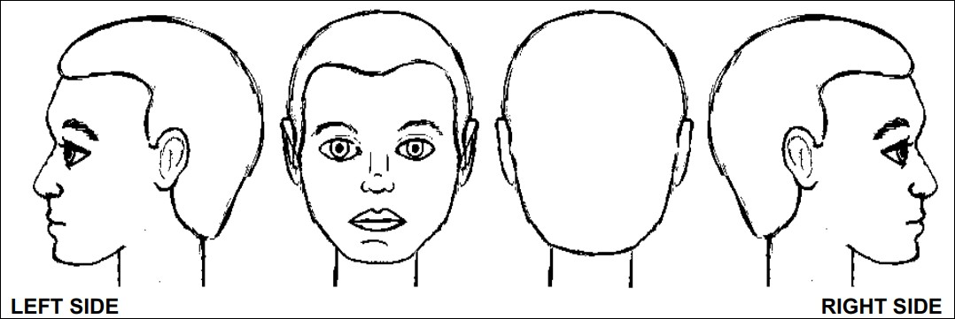
Name of Child:  Date of Birth: | Recorded by:  Job role: | Date injury observed:  Time injury observed: | Date injury recorded:  Time injury recorded:

Description of Injury:

Recording Proforma: Body Map
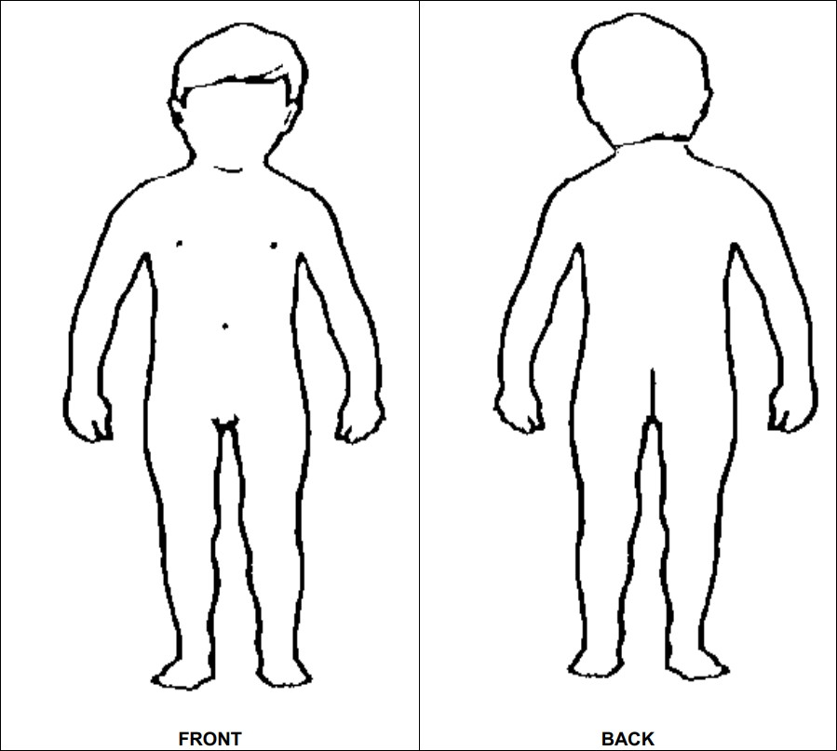
Name of Child:  Date of Birth: | Recorded by:  Job role: | Date injury observed:  Time injury observed: | Date injury recorded:  Time injury recorded:

Description of Injury:

Recording Proforma: Body Map
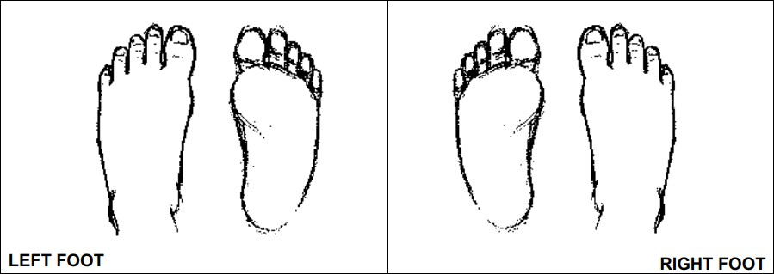
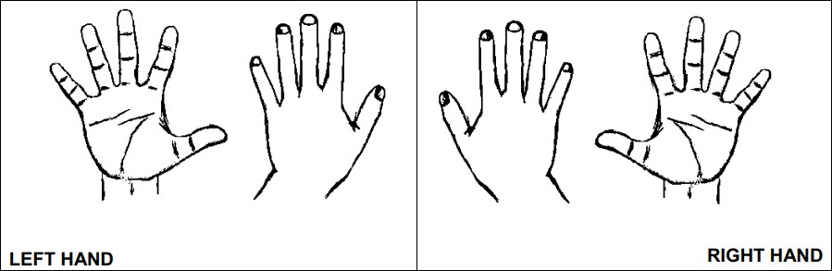
Name of Child:  Date of Birth: | Recorded by:  Job role: | Date injury observed:  Time injury observed: | Date injury recorded:  Time injury recorded:

Description of Injury:

Recording Proforma: Physical injuries to child
This sheet should be completed every time the body map proforma is completed and filed with the corresponding body map.

Name of Child:  Date of Birth: | Recorded by:  Job role: | Date injury observed:  Time injury observed: | Date injury recorded:  Time injury recorded:

Summary of how injury came to be known to staff:

Child’s account of the injury:
Parent/s’ account of the injury (if appropriate):
Name of Staff: Signed:
Date:
Name of DSL: Signed:
Date:

Signed:
Time:
Date:
Record of discussions with Designated Safeguarding Lead:
Follow-up required: (Agreed actions and timescales)
Action taken:

