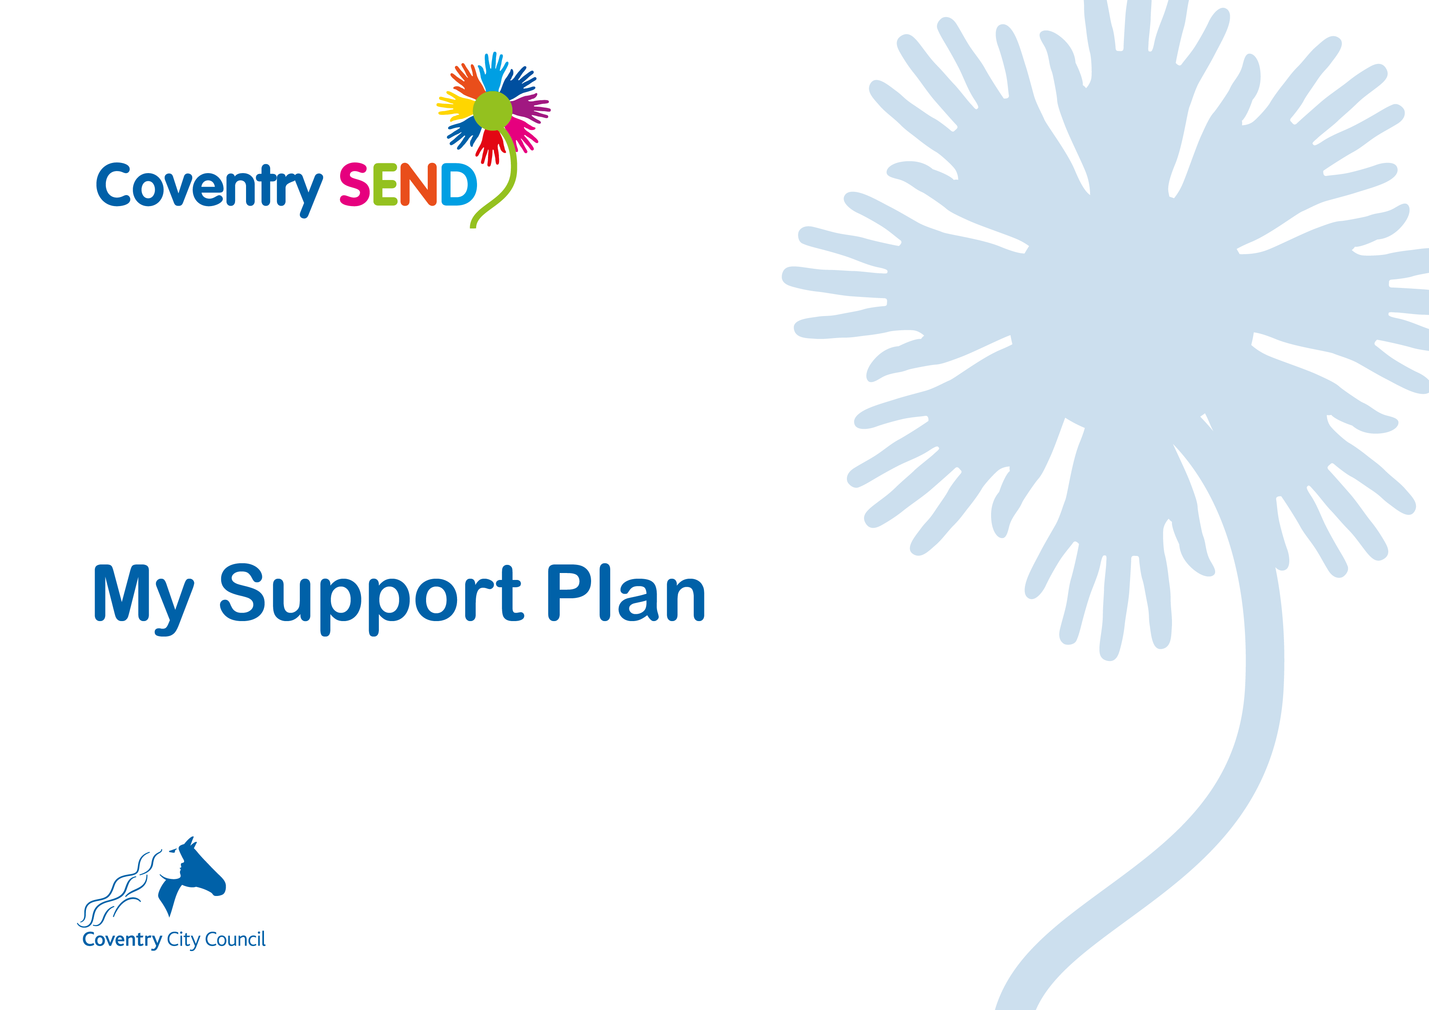
Name
Setting
Plan Start Date
Plan Review Date

My Views

My Family’s views

My Team
People in my family
_{Name} | _{Gender} | _{Relationship} | _{Contributed to My Plan} | _{Parental responsibility}  _{Y/N}

Professionals supporting me and my family
Name | Role | Agency | Contributed to My Plan

My Progress

Area of Learning | Attainment prior to beginning  My Support Plan  Age in months | Attainment at review of plan  Age in months
Personal, Social and Emotional Development  Making Relationships/ Self Confidence & Self Awareness / Managing Feelings & Behaviour | MR -  SCSA -  MFB -
Communication and Language  Listening & Attention / Understanding / Speaking | LA –  U –  S -
Physical Development  Moving & Handling / Health & Self Care | MH –  HSC -
Literacy  Reading / Writing | R –  W –
Mathematics  Numbers / Shape, Space & Measures | N –  SSM -
Expressive Arts and Design  Exploring & Using Media & Materials / Being Imaginative | EUMM –  BI -
Understanding the World  People & Communities / The World / Technology | PC –  TW -  T -

My Strengths and Needs
Personal, Social and Emotional Development
Communication and Language
Physical and Sensory Development and Self Help Skills
Cognition and Learning

My Outcomes and Provision
To be completed at the plan writing meeting |  | To be completed at the Review Meeting
Outcomes Sought | Educational provision to meet my outcomes | Was the agreed support fully implemented? | Has the outcome been achieved?

Health and Social Care Details (if appropriate)
My Health Needs (including confirmed diagnoses)
Diagnosis / Disability | Diagnosed By |  | Is medication taken for disability/diagnosis?  Y/N | Is this medication taken during school hours?
Other health issues
My Social Care Needs
Social Care Processes in operation
Local authority responsible:
Other plans:

