There are specific areas in Coventry City Centre where Street Collections can be authorized. Please refer to your permit for the places that you have been authorized.

Due to ongoing public realm building works we are unfortunately unable to offer all our normal areas for street collections:
- Precinct Crossover (Open by end of June 2021)
- Upper Precinct (Open by end of June 2021)
- Smithford Way (Open by end of June 2021)
- Market Way (Open by end of June 2021)
- Shelton Square
- Dresden Place
- Hertford Street

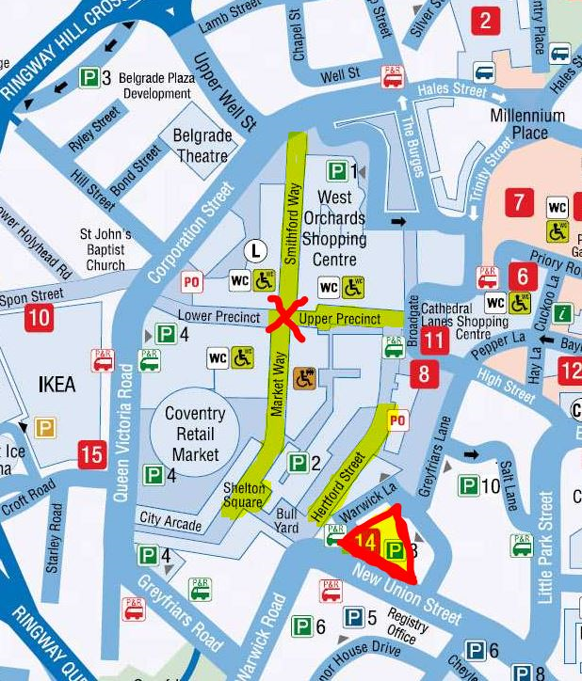
Precinct Crossover Dresden Place

