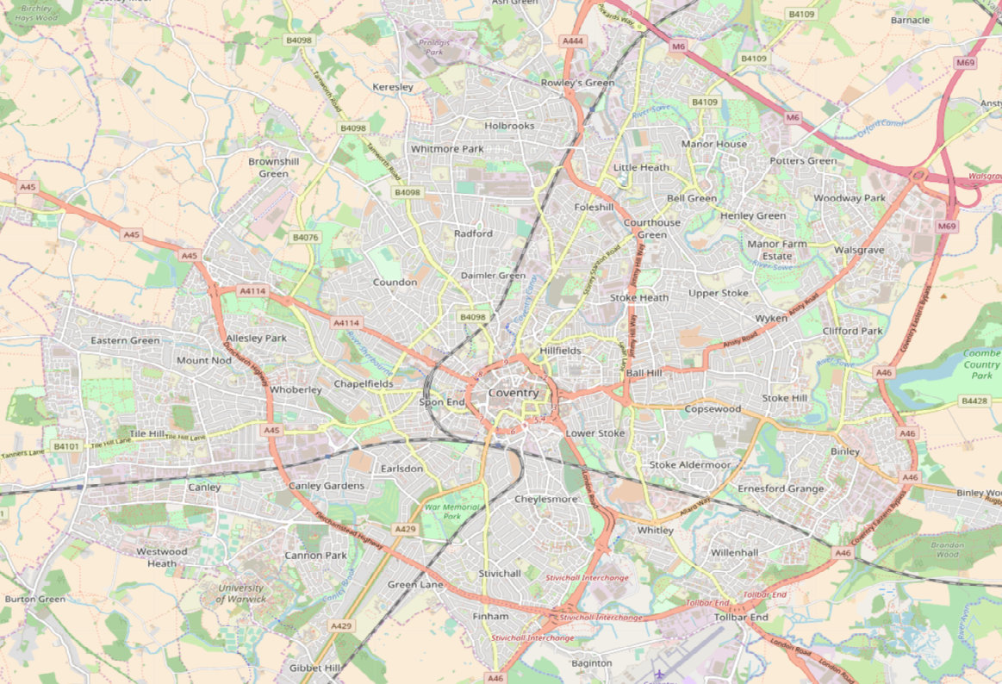

Jardine Crescent Sports Ground

Coundon Hall Park

Nauls Mill Park

Gosford Green

Spencer Park

Hearsall Common

Sovereign Row Park

Lake View Park

Floyds Field

Park Wood Meadow

Prior Deram Park

Tutbury Ave Open Space

War Memorial Park

Stivichall Open Space

Whitley Common

Humber Rd Open Space

Stoke Green

Gosford Park

Stoke Aldermore Open Space

Willenhall Brookstray

Binley Recreation Ground

Brinklow Rd Open Space

Morris Ave Open Space

Barras Heath Park

Wyken Croft Nature Park

Blackberry Lane open space

Stoke Heath Sports Ground

Caludon Castle Park

Moat House Park Park

Wood End Brookstray

[**WWW.COVENTRY.GOV.UK/COVONTHEMOVE**](http://WWW.COVENTRY.GOV.UK/COVONTHEMOVE)

Simon Stone Street Open Space

Allesley Park

St Margarets Park

Sowe Common Sports Grounds

Blackwatch Recreational ground

Woodway Walk

Holbrooks Park

Radford Recreation Ground

Cash’s Park

Edgwick Park

Cubbington Rd Open Space



**FIND COVENTRY’S NEW WALKING AND RUNNING ROUTES AT A PARK OR GREEN SPACE NEAR YOU!**