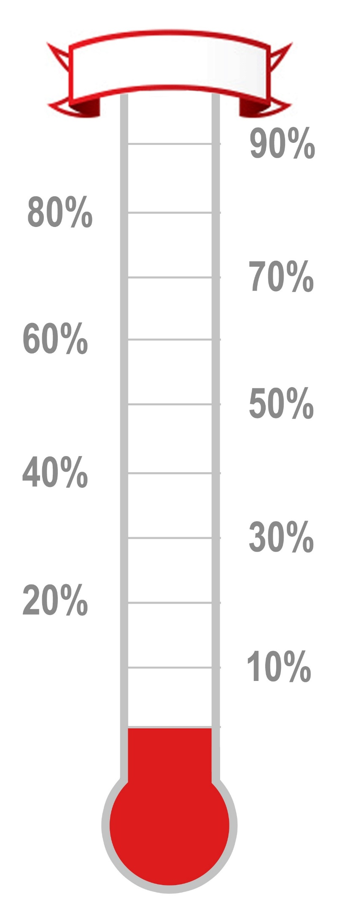

Attendance Targets

|  |  |  |
| --- | --- | --- |
| **W/C** | **Target** | **Actual** |
|  |  |  |
|  |  |  |
|  |  |  |
|  |  |  |
|  |  |  |
|  |  |  |
|  |  |  |
|  |  |  |
|  |  |  |
|  |  |  |
|  |  |  |
|  |  |  |
|  |  |  |
|  |  |  |
|  |  |  |
|  |  |  |
|  |  |  |

Equates to **133 days** off **per year**

Equates to **4 days** off **per week**

Equates to **1,080 lessons** missed **per year**

Equates to **114 days** off **per year**

Equates to **480 lessons** missed **per year**

Equates to **20 weeks** off **per year**

Equates to **57 days** off **per year**

Equates to **4 weeks** off **per year**

Equates to **1 day** off **per week**

**100%**