(Core beliefs act like a lens through which we view a situation)
Core Beliefs
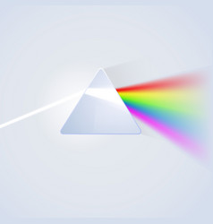
Situation
Different Emotions Motivate Us To Do Different Things – Emotions make us want to act:
Behaviours
(New Behaviours)
Emotions
(New Emotions)
Bodily Sensations
*Assuming the worst
Jumping to conclusions
Everything revolves around me?
Thoughts*
(Revised thoughts)
 | Joy, Happiness and Contentment motivates us to join in, take part, share |  | Shame motivates us to hide away
 | Fear and anxiety motivates us to get away |  | Disgust motivates us to withdraw, keep a distance
 | Sadness and grief motivates us to withdraw, brood, ruminate |  | Compassion or empathy motivates us to offer comfort, to be with
 | Lonely. Feeling, disconnected and unwanted. Unable to communicate things that seem important to you |  | Anger and aggression motivates us to attack, lash out, stand up for ourselves

Body feelings are associated with different emotions – As human beings we don’t just feel emotions in our heads; we feel them with our bodies too.
When we are ANGRY our body feels tense, energised
When we are HAPPY our body feels light, energised
When we are SAD our body feels heavy, tired, slow
When we are EXCITED our body feels jittery, butterflies in our stomach, quicker breathing
When we are ANXIOUS our body feels jittery, butterflies in our stomach, quicker breathing
