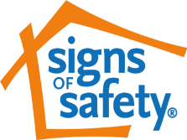

Signs of Safety in Coventry – One-Minute Guide

What is Signs of Safety?

Signs of Safety [SofS] started as an innovative, strengths and safety-based approach to child protection casework. The model was created in Western Australia by Andrew Turnell and Steve Edwards, who worked with over 150 front-line statutory practitioners and began developing the approach on what those practitioners knew worked well with families. It is now used in many Local Authorities across a wide range of services, working with Children and Young People.

It was re- introduced into Coventry Children’s Services in 2015 as a key practice approach to work with families supported by Social Care & Early Help Services – like Family Hubs, Health & Schools.
SofS provides a clear framework on how we should work with families within the Children’s Service Partnership – this includes building better relationships with families to work with them more effectively for children and young people.

The SofS model aims to create a more collaborative approach within Children’s Services, partnership organisations and families to address situations where children have experienced harm, are at current risk of harm or have identified unmet needs.

The SofS Assessment and Planning Framework can be used by any practitioners working with children and young people in Social Care or Early Help. For example, we may refer to Danger Statements and Safety Goals for a child who has a Child Protection Plan or Worry Statements and Wellbeing / Success goals for a child who is being supported by Early Help Services.

Developing Good Signs of Safety Practice

- Creating a clear understanding of past harm, current harm, possible future dangers for child / young person (if nothing changes), and what the complicating factors to supporting the family are, means we can create better safety & well-being goals for everyone to work towards achieving.

- Identifying existing strengths and existing safety and working with extended family and community networks helps to improve safety & well-being for children.
- Ensuring all communication with children, young people and their families is understandable. Research tells us professionalised language can make it difficult for families to work with Practitioners because they don’t always understand what the impact of the worries are for their children and what changes are expected from them for Services to end their involvement. Hence Danger/Worry statements and Safety / Well-Being goals should be created and agreed with families.
- Supportive Action plans are created with families to outline how the safety goals or wellbeing/success goals are going to be met – which includes agreed timescales to ensure children’s lives are getting better. This requires Skilful Use of Professional Authority.
- The Assessment and Planning Framework and action plan should be reviewed regularly with families to ensure it still remains relevant and any new information - like additional risks or additional safety for the child - is considered using the information within the Sofs Framework.
- Parents/Carers are supported to create Words and Pictures explanations to help children understand why services are involved & what Services are working with their parents/families to improve.
Child-centred Safety Plans can also be presented in Words and Pictures format so it is clear for the child/ young person what will happen, what they can expect from everyone involved, and what they can do if they don’t feel safe.

Signs of Safety Assessment and Planning Framework

The Assessment and Planning Framework is used for ‘mapping’ the dangers / worries, strengths and required safety & well-being for children. The mapping tool has four domains for discussion with families and other professionals around the family.

The “Three Columns”:
- What we are worried about (past harm, current harm, future danger and any complicating factors)?
- What is working well (existing strengths and existing safety)?
- What needs to happen next? (this includes agreeing the safety & well-being goals and how best to plan actions to achieving them, and also any

Children’s Services bottom lines (non-negotiables) that family must maintain / not do to ensure safety for the children in their care.

Using the analysis from the three columns, the danger/worry statements and safety/wellbeing goals are created.

A scaling question linked to the statements and goals is used to gain the perspective of the Social Worker or Lead Professional, the family, their networks and other professionals around the family, about where they scale the current level of safety or worry about unmet needs.

This helps to develop understanding between everyone involved and to work towards the required changes for children within agreed timescales.

The SofS Assessment and Planning Framework, identifying the 4 main domains of enquiry and the seven analysis categories, is set out below
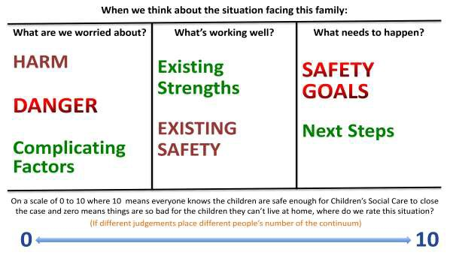

How does Signs of Safety support us to engage with Children and Young People?

Talking to children is at the heart of SofS. There are numerous tools that will encourage practitioners to consider the child’s lived experience and see the “world through the child’s eyes”.

The Three Houses is one of practice tool, and is a child’s version of the three columns to capture their experience.
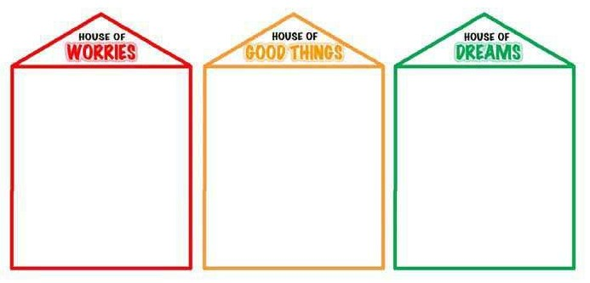

There are other tools that are being created by practitioners to suit specific family needs. Many of the SofS Practice Leaders in Coventry who are supporting colleagues in their service area can share these good practice examples – if you would like to know who your Practice Leaders are, please contact one of the SofS Service Implementation Leads below

Signs of Safety – Where are we on our journey?

There is a “One Coventry” commitment to using Signs of Safety when working with children, young people and families within Children’s Social Care & Early Help, Health, Education, Police and the Voluntary sector.

There is a clear expectation that SofS will thread through all our practice to ensure that children, young people & their families are provided with the Right Help, in the Right Way, at the Right Time, and with the Right Outcome.

Recording Practices using SofS approach have been reviewed by Children’s Services to ensure they are aligned to the SofS model; on LCS and EHM this includes Assessments, Case Recordings, Strategy Meetings, Child Protection Conferences, Looked After Children Reviews and Team Around the Family meetings
Other Services are also reviewing their recording procedures and practices -please contact your SofS Practice Implementation Lead for further up-dates on this.

For further information on Signs of Safety & Well-Being in Coventry, contact:
- Dinesh Ranchhod - Signs of Safety Practice Implementation Lead dinesh.ranchhod@coventry.gov.uk

- Charlotte Hegarty - Safeguarding In Education Advisor Charlotte.Hegarty@coventry.gov.uk

- Lyn Parsons - Signs of Safety Strategic Health Lead
lynette.parsons@nhs.net
- Rebecca Lydon - Named Nurse for Safeguarding Children and Young People. Rebecca.lydon@uhcw.nhs.uk

- Charlie Crowl - charlotte.crowl@covwarkpt.nhs.uk

To book a place on the 2 days Signs of Safety Training, please use the following link: www.coventry.gov.uk/safeguardingbookingform
Signs of Safety website – http://www.signsofsafety.net

