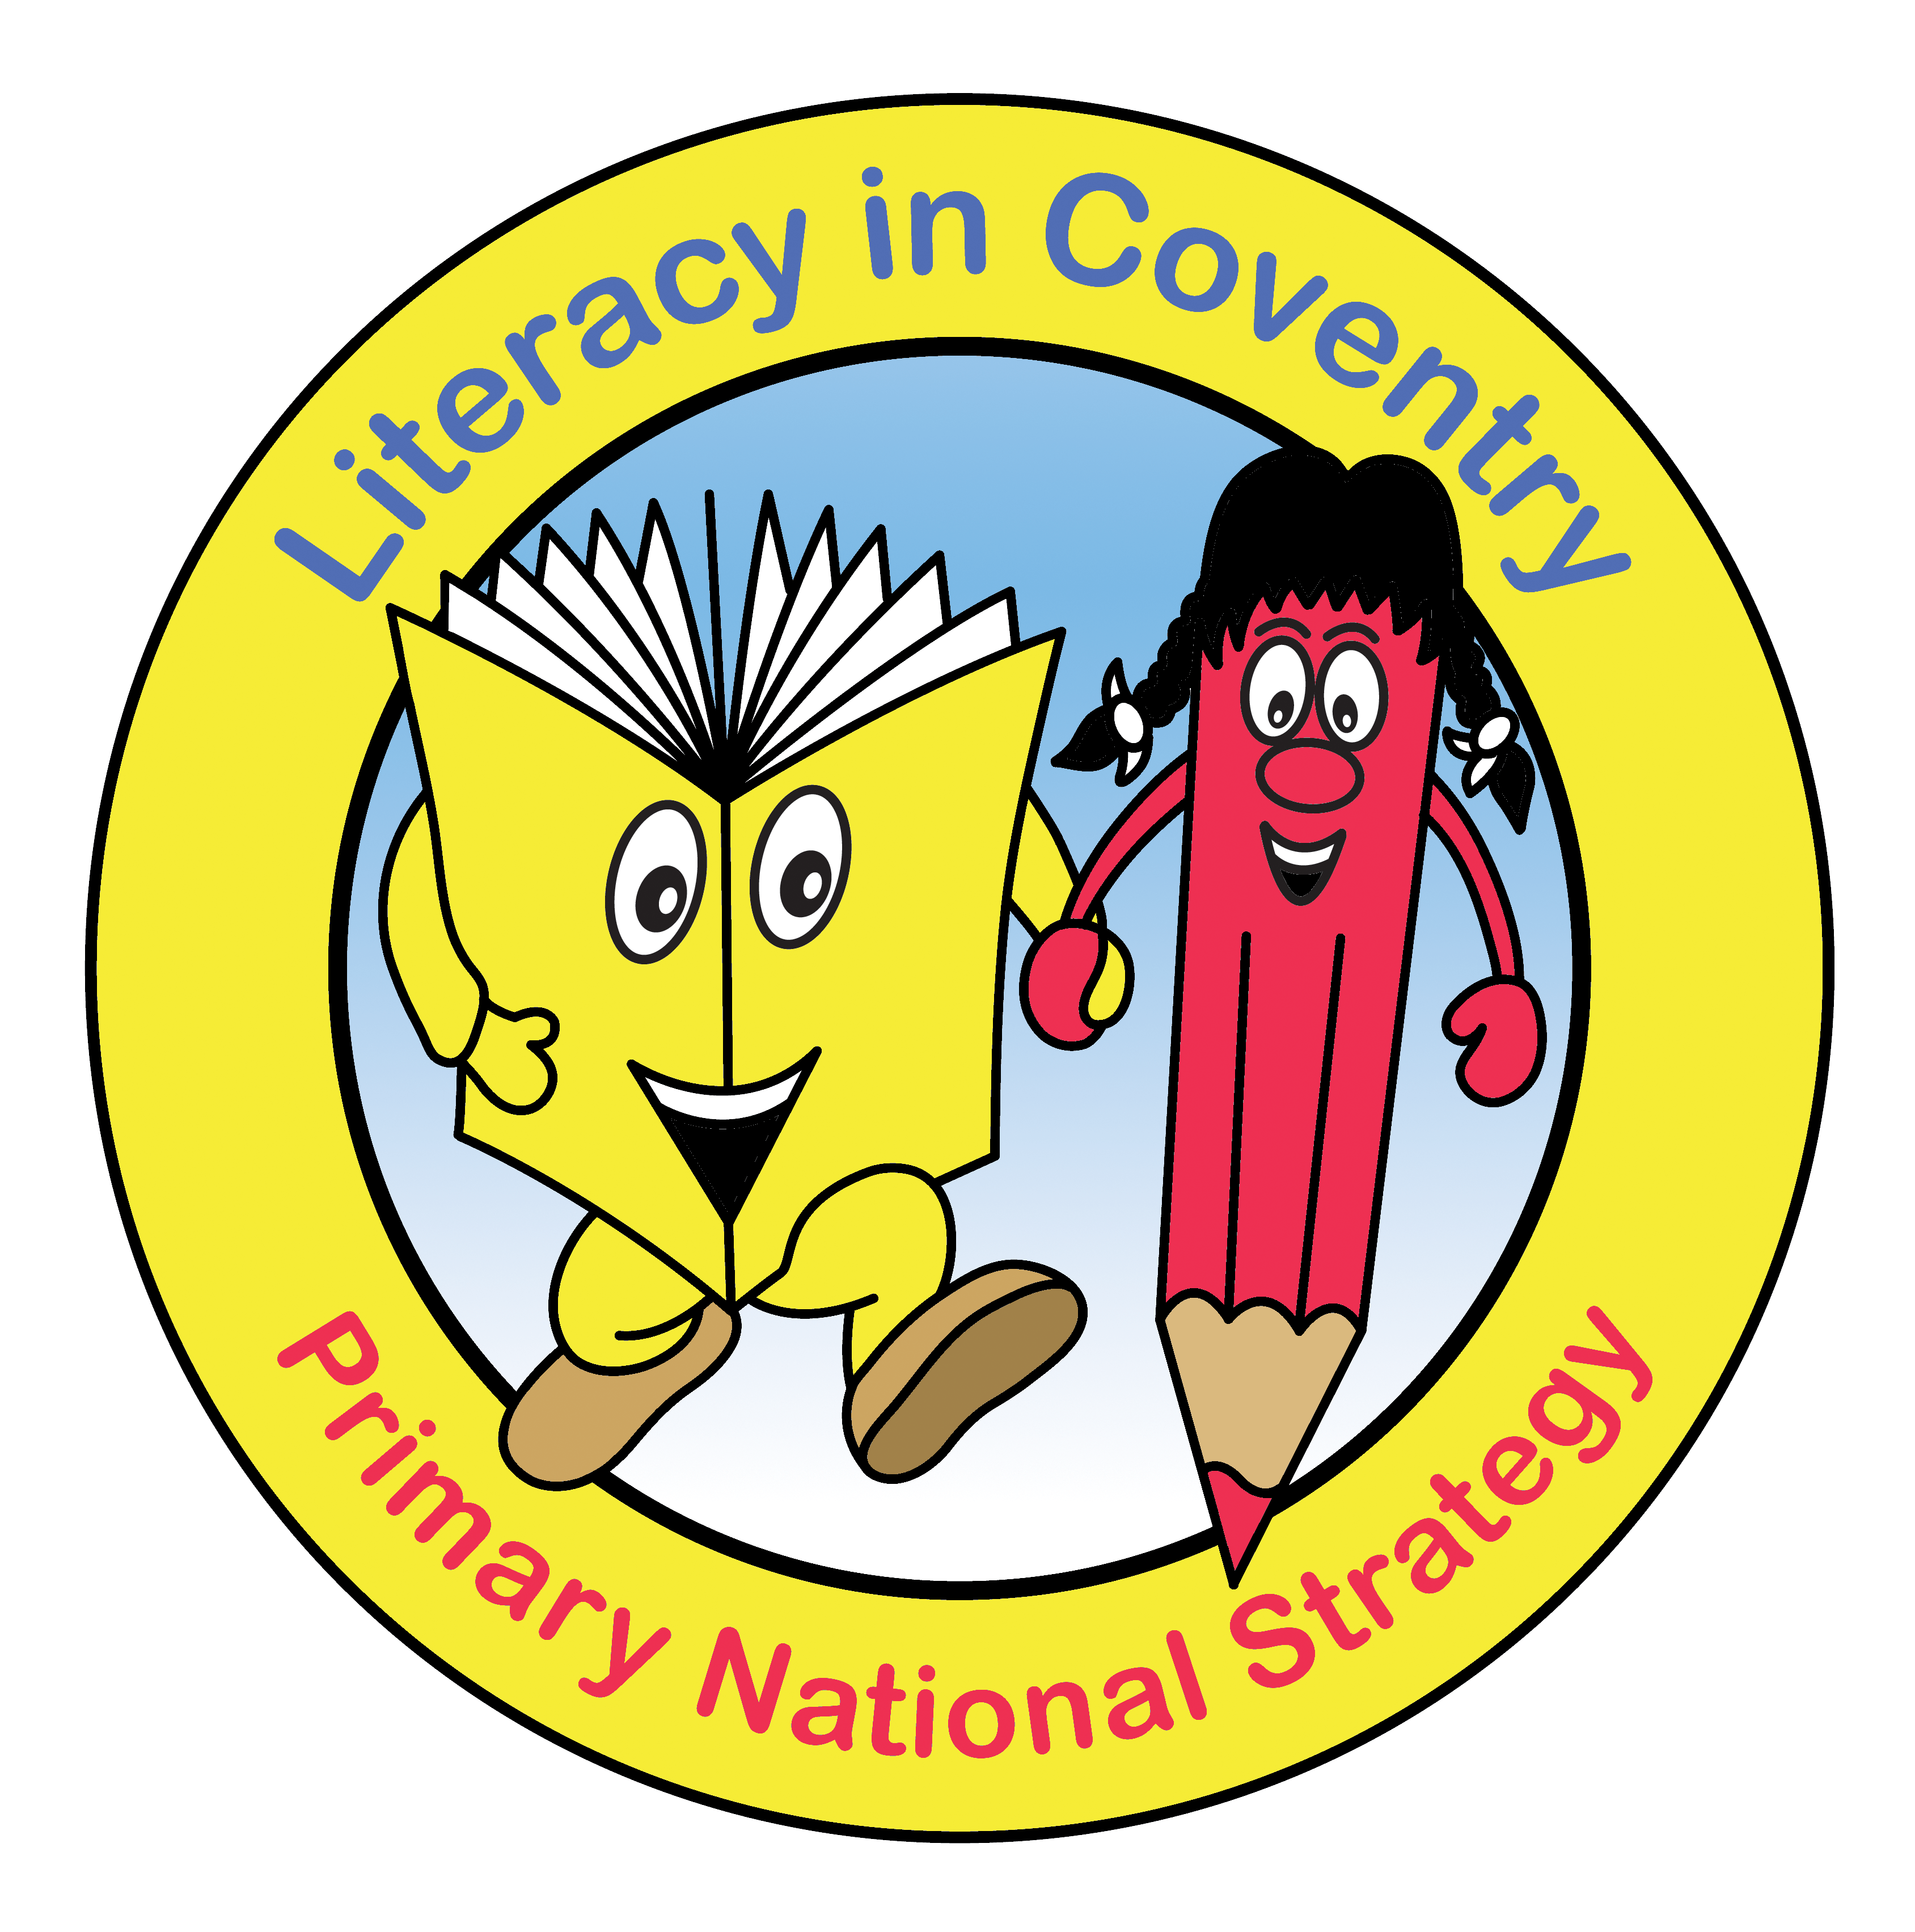

Guided Reading Prompts for the Assessment Focuses

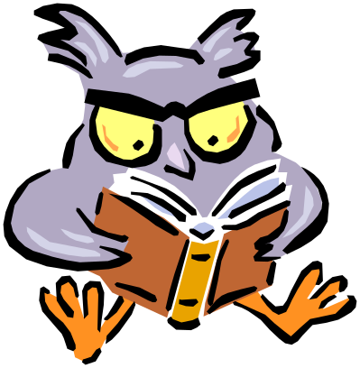

AF2: Understand, describe, select or retrieve information, events or ideas from texts. Use quotations and reference to text.

Recall Questions

- Where does the story take place?
- When did the story take place?
- What did s/he/it look like?
- Who was s/he/it?
- Where did s/he/it live?
- Who are the characters in the book?
- Where in the book would you find…?

Simple Comprehension Questions

- What do you think is happening here?
- What happened in the story?
- What might this mean?
- Through whose eyes is the story told?
- Which part of the story best describes the setting?
- What words and /or phrases do this?
- What part of the story do you like best?
AF3: Deduce, infer or interpret information, events or ideas from texts.

Application Questions

- Can you think of another story, which has a similar theme; e.g. good over evil; weak over strong; wise over foolish?
- Do you know of another story which deals with the same issues; e.g. social; moral; cultural?
- Which other author handles time in this way; e.g. flashbacks; dreams?
- Which stories have openings like this?

Analytical Questions

- What makes you think that?
- What words give you that impression?
- How do you feel about…?
- Can you explain why…?
- I wonder what the writer intended?
- I wonder why the writer decided to…?
- What do these words mean and why do you think the author chose them?
- Has the author used adjectives to make this character funny?
- Why did the author choose this setting?
AF4: Identify and comment on the structure and organisation of texts, including grammatical and presentational features at text level

- Why do you think the author chose to use a… question/bullet/subheading/table etc to present the information?
- How does the title/layout encourage you to read on?
- How does the layout of the page/chapter/book etc help you to find information quickly/clearly?
- How are the different sections made clear?
- Where does it tell you that…?
- Why has the writer written instructions/information in this way?
- In what ways do the illustrations support the instructions?
- Which instructions/illustrations is the easiest to follow? Why?
- How could these instructions/information texts be improved?
- Who do you think this information is for?
- What tense have these instructions been written in? What would happen if I changed tense?

- Has the writer/page designer/editor been successful (purpose/audience/organisation/use of language)?
- How could you adapt these instructions for younger pupils?
- Compare the given instructions. Which are more effective and why (clarity/layout/use of language/use of illustrations/colour etc)?
- How does the writer/page designer/editor make sure that the reader reads the text in a certain way?
- Compare two non-fiction texts on a similar theme/topic. Evaluate the purpose, audience, organisation and use of language.

AF5: Explain and comment on the writer's use of language, including grammatical and literary features at word and sentence level.

Words
- What does the word 'x' tell you about 'y'?
- Find two or three ways that the writer tells you 'x'.
- What does this… word/phrase/sentence… tell you about… character/setting/mood etc?
- Highlight a key phrase or line. By writing a line in this way what effect has the author created?
- In the story, 'x' is mentioned a lot. Why?
- The writer uses words like … to describe …. What does this tell you about a character or setting?
- What other words/phrases could the author have used?
- The writer uses …words/phrases…to describe … How does this make you feel?
- How has the writer made you and/or character feel …happy /sad/angry/ frustrated/lonely/bitter etc?
- Has the writer been successful in their purpose or use of language?
- What do you think the writer meant by… 'x'?
- Which words do you think are most important? Why?
- Which words do you like the best? Why?
- The author makes an action/description 'like' something else. Why?
- The author states that 'x' is something it isn't. What is the effect of this? Why have they done this?

Characters
- Explain why a character did something.
- Explain a character's different/changing feelings throughout a story. How do you know?
- What are the clues that a character is liked/disliked/envied/feared/loved/hated etc…?
- What is similar/different about two characters?
- Describe different characters' reactions to the same event in a story.
- Why is 'x' (character/setting/event) important in the story?

AF6: identify and comment on writers' purposes and viewpoints, and the overall effect of the text on the reader

- What makes this a successful story?
- What evidence do you have to justify your opinion?
- Does it work?
- Could it be better? How?
- Is it as good as …?
- How is it similar to …?
- How is it different to …?
- Is it as good as …?
- Which is better and why?
- What is the most … important/exciting part of the text?
- Why has the author written this article?
- How does the writer try to make sure the reader will do what is recommended?
- Give a statement. Is this a fact or opinion?
- Is there an alternative point of view?
- What would happen if that opinion was a fact?
- What advice would you give 'x'?
- Why has the writer included …?
- Why has the writer written/included/chosen these words…?
- What else could the writer have done? What impact would that have had?
- Which character(s) does the writer want you to be more/less sympathetic to? How have they done this? Are they successful?
- What is your opinion? What evidence do you have to support your view?
- Using all the evidence available, can you tell me what you feel about…?
- Given what you know about … what do you think?
- How would the views put across in this text affect your views on…?
- What would this character think about…(possibly a present day situation)?
- Why do you like 'x's (author/poet) work? Choose one thing and say why you like it.
- How would you feel in this situation?
- Has anything like this happened to you? How did you feel?
- What advice could you give to a character?
- Who is the audience for this text? How do you know?
- What tricks has the writer used to persuade the reader?
- How successful is a text in persuading you or not? Why?
- Who is the 'voice' or point of view in this story/poem? How do you know? Why do you think the writer has chosen to do this?
- What would be different if this story/poem was written from another character's point of view?
- What do you think character 'x' thinks of character 'y'? How do you know?
- (1st person writing ) Is the author 'talking' or is it a character pretending to be the author? How do you know?

