Join Microsoft Teams Meeting by using the Email Invite Link
When you receive an invite click the link that says Join Microsoft Teams Meeting.
After clicking on the meeting join link, the link will open in the default web browser taking you to the Microsoft Teams website. You will be prompted if you want to open the application, if you already have it installed or download the application. Click Open or download and follow the instructions.

Joining a Teams Meeting by using the Meeting Link in the Browser
One other way to utilize the link is by copying it and navigating the meeting URL using your web browser.
When you open the Teams meeting URL link using the web browser, you will be asked to choose an option whether to Download the Windows app or Join on the web instead.
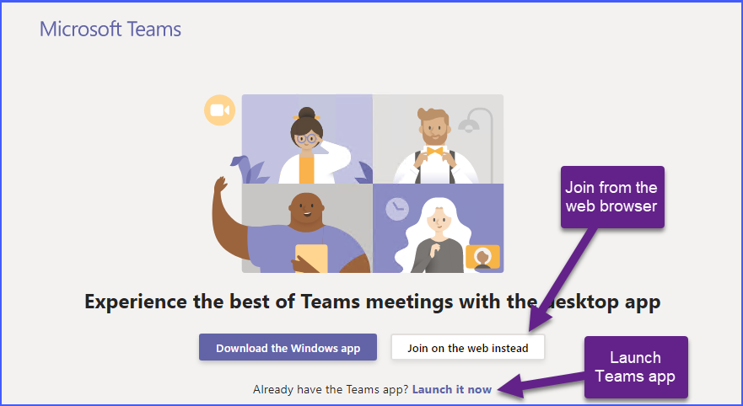

If you chose to join using the web browser instead, you will be prompted by your browser to allow the site access to your computer microphone and camera. Click on the Allow button, as shown below. Otherwise, you won’t be able to use your camera and microphone for the Teams meeting. Allow Teams access to your computer’s microphone and camera and follow the instructions.

