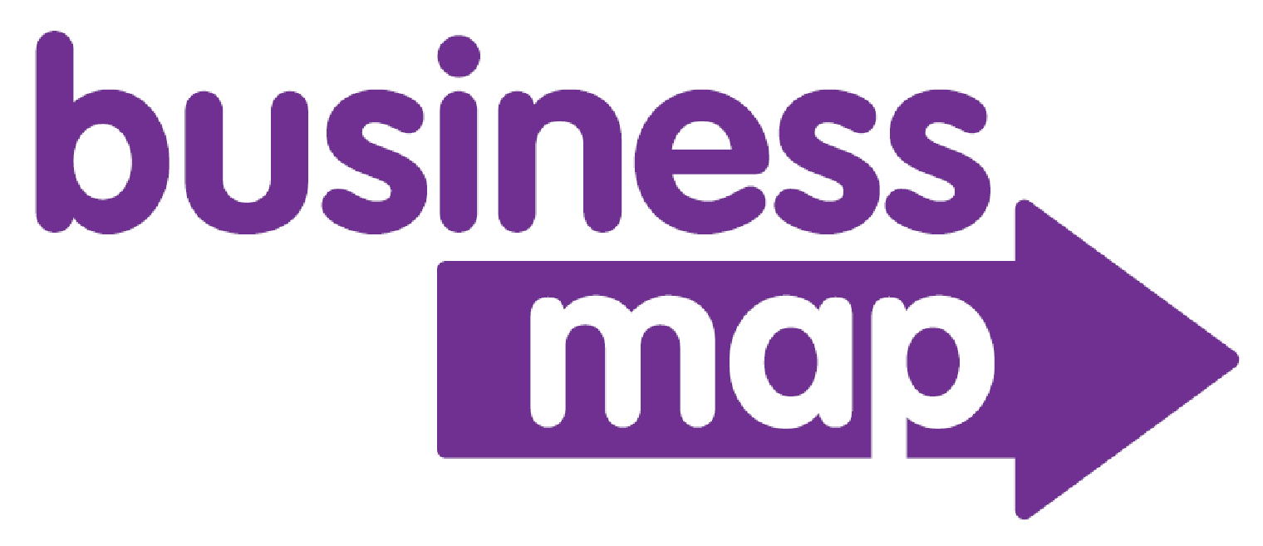
A Hempsall’s Business Change and COVID-19 ResponseTool

The Business Map sets out the information to consider and collate, ultimately leading to a business action plan. It uses a six-step process:

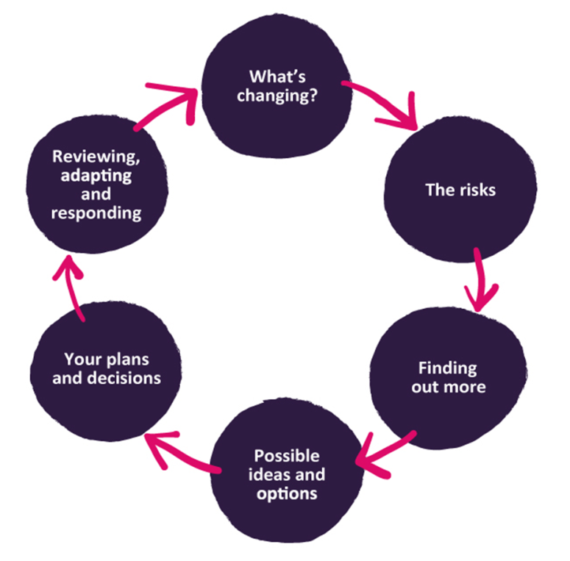

Things to do | √
1.First, complete the ‘what’s changing’ section.
- Analyse demand and occupancy
- Understand if parental preferences and behaviours are changing
2. Then use the tools to ‘find out more’ about the business and the environment in which it operates.
- Complete a SWOT analysis
- Complete a PEST analysis
- Market analysis
- Complete a breakeven cost analysis
- Calculate the breakeven hourly rate
- Compare to last year
- Review fee structure
- Complete/update the cash flow forecast
- Develop a cash flow forecast for 2021 – 2022
- Review reserves and contingency plans
- Review COVID 19 Government funding opportunities
3. After that, identify the risks.
- Complete the ‘risk register’
4. Then it is time to consider the possible ideas and options.
- Establish if demand has changed
- Review model of delivery to ensure it works for the setting and families
- Review finances
- Consider if cost savings are needed or possible
- Develop contingency plans
- Review reserves and be clear how long the business can continue without extra financial support.
- Find financial support for the business.
- Help parents to help themselves – what can help to reduce the cost of paying for childcare?
- Communicate
5. Next, return to the risks and think about the actions to reduce or remove them.
- Return to the risks and think about the actions to take to reduce or remove them
- Complete the risk register and develop an action plan
6 Measure progress and review regularly
- Keep updating the cash flow, it will show how new arrangements are affecting the business.
- Monitoring a range of measurements will help to understand if things are working. Set the targets and build them into monthly monitoring discussions

