

Community Short Breaks December Half Term Activities 2025

Dear Parents and Carers

Community Short Breaks provide activities for children living in Coventry with diagnosed disabilities aged 5 – 17 years old.

The Booking Hotline for December Half Term Activities 2025 will be open from Monday 1st December 2025 until Friday 5th December 2025 from 09.00am until 4.00pm.

Please call 024 76 975464 to book. Bookings can also be made online at www.coventry.gov.uk/bookashortbreak during this period.
Bookings either online or by telephone that are outside of the dates and times stated will be placed on the waiting list.

Places in activities are limited; you will be able to select one venue for your child or young person to attend across the week as part of your ‘activity’, you can also select one venue as a second option if the first choice is not available. If you do not require an activity select ‘not required’.

Activities will be delivered for children and young people registered with Community Short Breaks unless stated otherwise. Please find this information below the named activity.

If your child or young person has never attended a Community Short Breaks activity, we will require a completed Short Breaks passport and supporting letter.

An induction visit is required prior to attending an activity this will be arranged by Development Officer.

Please continue with your booking and Development Officer will contact you as soon as possible.

Please note we cannot support siblings in activities unless stated.
Please Read: Important information about activities and venues

Date | Activity | Venue
Monday  22nd December 2025 | Make your own Gingerbread man and biscuit decorating with crafts and games.  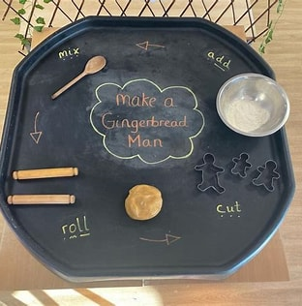    Christmas tree decorating      9:30am – 11:00am  (5 years old – 10 years old)  Snowman craft activities and Pass the parcel with games      11:30am – 1:00pm  (11 years old – 17 years old) | Woodside Family Hub  Upper Ride  Coventry  CV3 3GL  Please inform Development Officer in advance of any allergies or food intolerances.  Woodside Family Hub  Upper Ride  Coventry  CV3 3GL  Please inform Development Officer in advance of any allergies or food intolerances.
Tuesday  23rd December 2025 | Christmas Bauble decorating with crafts and games.    11:15 am – 12:45pm  (5 years old – 10 years old)  Make your own hot chocolate cones with pass the parcel and games    1:15pm – 2:45pm  (11 years old – 17 years old)  Short Breaks Family Swim  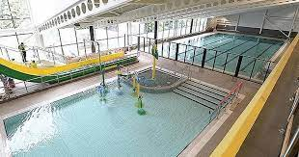  2:00pm – 3:00pm  (5 – 11 years) | Broad Park House  Logan Road  Coventry  CV2 1AG  Please inform Development Officer in advance of any allergies or food intolerances.  Broad Park House  Logan Road  Coventry  CV2 1AG  Please inform Development Officer in advance of any allergies or food intolerances.  Centre AT7  12 Bell Green Road  Coventry  CV6 7GP  Please provide all the names of children and adults that will be supporting in the Splash pool.  Children must be within the family household.  Public Pool Rules: All children aged 8 and under must be accompanied by an adult.  Any child that cannot swim must be accompanied by an adult.  Parent/carers must stay at the pool side if not swimming with children.  £1.00 will be required for individual lockers.  If a child has a medical history, please notify the Short Breaks staff member/lifeguard on duty on arrival in case of an emergency.
Wednesday  24th December 2025 | Christmas tree decorating using stickers with polar bear express and snow (including crafts and games).    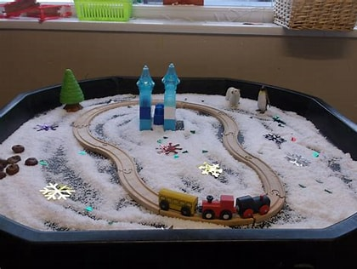  10:00pm – 11:30pm  (5 years old – 11 years old)  Pool and Air Hockey      Christmas Hema Beads decorations and games    12:00pm – 1:30pm  (12 years old – 17 years old) | Mosaic Hub  Jardine Cresent  Tile Hill  Coventry  CV4 – 9PL  Mosaic Hub  Jardine Cresent  Tile Hill  Coventry  CV4 – 9PL
Thursday  25th December 2025 | BANK HOLIDAY | BANK HOLIDAY
Friday  26th December 2025 | BANK HOLIDAY | BANK HOLIDAY
Monday  29th December 2025 | Paper Plate winter hats  with celebration sensory bin and cupcake making dough.        9:30am – 11:00am  (5 years old – 10 years old)  Cardboard donuts with coloured shaving foam and sprinkles  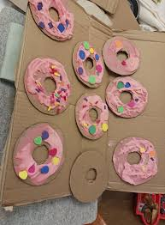  11:30am – 1:00pm  (11 years old – 17 years old) | Woodside Family Hub  Upper Ride  Coventry  CV3 3GL  Please inform Development Officer in advance of any allergies or food intolerances.  Woodside Family Hub  Upper Ride  Coventry  CV3 3GL  Please inform Development Officer in advance of any allergies or food intolerances.
Tuesday  30th December 2025 | Ice-cream cones and cornflour sensory play  with crafts and games.      11:15 am – 12:45pm  (5 years old – 10 years old)  Make your own celebration slime and party hats      1:15pm – 2:45pm  (11 years old – 17 years old)  Short Breaks Family Swim  2:00pm – 3:00pm  (5 – 11 years) | Broad Park House  Logan Road  Coventry  CV2 1AG  Please inform Development Officer in advance of any allergies or food intolerances.  Broad Park House  Logan Road  Coventry  CV2 1AG  Please inform Development Officer in advance of any allergies or food intolerances.  Centre AT7  12 Bell Green Road  Coventry  CV6 7GP  Please provide all the names of children and adults that will be supporting in the Splash pool.  Children must be within the family household.  Public Pool Rules: All children aged 8 and under must be accompanied by an adult.  Any child that cannot swim must be accompanied by an adult.  Parent/carers must stay at the pool side if not swimming with children.  £1.00 will be required for individual lockers.  If a child has a medical history, please notify the Short Breaks staff member/lifeguard on duty on arrival in case of an emergency.
Wednesday  31st December 2025 | Happy New Year 2026  Candy Floss  Crafts and games      10:00am – 11:30am  (5 years old – 11 years old)  Happy New Year 2026  Make your own celebration drinks using fruit juice and treats.      12:00pm – 1:30pm  (12 years old – 17 years old) | Families For All  454 Foleshill Road  Foleshill  Coventry  CV6 5LB  Please inform Development Officer in advance of any allergies or food intolerances.  Families For All  454 Foleshill Road  Foleshill  Coventry  CV6 5LB  Please inform Development Officer in advance of any allergies or food intolerances.
Thursday  1st January 2026 | BANK HOLIDAY | BANK HOLIDAY
Friday  2nd January 2026 | Butter Cookies with chocolate drizzle    9:30am – 11:00am  (5 years old – 11 years old)  Butter Cookies with chocolate drizzle  11:30pm – 1:00pm  (12 years old – 17 years old) | Pathways Family Hub  Lawrence Saunders Road  Coventry  CV6 1HD  Please inform Development Officer in advance of any allergies or food intolerances.  Pathways Family Hub  Lawrence Saunders Road  Coventry  CV6 1HD  Please inform Development Officer in advance of any allergies or food intolerances.

