

Community Short Breaks March Half-Term Activities 2026
https://www.coventry.gov.uk/special-educational-needs-disabilities/short-breaks
Dear Parents and Carers
Community Short Breaks provide activities for children living in Coventry with disabilities aged 5 – 17 years old.

The Booking Line for March Half Term Activities will be open from Monday 16th March 2026 (9:00am) until Friday 20th March 2026 (4:00pm).

Please call 024 76 975464 to book by phone (available Monday to Friday from 9:00am – 4:00pm).

Bookings can also be made online at www.coventry.gov.uk/bookashortbreak during this period.

Bookings either online or by telephone that are outside of the dates and times stated will not be processed.

Please note places in activities are limited; you will be able to select one venue for your child or young person to attend across the week as part of your ‘activity’, you can also select one venue as a second option if the first choice is not available. If activities are not required, please select ‘not required’.

Activities will be delivered for children and young people aged 5 – 11 years old or 12 -17 years old registered with Community Short Breaks unless stated otherwise. Please find this information below the named activity.

If your child or young person has never attended a Community Short Breaks activity, we will require a completed Short Breaks passport and DLA letter or supporting letter.
An induction visit is required prior to attending an activity this will be arranged by Development Officer. Please let us know at the point of booking if you require this information.

Please note we cannot support siblings in activities unless stated.
Please Read: Important information about activities and venues

Date | Activity | Venue
WEEK ONE
Monday  30th March 2026 | Growing Theme Sensory Bin with crafts - Spring flower making and games.  (5 – 9 years old)  9:30am – 11:00am    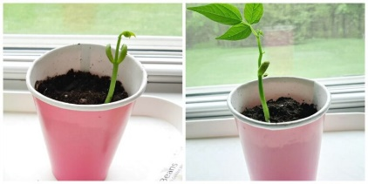  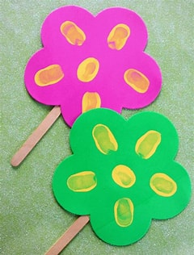  Make your own Easter Egg slime with Indoor Egg Hunt games.  (10 – 17 years)  11:30am – 1:00pm   | Woodside Hub  Upper Ride  Coventry  CV3 – 3GL  *Activities can be amended to meet the interests of children.  *Please notify Development Officer in advance if your child has a food allergy or food intolerance.  Woodside Hub  Upper Ride  Coventry  CV3 – 3GL  *Activities can be amended to meet the interests of children.  *Please notify Development Officer in advance if your child has a food allergy or food intolerance.
Tuesday  31st March 2026 | Easter Egg Painting and Easter Hats.  (5 – 9 years old)  9:30am – 11:00am  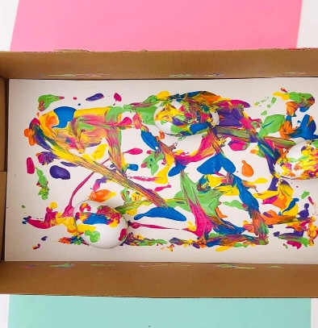  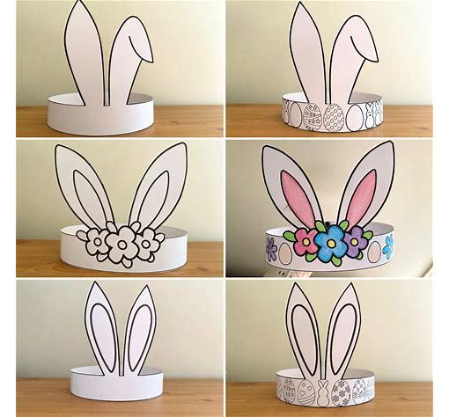  Marble Painting using Shaving Foam and Easter Cone treats.  (10 – 17 years old)  11:30pm – 1:00pm      Short Breaks Family Swim  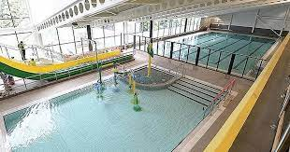  (5 – 11 years old)  2:00pm – 3:00pm | Broad Park House  Logan Road  Coventry  CV2 - 1AG  *Please notify Development Officer in advance if your child has a food allergy or food intolerance.  Broad Park House  Logan Road  Coventry  CV2 - 1AG  *Please notify Development Officer in advance if your child has a food allergy or food intolerance.  Centre AT7  12 Bell Green Road  Coventry  CV6 7GP  Please provide all children and adult’s names on the booking form attending Family Swim (5 – 11 years old).  Children must live within the family household.  Public Pool Rules: All children aged 8 and under must be accompanied by an adult.  Any child that cannot swim must be accompanied by an adult.  Parent/carers must stay at the pool side if not swimming with children.  £1.00 will be required for individual lockers.  If a child has a medical history, please notify the Short Breaks staff member/lifeguard on duty on arrival in case of an emergency.
Wednesday  1st April 2026 | Colour Mixing Art – Make your own Easter Chicks.  (5 – 10 years old)  10:30am to 12:00pm    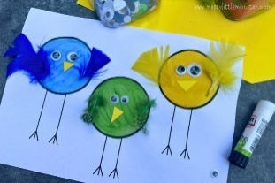  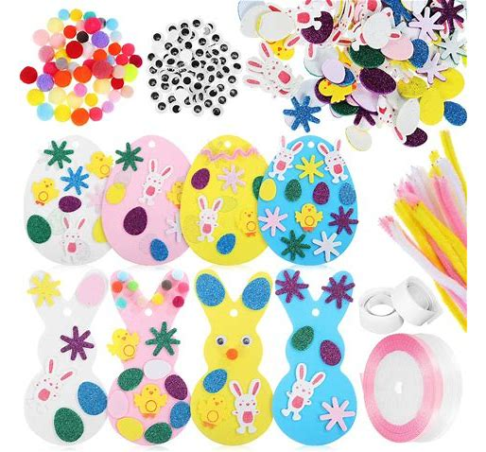  Chess and small board games with board games.  (11 – 17 years old)  12:15pm – 1:45pm  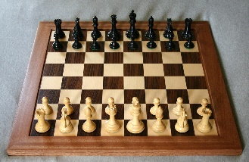  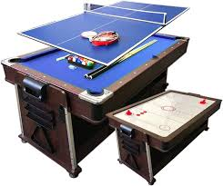 | Mosaic Hub  Jardine Cresent  Coventry  CV4-9PL  Mosaic Hub  Jardine Cresent  Coventry  CV4-9PL
Thursday  2nd April 2026 | Easter Bonnet Decorating and Chocolate Coin Hunt.  (5 – 10 years old)  12:15pm – 1:45pm      Marble Spring Painting with board games and crafts,  (11 – 17 years old)  2:15pm – 3:45pm  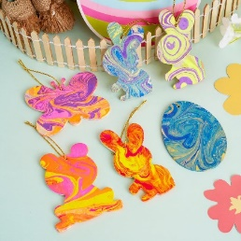 | Families For All  454 Foleshill Road  Foleshill  Coventry  CV6 5LB  Families For All  454 Foleshill Road  Foleshill  Coventry  CV6 5LB  *Please notify Development Officer in advance if your child has a food allergy or food intolerance.
Friday  3rd April 2026 | BANK HOLIDAY | BANK HOLIDAY
WEEK TWO
Monday  6th April 2026 | BANK HOLIDAY | BANK HOLIDAY
Tuesday  7th April 2026 | Sticker crafts with games  (5 – 11 years old)  9:30am – 11:00am  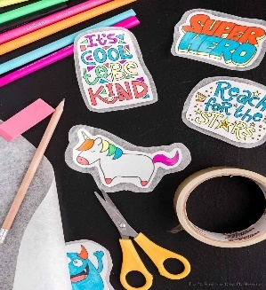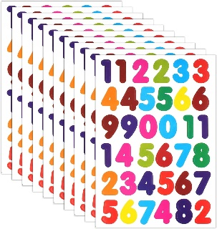  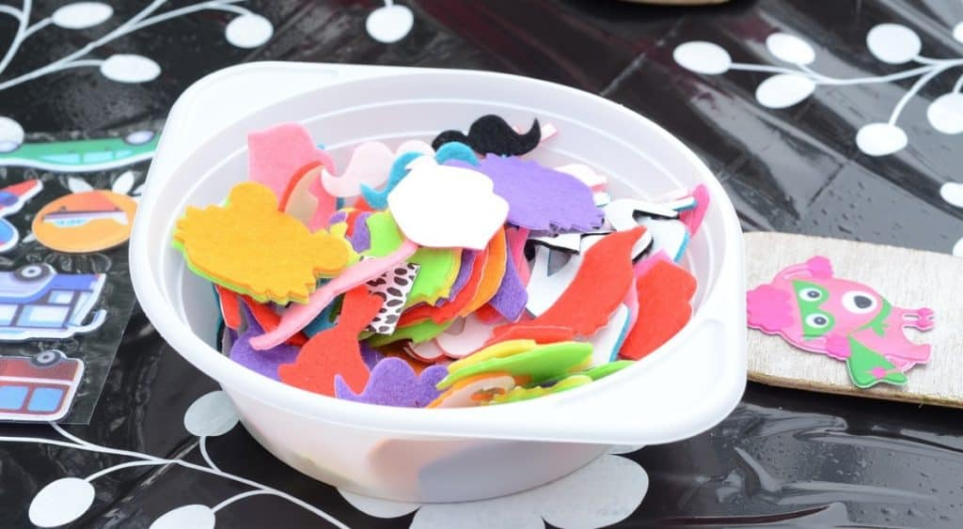  Edible jewellery making with sweet necklaces, shortbread biscuits and mixed treats with games and crafts.  (12 – 17 years old)  11:30am – 1:00pm    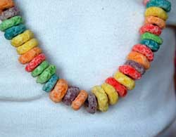  Short Breaks Family Swim  (5 – 11 years old)  2:00pm – 3:00pm | Broad Park House  Logan Road  Coventry  CV2 - 1AG  *Please notify Development Officer in advance if your child has a food allergy or food intolerance.  Broad Park House  Logan Road  Coventry  CV2 - 1AG  *Please notify Development Officer in advance if your child has a food allergy or food intolerance.  Centre AT7  12 Bell Green Road  Coventry  CV6 7GP  Please provide all children and adult’s names on the booking form attending Family Swim (5 – 11 years old).  Children must live within the family household.  Public Pool Rules: All children aged 8 and under must be accompanied by an adult.  Any child that cannot swim must be accompanied by an adult.  Parent/carers must stay at the pool side if not swimming with children.  £1.00 will be required for individual lockers.  If a child has a medical history, please notify the Short Breaks staff member/lifeguard on duty on arrival in case of an emergency.
Wednesday  8th April 2026 | Dinosaur painting with Jungle animal activities and games of interest.  (5 – 11 years old)  10:30am – 12:00pm  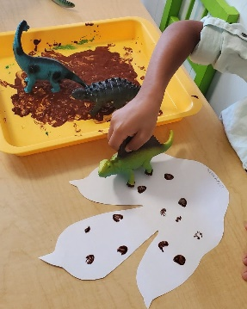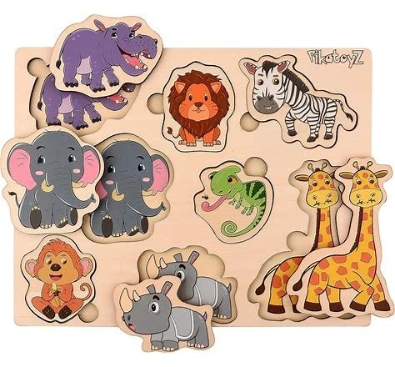  Ping-Pong, Air Hockey and other games.  (12-17 years old)  12:15pm – 1:45pm  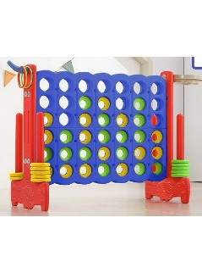 | Mosaic Hub  Jardine Cresent  Coventry  CV4-9PL  Mosaic Hub  Jardine Cresent  Coventry  CV4-9PL
Thursday  9th April 2026 | Egg Carton Caterpillars and Plasticine models.  (5 – 11 years old)  12:15pm – 1:45pm  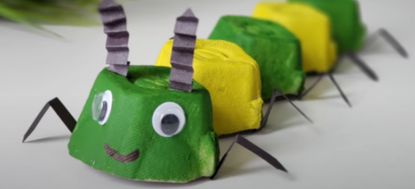  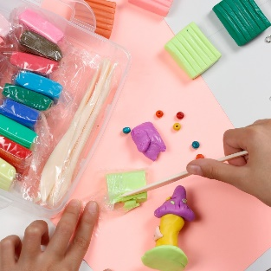  Letter Art using Buttons and Waffle cone fruit salad.  (10 – 17 years old)  2:15pm – 3:45pm   | Families For All  454 Foleshill Road  Foleshill  Coventry  CV6 5LB  *Please notify Development Officer in advance if your child has a food allergy or food intolerance.  Families For All  454 Foleshill Road  Foleshill  Coventry  CV6 5LB  *Please notify Development Officer in advance if your child has a food allergy or food intolerance.
Friday  10th April 2026 | Pizza Bagels, Sensory Room and Role Play  (5 – 11 years old)  9:30am – 11:00am  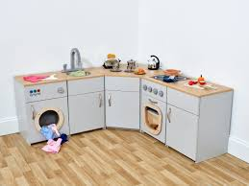    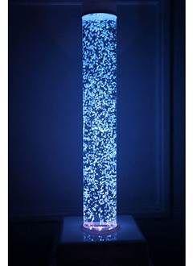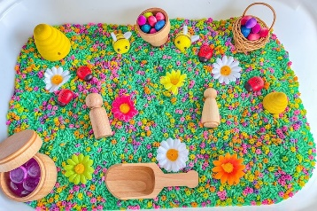  Edible jewellery making, Waffle Cone Fruit Salad and marble Painting.  (12 – 17 years old)  11:30am – 1:00pm   | Woodside Hub  Upper Ride  Coventry  CV3 – 3GL  *Activities can be amended to meet the interests of children.  *Please notify Development Officer in advance if your child has a food allergy or food intolerance.  Woodside Hub  Upper Ride  Coventry  CV3 – 3GL  *Activities can be amended to meet the interests of children.  *Please notify Development Officer in advance if your child has a food allergy or food intolerance.

