

Community Short Breaks October Half-Term Activities 2026
https://www.coventry.gov.uk/special-educational-needs-disabilities/short-breaks
Dear Parents and Carers
Community Short Breaks provide activities for children living in Coventry with disabilities aged 5 – 17 years old.

The Booking Line for October Half Term Activities will be open from Monday 28th September 2026 (9:00am) until Friday 2nd October 2026 (4:00pm).

Please call 024 76 975464 to book by phone (available Monday to Friday from 9:00am – 4:00pm).

Bookings can also be made online at www.coventry.gov.uk/bookashortbreak during this period.

Bookings either online or by telephone that are outside of the dates and times stated will not be processed.

Please note places in activities are limited; you will be able to select one venue for your child or young person to attend across the week as part of your ‘activity’, you can also select one venue as a second option if the first choice is not available. If activities are not required, please select ‘not required’.

Activities will be delivered for children and young people aged 5 – 11 years old or 12 -17 years old registered with Community Short Breaks unless stated otherwise. Please find this information below the named activity.

If your child or young person has never attended a Community Short Breaks activity, we will require a completed Short Breaks passport and DLA letter or supporting letter.

An induction visit is required prior to attending an activity this will be arranged by Development Officer. Please let us know at the point of booking if you require this information.

Please note we cannot support siblings in activities unless stated.
Please Read: Important information about activities and venues

Date | Activity | Venue
WEEK ONE
Monday  26th October 2026 | Autumn Sensory Play  Pumpkin Soup Story themed activities  5 – 7 years old  9:30am – 11:00am  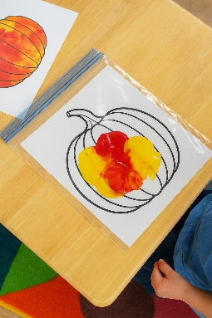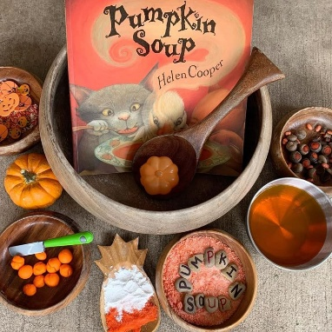    Baking Pumpkin Bread  with ‘Pick your own Pumpkin’ (from the garden) and Autumn treats.  8 – 13 years old  11:30am – 1:00pm     | Woodside Hub  Upper Ride  Coventry  CV3 – 3GL  *Please notify Development Officer in advance if your child has a food allergy or food intolerance.  Woodside Hub  Upper Ride  Coventry  CV3 – 3GL  *Please notify Development Officer in advance if your child has a food allergy or food intolerance.
Tuesday  27th October 2026 | Indoor Camping Imaginative play with crafts and games.  (5 – 7 years old)  9:30am – 11:00am  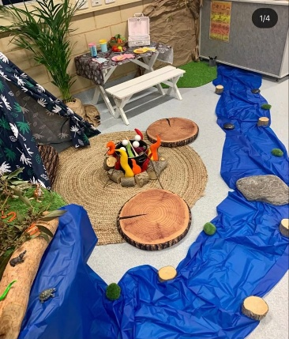  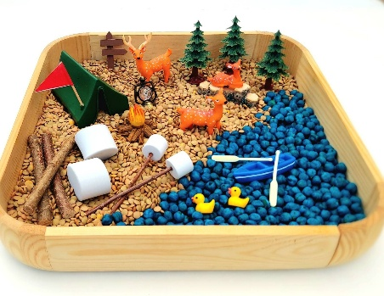  Indoor Camping - Smores and Hot Chocolate  Explore Nature outdoors.  (8 – 11 years old)  11:30am – 1:00pm    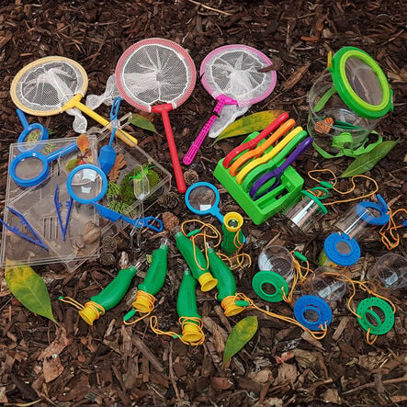  Camping Theme with Smores and Hot  Chocolate  (12 – 17 years old)  1:30pm – 3:00pm  Short Breaks Family Swim  (5 – 11 years old)  2:00pm – 3:00pm  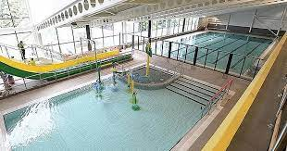 | Broad Park House  Logan Road  Coventry  CV2 - 1AG  *Please notify Development Officer in advance if your child has a food allergy or food intolerance.  Broad Park House  Logan Road  Coventry  CV2 - 1AG  *Please notify Development Officer in advance if your child has a food allergy or food intolerance.  Broad Park House  Logan Road  Coventry  CV2 - 1AG  *Please notify Development Officer in advance if your child has a food allergy or food intolerance.  Centre AT7  12 Bell Green Road  Coventry  CV6 7GP  Please provide all children and adult’s names on the booking form attending Family Swim (5 – 11 years old).  Children must live within the family household.  Public Pool Rules: All children aged 8 and under must be accompanied by an adult.  Any child that cannot swim must be accompanied by an adult.  Parent/carers must stay at the pool side if not swimming with children.  £1.00 will be required for individual lockers.  If a child has a medical history, please notify the Short Breaks staff member/lifeguard on duty on arrival in case of an emergency.
Wednesday  28th October 2026 | Autumn inspired snack and sensory play  (5 – 7 years old)  9:00am to 10:30am  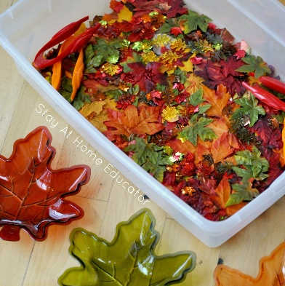  Autumn water play, sensory play with Autumn inspired snack.  (8 – 11 years old)  10:45am to 12:15pm  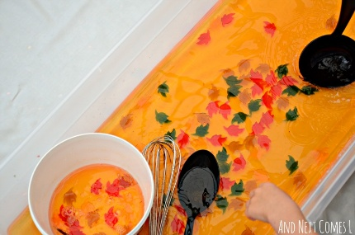  Pool, Ping-Pong with crafts and games and Autumn inspired snack.  (12 – 17 years old)  12:30pm – 2:00pm   | Mosaic Hub  Jardine Cresent  Coventry  CV4-9PL  *Please notify Development Officer in advance if your child has a food allergy or food intolerance.  Mosaic Hub  Jardine Cresent  Coventry  CV4-9PL  *Please notify Development Officer in advance if your child has a food allergy or food intolerance.  Mosaic Hub  Jardine Cresent  Coventry  CV4-9PL  *Please notify Development Officer in advance if your child has a food allergy or food intolerance.
Thursday  29th October 2026 | Vegetable decorating and monster biscuit decorating with Arts and Crafts.  (5 – 10 years old)  12:15pm – 1:45pm      Apple coloured Slime  Popcorn making with hot chocolate and marsh mellows  (11 – 17 years old)  2:15pm – 3:45pm     | Families For All  454 Foleshill Road  Foleshill  Coventry  CV6 5LB  Families For All  454 Foleshill Road  Foleshill  Coventry  CV6 5LB  - Please notify Development Officer in advance if your child has a food allergy or food intolerance.
Friday  30th October 2026 | Apple Turnovers using puff-pastry and Autumn crafts.  (5 - 11 years old)  9:30am – 11:00am    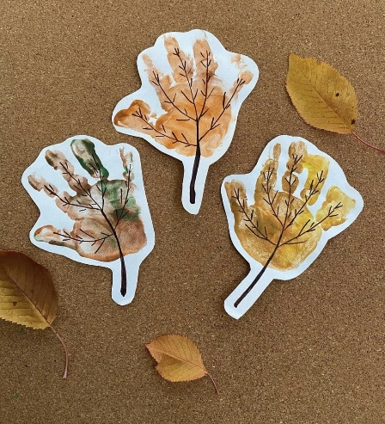  Apple Turnovers using puff pastry or fresh pastry and clay leaf prints.  (12 -17 years old)  11:30am – 1:00pm   | Pathways Hub  Lawrence Saunders Road  Coventry  CV6 – 5LB  - Please notify Development Officer in advance if your child has a food allergy or food intolerance.  Pathways Hub  Lawrence Saunders Road  Coventry  CV6 – 5LB  - Please notify Development Officer in advance if your child has a food allergy or food intolerance.

