

Community Short Breaks Summer Activities 2026
https://www.coventry.gov.uk/special-educational-needs-disabilities/short-breaks
Dear Parents and Carers
Community Short Breaks provide activities for children living in Coventry with disabilities aged 5 – 17 years old.

The Booking Line for Summer Activities will be open from Monday 15th June 2026 until Friday 19th June 2026 (9:00am to 4:00pm).
.
Please call 024 76 975464 to book by phone (available Monday to Friday from 9:00am – 4:00pm).

Bookings can also be made online at www.coventry.gov.uk/bookashortbreak during this period.

Bookings either online or by telephone that are outside of the dates and times stated will not be processed.

Please note places in activities are limited; you will be able to select one venue for your child or young person to attend across the week as part of your ‘activity’, you can also select one venue as a second option if the first choice is not available. If activities are not required, please select ‘not required’.

Activities will be delivered for children and young people aged 5 – 11 years old or 12 -17 years old registered with Community Short Breaks unless stated otherwise. Please find this information below the named activity.

If your child or young person has never attended a Community Short Breaks activity, we will require a completed Short Breaks passport and DLA letter or supporting letter.
An induction visit is required prior to attending an activity this will be arranged by Development Officer. Please let us know at the point of booking if you require this information.

Please note we cannot support siblings in activities unless stated.
Please Read: Important information about activities and venues

Date | Activity | Venue
WEEK ONE
Tuesday  21st July 2026 | Jungle Themed Crafts  (5 – 11 years old)  11:00am – 12:30pm    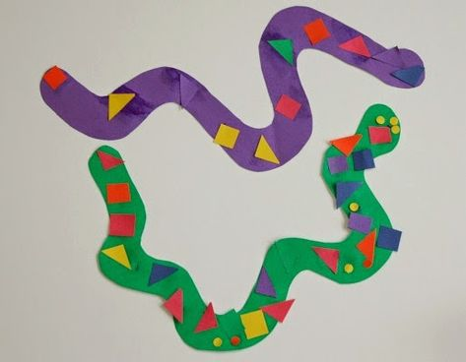  Animal Art Magnets with Board Games and treats  (12 – 17 years old)  1:00pm – 2:30pm  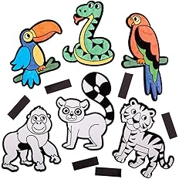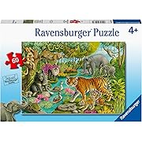  Short Breaks Family Swim  (5 – 11 years old)  2:00pm – 3:00pm  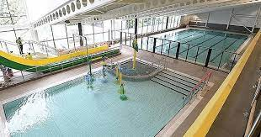 | Broad Park House  Logan Road  Coventry  CV2 - 1AG  *Please notify Development Officer in advance if your child has a food allergy or food intolerance.  Broad Park House  Logan Road  Coventry  CV2 - 1AG  *Please notify Development Officer in advance if your child has a food allergy or food intolerance.  Centre AT7  12 Bell Green Road  Coventry  CV6 7GP  Please provide all children and adult’s names on the booking form attending Family Swim (5 – 11 years old).  Children must live within the family household.  Public Pool Rules: Each child aged 8 and under must be accompanied by an adult.  Any child that cannot swim must be accompanied by an adult.  Parent/carers must stay at the pool side if not swimming with children.  £1.00 will be required for individual lockers.  If a child has a medical history, please notify the Short Breaks staff member/lifeguard on duty on arrival in case of an emergency.  Please bring your own floating devices (armbands) as these are not provided.
Wednesday  22nd July 2026 | Dear Zoo Sensory Bin with activities, music and games.  (5 – 11 years old)  10:45am to 12:15pm    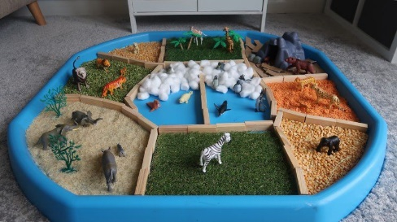  Donkey Kong with Pool Table, Ping-Pong, Connect 4 and various board games.  (12 – 17 years old)  12:30pm – 2:00pm  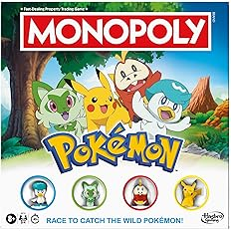    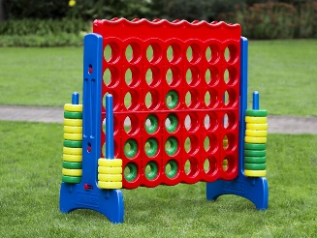 | Mosaic Hub  Jardine Cresent  Coventry  CV4-9PL  *Please notify Development Officer in advance if your child has a food allergy or food intolerance.  Mosaic Hub  Jardine Cresent  Coventry  CV4-9PL  *Please notify Development Officer in advance if your child has a food allergy or food intolerance.
Thursday  23rd July 2026 | Animal Bingo with prizes, Animal themed crafts and games  (5 – 11 years old)  12:15pm – 1:45pm  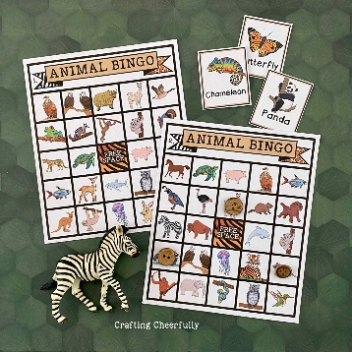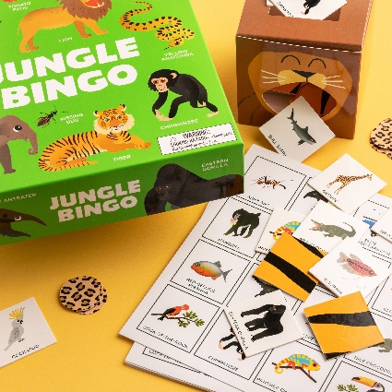    Create your own animal themed snack bags  (12 – 17 years old)  2:15pm – 3:45pm  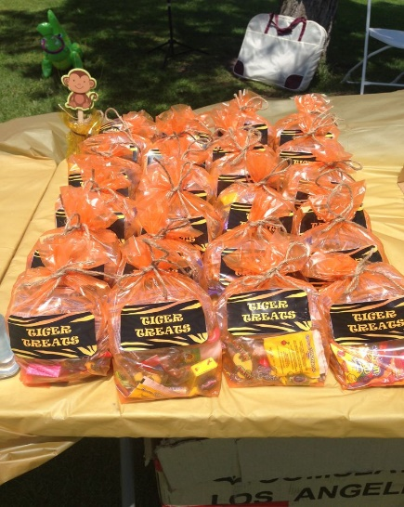 | Families For All  454 Foleshill Road  Foleshill  Coventry  CV6 5LB  - Please notify Development Officer in advance if your child has a food allergy or food intolerance.  Families For All  454 Foleshill Road  Foleshill  Coventry  CV6 5LB  - Please notify Development Officer in advance if your child has a food allergy or food intolerance.
Friday  24th July 2026 | Jungle themed Binoculars with animal arts and crafts and games.  (5 - 11 years old)  9:30am – 11:00am    Animal themed pizza making  (12 -17 years old)  11:30am – 1:00pm     | Pathways Hub  Lawrence Saunders Road  Coventry  CV6-1HD  - Please notify Development Officer in advance if your child has a food allergy or food intolerance.  Pathways Hub  Lawrence Saunders Road  Coventry  CV6-1HD  - Please notify Development Officer in advance if your child has a food allergy or food intolerance.
WEEK TWO
Monday  27th July 2026 | Bake your own Cake with Sensory Room  (Arts and crafts and toys of interest)  (5 – 11 years old)  9:30am – 11:00am  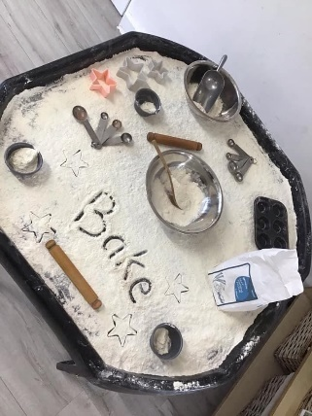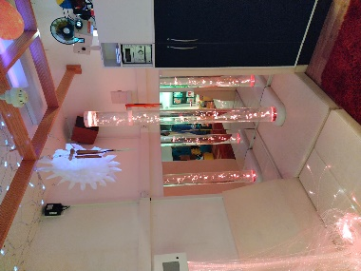  Make your own Sand Foam – Create your own flavoured ice-creams.  (with board games and crafts)  (12 – 17 years)  11:30am – 1:00pm  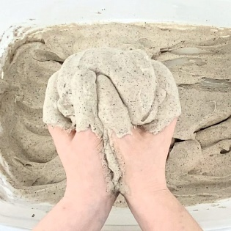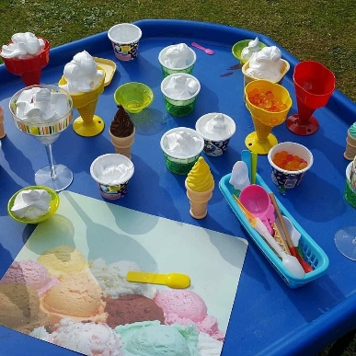 | Woodside Family Hub  Upper Ride  Coventry  CV3 – 3GL  - Please notify Development Officer in advance if your child has a food allergy or food intolerance.  - Messy activity – please wear play clothes that can get messy.  Woodside Family Hub  Upper Ride  Coventry  CV3 – 3GL  - Please notify Development Officer in advance if your child has a food allergy or food intolerance.
Tuesday  28th July 2026 | Numbers with Wet Sand  (Arts & Crafts with games)  (5 – 11 years old)  11:00am – 12:30pm  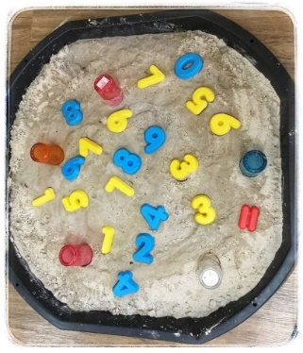  Plastic Sand Art Bottles Or Keyrings  (12 – 17 years old)  1:00pm – 2:30pm      Short Breaks Family Swim  (5 – 11 years old)  2:00pm – 3:00pm | Broad Park House  Logan Road  Coventry  CV2 - 1AG  *Please notify Development Officer in advance if your child has a food allergy or food intolerance.  Broad Park House  Logan Road  Coventry  CV2 - 1AG  *Please notify Development Officer in advance if your child has a food allergy or food intolerance.  Centre AT7  12 Bell Green Road  Coventry  CV6 7GP  Please provide all children and adult’s names on the booking form attending Family Swim (5 – 11 years old).  Children must live within the family household.  Public Pool Rules: Each child aged 8 and under must be accompanied by an adult.  Any child that cannot swim must be accompanied by an adult.  Parent/carers must stay at the pool side if not swimming with children.  £1.00 will be required for individual lockers.  If a child has a medical history, please notify the Short Breaks staff member/lifeguard on duty on arrival in case of an emergency.  Please bring your own floating devices (armbands) as these are not provided.
Wednesday 29th July 2026 | Edible Sand with Sea Creatures  Arts and Crafts with Sensory Room.  (5 – 11 years old)  10:45am – 12:15pm  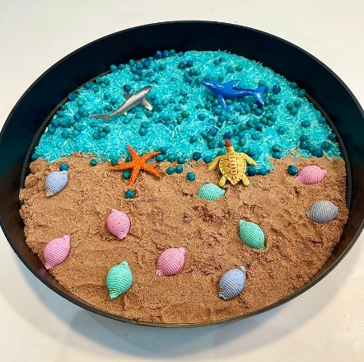  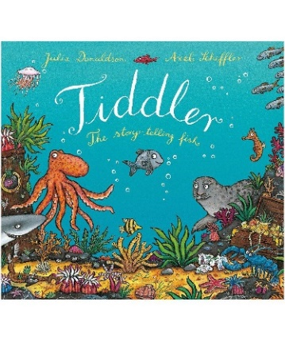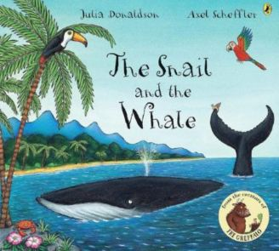  Sand Art  With Donkey Kong, Pool Table, Ping-Pong, Connect 4 and various board games.  (12 – 17 years old)  12:30pm – 2:00pm   | Mosaic Hub  Jardine Cresent  Coventry  CV4-9PL  *Please notify Development Officer in advance if your child has a food allergy or food intolerance.  - Edible Sand made with blended cereal.  Mosaic Hub  Jardine Cresent  Coventry  CV4-9PL  *Please notify Development Officer in advance if your child has a food allergy or food intolerance.
Thursday  30th July 2026 | Sand Clay Hand-print keepsake with play-dough equipment.  (Arts and Crafts and Games)  (5 – 11 years old)  12:15pm – 1:45pm    Potion bottles - glitter sand, oil and water.  (Arts and Crafts and Board Games)  (12 – 17 years old)  2:15pm – 3:45pm  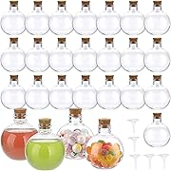 | Families For All  454 Foleshill Road  Foleshill  Coventry  CV6 5LB  - Please notify Development Officer in advance if your child has a food allergy or food intolerance.  Families For All  454 Foleshill Road  Foleshill  Coventry  CV6 5LB  - Please notify Development Officer in advance if your child has a food allergy or food intolerance.
Friday  31st July 2026 | Let’s Make Sandcastles  (9:30am – 11:00am)  5 – 11 years old  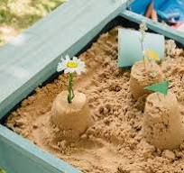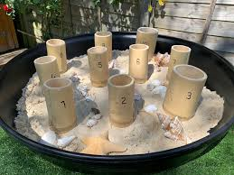  Sand Bottles  (12 – 17 years old)  11:30am – 1:00pm   | Pathways Hub  Lawrence Saunders Road  Coventry  CV6-1HD  - Please notify Development Officer in advance if your child has a food allergy or food intolerance.  Pathways Hub  Lawrence Saunders Road  Coventry  CV6-1HD  - Please notify Development Officer in advance if your child has a food allergy or food intolerance.
WEEK THREE
Monday  3rd August 2026 | Finger Painting with Sensory play and Craft Activities.  (5 – 11 years old)  9:30am – 11:00am    Shell Painting with Craft Activities.  (12 – 17 years old)  11:30am – 1:00pm  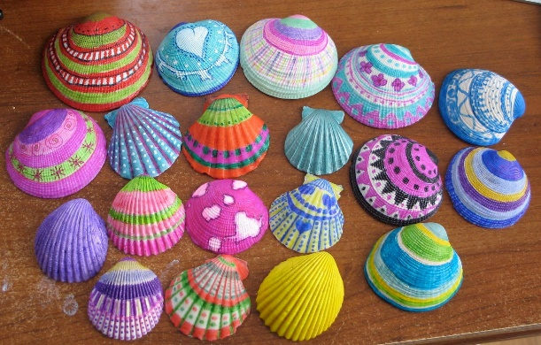 | Woodside Family Hub  Upper Ride  Coventry  CV3 – 3GL  - Please notify Development Officer in advance if your child has a food allergy or food intolerance.  - Messy activity – please wear play clothes that can get messy.  Woodside Family Hub  Upper Ride  Coventry  CV3 – 3GL  - Please notify Development Officer in advance if your child has a food allergy or food intolerance.  - Messy activity – please wear play clothes that can get messy.
Tuesday  4th August 2026 | Letter Art and Music Rhymes  (5 – 11 years old)  11:00am – 12:30pm  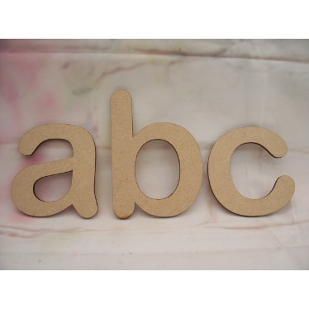  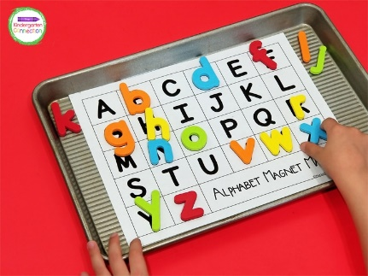  Pokémon, Mario and K-Pop  (12 – 17 years old)  1:00pm – 2:30pm  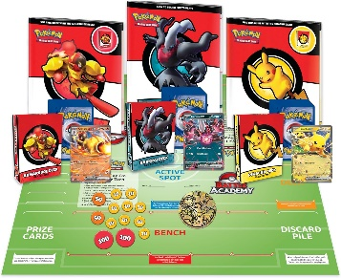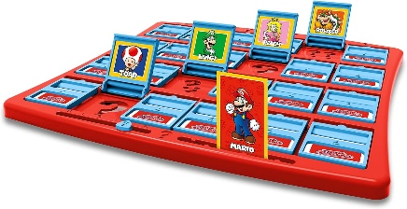  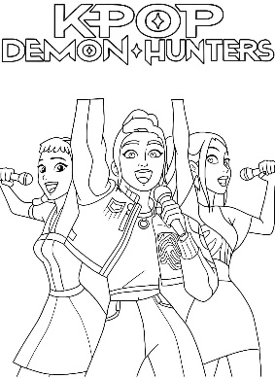  Short Breaks Family Swim  (5 – 11 years old)  2:00pm – 3:00pm | Broad Park House  Logan Road  Coventry  CV2 - 1AG  *Please notify Development Officer in advance if your child has a food allergy or food intolerance.  Broad Park House  Logan Road  Coventry  CV2 - 1AG  *Please notify Development Officer in advance if your child has a food allergy or food intolerance.  Centre AT7  12 Bell Green Road  Coventry  CV6 7GP  Please provide all children and adult’s names on the booking form attending Family Swim (5 – 11 years old).  Children must live within the family household.  Public Pool Rules: Each child aged 8 and under must be accompanied by an adult.  Any child that cannot swim must be accompanied by an adult.  Parent/carers must stay at the pool side if not swimming with children.  £1.00 will be required for individual lockers.  If a child has a medical history, please notify the Short Breaks staff member/lifeguard on duty on arrival in case of an emergency.  Please bring your own floating devices (armbands) as these are not provided.
Wednesday  5th August 2026 | Stone Painting with Sensory Play and craft activities.  (5 – 11 years old)  10:45am – 12:15pm  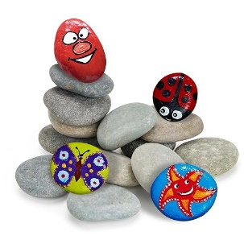  Pool Table, Ping-Pong, Connect 4 and various board games.  (12 – 17 years old)  12:30pm – 2:00pm | Mosaic Hub  Jardine Cresent  Coventry  CV4-9PL  *Please notify Development Officer in advance if your child has a food allergy or food intolerance.  Mosaic Hub  Jardine Cresent  Coventry  CV4-9PL  *Please notify Development Officer in advance if your child has a food allergy or food intolerance.
Thursday  6th August 2026 | Badge Making  (5 – 11 years old)  12:15pm – 1:45pm  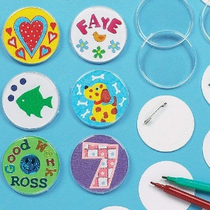  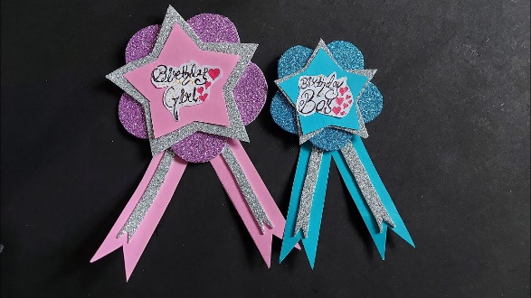  Hama Beads and bracelet making  (12 – 17 years old)  2:15pm – 3:45pm  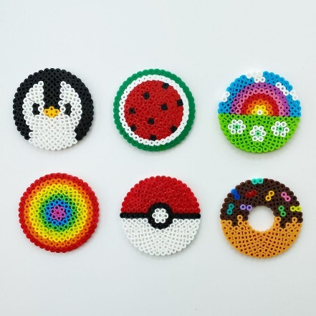  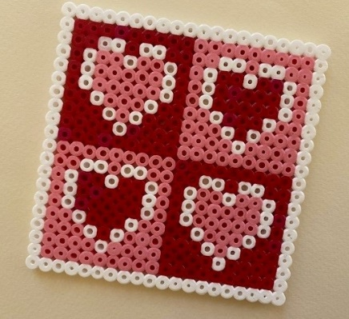 | Families For All  454 Foleshill Road  Foleshill  Coventry  CV6 5LB  - Please notify Development Officer in advance if your child has a food allergy or food intolerance.  Families For All  454 Foleshill Road  Foleshill  Coventry  CV6 5LB  - Please notify Development Officer in advance if your child has a food allergy or food intolerance.
Friday  7th August 2026 | Decorate Your Own Fan  (5 – 11 years old)  9:30am – 11:00am  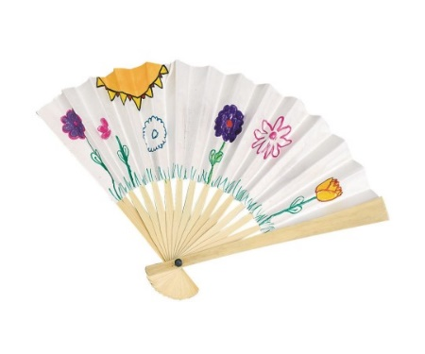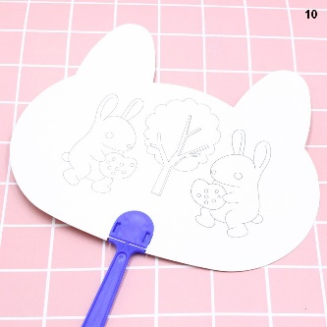  Beaded Keychains with Arts and Crafts and Games.  (12 – 17 years old)  11:30am – 1:00pm   | Pathways Hub  Lawrence Saunders Road  Coventry  CV6-1HD  - Please notify Development Officer in advance if your child has a food allergy or food intolerance.  Pathways Hub  Lawrence Saunders Road  Coventry  CV6-1HD  - Please notify Development Officer in advance if your child has a food allergy or food intolerance.
WEEK FOUR
Monday  10th August 2026 | Growing Activity - Planting Seeds  with Sensory Room, outdoor garden games and Crafts,  (5 – 11 years old)  9:30am – 11:00am  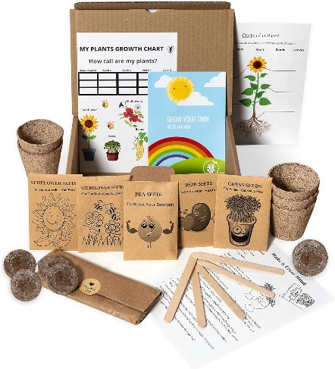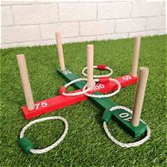  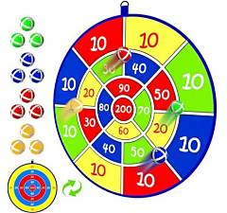  Plant Pot Decorating and planting  (12 – 17 years old)  11:30am – 1:00pm   | Woodside Family Hub  Upper Ride  Coventry  CV3 – 3GL  - Please notify Development Officer in advance if your child has a food allergy or food intolerance.  - Messy activity – please wear play clothes that can get messy.  Woodside Family Hub  Upper Ride  Coventry  CV3 – 3GL  - Please notify Development Officer in advance if your child has a food allergy or food intolerance.  Messy activity – please wear play clothes that can get messy.
Tuesday  11th August 2026 | Summer Vegetable Soup (chopping vegetables)  with Arts and Crafts and play activities.  (5 – 11 years old)  11:00am – 12:30pm    Summer Vegetable Soup (chopping vegetables)  with Arts and Crafts and play activities.  (12 – 17 years old)  1:00pm – 2:30pm  Short Breaks Family Swim  (5 – 11 years old)  2:00pm – 3:00pm | Broad Park House  Logan Road  Coventry  CV2 - 1AG  *Please notify Development Officer in advance if your child has a food allergy or food intolerance.  Broad Park House  Logan Road  Coventry  CV2 - 1AG  *Please notify Development Officer in advance if your child has a food allergy or food intolerance.  Centre AT7  12 Bell Green Road  Coventry  CV6 7GP  Please provide all children and adult’s names on the booking form attending Family Swim (5 – 11 years old).  Children must live within the family household.  Public Pool Rules: Each child aged 8 and under must be accompanied by an adult.  Any child that cannot swim must be accompanied by an adult.  Parent/carers must stay at the pool side if not swimming with children.  £1.00 will be required for individual lockers.  If a child has a medical history, please notify the Short Breaks staff member/lifeguard on duty on arrival in case of an emergency.  Please bring your own floating devices (armbands) as these are not provided.
Wednesday  12th August 2026 | Growing Sensory Bin using Edible cereal  Art and Crafts, Sensory Room and Music & Rhymes.  (5 – 11 years old)  10:45am – 12:15pm  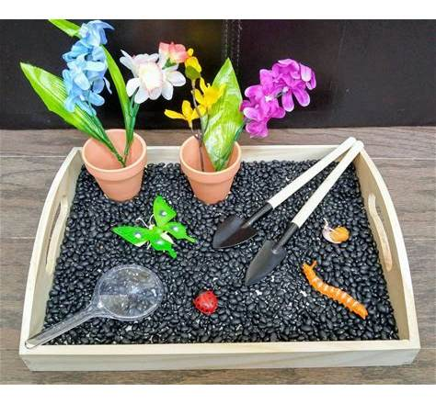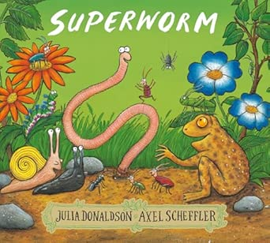  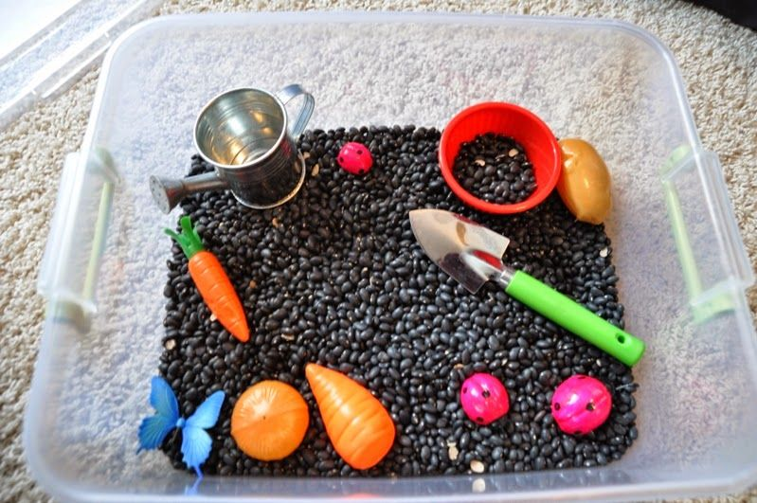  Pool Table, Ping-Pong and various board games.  (12 – 17 years old)  12:30pm – 2:00pm  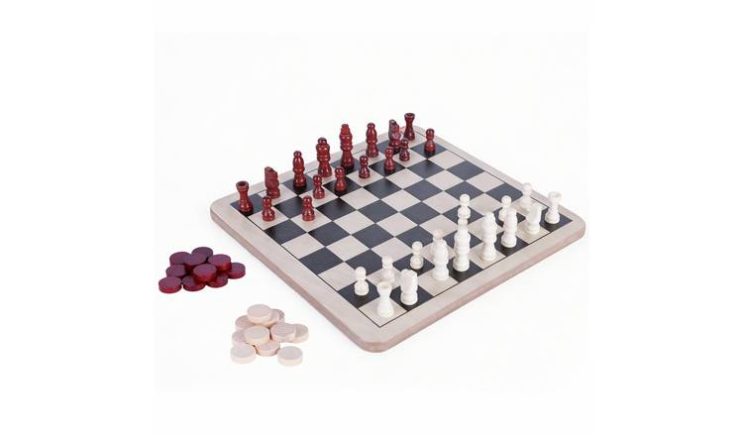 | Mosaic Hub  Jardine Cresent  Coventry  CV4-9PL  *Please notify Development Officer in advance if your child has a food allergy or food intolerance.  Mosaic Hub  Jardine Cresent  Coventry  CV4-9PL  *Please notify Development Officer in advance if your child has a food allergy or food intolerance.
Thursday  13th August 2026 | Growing Vegetables with crafts and games  (5 – 11 years old)  12:15pm – 1:45pm  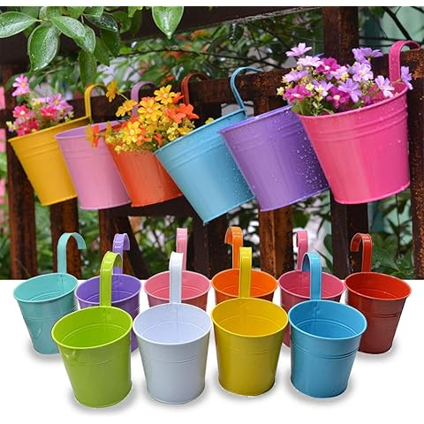  Soup using a Soup Maker  and Fresh Vegetables  (with Crafts and Games)  (12 – 17 years)  2:15pm – 3:45pm  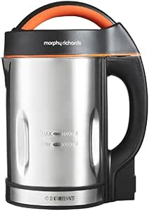  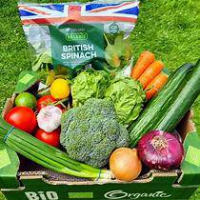 | Families For All  454 Foleshill Road  Foleshill  Coventry  CV6 5LB  - Please notify Development Officer in advance if your child has a food allergy or food intolerance.  Families For All  454 Foleshill Road  Foleshill  Coventry  CV6 5LB  - Please notify Development Officer in advance if your child has a food allergy or food intolerance.
Friday  14th August 2026 | Growing activity using seeds and Garden themed Sensory Bin.  (5 – 11 years old)  9:30am – 11:00am  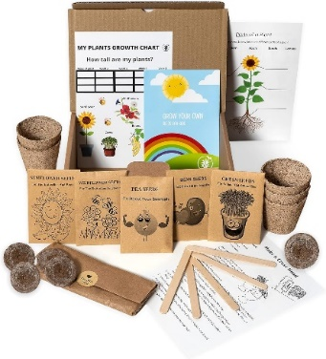  Summer Vegetable Soup (chopping vegetables)  (12 – 17 years old)  11:30am – 1:00pm | Pathways Hub  Lawrence Saunders Road  Coventry  CV6-1HD  - Please notify Development Officer in advance if your child has a food allergy or food intolerance.  Pathways Hub  Lawrence Saunders Road  Coventry  CV6-1HD  - Please notify Development Officer in advance if your child has a food allergy or food intolerance.
WEEK FIVE
Monday  17th August 2026 | Corn Flour (GLOOP) with icing piping bags  (5 – 11 years old)  9:30am – 11:00am      Marble Painting using oils  (12 – 17 years old)  11:30am – 1:00pm   | Woodside Family Hub  Upper Ride  Coventry  CV3 – 3GL  - Please notify Development Officer in advance if your child has a food allergy or food intolerance.  - Messy activity – please wear play clothes that can get messy.  Woodside Family Hub  Upper Ride  Coventry  CV3 – 3GL  - Please notify Development Officer in advance if your child has a food allergy or food intolerance.  - Messy activity – please wear play clothes that can get messy.
Tuesday  18th August 2026 | Clear glue Art and paints  (with games and baking)  (5 – 11 years old)  11:00am – 12:30pm    Glue Gun activity with supervision  (crafts and games)  (12 – 17 years old)  1:00pm – 2:30pm  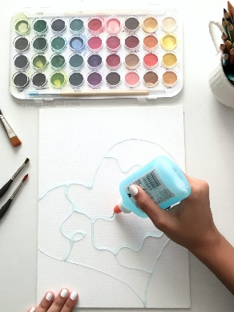    Short Breaks Family Swim  (5 – 11 years old)  2:00pm – 3:00pm | Broad Park House  Logan Road  Coventry  CV2 - 1AG  *Please notify Development Officer in advance if your child has a food allergy or food intolerance.  Broad Park House  Logan Road  Coventry  CV2 - 1AG  *Please notify Development Officer in advance if your child has a food allergy or food intolerance.  Centre AT7  12 Bell Green Road  Coventry  CV6 7GP  Please provide all children and adult’s names on the booking form attending Family Swim (5 – 11 years old).  Children must live within the family household.  Public Pool Rules: Each child aged 8 and under must be accompanied by an adult.  Any child that cannot swim must be accompanied by an adult.  Parent/carers must stay at the pool side if not swimming with children.  £1.00 will be required for individual lockers.  If a child has a medical history, please notify the Short Breaks staff member/lifeguard on duty on arrival in case of an emergency.  Please bring your own floating devices (armbands) as these are not provided.
Wednesday  19th August 2026 | Shaving Foam and Glue with Paints  (5 – 11 years old)  10:45am – 12:15pm    Canvas Art  (12 – 17 years old)  12:30pm – 2:00pm  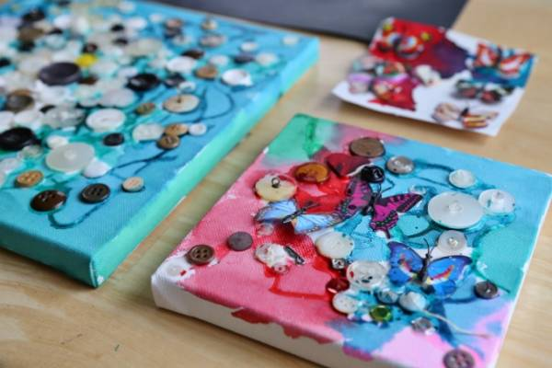 | Mosaic Hub  Jardine Cresent  Coventry  CV4-9PL  *Please notify Development Officer in advance if your child has a food allergy or food intolerance.  Mosaic Hub  Jardine Cresent  Coventry  CV4-9PL  *Please notify Development Officer in advance if your child has a food allergy or food intolerance.
Thursday  20th August 2026 | Sand and Glue Art  (5 – 11 years old)  12:15pm – 1:45pm  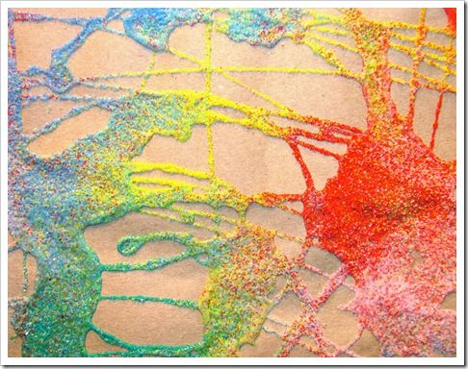  Fabric Art using Fabric Glue  (12 – 17 years old)  2:15pm – 3:45pm  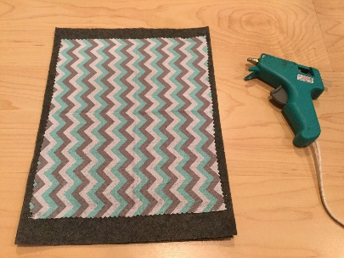 | Families For All  454 Foleshill Road  Foleshill  Coventry  CV6 5LB  - Please notify Development Officer in advance if your child has a food allergy or food intolerance.  Families For All  454 Foleshill Road  Foleshill  Coventry  CV6 5LB  - Please notify Development Officer in advance if your child has a food allergy or food intolerance.
Friday  21st August 2026 | Corn Flour (GLOOP)  (5 – 11 years old)  9:30am – 11:00am  Sand and Glue art  (12 – 17 years old)  11:30am – 1:00pm | Pathways Hub  Lawrence Saunders Road  Coventry  CV6-1HD  - Please notify Development Officer in advance if your child has a food allergy or food intolerance.  Pathways Hub  Lawrence Saunders Road  Coventry  CV6-1HD  - Please notify Development Officer in advance if your child has a food allergy or food intolerance.
WEEK SIX
Monday  24th August 2026 | Sensory Room Den Making  (5 – 11 years old)  9:30am – 11:00am)  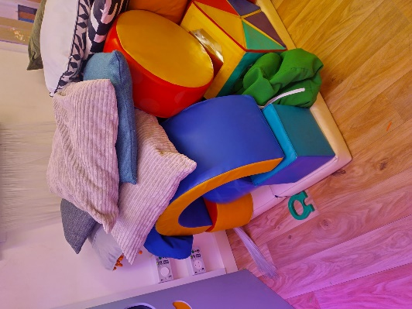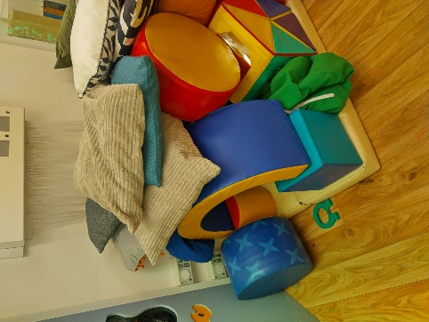  Lego Making with games  (12 – 17 years old)  11:30am – 1:00pm  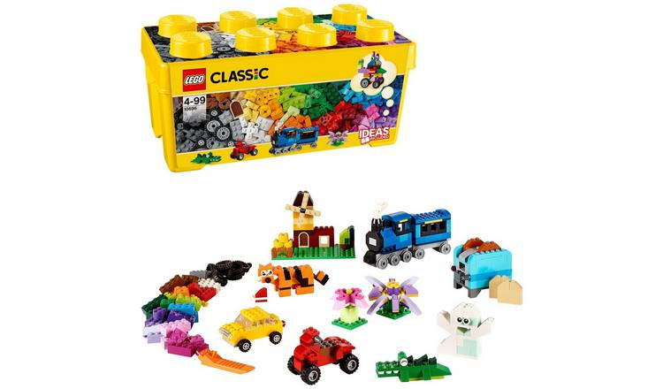 | Woodside Family Hub  Upper Ride  Coventry  CV3 – 3GL  - Please notify Development Officer in advance if your child has a food allergy or food intolerance.  - Messy activity – please wear play clothes that can get messy.  Woodside Family Hub  Upper Ride  Coventry  CV3 – 3GL  - Please notify Development Officer in advance if your child has a food allergy or food intolerance.  - Messy activity – please wear play clothes that can get messy.
Tuesday  25th August 2026 | Number Blocks and Magnets  (5 – 11 years old)  11:00am – 12:30pm  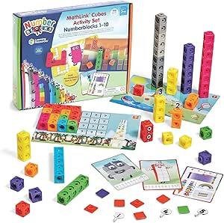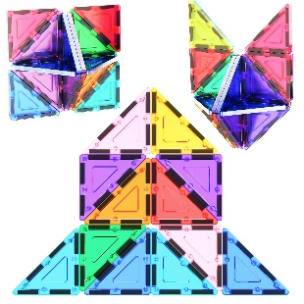  Pineapple Upside Down Cake  (12 – 17 years old)  1:00pm – 2:30pm    Short Breaks Family Swim  (5 – 11 years old)  2:00pm – 3:00pm | Broad Park House  Logan Road  Coventry  CV2 - 1AG  *Please notify Development Officer in advance if your child has a food allergy or food intolerance.  Broad Park House  Logan Road  Coventry  CV2 - 1AG  *Please notify Development Officer in advance if your child has a food allergy or food intolerance.  Centre AT7  12 Bell Green Road  Coventry  CV6 7GP  Please provide all children and adult’s names on the booking form attending Family Swim (5 – 11 years old).  Children must live within the family household.  Public Pool Rules: Each child aged 8 and under must be accompanied by an adult.  Any child that cannot swim must be accompanied by an adult.  Parent/carers must stay at the pool side if not swimming with children.  £1.00 will be required for individual lockers.  If a child has a medical history, please notify the Short Breaks staff member/lifeguard on duty on arrival in case of an emergency.  Please bring your own floating devices (armbands) as these are not provided.
Wednesday  26th August 2026 | Sea Creature activities  (5 – 11 years old)  10:45am – 12:15pm  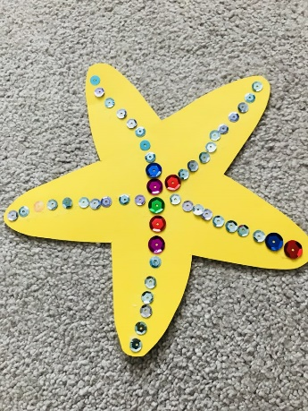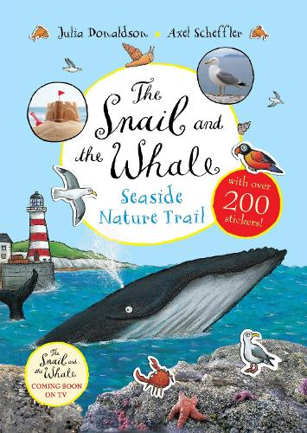  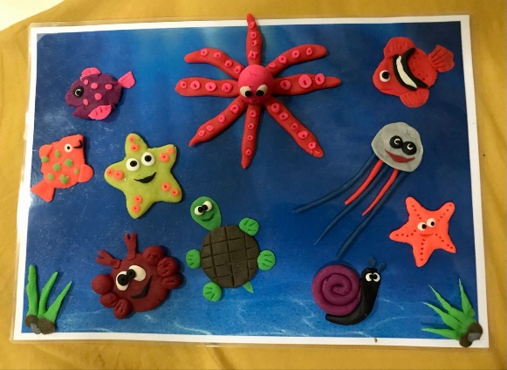  Ping-Pong, Air Hockey and Board Games  (12- 17 years old)  12:30pm – 2:00pm | Mosaic Hub  Jardine Cresent  Coventry  CV4-9PL  *Please notify Development Officer in advance if your child has a food allergy or food intolerance.  Mosaic Hub  Jardine Cresent  Coventry  CV4-9PL  *Please notify Development Officer in advance if your child has a food allergy or food intolerance.
Thursday  27th August 2026 | Music and Dance (with musical chairs)  (5 – 11 years old)  12:15pm – 1:45pm    Sand Slime with crafts and games.  2:15pm – 3:45pm  (12 – 17 years old) | Families For All  454 Foleshill Road  Foleshill  Coventry  CV6 5LB  - Please notify Development Officer in advance if your child has a food allergy or food intolerance.  Families For All  454 Foleshill Road  Foleshill  Coventry  CV6 5LB  - Please notify Development Officer in advance if your child has a food allergy or food intolerance.
Friday  28th August 2026 | Badge Making  (5 – 11 years old)  9:30am – 11:00am    Indoor games  (12 – 17 years old)  11:30am – 1:00pm  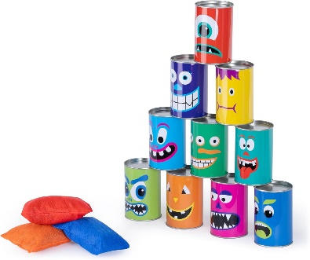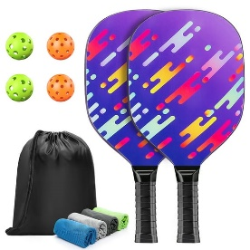  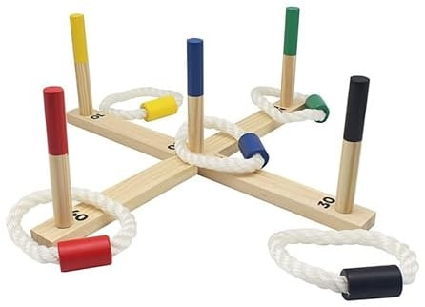 | Pathways Hub  Lawrence Saunders Road  Coventry  CV6-1HD  - Please notify Development Officer in advance if your child has a food allergy or food intolerance.  Pathways Hub  Lawrence Saunders Road  Coventry  CV6-1HD  - Please notify Development Officer in advance if your child has a food allergy or food intolerance.

