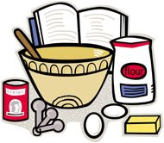
How to make a perfect day
Let’s think about how to make a perfect day for ourselves.

What ingredients would you need for a perfect day?

Imagine you have just had the most perfect day…
Describe what happened!

