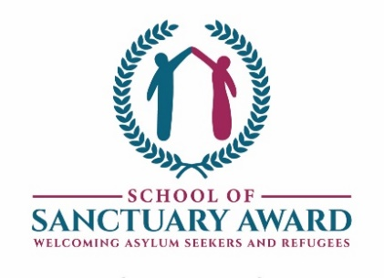
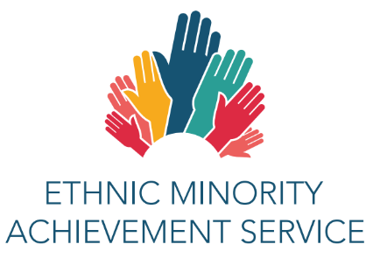

EMAS TRAINING PROGRAMME 2021-2022
CPD webinars delivered by the EMAS advisory teaching team
As we are all moving into a new ‘normal’, EMAS training has moved to being delivered virtually using MS Teams at convenient twilight timings. The cost of each session is £35 per delegate and the EAL Coordinator sessions are free of charge.

Contact us at  admin.emas@coventry.gov.uk  024 7697 5491
You will be sent a link once your booking is confirmed.

Including Newly Arrived Pupils: Planning and Support in the Classroom
Newly Arrived pupils need time to settle at school, acquire basic English and learn how to fit in.
This course will enable practitioners to build a whole school approach to welcoming new arrivals
and gain an understanding of potential barriers to learning. You can explore planning for an
inclusive environment and ensure key staff are confident and equipped with strategies to engage
new arrivals from the outset!
Wednesday 22 September 2021 3.30pm – 5.00pm
New EAL Co-ordinators and planning for the forthcoming academic year
If you are new to this role, this session will equip you to co-ordinate EAL work in your school with a
whole school approach. The session focuses on successful whole school induction systems for
new EAL pupils, and assessment, target setting and tracking progress to raise the achievement of
EAL pupils links to school improvement. You will learn how to plan and teach with colleagues in
order to develop expertise in meeting the language and learning needs of bilingual children.

Wednesday 6 October 2021 3.30pm – 5.00pm
Attainment of More Advanced Bilingual Learners
How to ensure that your staff can identify and meet the needs of more advanced bilingual leaners
to reach or exceed targets. Pupils who have had all or most of their education in the UK and
whose oral proficiency in English is usually indistinguishable from that of English monolingual
learners may still require guidance in improving academic writing. We will explore how EAL
learners can work with challenging texts and improve writing and exam techniques and outcomes.
Wednesday 13 October 2021 3.30pm -5.00pm
The distinctiveness of refugee and asylum-seeking children: trauma and attachment impact on learners from areas of conflict and natural disasters
Whilst some refugee children can present challenging or worrying behaviour at school, not all children who have experienced armed conflict and flight will suffer from trauma and stress. There are, however, key factors which lead to these pupils being some of our most vulnerable. The session will help school staff understand how negative experiences can impact on students’ health, well-being and ability to engage in learning resulting in poorer education outcomes.
We will share advice and strategies on how to successfully include these vulnerable children and develop emotional literacy and empathy in your classroom. Extensive research has shown that school and most importantly the relationships formed at school can be an incredibly stabilising, positive and nurturing experience.
Thursday 24 November 2021 3.30 – 5.00pm

Working with English as an additional language (EAL) learners in EYFS
How effective practice can ensure that the bilingual and multilingual learners in our Early Years Settings are progressing well in all areas of learning. This session will cover areas such as; building positive relationships with parents of EAL learners, the importance of home language, classroom strategies and resources and carrying out observations and tracking progress.
Wednesday 1 December 2021 3.30 -5.00pm

Effective communication with new communities for admin and reception (front of house) staff
It is important that our EAL families feel welcomed and included in the school community. This course will cover some concrete and practical ways in which staff can support parents in the initial days. Collecting appropriate data, providing comprehensible information about the school, conducting initial meetings and highlighting the importance of home language will be just some of the areas covered in this session.

Wednesday 8th December 2021 10.00-11.30am

English as an additional language and Special Educational Needs
When a child learning English as an additional language makes slow progress in school, it can be difficult to establish whether the delay is caused because they are not confident using the language of the school or because they have additional learning needs independent of the language barrier. Similarly, language differences may mask the potential and ability of gifted or more able learners. Join us to discover more about the process of distinguishing whether an EAL learner may have additional language or learning needs.
Tuesday 11 January 2022 3.30-5.00pm
Effective partnership working for support staff
The support of additional adults in the classroom when working with English as an additional language (EAL) learners is invaluable. To be most effective, access to training about the specific needs of these learners is essential so that mainstream teachers and additional adults can provide effective support.
This course is aimed at support staff and will offer an insight into the needs of EAL learners at different stages of bilingualism, the importance of sharing planning for language development, liaison with parents, carrying out assessments, interventions and tracking progress and in-class strategies.
Wednesday 26 January 2022 3.30 -5.00pm

Strategies and resources to support newly arrived and more advanced EAL learners in the classroom for the early career teacher (ECT)
We will be looking at the differences between newly arrived and more advanced EAL learners and the strategies we can implement to help them demonstrate their skills and knowledge and access the mainstream curriculum.
Wednesday 9th February 2022 3.30-5.00pm
The culturally inclusive and diverse classroom and school
‘A culturally inclusive classroom is one where students and staff alike recognise, appreciate and capitalise on diversity so as to enrich the overall learning experience’.
In our ever-growing global society, teachers must be open to and accepting of all the students they engage with in the classroom. An inclusive school creates a safe, welcoming, and non-judgmental environment where a pupil and his or her culture(s) feel valued and important and they can freely express who they are, their own opinions and points of view.
Recognising the diversity in our school communities ensures that students are making positive connections and comparisons between their home culture and life in the UK.
Thursday 3 March 2022 3.30 – 5.00pm
The new Ofsted framework
An informative session focussing on the inspection of schools under the new Ofsted framework (2019) and the implications for teaching and learning of English as an additional language. We will consider the judgement areas in the new framework and new approaches to inspecting EAL. Exploring the methodology of inspection, e.g., deep dives, pupil groups and use of data will provide school professionals with guidance and ideas to ensure that you can demonstrate good progress of EAL learners in your school.
Tuesday 22 March 2022 3.30 – 5.00pm
Working with EAL Parents
Successfully collaborating with and supporting parents of English as an additional language (EAL) learners in our school communities is crucial if our learners are going to achieve successful outcomes. This session focuses on ways in which schools can engage effectively with the parents of their EAL learners to ensure that parents understand the importance of the role they have in their child’s bilingual development.
Wednesday 6 April 2022 3.30 -5.00pm
Assessment, progress tracking and target setting for learners of English as an
additional language
Learners of EAL in your school make up a diverse group with a wide range of language skills and prior educational experiences, and time of arrival into the English school system. This session will help you evaluate your current practice and adopt processes for English language proficiency assessment of pupils learning EAL to improve your understanding of the language learning needs of their pupils with EAL and develop appropriate targeted support.
Monday 23 May 2021 3.30pm – 5.00pm (rescheduled)

EAL Co-ordinators’ Network Meetings
If you are an EAL Co-ordinator working in one of Coventry’s primary or secondary schools, please
join us at these regular, termly meetings.
Each term you will receive updates on the latest information and research around EAL practice,
both locally and nationally. There will be opportunities to hear about new resources.
Colleagues are also invited to share ideas and examples of good practice from their schools in 3
or 5 minute presentation slots. If you would like to do this on behalf of your school, please email
admin.emas@coventry.gov.uk in advance and we’ll book you in.
Finally, you can meet and network with colleagues across the City who are facing the same
challenges and whose experiences and solutions to these challenges could help your school
practice.
Our first meeting will focus on post Covid-19 restrictions and possible return to school challenges for EAL learners and families, a discussion around pros and cons of home learning during lockdown and future recovery strategies. Come and join us for a virtual coffee/tea, a recommended cake/ biscuit and a catch-up on everything EAL!
Tuesday 9th November 2021 3.30pm - 5.00pm
Wednesday 16 March 2022 3.30pm – 5.00pm
Thursday 5 May 2022 3.30pm – 5.00pm

