Early Help Module (EHM)
How to record a COVID 19 Vaccination
Step by Step User Guide
August 2021

From the child’s record, select the Health section from the left-hand side.
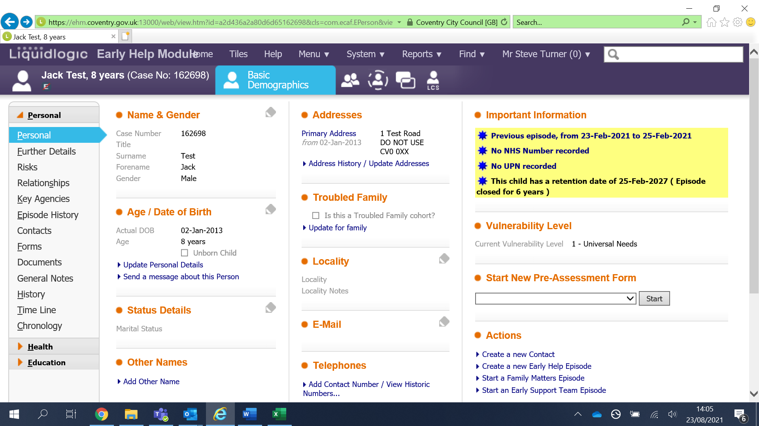
From here click on Immunisations.
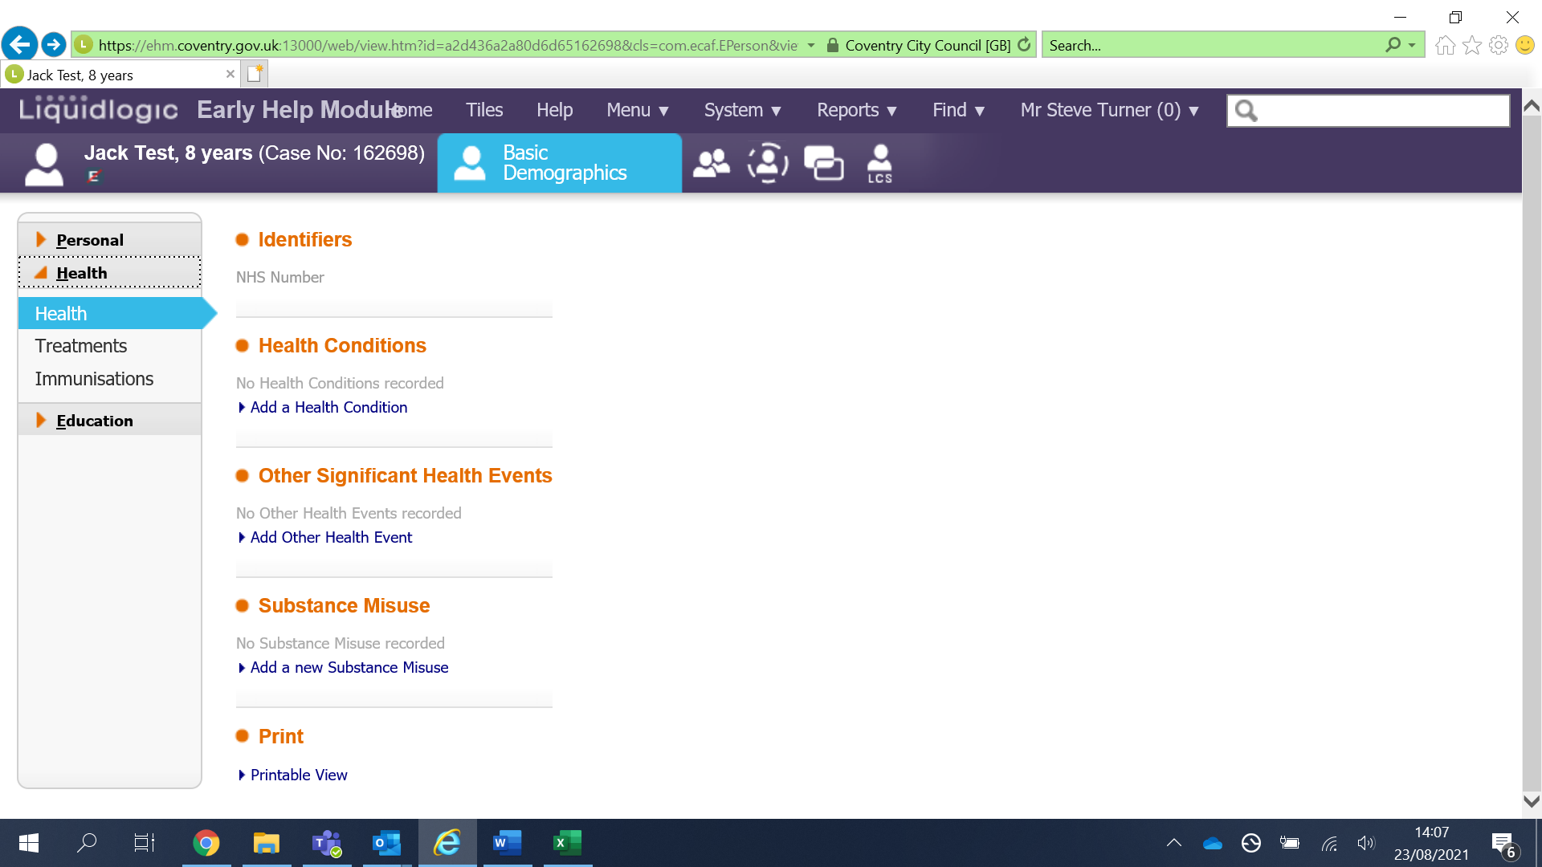

Now click on the blue link ‘Add a new immunisation record’.
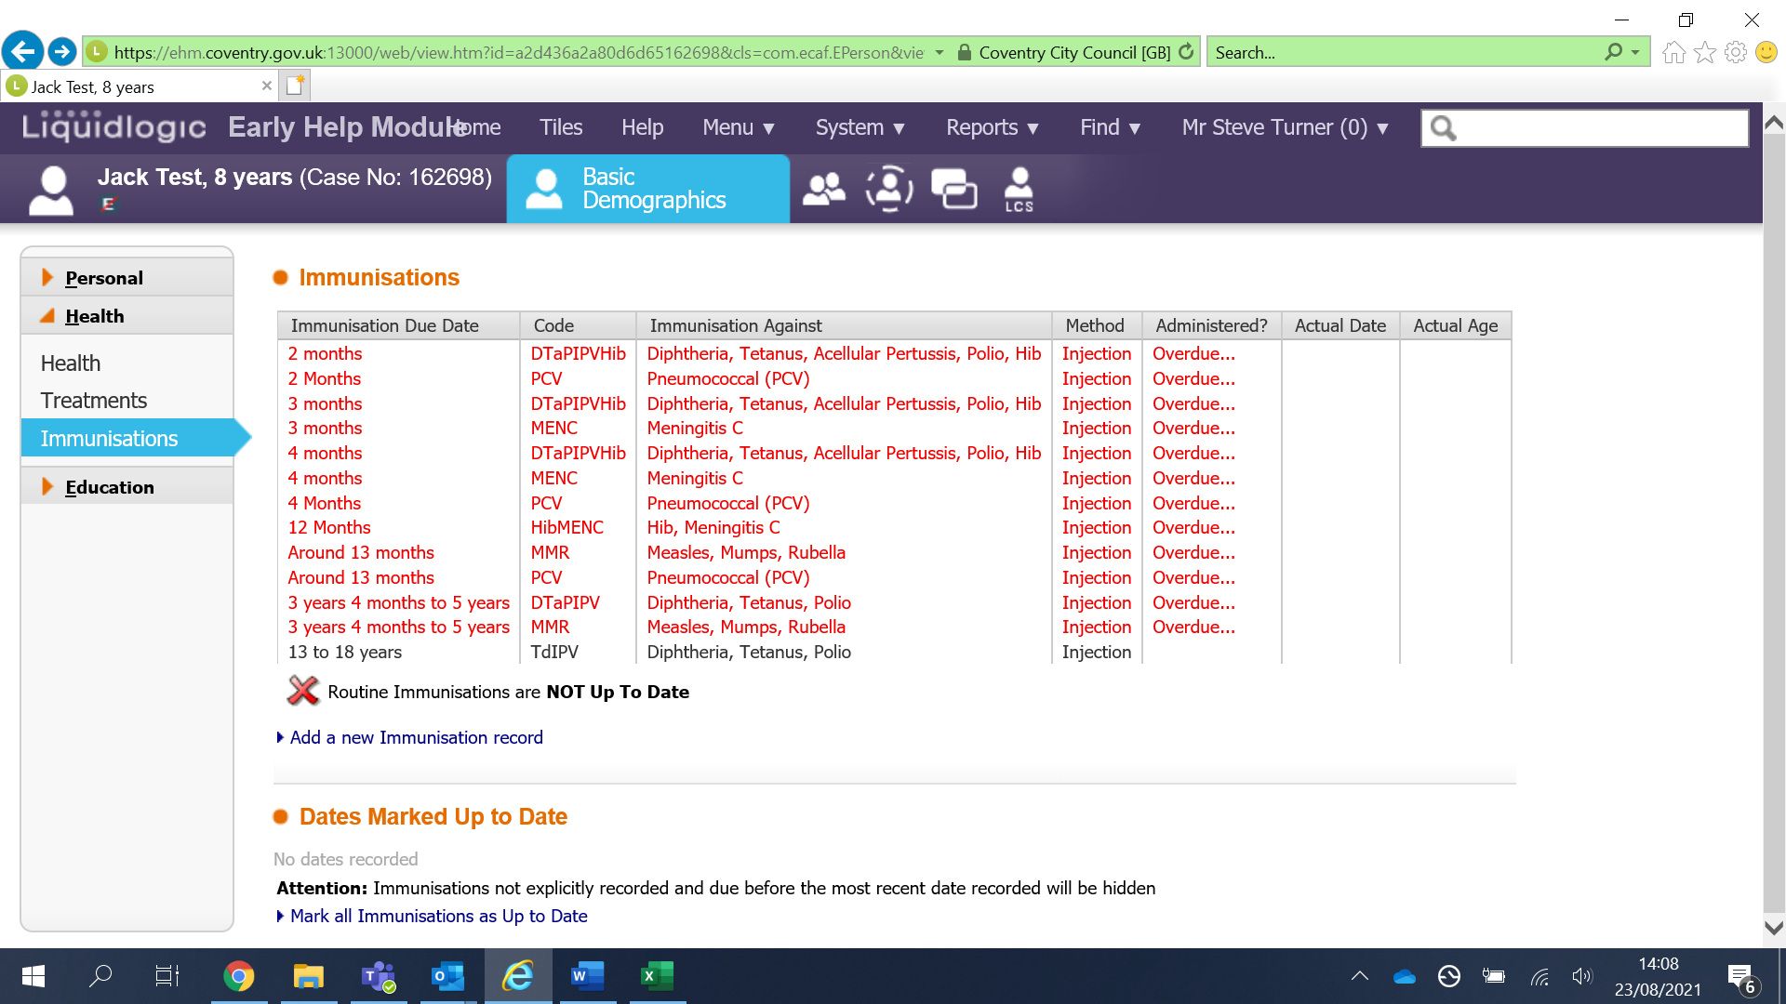
From here click on ‘Immunisation’ and from the drop-down list select either:
COVID _19 First Dose
COVID_19 Second Dose
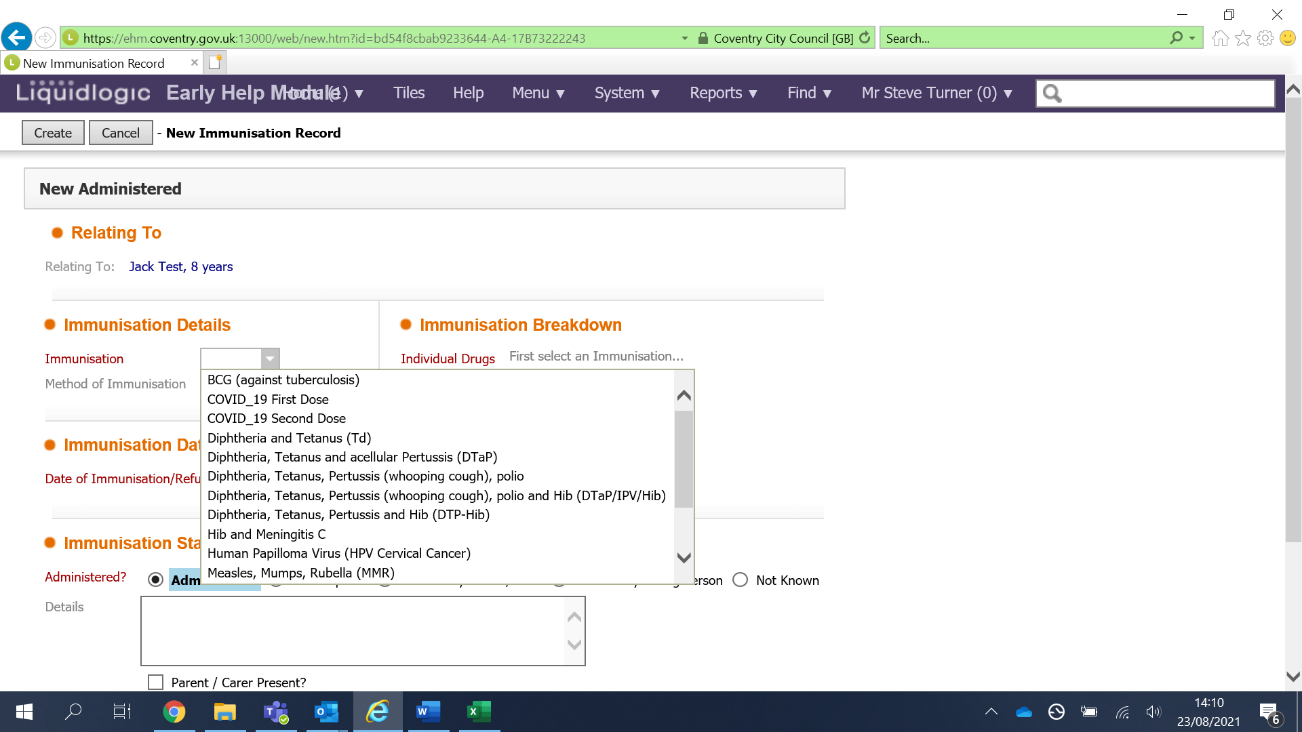

Then select the ‘Date of Immunisation’.
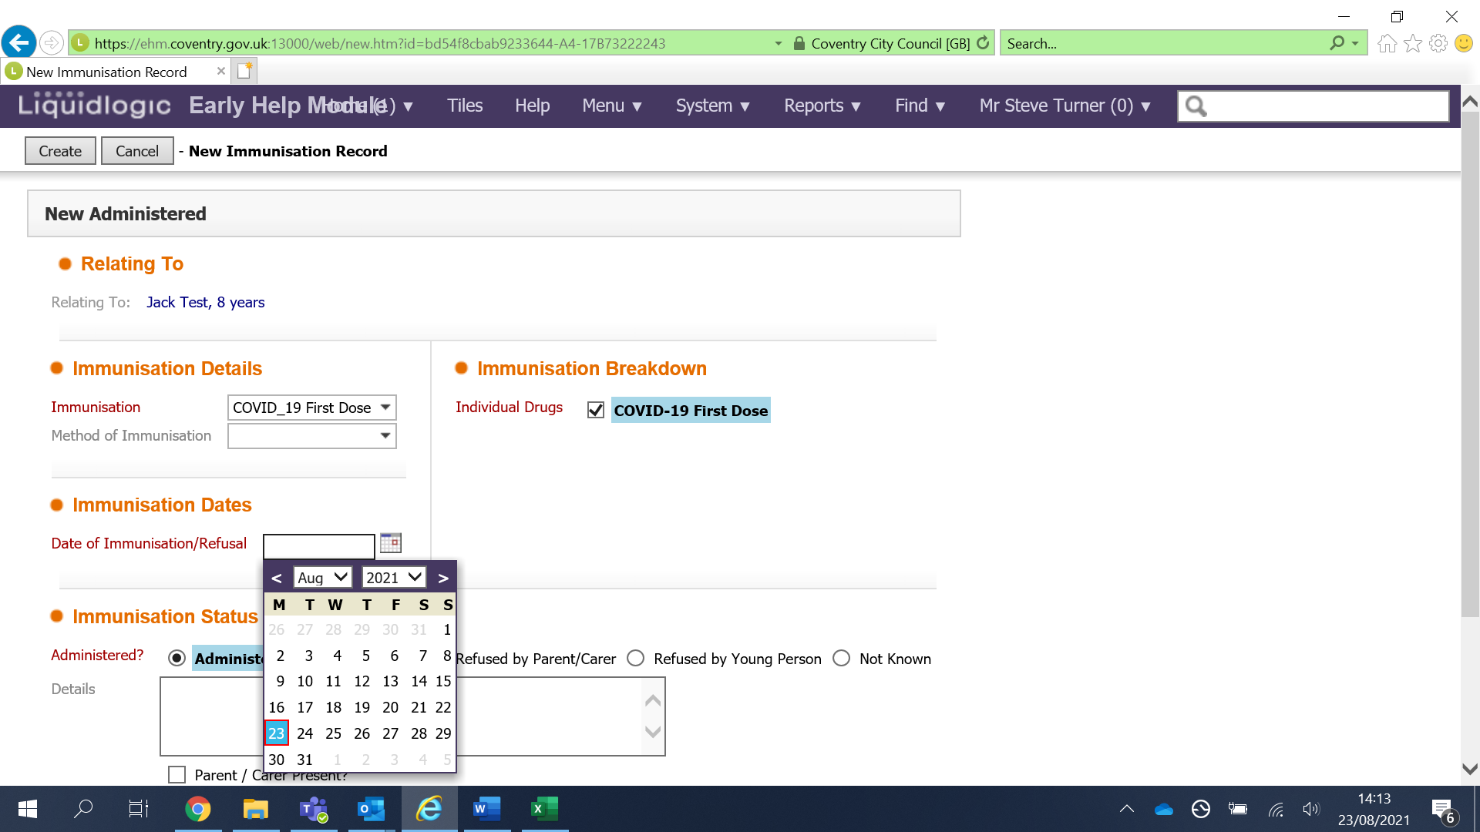
There is a ‘free typing’ box to enter any other details I.E the venue the immunisation was administered.
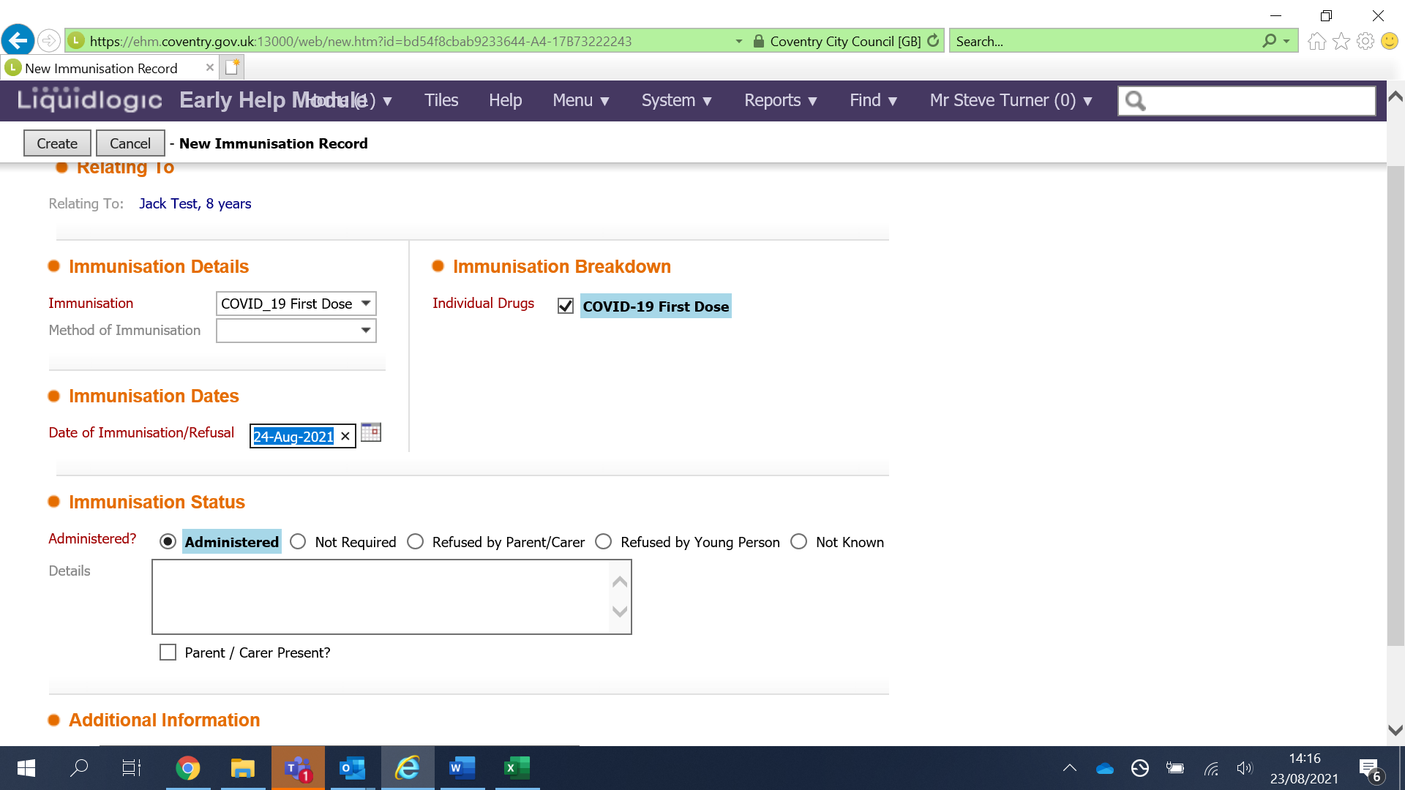

Once all of the information has been entered click ‘Create’
