STATEMENT OF QUALITY

The management of the Coventry Communications Centre is dedicated to providing all clients with services that meet or exceed their expectations and which meet the requirements of BS.EN.ISO 9001, the Biometric and Surveillance Camera Commissioner’s ‘Surveillance Camera Code of Practice 2021 and all British Standard Codes of Practice relevant to our services including maintaining the high standards of the building itself.

Our commitment to each of our clients is to provide a high quality level of service and commit to continual improvement. We are confident that in doing so we enhance the security of their premises, thereby providing them and their employees with the safest practicable working environment.

Implementation of the Quality Procedures is the responsibility of every member of staff starting with the Chief Executive who provides inspirational leadership to all areas of the Council.

The Quality Procedures have the full support of senior management to ensure that activities are controlled in a manner compatible with achieving required service levels and obligations effectively. It is mandatory that all staff adhere to the procedures in order to achieve a consistent approach to quality within the centre. This is supported by business objectives which are discussed during the management reviews of the Quality Management System.
—
The management accepts responsibility for communicating to all employees the Coventry Communications Centre's commitment to quality and ensuring the Quality Procedures are understood, implemented and maintained at all levels. All members of staff are encouraged and motivated to carry out their business with integrity and in an ethical manner, demonstrating respect for others within a diverse cultural environment that does not tolerate prejudice or discrimination.

Davina Blackburn
Strategic Lead – Regulation and Communities
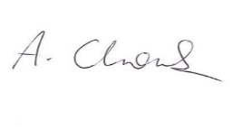
Adrian Chowns
Head of Safer Housing and Communities
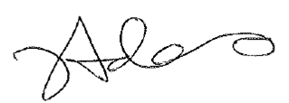

Joy Adams
Manager, Coventry Communications Centre

Julie Newman
Chief Legal Officer

November 2023

