Step by Step guide on how to start and complete the Supporting Families Outcome Plan (SFOP)
The SFOP is started from the assessment stage of the early help episode, as you can see on the below screen shot.
From the list of sections on the left-hand side, you can see the Outcome section highlighted in blue.
To start the SFOP YES must be answered for the 2 red mandatory questions:
Is this a whole family Assessment?
Is this generating a plan that takes into account all relevant family members?
When YES is answered to the 2 questions a statement appears and a link to start the SFOP. The SFOP is a standalone form, this means when you click on the link the form will be started and will be outside of the early help episode. The form will appear in your EHM Work Tray.
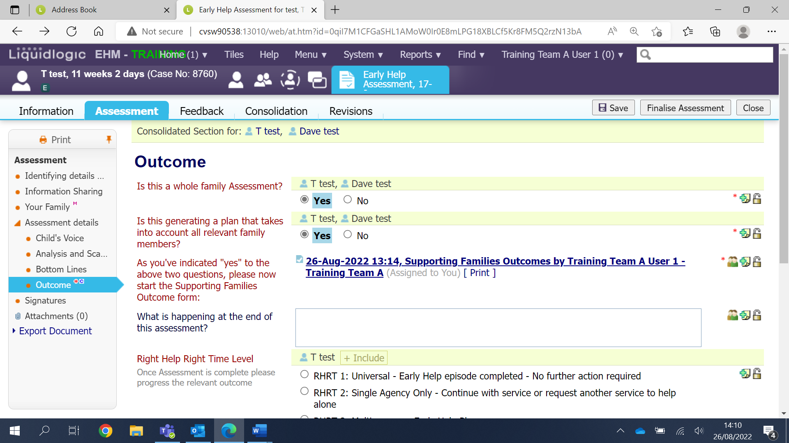
The link to the SFOP will be in your work tray
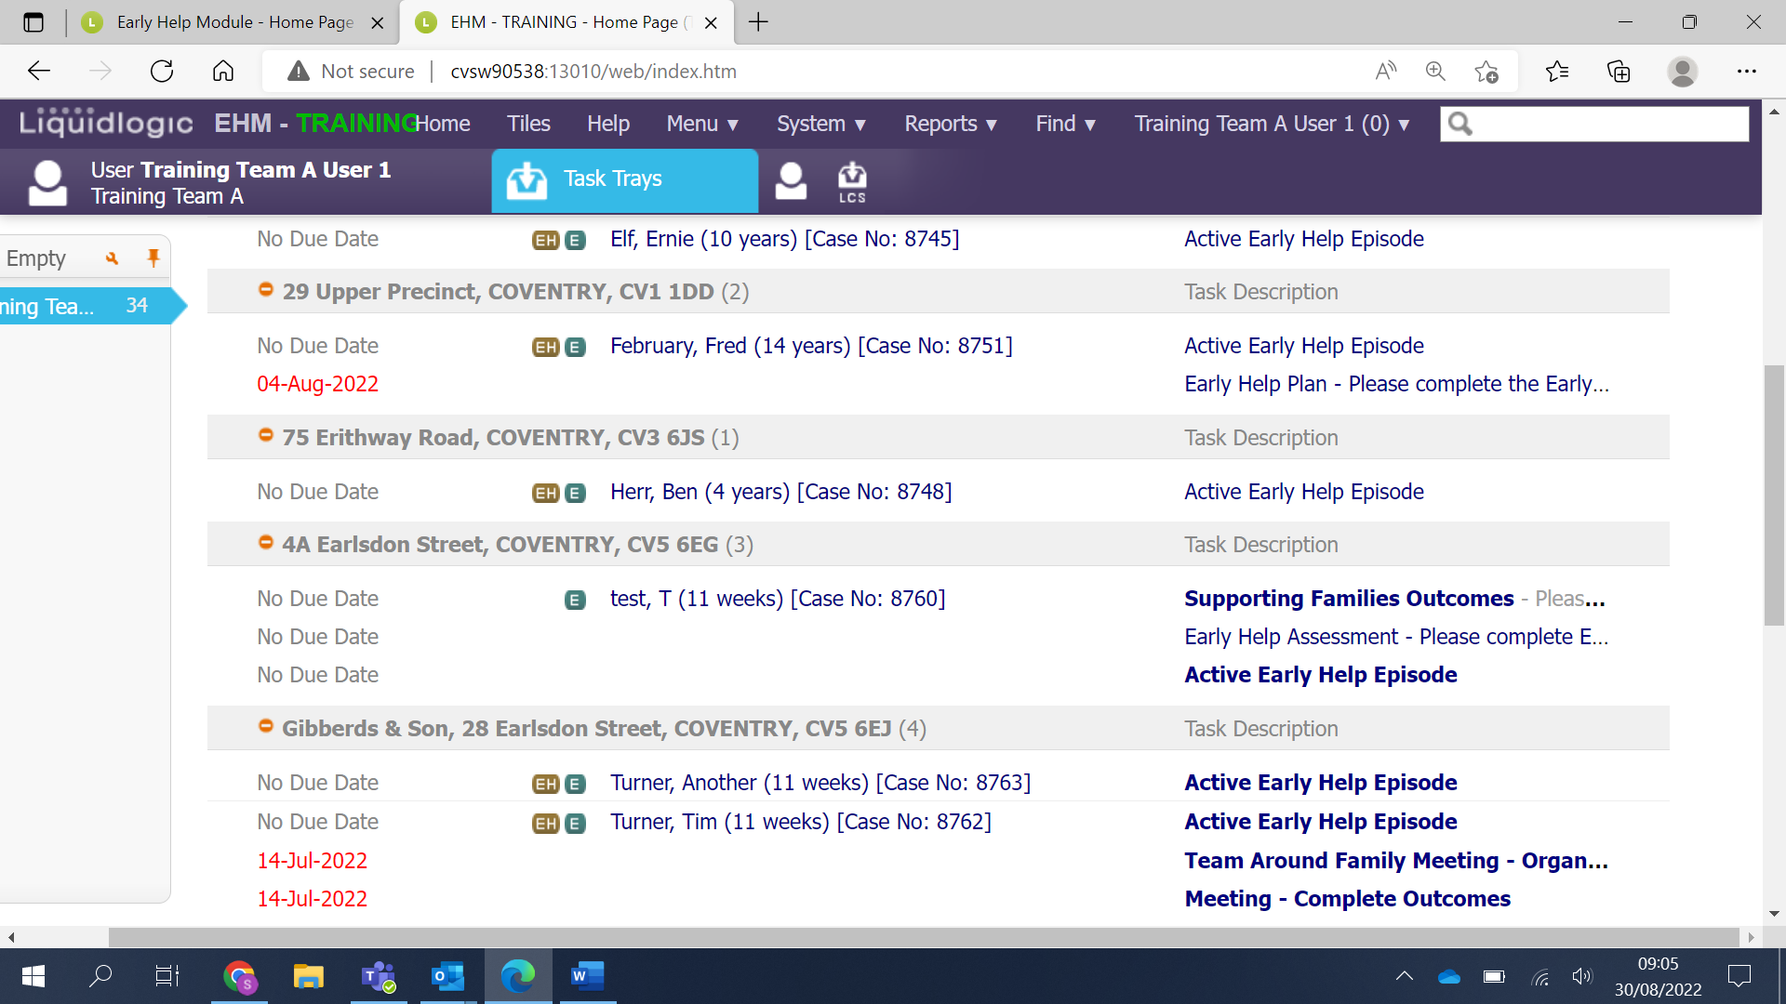

The first page of the SFOP:
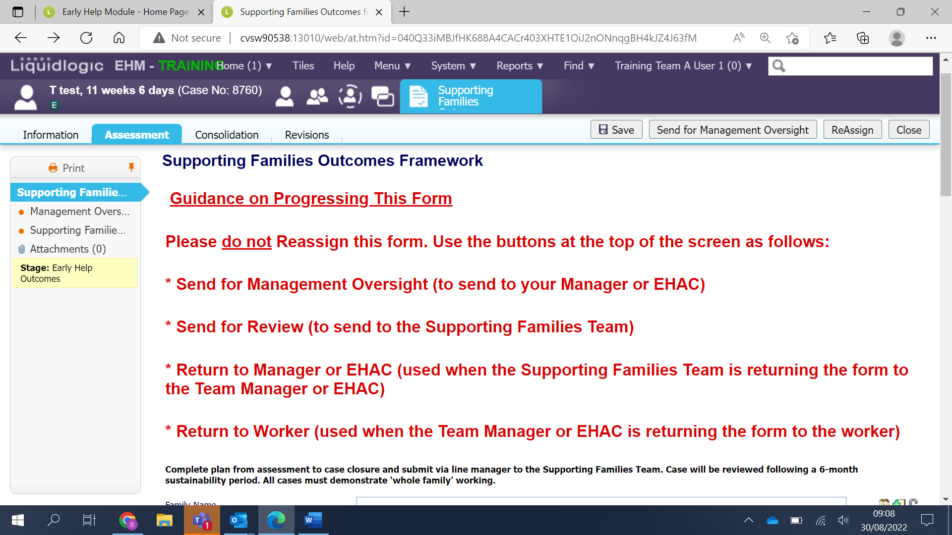
As you scroll down the page all fields need to be completed, paying particular attention to the red mandatory fields.
Please Note: As you move down the page you will see the 10 Supporting Families headlines, a Yes or No must be answered for each one. If you answer a YES this headline will then appear on the left hand side of the form. This will allow you to then complete that headline as required.
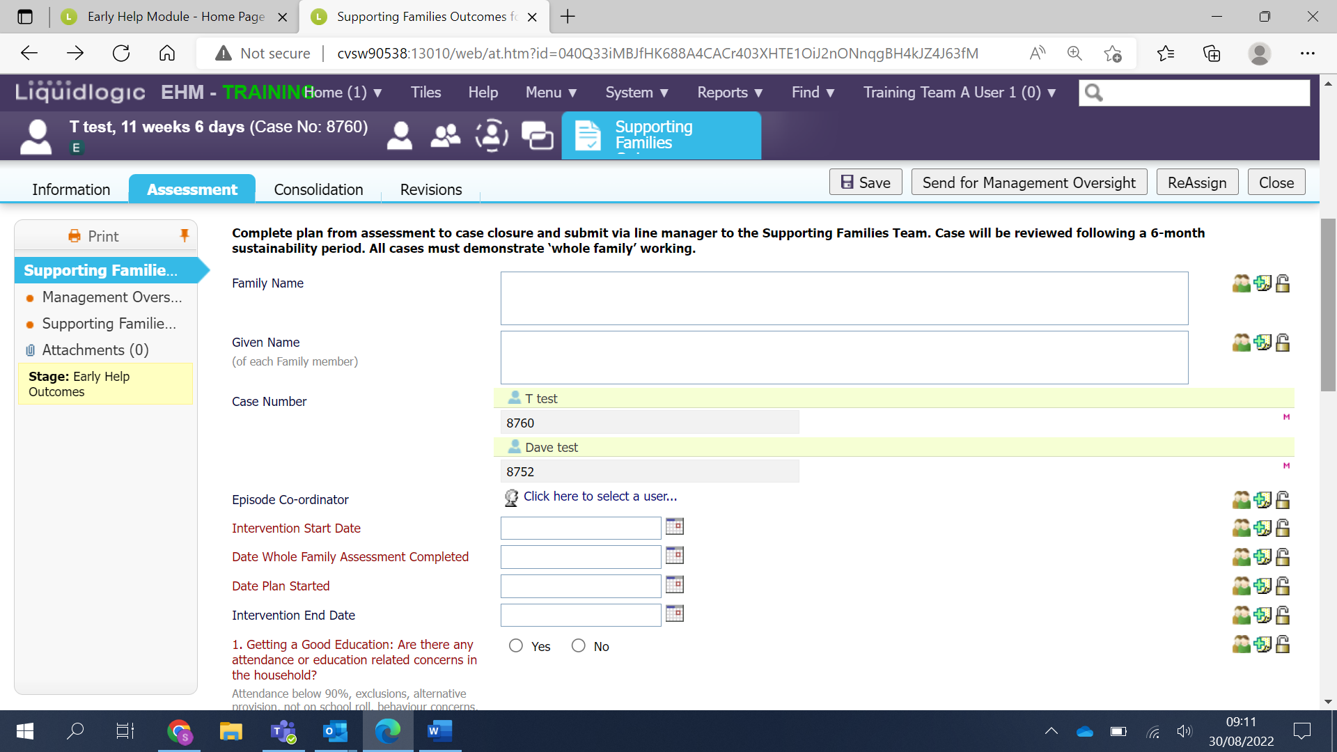

As you can see on the below screen shot – Headline 1 and 2 have been answered with a Yes and now appear on the left-hand side, whereas headline 3 was answered with a No, so we have no further work to do for headline 3.
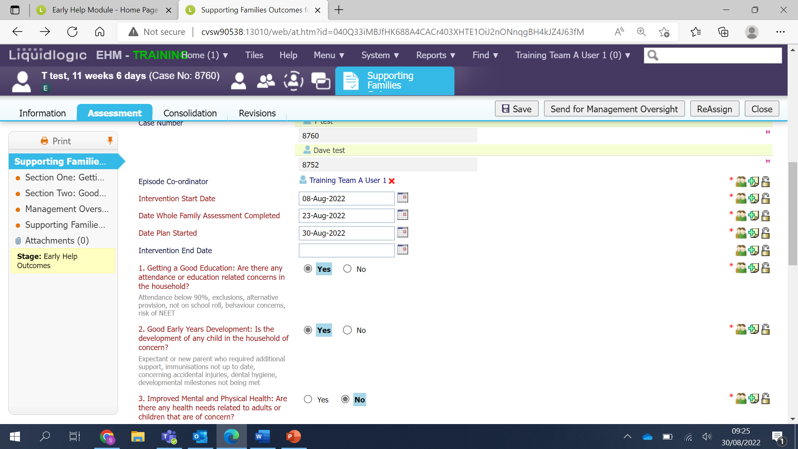
The final question to answer on the front page is to select the Manager or EHAC who will be providing oversight.
With regards to the manager who will be providing oversight. If you work for Children’s Services, then this will be your line manager.
If you do not work for Children’s Services, then this will either be your Early Help Assessment Coordinator (EHAC) or if you do not have an allocated EHAC then you can select yourself.
If you have a question about this, please email; steven.turner@coventry.gov.uk
To do this click on the blue link.
The blue link will take you to your EHM address book, in your address book you can search for your manager or EHAC. Please see below screen shot for guidance on using the address book.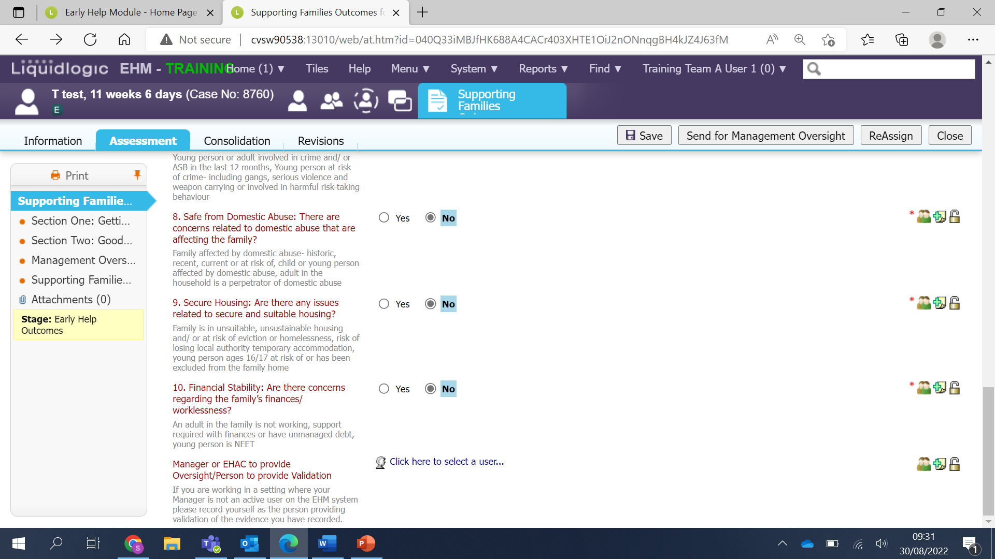
The EHM Address Book:
In your address book you will see the My Contacts section highlighted in blue. If you are providing valadation for your own SFOP select your own name from the Manager Contacts section.
If not you can search for an EHM professional by clicking on the All Professionals section.
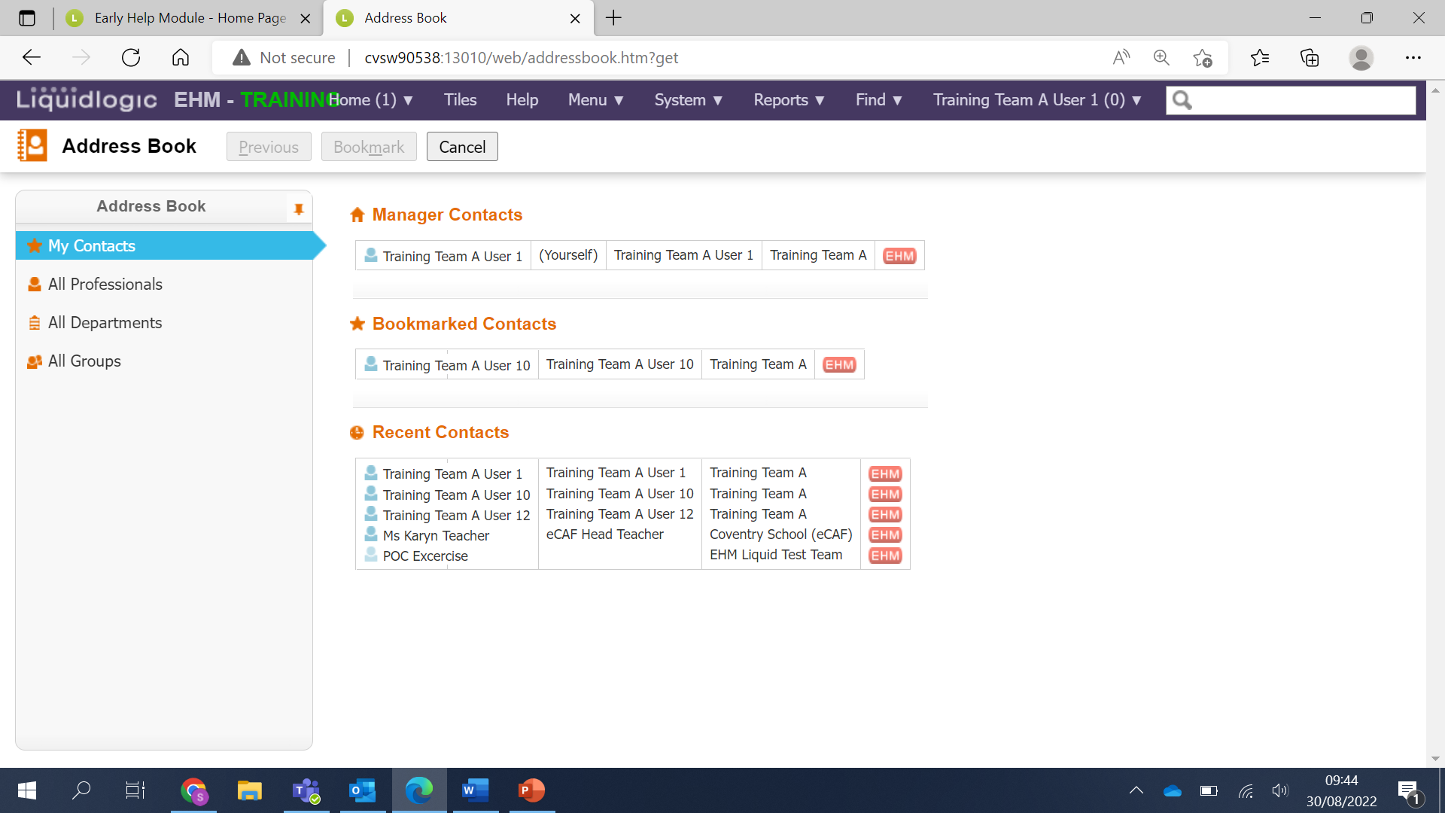
Selecting All professionals will allow you to enter the Surname and Forename of the professional you are searching for. Once you have entered the details click Search
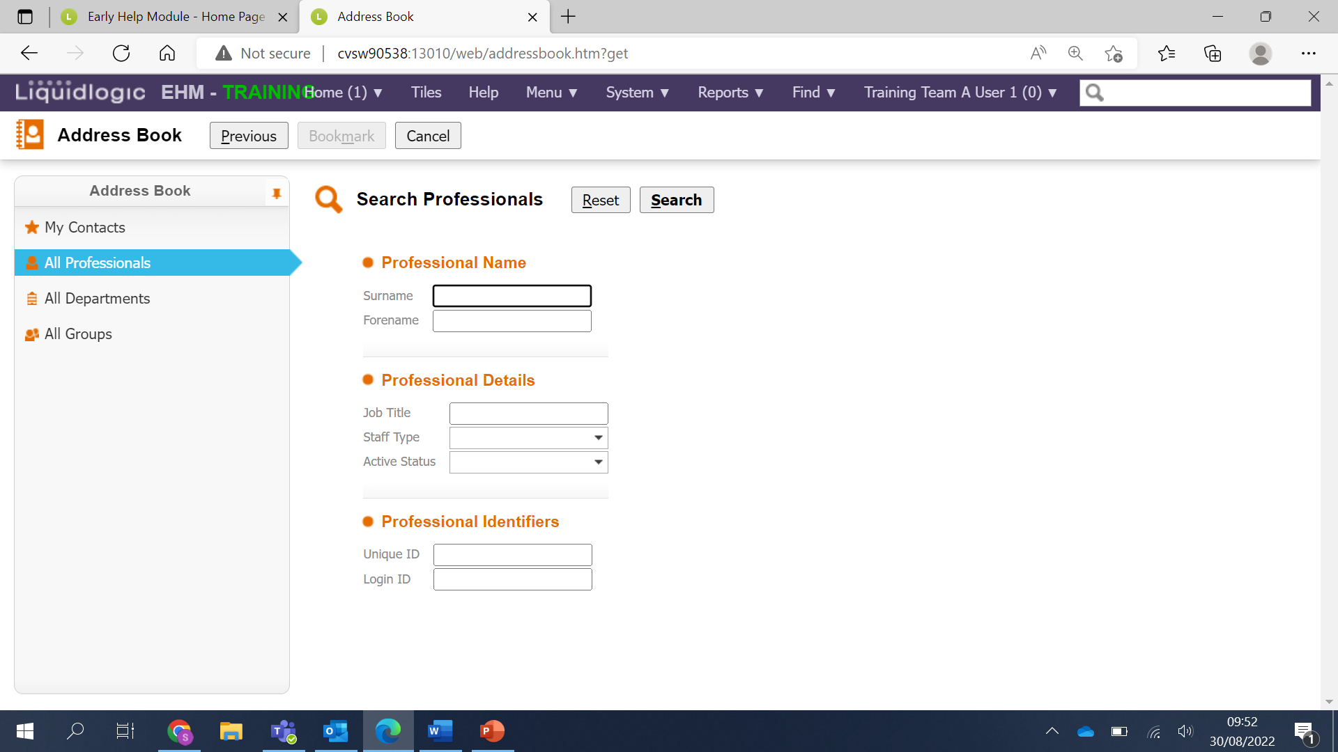

Select the relevant person. It’s important to make sure you select the correct account; some professionals have an LCS and EHM account. Use the icon to check (always select the EHM account) click on their name to select them.
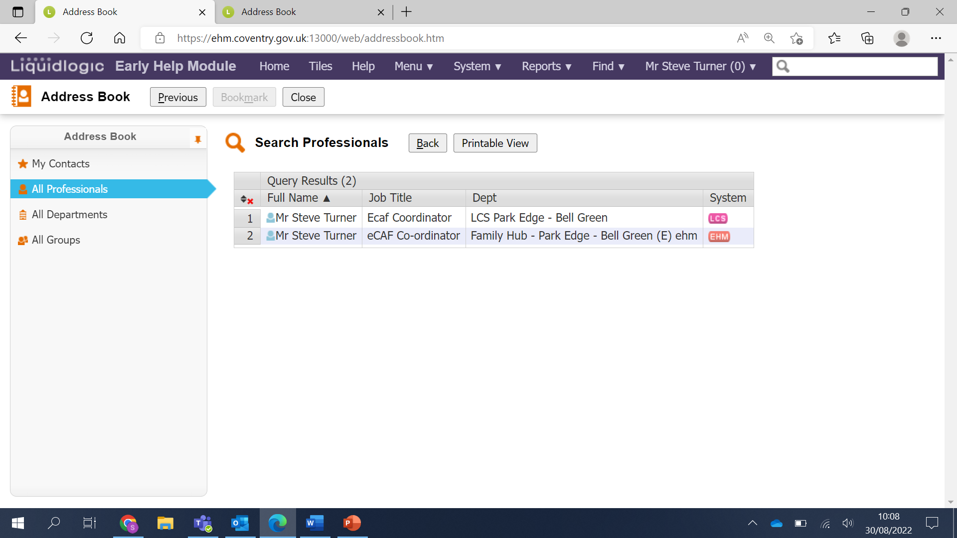
Select Confirm
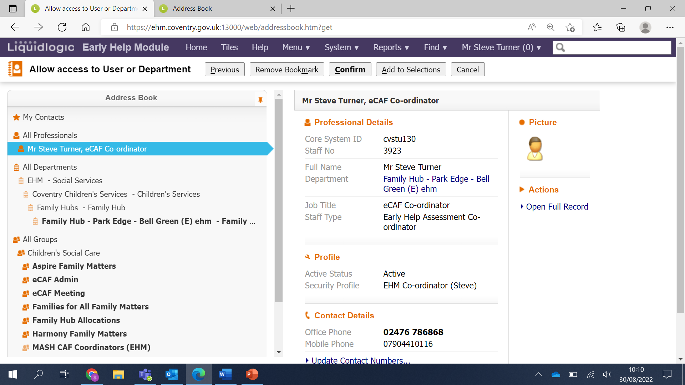

You will now see the name of the professional you have selected.
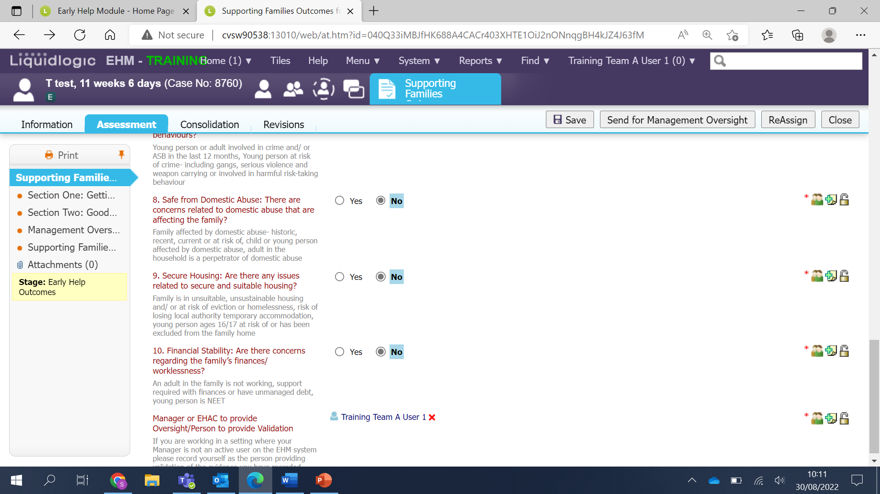
Please Note: It’s important to regularly save the form by clicking the grey Saved button at the top of the page.
Now you have completed the front page you can move onto completing the headline sections.
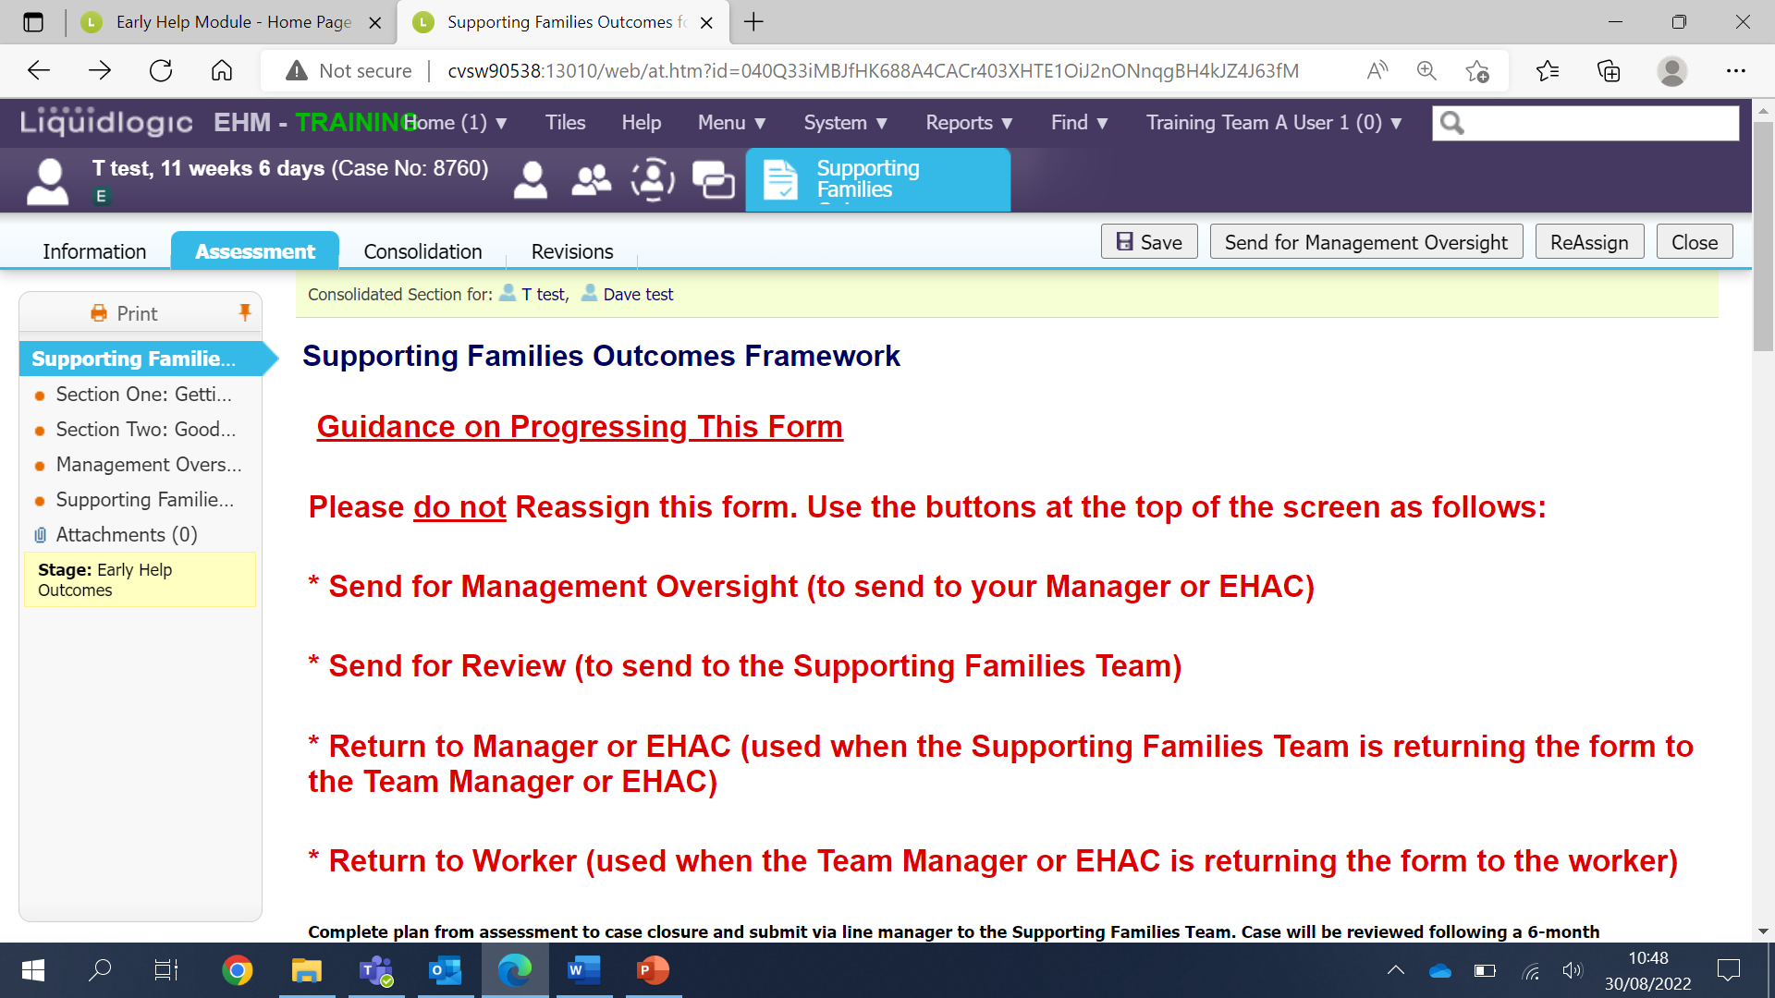

Each headline section looks like the below – You will see the mandatory questions to answer with a Yes or No.
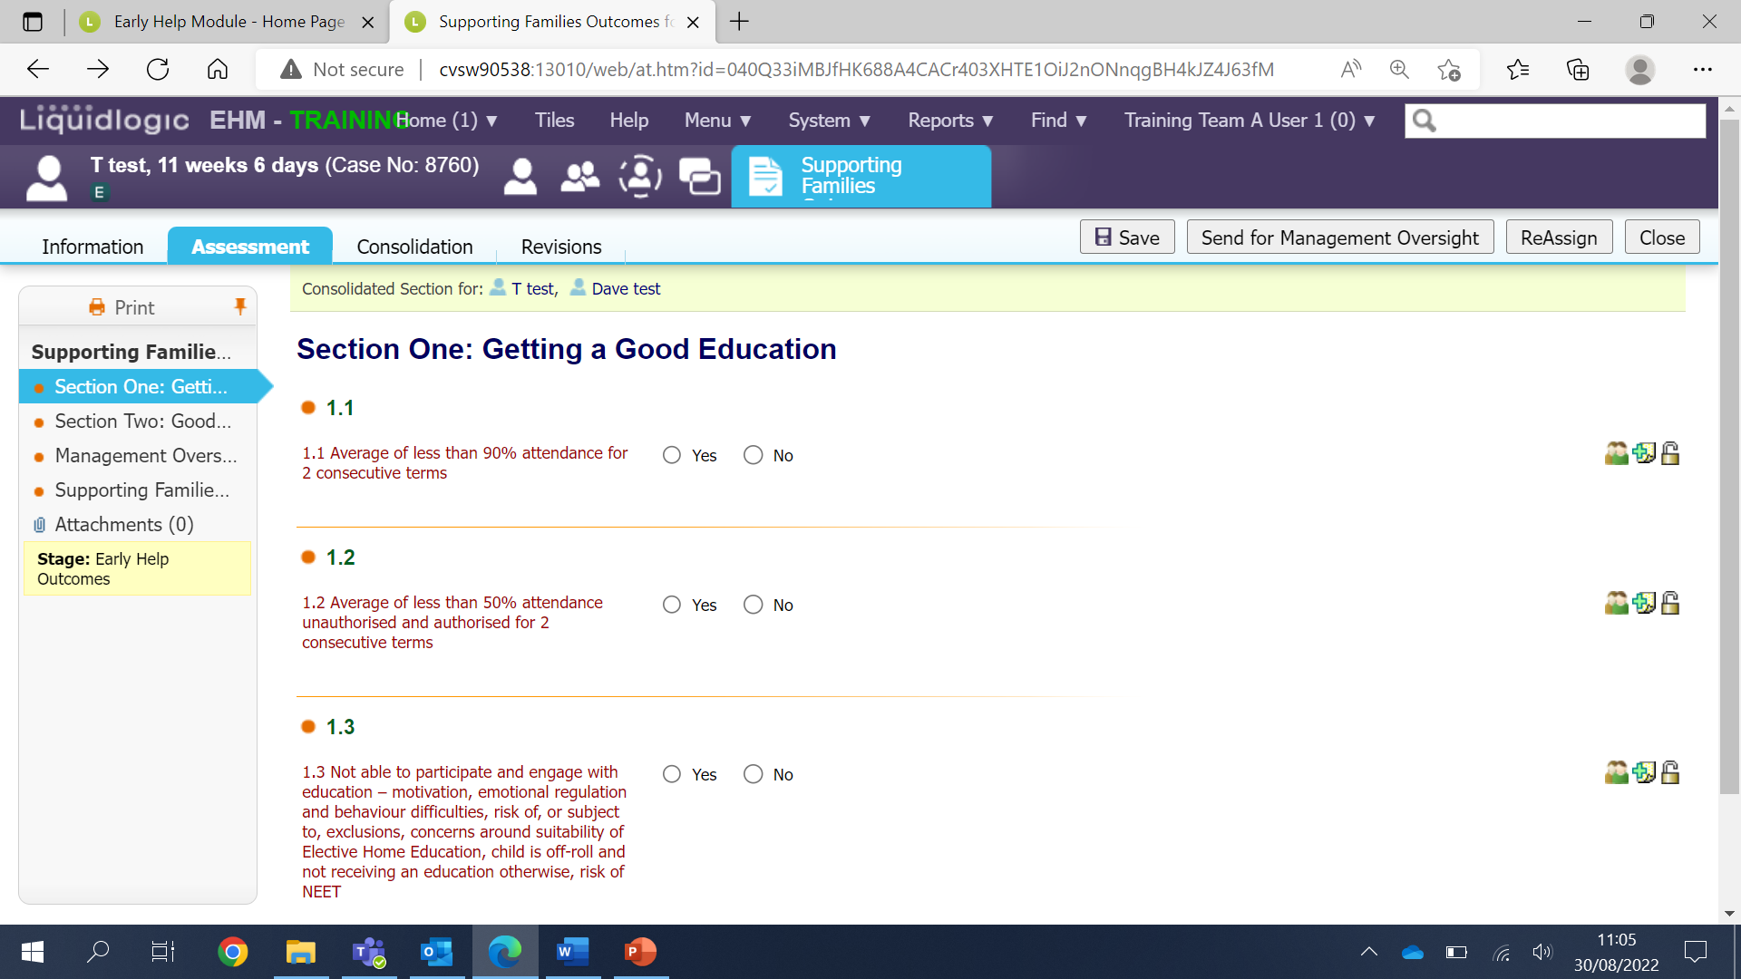
If you select Yes to a question, the mandatory evidence and scaling field must be completed as well as the Outcome fields.
Also please note: if you have finished working on the form for the day you can save and then close. The form will still be in your work tray for you to access at any time.
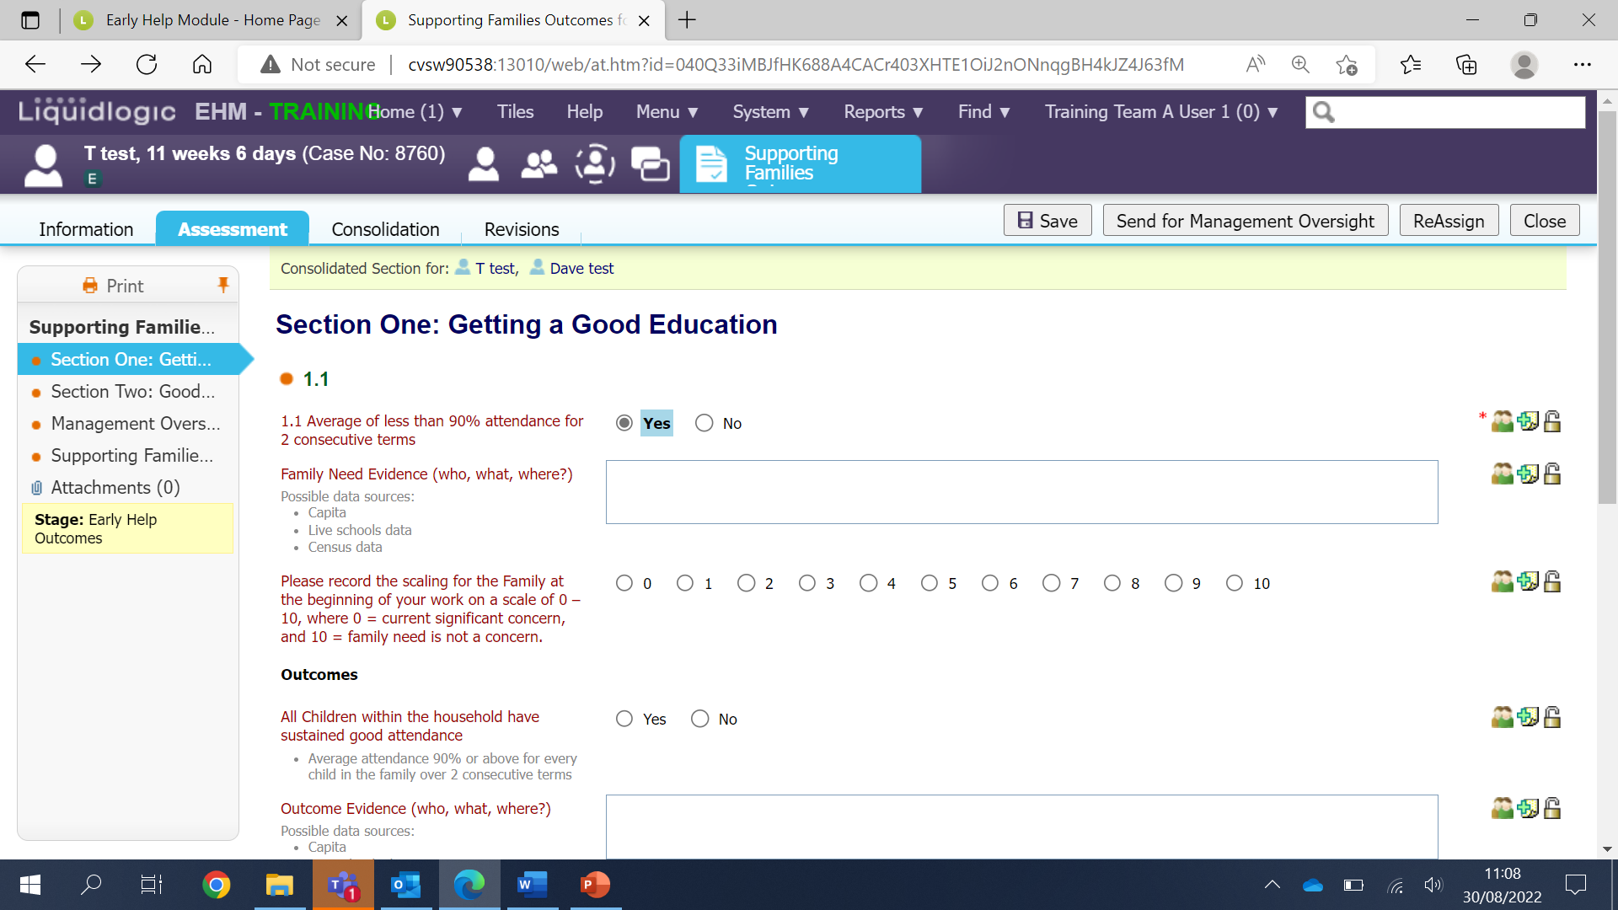

When you have completed all the relevant headline sections and the early help episode is ready to close the form can be sent for Management Oversight.
If you have any questions about the form, you can email the Supporting Families Team: troubledfamiliesdatateam@coventry.gov.uk
It is important to note that the early help episode must be kept open until the SFOP has been authorised.
Sending the SFOP for Management Oversight
When you are ready to send the form for management oversight click on the grey ‘Send for Management Oversight’ button.
The form will now go to your manager or EHAC for them to undertake an oversight. Once they have completed the Management Oversight section 1 of 2 things will happen.
1 – Your manager will be happy with everything in the form and will send it for review – No more for you to do. Await an email from the Supporting Families Team.
2 – Your manager will require you to add further informtion so the form will be retuned to you. It will be back in your work tray. Once you have acted on your managers advice you can then send it back for management oversight by clicking on the ‘Send for Management Oversight’ button.
Please Note: If you are undertaking the oversight yourself the form will be in your work tray and the managment oversight field will be active for you to complete. Please scroll down the guide to see how to complete the oversight section.
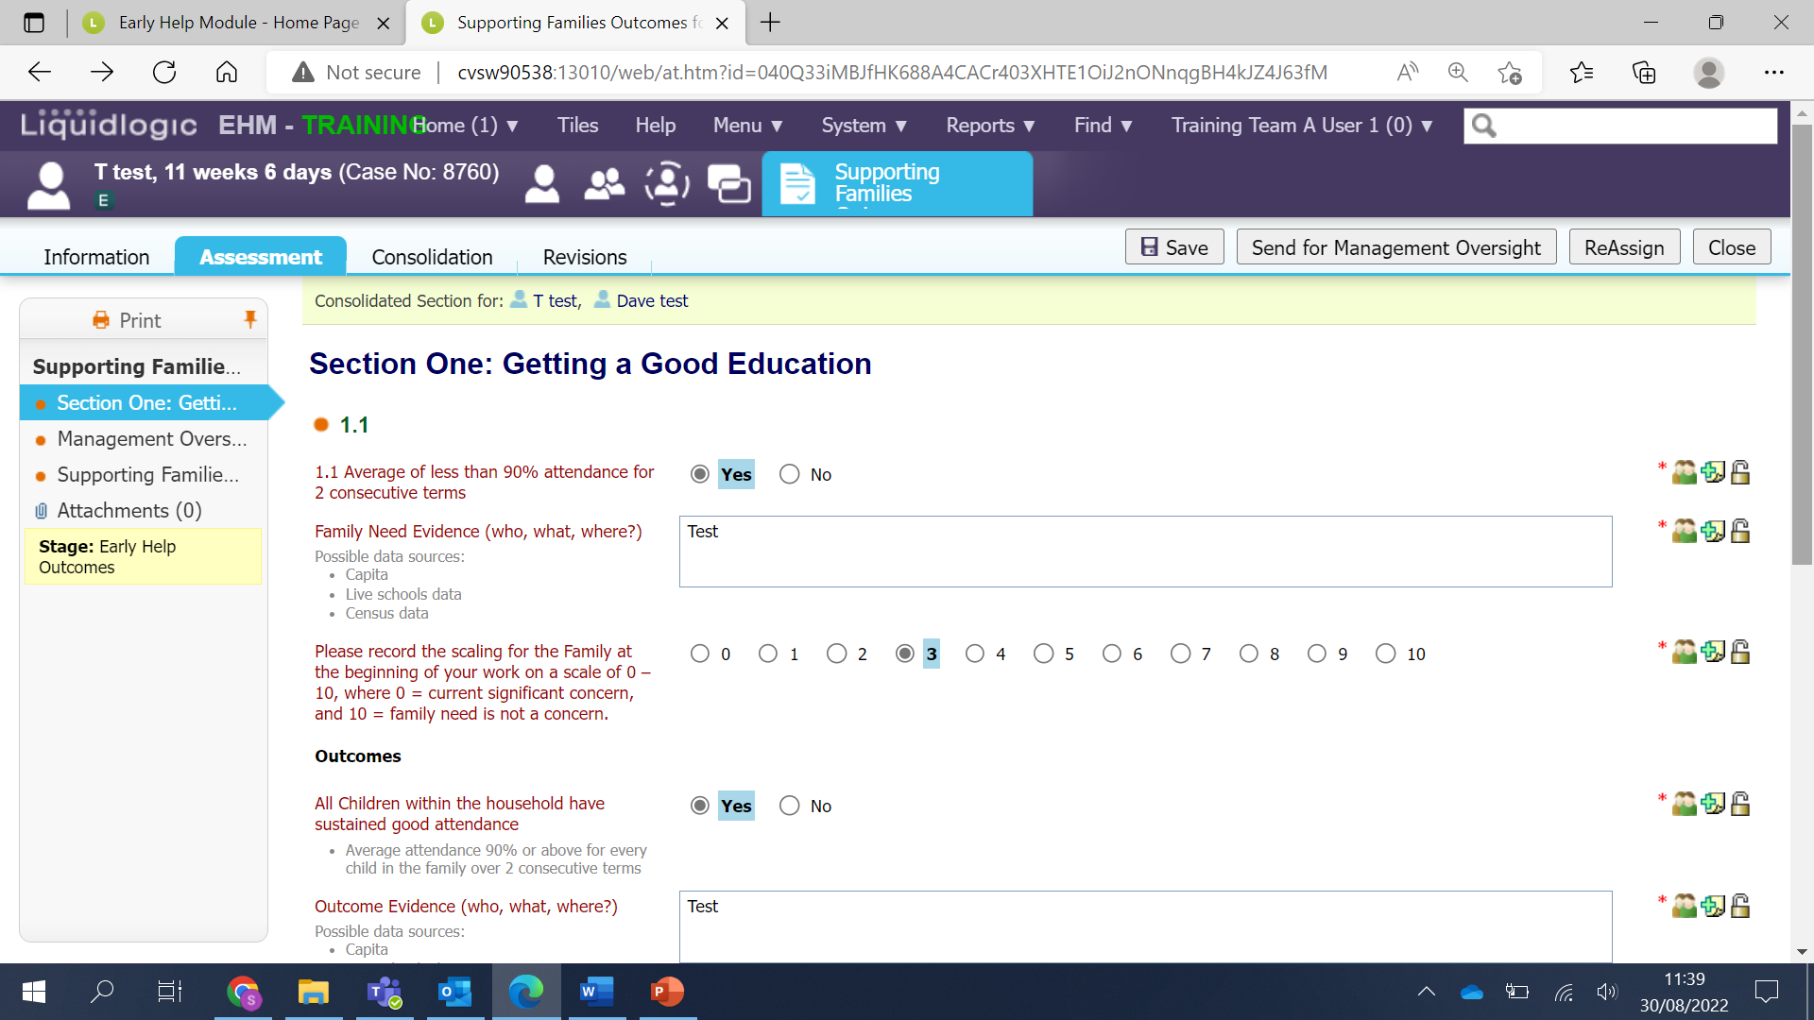

How to undertake Management Oversight
The SFOP will be in your work tray- Click on the link to open the form.
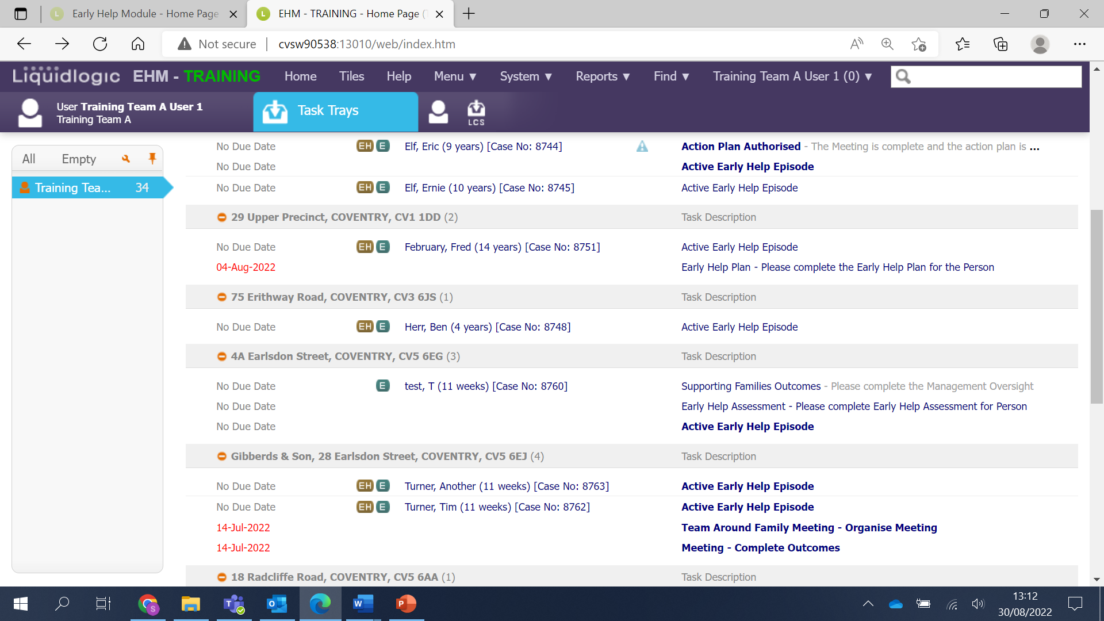
Click on the Management Oversight section
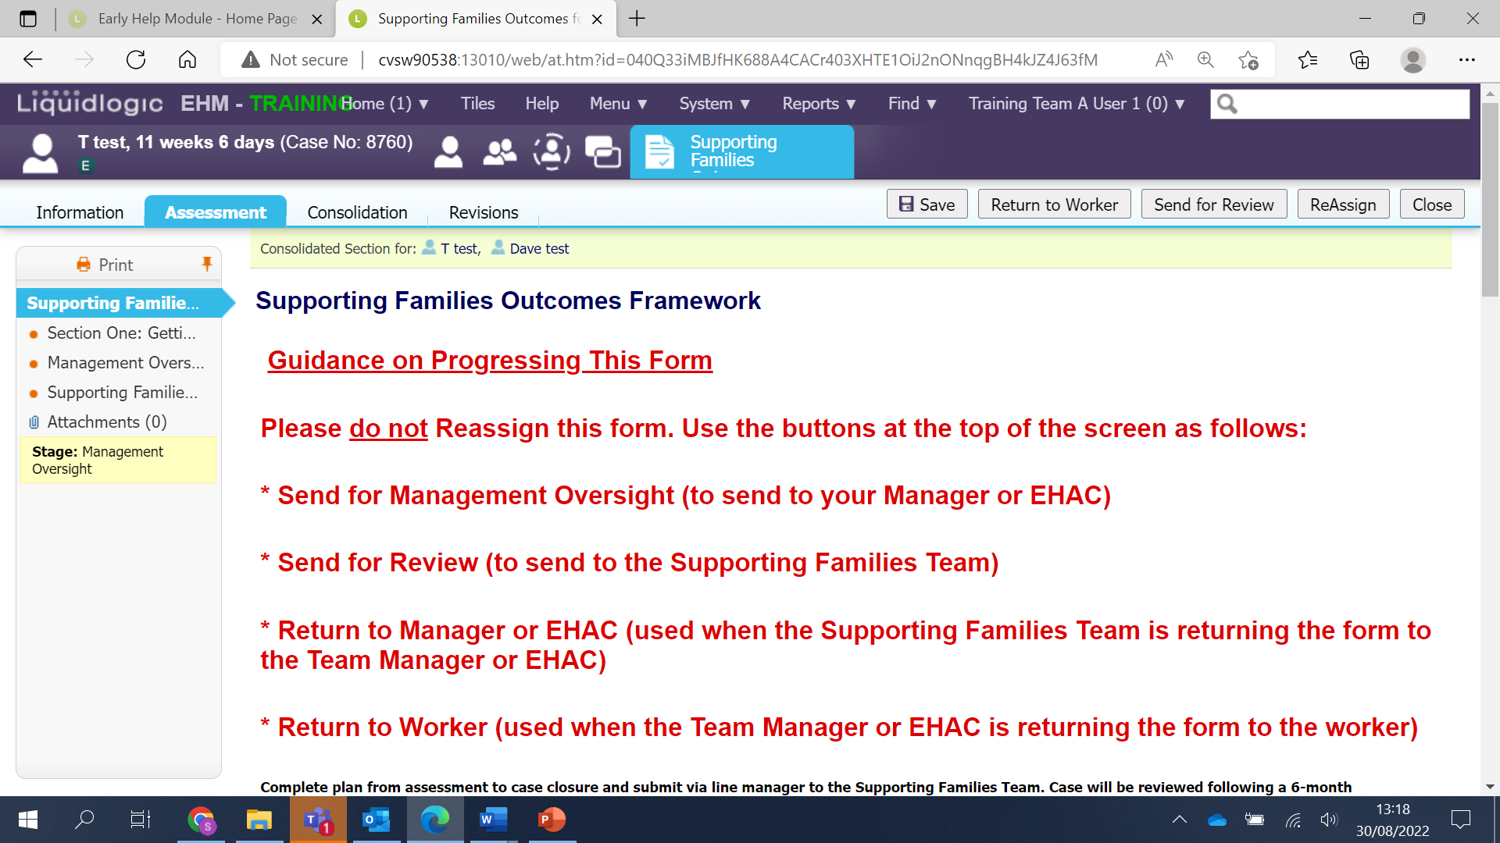

Answer Yes or No to the mandatory question and then fill in the fields on the form.
Once you have done that click on ‘Send for review’.
The form now goes to the Supporting Families Team for them to review.
Please Note: You must NOT close the early help episode until you have received notification from the Supporting Families Team that the SFOP has been approved.
Once it has been approved you can then close the early help episode.
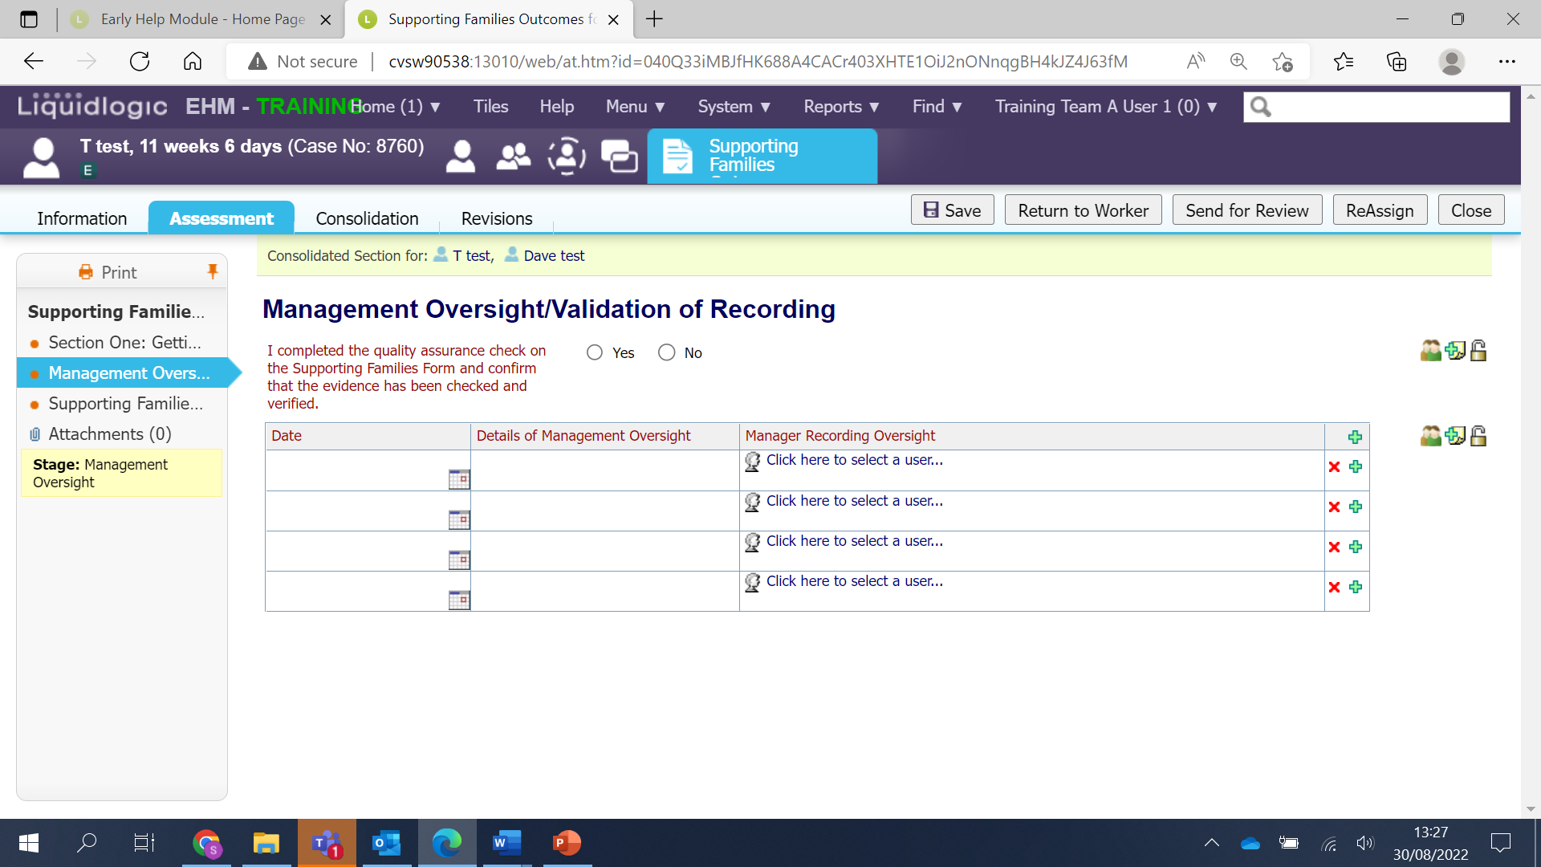
Helpful Contacts:
Troubledfamiliesdatateam@coventry.gov.uk
Steven.turner@coventry.gov.uk

