pharmaceutical Needs Assessment

Coventry City Council and Warwickshire County Council
2022 - 2025

Document Information
Document Name: | Pharmaceutical Needs Assessment
Published Date: | Saturday, 01 October 2022 | Version: | 1st | Release: | Final
Author: | Coventry and Warwickshire PNA Steering Group
Owner: | Coventry City Council & Warwickshire County Council
This document is only valid on the day it was printed.
The source of the document will be found at this location: https://www.coventry.gov.uk/data-reports/pharmaceutical-needs-assessment-pna

Contents
Document Information 2
Abbreviations 5
Recommendations 7
Introduction 10
Purpose of the Pharmaceutical Needs Assessment (PNA) 10
Background and Legislation 10
Health and Wellbeing Board Duties in Regard to pna 11
Scope of the PNA 11
Exclusions from the PNA 12
Minimum Requirements for a PNA 12
Approach to PNA 13
Determining Localities 13
PNA Steering Group 17
How the Assessment Was Done 17
Information Sources 19
Equality Assessment 19
Process of Formal Consultation 20
Other relevant work 21
JSNA 21
Health inequalities plan 21
Integrated Care Board (ICB) 22
Healthwatch 22
Integrated Pharmacy Medicines Optimisation (IPMO) 22
Local Picture 24
Population 24
Ethnicity 26
Household Languages 28
Index of Multiple Deprivation 29
Rural Deprivation Index for Health 36
Life Expectancy 37
Households & Housing Development Projections 38
Cost of Living Crisis 43
Car Ownership 43
General Health Needs 45
Physical Health 45
Long Term Conditions 48
COVID-19 51
Pharmacy Provisions and Access 57
Community Pharmacy Contractual Framework 57
Pharmaceutical Lists 57
Community Pharmacy Benchmarking 58
Access to Pharmacies in Coventry and Warwickshire 59
Pharmacy Services 85
Essential Services 85
Advanced Services 90
Enhanced and Locally Commissioned Services 99
Conclusion 117
Coventry 117
Warwickshire 119
Appendicies 121
Appendix 1 - Pharmacy Survey 121
Appendix 2 - Public Survey 126
Appendix 3 – Public Survey Question Feedback 134
Appendix 4 – Formal Consultation Feedback 145

Abbreviations
AUR.......................................................................................................Appliance Use Review BAME................................................................................................Black and Minority Ethnic CHWB.............................................................................Coventry Health and Wellbeing Board CCG............................................................................................Clinical Commissioning Group CVD.......................................................................................................Cardiovascular Disease COPD...........................................................................Chronic Obstructive Pulmonary Disease CPCF……………………………………..……….Community Pharmacy Contractual Framework
CPCS..................................................................Community Pharmacist Consultation Service
DAC……………………………………………………………….Dispensing Appliance Contractors DD……………………………………………………………………………….…Dispensing Doctors DH..............................................................................................................Department of Health DSP………………………………………………………………………Distance Selling Pharmacy EHC.................................................................................. Emergency Hormonal Contraception GP................................................................................................................General Practitioner HLP……………………………………………………………………….…Healthy Living Pharmacy HLS………………………………………………………………………….Healthy Lifestyle Service
HWB...............................................................................................Health and Wellbeing Board ICB………………………………………………………………………..……Integrated Care Board
ICS……………………………………………………………………………Integrated Care System
IPMO………………………………………………….Integrated Pharmacy Medicine Optimisation
ISHS………………………………………………………………Integrated Sexual Health Services
JSNA ....................................................................................Joint Strategic Needs Assessment LA……………………………………………………………………………………...Local Authorities LMC…………………………………………………………………………Local Medical Committee LPC.........................................................................................Local Pharmaceutical Committee LSOA………………………………………………………………………Lower Super Output Areas LTC…………………………………………………………………………..…Long Term Conditions NMS…………………………………………………………………………..New Medicines Service NHS BSA………………………………………………………….NHS Business Services Authority NHSE ......................................................................................National Health Service England
NHSI………………………………………………………..…National Health Service Improvement NICE……………………………………………………..…National Institute for Clinical Excellence NUMSAS………………………………………………..NHS Urgent Medicines Advanced Service OOH………………………………………………………………………………………..Out of Hours ONS……………...………………………………………………………..Office of National Statistics NRT........................................................................................... Nicotine Replacement Therapy PCN......................................................................................................... Primary Care Network PHE………………..……………………………….…………………………..Public Health England PNA.................................................................................... Pharmaceutical Needs Assessment PSNC……………………………………..……..Pharmaceutical Services Negotiating Committee SAC.......................................................................................... Stoma Appliance Customisation STI.............................................................................................. Sexually Transmitted Infection SWFT…………………………..…………………………….South Warwickshire Foundation Trust
UHCW……………………………………………….University Hospital Coventry & Warwickshire UK …………………………..………………………………………...............…….. United Kingdom WHWB…………………………………………………….Warwickshire Health & Wellbeing Board

Recommendations
Taking into account current service provision and other factors that may affect need for pharmaceutical services in the future; the following recommendations have been put forward:
- Currently there is a sufficient provision of pharmacies. Supplementary statements will be produced by the Community Pharmacy Steering Group on behalf of both the Coventry and Warwickshire Health and Wellbeing Boards should there be a significant change across Coventry and Warwickshire or within localities. Significant new housing developments should also be considered.
- Consideration should be given to the increase in pressure on community pharmacies caused by the COVID-19 pandemic, particularly as the country enters a cost-of-living crisis.
- Consideration of any change within predominantly rural areas should be undertaken within the lifetime of the PNA.
- Consideration should be given to commissioning evening or weekend rotas if needed to support extended hours by general practice in addition to the current bank holiday rotas.
- There is an opportunity for more joined up work when it comes to signposting, both to and from community pharmacies. Community pharmacies should be continually consulted as to the best pathways for care. Patients, public, and other care settings should be provided with clear information on opening times, services offered (including provision of confidential consulting space), and alternative provisions when pharmacies are not open.
- Health Education England (HEE) training should be supported for prescribers in community pharmacies.
- The HEE Community Pharmacy Survey 2021 should be used when released later in 2022 to help understand community pharmacy workforce further, and support should be given to the delivery of an annual HEE Community Pharmacy Survey to build data and insight going forward, including use in the next PNA.
- Under the Hep-C service, pathways for referral to a confirmatory PCR test are currently under development. There is currently a limited pathway for PCR testing, so this pathway development should be supported.
- As the Smoking Cessation advanced service is a newly commissioned service pharmacies are still signing up to provide it. The number of pharmacies providing this service should be monitored whilst this initial sign-up is taking place. The referral pathway from Trusts into community smoking cessation services are being developed, this work should be supported as part of the NHS long term plan tobacco dependency work.
- There is an opportunity to develop pathways for the NHS Blood Pressure Check service from pharmacies and GPs straight through to lifestyle service for people who want support around lifestyle interventions.
- Partnership work needs to be done between Commissioners of Stop Smoking and Stop Smoking in Pregnancy locally commissioned services and pharmacies to identify the actions to increase activity across those pharmacies where behavioural support and prescribing is low, with a particular focus on areas of greatest need.
- Consideration should be given to the role of pharmacies within the NHS long term plan tobacco dependency commitment to deliver NHS funded tobacco dependence treatment services which includes inpatient, maternity, outpatients, and community settings.
- To achieve the national ambition outlined in the Drug Strategy 2021, more work will be required to improve the quality of services and expand the number of providers delivering supervised consumption and needle exchange programmes in Warwickshire. More work is required to map out the current provision to ensure there is fair and equitable provision countywide. Adequate provision will need to be sought in the more deprived areas and those with higher drug and alcohol prevalence. Individuals within these areas are more likely to have a range of health inequalities and poorer health outcomes.
- Within Coventry and Warwickshire work can be done to strengthen the pathways around the Stop Smoking in Pregnancy service (SSiPS), especially to encourage pharmacists to redeem and dispense the letters of recommendation. The SSiPS is commissioned separately to the generic Stop Smoking service, more promotion can be done between these 2 services to increase the number of pharmacies able to dispense NRT products to pregnant women.
- Local data shows that some Coventry residents are accessing Emergency Hormornal Contraception (EHC) in Warwickshire, this could be as Warwickshire doesn't have an upper age limit whereas Coventry does. Bringing the Integrated Sexual Health contracts together to one contract will enable the current pharmacy offers to be aligned, this will help to reduce service user confusion as to what is offered where and to whom.
- Pharmacies provide a convenient access to End of Life medicines throughout Coventry and Warwickshire. At present there is a limit to the number of pharmacies commissioners can commission to provide the End of Life medicines service. This is currently being reviewed, and a supplementary statement to this PNA will be produced if there is any change in this service.
- There are different sharps service collections in place which can be unclear to both the public and pharmacies, such as the service provided by PHS which also collects sharps. Because of this, the quantity of sharps collected by the locally commissioned service Sharps Disposal in Warwick District has been minimal. To help with this the following opportunities have been identified:
  - Provide clarification on the different services to clear up confusion for pharmacies and patients, including over the size of sharps containers accepted with the different services.
  - Provide better communication between pharmacies who provide a sharps disposal service and GPs so better signposting can be done.
Additionally, consideration could be given to expanding the service to cover Coventry and Warwickshire to create equitable access.

Introduction

Purpose of the Pharmaceutical Needs Assessment (PNA)
The purpose of the PNA is to assess local needs for pharmaceutical service provision across Coventry and Warwickshire. It should identify any gaps in service or unmet needs of the local population. It should also identify any services that pharmacies could provide to address these needs, and to promote Coventry and Warwickshire’s population to improve uptake of these services. It is a tool to enable Health and Wellbeing Boards (HWBs) to identify the current and future commissioning of services required from pharmaceutical service providers.
Coventry City Council and Warwickshire City Council HWBs approached the development of the 2022 PNA as a collaborative project, with one report being produced for both areas. This decision was taken due to the interconnectivity of health and care systems across Coventry and Warwickshire, the joint recommissioning of several services which community pharmacies are involved in, and creating a consistency for a population who access services across both areas.
The 2022 PNA replaces the 2018 PNA for both Coventry and Warwickshire, which were done as separate reports.

Background and Legislation
The responsibility for producing and updating PNAs was changed from Primary Care Trusts (PCTs) to Health and Wellbeing Boards by The Health and Social Care Act 2012. In 2013 this was followed by the NHS Pharmaceutical and Local Pharmaceutical Services Regulations introducing a statutory requirement on Health and Wellbeing Boards to publish and update a statement of needs for pharmaceutical services for their area. Local Authorities (LA) and Integrated Care Boards (ICBs) have equal and joint responsibility for producing the Joint Strategic Needs Assessment (JSNA), through the HWB.
NHS England uses PNAs when assessing applications for opening new pharmacies, and to help make informed decisions on the commissioning of NHS funded services that are provided by local community pharmacies and other pharmaceutical providers.
A PNA published by a Health and Wellbeing Board has a maximum lifetime of three years, after which a new PNA will need to be produced.

Health and Wellbeing Board Duties in Regard to pna
Health and Wellbeing Boards work to improve health and wellbeing and reduce inequalities through partnership working and collaboration. Health and Wellbeing boards became statutory bodies on the 1^{st of} April 2013 and every Local Authority has a Health and Wellbeing Board.
A revised PNA needs to be published within three years of a Health and Wellbeing Board producing their first assessment. If significant changes take place to the availability of pharmaceutical services the board are required to publish a revised assessment as soon as reasonably practical, unless producing a revised assessment would be a disproportionate response to those changes. If producing a revised assessment is deemed to be a disproportionate response, a supplementary statement should be produced. The board will publish subsequent PNAs every three years to comply with regulatory requirements.

Scope of the PNA
A PNA is defined as:
“The statement of the needs for pharmaceutical services which each HWB is required to publish by the virtue of section 128A of the 2006 Act(1) (pharmaceutical needs assessments), whether it is the statement of its first assessment or of any revised assessment, is referred to in these Regulations as a pharmaceutical needs assessment.” - http://www.legislation.gov.uk/uksi/2013/349/part/2/made
The PNA informs both professional bodies and the public about the need for pharmaceutical services, and will consider pharmaceutical services as all services delivered through pharmacies, dispensing doctors, or appliance contractors that are commissioned on a national or local basis in Coventry and Warwickshire.

Exclusions from the PNA
Pharmacy provisions in prisons or in secondary care settings such as hospitals will not be considered as part of the PNA. Whilst the PNA does not assess pharmaceutical services in secondary care settings, it is important to ensure the smooth transition of patients moving in and out of hospital that creates the seamless continuity of support around medicines.
Distance selling of medicines and appliances that residents may use are not considered by the PNA. This is because they are available nationally and aren’t localised to a LA, ICB, or NHS England area team. The service provision from these providers has therefore not informed the decision-making process in the PNA.

Minimum Requirements for a PNA
A statement of the following must be included as a minimum, as set out in schedule 1 of the NHS 2013 Regulations:
Necessary services – services which have been assessed as required to meet a pharmaceutical need. This should include both their current provision (inside the Health and Wellbeing board area and outside of their area within a range that may affect the provision within the area), and any gaps, either current or likely to occur in the future.
Relevant services – services that have created better access to pharmaceutical services. This should include both their current provision (inside the Health and Wellbeing board area and outside of their area within a range that may affect the provision within the area), and any gaps, either current or likely to occur in the future.
Other NHS services – Services that either impact the need for pharmaceutical services or create better access to pharmaceutical services within the area. These are provided or arranged by a LA, NHS England, a ICB, an NHS Trust or Foundation Trust.
Map of pharmaceutical services – a map showing the places where pharmaceutical services are provided and assess the implications of distance to these places.
Explanation of assessment – an explanation of how the assessment was made, including details of the public and pharmaceutical surveys that have been undertaken.

Approach to PNA

Determining Localities
Warwickshire is a two-tier local authority and is made up of 5 district and borough areas with an area of 1975km², whereas Coventry is a single-tier authority with an area of 99km². The geographical size of Coventry is equivalent to one of the district or boroughs within Warwickshire. Coventry is a high density area with a population of approximately 3100 individuals per square kilometre. Warwickshire has pockets of high density population but also considerable rural areas, with a population of approximately 296 individuals per square kilometre.
Coventry will be considered as one locality and Warwickshire will reflect it’s five districts and boroughs. These localities are used for many of the Local Authority and Health and Wellbeing Board resources and documents, and so creates logical cross referencing with the PNA. They also correlate with the new JSNA Geographies that were approved by the JSNA Strategic Group in June 2017.
The localities are therefore defined as (Figure 1):
- Coventry
- North Warwickshire Borough
- Nuneaton & Bedworth Borough
- Rugby Borough
- Stratford-on-Avon District
- Warwick District
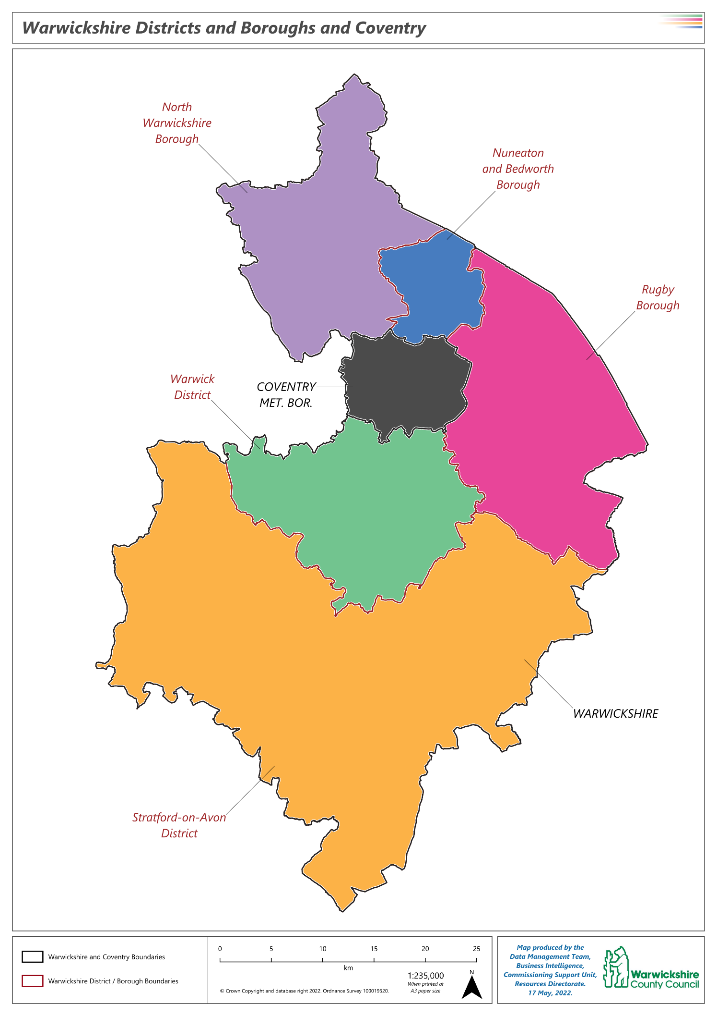
Figure 1: Map of localities
For the purpose of this PNA, LSOA’s have been chosen as the unit of geography to capture more granular differences in needs and services. LSOA’s are ideal for the PNA as they are small enough to distinguish different characteristics of areas within the localities of Coventry and Warwickshire, and large enough for statistical information to be meaningful.
Figure 2 shows the LSOA’s within Coventry:
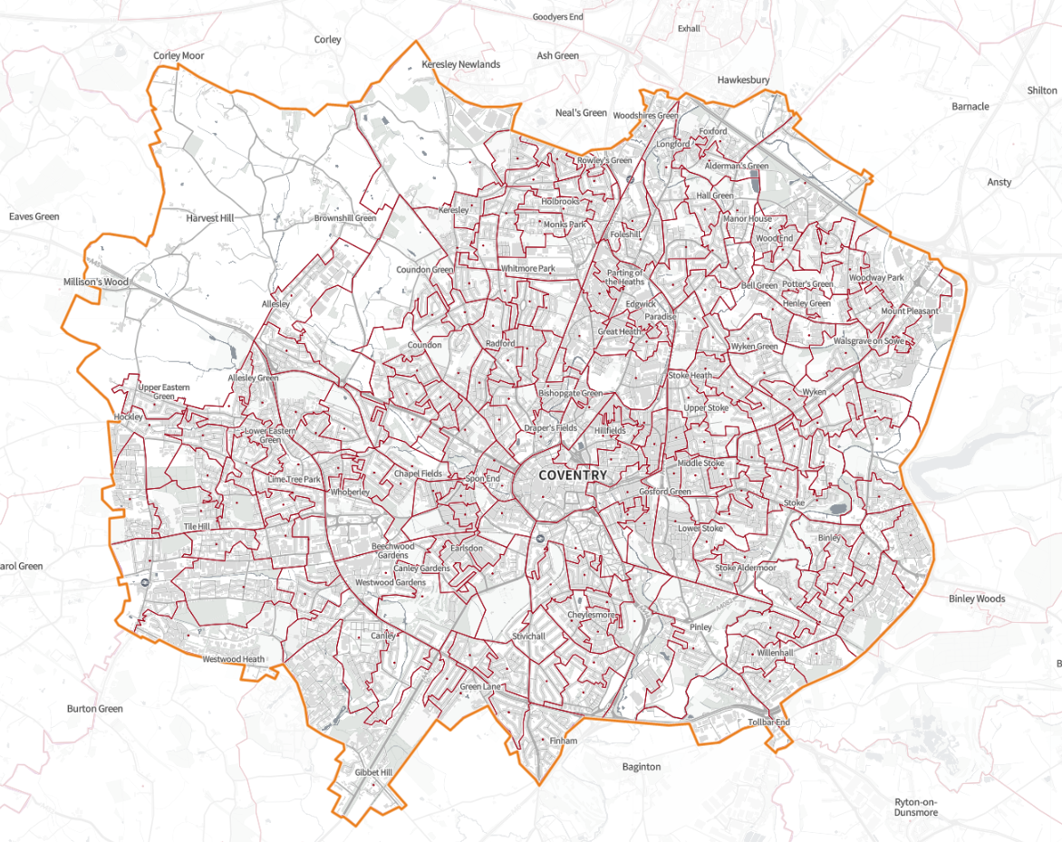
Figure 2: Map of LSOA’s within Coventry
Source: SHAPE
Figure 3 shows the LSOA’s within Warwickshire:
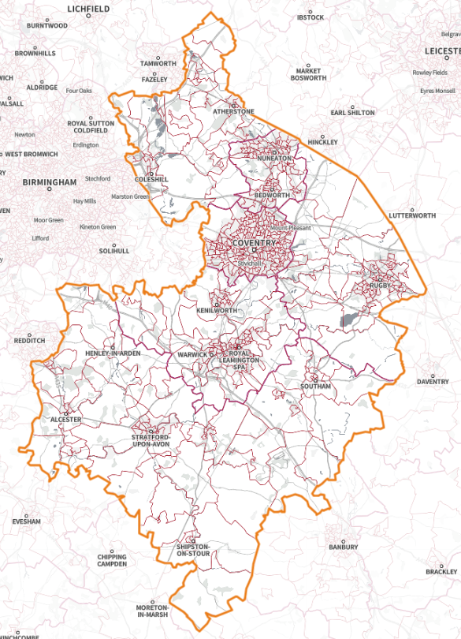
Figure 3: Map of LSOA’s in Warwickshire
Source: SHAPE

PNA Steering Group
The Health and Wellbeing Boards of Coventry and Warwickshire are approaching the development of the PNA as a collaborative project, with one report being produced to cover both Local Authorities, in accordance with the regulations.
The development of the PNA is being overseen by one multi-disciplinary steering group which includes representation from organisations for both the Coventry and Warwickshire areas such as the Warwickshire Local Pharmaceutical Committee (LPC), Coventry LPC, Healthwatch and local ICBs. The steering group has the following responsibilities:
- Reviewing the PNA to ensure it meets the statutory requirements.
- Approving all public facing documentation.
- Providing advice on the best method to integrate/align the PNA to the Joint Strategic Needs Assessment (JSNA).
- Providing advice and information to the Health and Wellbeing Boards about community pharmacies in the area.
- Providing advice and information to the Health and Wellbeing Boards about the potentials of community pharmacy to address health inequalities as addressed by the JSNA.
- Providing leadership in developing a single robust PNA across Coventry and Warwickshire.
- Ensuring the engagement and involvement of relevant people/bodies in the development of the PNA.

How the Assessment Was Done
Pharmaceutical Needs Assessments were due to be renewed and published by Local Authority Health and Wellbeing Boards in April 2021. Due to the pressures in response to the COVID-19 pandemic, the Department of Health and Social Care announced that the requirement to publish renewed Pharmaceutical Need Assessments was suspended until October 2022.
The process of developing the PNA has taken into account the requirement to involve and consult with patients and professionals about changes to health services. All specific legislative requirements in relation to the development of PNAs were duly considered and adhered to.
Stage 1
A project management approach was used to develop the PNA and so a steering group was established which met regularly during the development of the PNA. The views of stakeholders were gathered through feedback in meetings, via telephone or feedback online via email.
Stage 2
A pharmacy survey and a public survey were developed to capture the views of Coventry and Warwickshire residents on the current pharmaceutical services provision available in Coventry and Warwickshire. The content of the surveys was then approved by the steering group. The surveys were undertaken in Feb/March 2022. Following the closure of the surveys the responses were analysed.
Stage 3
Following the initial data collection period, results were collated and analysed in April/May 2022 and a summary of current provisions and the gaps in provision of pharmaceutical services was identified and fed back into the draft report. The content of the PNA including demographics, localities and background information was approved by the steering group.
In addition to taking account of all views submitted from the stakeholders outlined above, this PNA considered several factors, including:
- The size and demography of the population across Coventry and Warwickshire
- Adequacy of access to pharmaceutical services across Coventry and Warwickshire
- Differing needs of individual localities within Coventry and Warwickshire
- NHS services provided in or outside Coventry and Warwickshire’s area which affect the need for pharmaceutical services.
- If further provision of pharmaceutical services would secure better access to pharmaceutical services.
- The impact of predicted changes to the size of the population, the demography of the population and changing needs in the future which could lead to gaps in the provision of pharmaceutical services.
Stage 4
As required by legislation, a 60-day consultation is necessary during the process of producing this document.

Information Sources
Various sources of information have been used to identify the local need and the priorities for the PNA. These are:
- Joint Strategic Needs Assessments
- Coventry and Warwickshire Strategic Transformation Plan
- Patient Experience Survey
- Pharmacy Contractors Survey
- Office of National Statistics (ONS), Census data 2011
- Public Health Sources (i.e. Coventry City Council and Warwickshire County Council)
- Healthwatch Annual Report 2016/17
This data has been combined to provide a picture of the Coventry and Warwickshire population, their current and future health needs and how pharmaceutical services can be used to support the Coventry and Warwickshire Health and Wellbeing Boards to improve the health and wellbeing of the Coventry and Warwickshire population.
The following should be noted about the data in this PNA:
- We will receive new census data in July 2022, however due to the consultation timeline for report release before October 1st we will not receive this data in time to include in this report. Once we have received the 2022 census data, should the current picture and predications need updating, we will produce a supplementary statement noting any updates.
- There is a slight discrepancy between the pharmacies presented in the SHAPE mapping tool and the formal pharmacy list received for this PNA. Whilst we acknowledge the discrepancy, it has been decided that the SHAPE tool still reflects an accurate picture of need within Coventry and Warwickshire, and therefore it is appropriate to use.

Equality Assessment
The Public Sector Equality Duty (PSED) was introduced via the Equality Act 2010. It ensures that Councils and other public bodies consider how different people will be affected by their activities and services.
The council must have due regard to the need to:
- Eliminate discrimination, harassment, and victimisation.
- Advance equality of opportunity between people who share a protected characteristic and people who do not share it.
- Foster good relations between people who share a protected characteristic and people who do not share it.

Process of Formal Consultation
Under the 2013 regulations, there is a requirement to consult at least once on a draft of the PNA during the process and this consultation period must last for a minimum of 60 days.
The regulations set out that Health and Wellbeing Boards must consult the following bodies at least once during the process of developing the PNA:
- Any Local Pharmaceutical Committee (LPC) for its area
- Any Local Medical Committees (LMC) for its area
- Any persons on the pharmaceutical lists and any dispensing doctors list for its area
- Any LPS chemist in its area
- Any Local Healthwatch organisation for its area
- Any NHS trust or NHS foundation trust in its area
- The National Health Service Commissioning Board (NHSCB) and any neighbouring Health and Wellbeing Boards.

Other relevant work

JSNA
The JSNA, provides the evidence base for understanding the needs of the local population. It is used to inform the Health and Wellbeing Strategy, along with specific commissioning decisions.
The JSNA contains a more complete analysis of health in Coventry and Warwickshire. In Warwickshire a place based approach to the JSNA was taken between 2017-2020, which focused on each of the 22 Warwickshire JSNA Geographies. Following that programme a thematic approach has been adopted.
Coventry undertook a place-based approach between 2018-2020 producing a citywide JSNA analytical profile, as well as profiles for each of the city’s eight Family Hub reach areas. In addition to this, detailed statistical data and evidence is available in the Citywide Intelligence Hub which provides tools to compare and contract metrics and indicators.

Health inequalities plan
Reducing health inequalities is core to the role of the Coventry and Warwickshire Integrated Care System (ICS). The ICS Health Inequalities Strategy sets out the system wide approach to tackling health inequalities based on the Kings Fund Model of Population Health. It recognises the importance of the wider determinants, healthy lifestyles, local communities and health and care services in reducing health inequalities. The ICS has adopted the Core20+5 framework for health inequalities; in addition to populations living in the more deprived areas the ICS will specifically consider newly arrived and transient communities as these groups experience significant health inequalities. The strategy will be delivered by embedding reducing health inequalities across all programmes of work and prioritising resources to communities with the greatest needs.

Integrated Care Board (ICB)
As part of the Health and Care Act 2022, 42 Integrated Care Systems (ICSs) will be established in England on a statutory basis as of 1st July 2022. An ICS will include an Integrated Care Board (ICB) which is a statutory NHS organisation responsible for developing a plan for meeting the health needs of the population, managing the NHS budget, and arranging for the provision of health services in the ICS area. Once these are legally established the current Clinical Commissioning Groups (CCGs) will be abolished.

Healthwatch
Healthwatch is there to listen and understand the needs, experiences and concerns of its local people and communities and how they experience health and social care services (such as dentists, GPs, hospitals, and community pharmacies). They take this feedback to NHS and other key decision makers to ensure they use feedback to improve services and standards of care. Healthwatch supports individuals through our information and signposting service to find reliable and trustworthy information about local services such as community pharmacy.
Healthwatch Coventry is provided by Voluntary Action Coventry, and the steering group is made up of individual local people and local voluntary organisations who set the topics and the direction of the Healthwatch work.
Healthwatch Warwickshire is an independent service for everyone who uses health and social care services in Warwickshire and is governed by a strategic board to ensure the legal and statutory obligations are met.

Integrated Pharmacy Medicines Optimisation (IPMO)
The NHS Five Year Forward View highlighted the need to communicate between organisations. In order to address this need, the formation of Sustainability and Transformation Partnerships (STP) and the shift to Integrated Care Systems (ICS) occurred.
More work is needed to deliver the best patient outcomes from medicines and value to the taxpayer. This is a key priority for the Integrating NHS Pharmacy and Medicines Optimisation programme. This programme relies on the expertise of pharmacy professionals to systemically tackle the medicines optimisation priorities for the local population in an STP/ICS footprint.
Seven pilot sites were selected, one from each of the NHS regions. The main finding of these sites has been that for a successful local medicine optimisations programme a named system-wide lead supported by a collaborative senior leadership group with a pharmacy professional lead role sitting in the STP/ICS structure is essential.
The board meets regularly following several workstreams. Representation on the IPMO includes all the Chief Pharmacists from the Trusts, Head of Medicines Management of the ICB, Chief Executive Officer LPC, and Chair of LPN for Pharmacy.
From an IPMO perspective, the group have prioritised the following for the Coventry and Warwickshire system:
- Workforce/Training & Education
- Digital Medicines
- Clinical Pharmacy
- Aseptic Production
- Medicines Supply/Medicines Value
- Quality Improvement & Surveillance
- Medicines Safety & Governance
- Emergency Department – Reducing unnecessary attendance through Community Pharmacy (ED CPCS)
- Discharge Medicines Service (DMS)
- Single ICS Formulary

Local Picture
In this section we will be discussing the local demographics within Coventry and Warwickshire. We have identified key demographics that have an impact on community pharmacy usage such as:
- People aged 55+ are more likely to use community pharmacy on a regular basis
- People from ethnically diverse communities may require consideration when accessing pharmacy services, especially regarding the diversity of languages spoken across Coventry and Warwickshire
- People who live in areas of deprivation are more likely to have a shorter healthy life expectancy and are therefore more likely to need access to healthcare services earlier, including community pharmacy
- Areas of high population density will have higher demand for community pharmacy, so it is important to consider new housing developments as an indicator of population and population density
- In the lifetime of this PNA there is a cost of living crisis which may affect people being able to afford over the counter medications
- It was acknowledged in the public survey that car travel was the most popular way to access community pharmacies, therefore it is important to consider car ownership and potential change in travel choice due to the cost of living crisis

Population
In 2020, the ONS estimated the usual resident population of Warwickshire to be 583,786 split between 288,334 (49%) males and 295,452 (51%) females. Within Coventry, the ONS estimated the population to be 379,387 persons, of whom 193,290 (51%) were males and 186,097 (49%) were females. When compared to England, Warwickshire has an older population, with 27% of the population being aged 60 or over compared to 24% in England. In comparison, Coventry has a younger population profile with 17% of the population aged 60 or over and 37% aged between 20-39. The age distribution varies across Warwickshire with more rural areas such as North Warwickshire and Stratford-on-Avon having older populations and Warwick District having a large population of those aged between 20-29 (24,331, 17%).
% Population
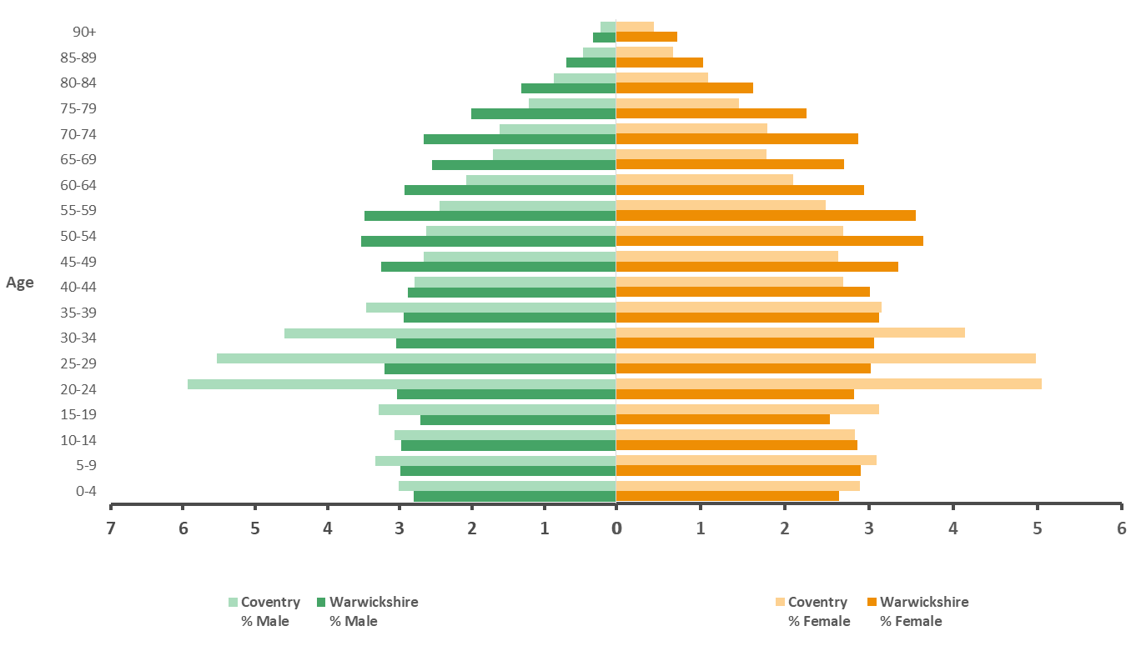
Figure 4: Mid 2020 Population estimates for males and females in Coventry and Warwickshire
Source: ONS Mid-year population estimates 2020

Age Group | Coventry | Warwickshire | North Warwickshire | Nuneaton & Bedworth | Rugby | Stratford-on-Avon | Warwick
0-19 | 25% | 22% | 21% | 24% | 25% | 21% | 22%
20-39 | 37% | 24% | 22% | 25% | 24% | 20% | 29%
40-59 | 21% | 27% | 28% | 27% | 27% | 27% | 25%
60+ | 17% | 27% | 28% | 25% | 24% | 32% | 24%
Table 1: Percentage age breakdown between localities
Source: ONS Mid-year population estimates 2020
In the three years to mid-2020, the population of both Coventry and Warwickshire increased but the drivers of this growth differed. In Coventry, net internal migration was negative at 9,550 meaning more people left to live elsewhere in the country than those who moved in. Net international migration into Coventry was far higher at 24,987 leaving Coventry with a population 15,437 higher in 2020 compared to 2017.
In Warwickshire, internal and international migration were both net positive, with internal migration making up 86% of the total net increase.
The population of both Coventry and Warwickshire are projected to increase in the future. By 2030, the population of Coventry is projected to increase to 419,366 persons (10.5%) whilst Warwickshire is projected to increase to 630,395 (8%). All districts within Warwickshire are projected to increase in population with the largest increases in North Warwickshire (11%) and Stratford-on-Avon (12%).
 | 2030 PROJECTED PERCENTAGE OF POPULATION (%)
Age Group | Coventry | +/- 2020 | Warwickshire | +/- 2020
0-19 | 25 | +0.3 | 22 | -0.4
20-39 | 36 | -0.6 | 24 | -0.4
40-59 | 21 | -0.2 | 25 | -2.1
60+ | 18 | +0.4 | 30 | +3.0

Table 2: percentage of projected population by age group in Coventry and Warwickshire
Source: ONS population projections (2020, reference period 2018)
By 2030, there is projected to be a 3 percentage point increase in those aged 60 and over in Warwickshire, with a decline in those primarily in the 40-59 age group. This shows that Warwickshire has an aging population on average. Coventry, in contrast, has a projected population structure that shows little change.
It is worth noting that these population figures are based on census data with more recent indicators like GP registrations used to estimate the current and project the future population. Whilst there was a census completed in 2021, the most recent available data at the time of writing is from 2011. The further away from a census, the less accurate estimates based on this data become.

Ethnicity
The Census (2011) is the most reliable study into the ethnicity composition of the population. Since this data is ten years old now, it should be viewed as a starting point whilst looking at other sources such as the school census. The School Census collects ethnicity data yearly which is provided by all state-funded schools in England. Comparing the 2011 Census data with the 2021 School Census, population changes in ethnicity can be estimated and projected. The population of Coventry is more ethnically diverse than the population of Warwickshire with 26% of the population reporting an ethnicity of non-white. (Figure 5), compared with Warwickshire’s 7%. This figure varies across Warwickshire with Rugby and Warwick reporting 10% and 9% respectively. 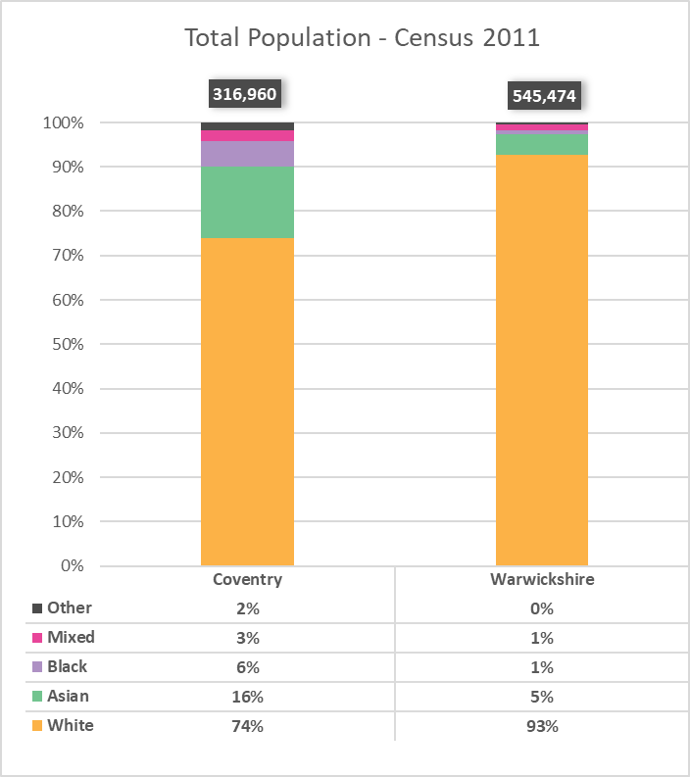
Figure 5: Total Population breakdown by Ethnicity
Source: Census 2011
When looking at the School Census ethnicity composition, it’s important to remember that this is a function of which population groups are growing, either by having children or through migration, not a direct comparison to total population data. The 2021 school population is more diverse than the 2011 Census data, with Coventry reporting 44% non-white and Warwickshire 15%.

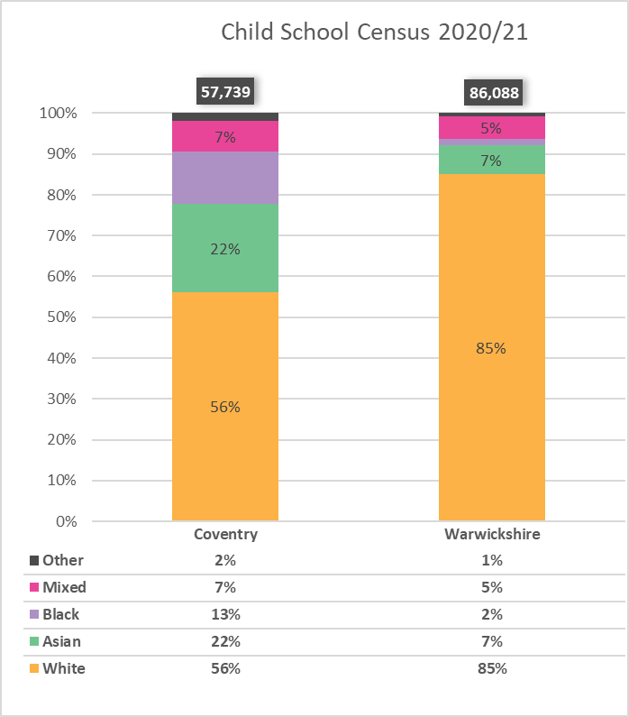
Figure 6: Child Ethnicity Breakdown
Source: Child School Census 2020/21

Household Languages
The 2011 Census also recorded the main language spoken in each household. In Coventry in 2011, only 84.6% of households had all occupants over the age of 16 speaking English as their main language. By comparison, 95% of households in Warwickshire were within this category. Furthermore, in 8.7% of Coventry households and 2.4% of Warwickshire households, English was not the main language of any occupant. The 2011 Census demonstrated that in Coventry, Nuneaton and Warwick Panjabi was the other most utilised main language whereas in North Warwickshire, Rugby and Stratford this was Polish.
This diversity of language is somewhat reflected in the more recent data of the 2020/21 School Census in which the first languages of pupils were recorded. It was noted that in Coventry, English was not the first language for 33.4% of pupils and in Warwickshire it was not the first language for 10.9% of pupils. This can be compared to England’s national average of pupils who do not speak English as their first language of 19.3%
Our current survey demonstrated that a pharmacy that spoke multiple languages was not a high priority. However, as our survey underrepresents BAME groups, language diversity might be something important to consider in the future to maintain accessibility to all.
Main Language | Coventry |  |  | Warwickshire
 | number | % | number |  | %
All categories: English as a household language | 128,592 | 100.0 | 231,005 |  | 100.0
All people aged 16 and over in household have English as a main language (English or Welsh in Wales) | 108,756 | 84.6 | 219,506 |  | 95.0
At least one but not all people aged 16 and over in household have English as a main language (English or Welsh in Wales) | 6,987 | 5.4 | 5,248 |  | 2.3
No people aged 16 and over in household but at least one person aged 3 to 15 has English as a main language (English or Welsh in Wales) | 1,679 | 1.3 | 704 |  | 0.3
No people in household have English as a main language (English or Welsh in Wales) | 11,170 | 8.7 | 5,547 |  | 2.4

Table 3: Main Language in a Household
Source: Census 2011

Index of Multiple Deprivation
All the Lower-layer Super Output Areas (LSOAs) in England (32,844) can be ranked according to their Index of Multiple Deprivation score. This allows users to identify the most and least deprived areas in England and to compare whether one area is more deprived than another. There are 195 LSOAs in Coventry with an average population of 1,900 residents. An area has a higher deprivation score than another if there is a higher proportion of people living there who are classed as deprived.
A geographical area itself is not deprived: it is the circumstances and lifestyles of the people living there that affect its deprivation score. It is important to remember that not everyone living in a deprived area is deprived, and that not all people experiencing deprivation live in deprived areas.
Figure 7 shows the LSOAs in Coventry ranked from most deprived to least deprived. The map shows particular areas of deprivation from the city centre into the North East of the city, as well as in the South East and pockets in the South West.
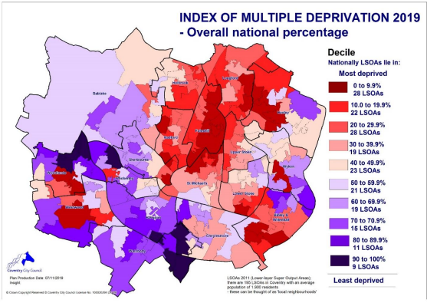
Figure 7: Coventry LSOAs by deprivation decile
Source: Index of Multiple Deprivation 2019

Figure 8 shows the LSOAs in Warwickshire ranked from most deprived (dark blue) to least deprived (light blue). The map shows particular areas of deprivation around North Warwickshire, Nuneaton and Bedworth, and Rugby.

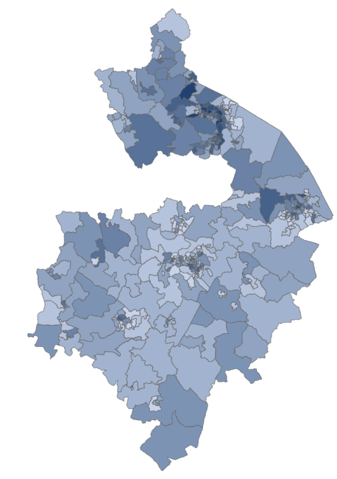

Decile 10
Decile 1
Figure 8: Warwickshire LSOAs by deprivation decile
Source: Index of Multiple Deprivation 2019

The SHAPE tool allows us to map pharmacies and other primary and secondary care settings across England. It also allows us to look at these with reference to the highest 20% of LSOAs on the IMD scale, Figure 9 shows us just these highest 20% of LSOAs.
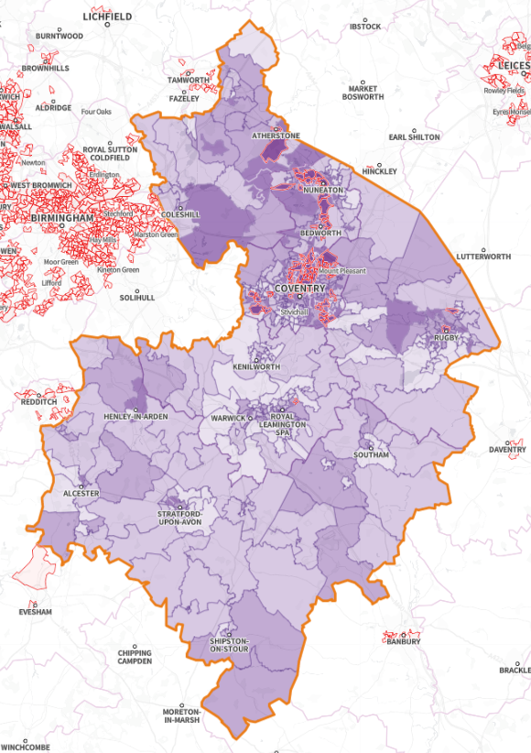
Figure 9: IMD with most deprived 20% in red outlines for Coventry and Warwickshire
Source: SHAPE
Figure 10 shows how IMD ranking has changed over time. An area which has “Fallen” by one or two deciles means that an LSOA has become relatively more deprived, where as an area which has “Risen” by one or two deciles means that an LSOA has become relatively less deprived.
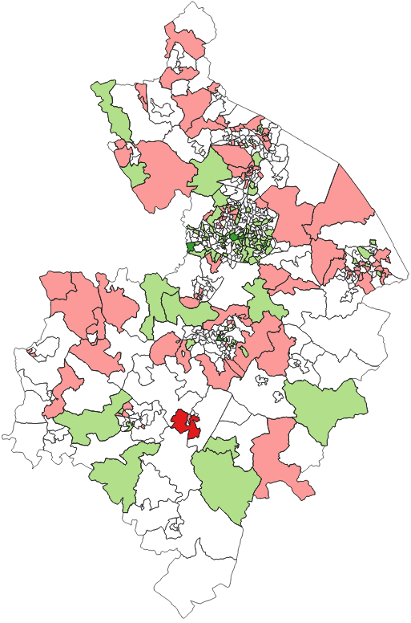 | Key  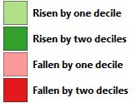  “Fallen” means that an LSOA has become relatively more deprived  “Risen” means that an LSOA has become relatively less deprived
Figure 10: IMD change in Coventry and Warwickshire
Source: IMD 2015 & 2019
Figure 11 focuses on Coventry, where three-quarters of LSOAs have risen by at least one decile. There is a pattern of greatest relative improvement in areas around the city centre, including parts of Hillfields and Charterhouse, radiating Southwards to parts of Cheylesmore and Eastwards to parts of Stoke and Binley. These are also the areas that have seen most notable and persistent relative improvement since the IMD 2010.
More recently, since 2015, there has also been a concentration of relative improvement near the city centre to the West, in Chapelfields and by Holyhead Road and Allesley Old Road. The recent improvements are often found in areas where students live, suggesting that the increase in full-time students studying in the city has been a factor in the improving deprivation measures.
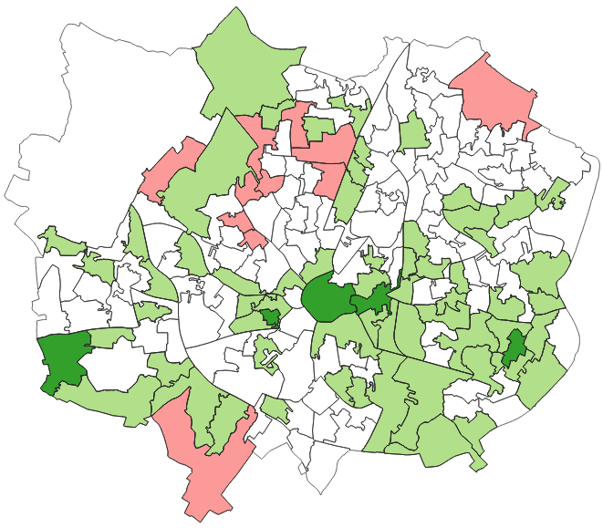
Figure 11: IMD change in Coventry
Source: IMD 2015 & 2019
Figure 12 shows the percentage of older people affected by income deprivation in Coventry and Warwickshire. Areas with a high percentage include areas within Coventry, Nuneaton and Bedworth, Rugby, and Leamington.

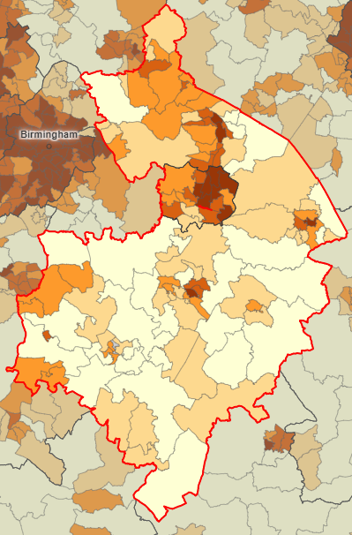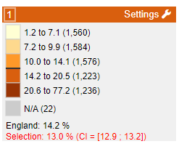
Figure 12: Percentage of older people affected by income deprivation
Source: SHAPE

Rural Deprivation Index for Health
The Rural Deprivation Index of Health is a new index that is designed to be more targeted for relevance to healthcare than the Index of Multiple Deprivation. Figure 13 shows that there are fewer LSOAs in red for Coventry and Warwickshire to indicate the lowest (most deprived) 10% on the Rural Deprivation Index for Health than there are for the lowest 20% of the IMD. These areas are still concentrated in Coventry, Bedworth, Nuneaton and Atherstone.
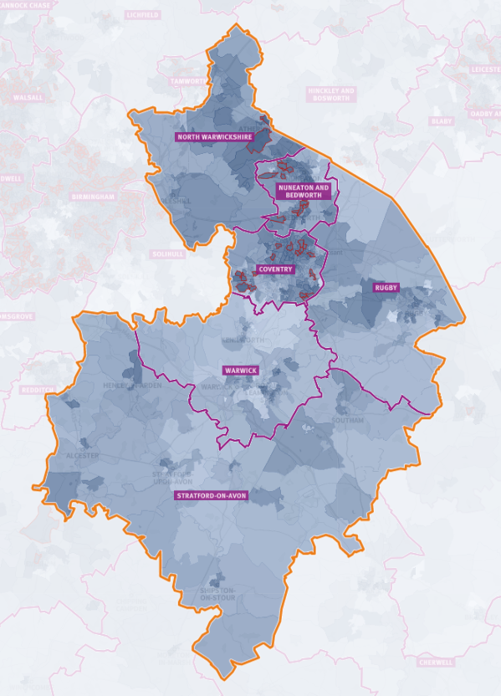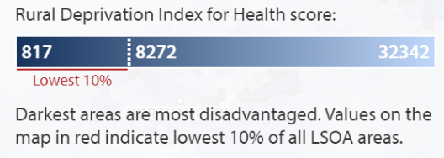
Figure 13: Rural Deprivation Index for Coventry and Warwickshire
Source: SHAPE

Life Expectancy
Life expectancy, on average, has fallen during the year 2020 for both men and women in Coventry and Warwickshire. Between the years 2018-20 a man was expected to live to an age of 79.31 and a woman to 83.07. However, in 2020 this is now 78.3 years, and 82.7 years respectively for men and women. This is more noticeable in the male population, especially those in Coventry where a drop in 1.77 years is seen over the year 2020. As male sex is a known factor for COVID-19 mortality, this drop in life expectancy might be due to the impact of COVID-19.
The areas of increased deprivation (Coventry, Nuneaton, Bedworth, and North Warwickshire) continue to have the lowest life expectancy. The most deprived areas, in England, had more than double the mortality rate from COVID-19 when compared to the least deprived areas, for both males and females. Therefore, we can expect COVID-19 to have affected the life expectancy in these areas with increased deprivation.
Figure 14: Male Life Expectancy at Birth over Time (3/1 Year Range)
Source: Fingertips

Figure 15: Female Life Expectancy at Birth over Time (3/1 Year Range)
Source: Fingertips

Households & Housing Development Projections
Table 4 shows the type and number of households across the 6 localities of this PNA. As seen in the population subchapter, Coventry has a high proportion of people aged 20 – 35 than Warwickshire, which can be seen in this figure with the high number of full-time student households in Coventry.
 | Coventry | North Warwickshire | Nuneaton and Bedworth | Rugby | Stratford-on-Avon | Warwick
Single Family Household | 75,186 | 17,709 | 34,720 | 27,494 | 34,498 | 35,403
Lone parent | 17,449 | 2,407 | 5,708 | 3,865 | 4,019 | 5,053
All children non-dependent | 5,053 | 899 | 1,735 | 1,190 | 1,486 | 1,705
Dependent Children | 12,396 | 1,508 | 3,973 | 2,675 | 2,533 | 3,348
Married or civil partnership couple | 37,696 | 9,904 | 18,939 | 15,243 | 19,898 | 19,657
All children non-dependent | 7,204 | 2,007 | 3,680 | 2,245 | 3,097 | 3,077
Dependent Children | 18,355 | 3,961 | 8,130 | 7,090 | 8,685 | 9,243
No Children | 12,137 | 3,936 | 7,129 | 5,908 | 8,116 | 7,337
Cohabiting couple | 11,071 | 2,911 | 5,492 | 4,451 | 4,444 | 5,690
All children non-dependent | 587 | 179 | 263 | 183 | 187 | 191
Dependent Children | 4,989 | 1,303 | 2,648 | 1,812 | 1,612 | 1,791
No Children | 5,495 | 1,429 | 2,581 | 2,456 | 2,645 | 3,708
All aged 65 and over | 8,970 | 2,487 | 4,581 | 3,935 | 6,137 | 5,003
One Person Household | 40,148 | 6,776 | 15,090 | 11,784 | 14,804 | 18,600
Aged 65 and over | 15,353 | 3,120 | 6,432 | 4,979 | 7,482 | 7,196
Other | 24,795 | 3,656 | 8,658 | 6,805 | 7,322 | 11,404
Other Household Type | 13,258 | 1,327 | 2,901 | 2,597 | 2,626 | 4,676
All aged 65 and over | 302 | 66 | 136 | 123 | 176 | 138
All full-time Students | 2,823 | 1 | 8 | 13 | 40 | 977
Other | 6,009 | 708 | 1,570 | 1,558 | 1,621 | 2,331
With dependent children | 4,124 | 552 | 1,187 | 903 | 789 | 1,230
Grand Total | 128,592 | 25,812 | 52,711 | 41,875 | 51,928 | 58,679
Table 4: Types of Household by Locality
Source: Census 2011
Figure 16 shows the net housing completions by Fiscal Year and Local Authority since the last PNA in 2018. A high number of completions can be seen in Coventry and Stratford-on-Avon, with the lowest being in North Warwickshire.

Figure 16: Net Housing Completions by Fiscal Year and Local Authority
Source: Authority monitoring reports from Warwickshire Boroughs and Districts & Coventry City Council website
Figure 17 shows the projected housing completions by Fiscal Year and Local Authority until 2028/29. Over the next 3 years there is a noticeable increase in completions in Coventry, and Nuneaton and Bedworth, whilst the number of completions in Stratford-on-Avon decreases over the next 3 years.

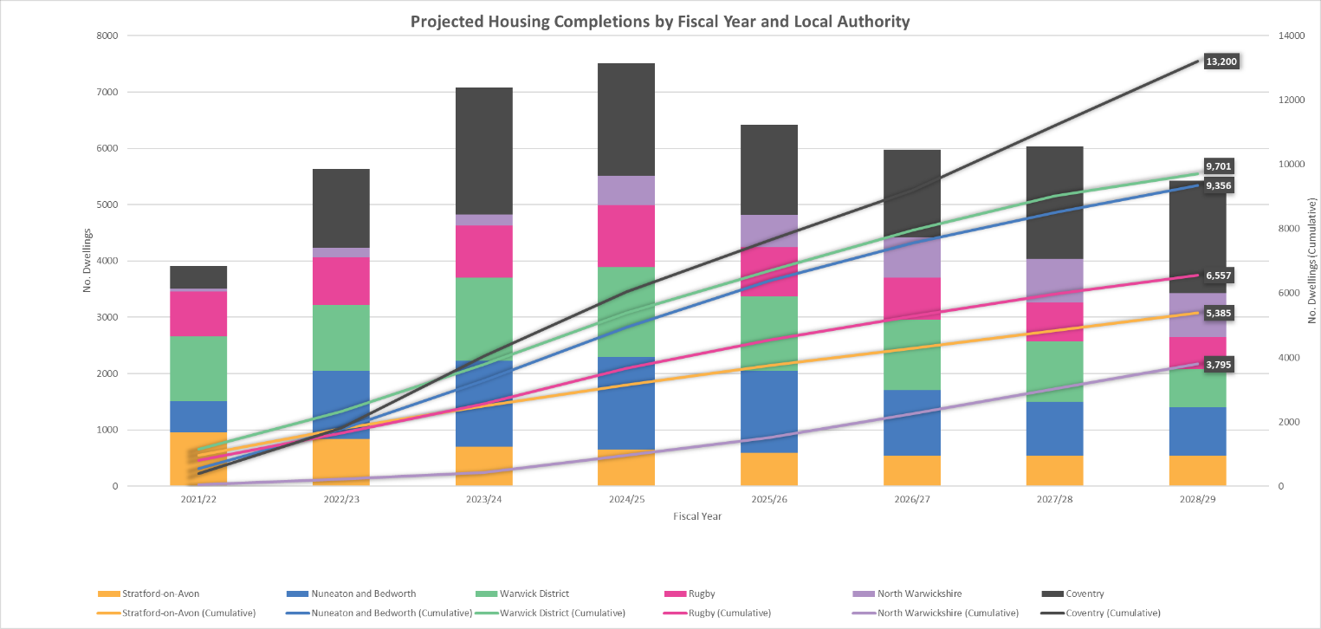
Figure 17: Projected Housing Completions by Fiscal Year and Local Authority
Source: Warwickshire Boroughs and Districts & Coventry City Council

Figure 18 maps the housing construction sites in Warwickshire and Coventry with 300 dwellings or more that have planning permission granted, or are to be started, to continue, or to be completed in the next five years. The circles map where these sites are, and the size and colour correlate to the size of the site. The largest site is located to the East of Rugby, with the next largest sites in the North West of Coventry, Lighthorne Heath in Stratford-on-Avon, and Lower Quinton in Stratford-on-Avon.
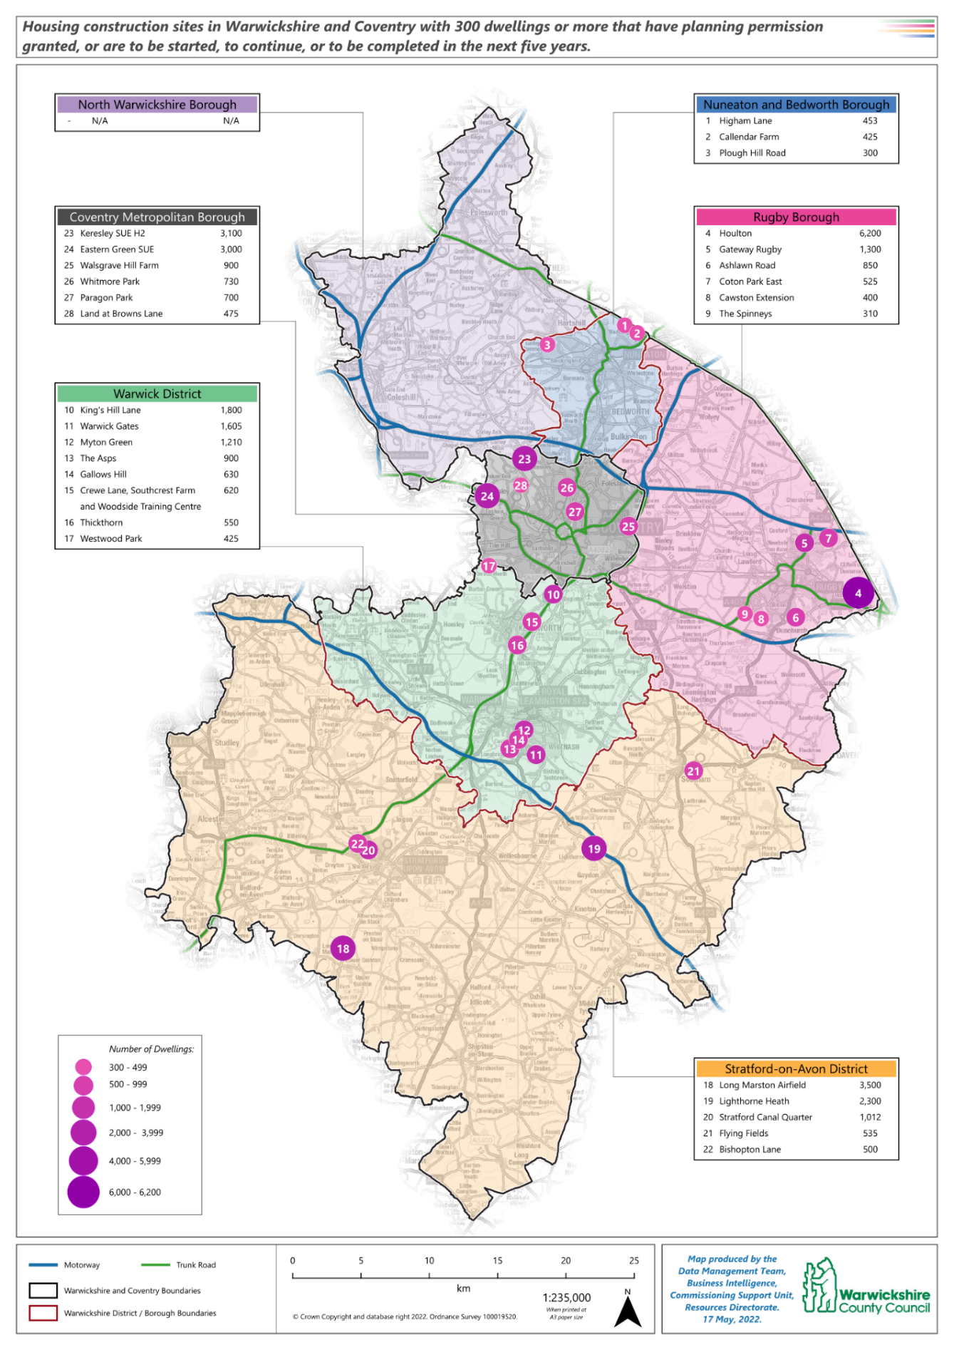
Figure 18: Housing Construction sites in Warwickshire and Coventry with 300 dwellings or more that have planning permission granted, or are to be started, to continue, or to be completed in the next five years
Source: Warwickshire Districts & Boroughs and Coventry City Council

Cost of Living Crisis
A cost of living crisis started in the second half of 2021 and is rapidly accelerating in first half of 2022. There is no indication that the cost of living crisis will be fully resolved within the duration of this PNA period. While this is primarily around home energy, fuel for vehicles, and food, it is affecting all areas of spending and debt levels. Other areas of concern that have already been noted by the local branch of Citizens Advice are the cost of public transportation and the cost of prescriptions. There is a reported reduction in subscriptions to online services, as well as anecdotal reports of some cancellations of home Internet services.
Therefore, there are ongoing risks to access to pharmaceutical services via: the direct cost of prescriptions, the cost of physical access via car or public transport, as well as the cost of digital access to online pharmacies.

Car Ownership
Consideration regarding car ownership is important due to accessibility of community pharmacy and the rising pressure of cost of living, including fuel prices. Our survey showed that 46.5% of respondents use cars/motorbike/van transportation, whilst 42% walk. This may certainly have an impact on how residents access pharmacies. Almost all of Warwickshire is within a 15-minute drive to a pharmacy, the exceptions being in South and Southeast of Stratford-on-Avon District, which are rural areas with low population density. The majority of Coventry is within a 5-minute drive to a pharmacy and all of Coventry is within a 15- minute drive. In addition to this most of these deprived areas in Coventry and Warwickshire are covered within a 16-minute cycle time.
With rising fuel prices, 44% of people have already driven their car less, and this is projected to increase. It is important to note that the 40-year high of inflation in April 2022 and the increase in petrol prices may lead the public to prefer to walk or take public transport. 72% of respondents in a Savanta survey of 4,011 UK adults on 10 June 2022 said that they had cut down on car journeys to save money in the previous 6 months.
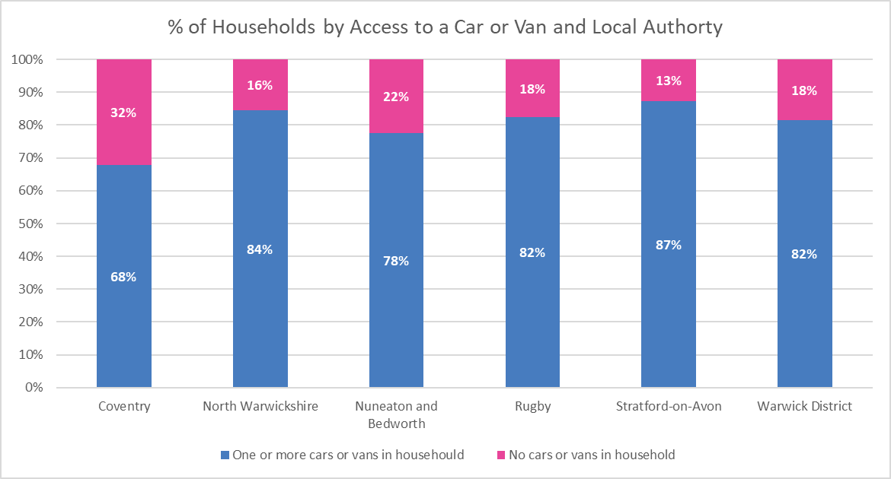
Figure 19: Percentage of households by access to a car or van and Local Authority
Source: Census 2011

General Health Needs

Physical Health
There are five conditions referenced within this section. How pharmacy supports these conditions is detailed in the “Pharmacy Provisions and Access” and “Pharmacy Services” chapters. What follows here is an overview of these conditions and the local rates across Coventry and Warwickshire.
Smoking
Smoking is the biggest cause of preventable deaths in England, accounting for more than 80,000 premature deaths each year. Smoking prevalence in adults aged 18+ has been falling nationally. In 2020 in England smoking prevalence was at 12.1% of adults aged 18+. Warwickshire is the same as the England rate (12.1%) whilst Coventry is slightly higher at 13.1% of adults aged 18+.
There is a clear relationship between smoking prevalence and affluence. People living in the most deprived areas are more likely to smoke than those living in the least deprived areas. Smoking prevalence is higher for those in routine and manual, as opposed to managerial and professional occupations. Most marginalised populations have very high rates of smoking – those who access services for drug and alcohol dependency usually also smoke tobacco.
Smoking in pregnancy results in an increased risk of complications during labour and risk of miscarriage, premature birth, stillbirth, low birth weight, sudden unexpected death in infancy, and infant mortality. Table 5 shows the percentage of women smoking at the time of booking an appointment with their midwife. Compared to the England average, Coventry has a higher percentage and Warwickshire has a lower percentage.
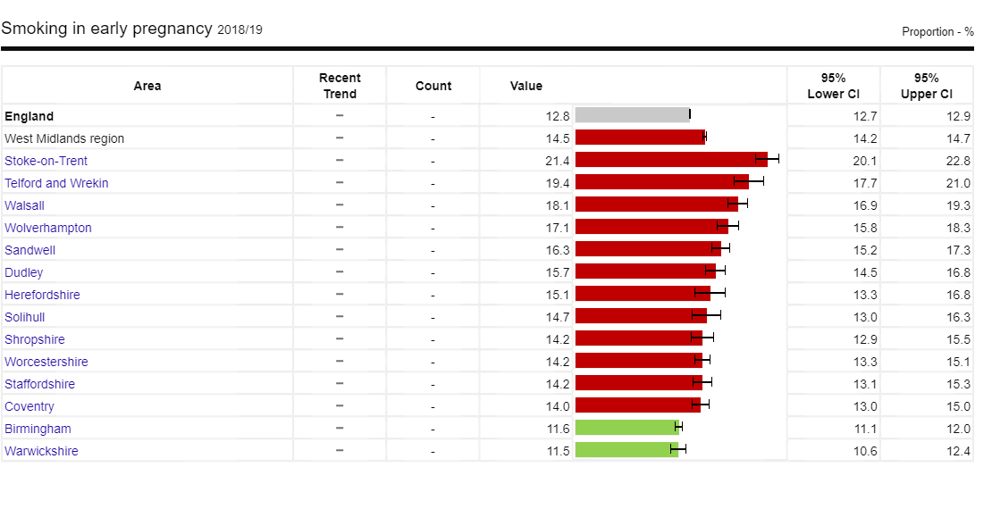
Table 5: Percentage smoking in early pregnancy
Source: Fingertips
In 2019/20 smoking was responsible for 506,100 hospital admissions. This represents 4% of all hospital admissions during that time period. As smoking has an impact on various systems of the body it can be attributable to many diseases such as respiratory, circulatory and cancer. There are many methods to stop smoking, prescriptions being one of them. During 2019/20, 710 thousand prescription items were dispensed to help people stop smoking. Currently there is ongoing work to encourage people to stop smoking in hospitals and to support them in the community.

Alcohol
Alcohol misuse is when you drink in a harmful way or when you are dependent on alcohol. Men and women are advised not to drink more than 14 units of alcohol a week on a regular basis. Short term risks of alcohol misuse include accidents and injuries, violent behaviour, unprotected sex, loss of personal possessions and alcohol poisoning. Long term effects increase your risk for heart disease, stroke, liver disease, liver cancer, bowel cancer, mouth cancer, breast cancer and pancreatitis. As well as these serious problems, long-term alcohol misuse can lead to other problems such as unemployment, divorce, domestic abuse, and homelessness.
The rate for admission episodes for alcohol-related conditions per 100,000 has risen nationally from 473.2 per 100,000 in 2016/17 to 494.4 in 2018/19. Larger increases have been seen in both Coventry and Warwickshire over that period, with Coventry increasing from 578.9 per 100,000 in 2016/17 to 691.8 in 2018/19, and Warwickshire increasing from 452.1 per 100,000 in 2016/17 to 525.4 in 2018/19.

Substance Misuse
Substance misuse develops when a person continually takes a substance that changes the way that person thinks and feels. This includes drugs, alcohol, and food. The most commonly misused substances are stimulants, opiates, cigarettes, alcohol, and food. Misusing substances can affect both your physical and mental health, and can affect the way you behave, causing problems with relationships, jobs, and daily life.
The rate for hospital admissions due to substance misuse in 15-24-year-olds in England for 2018/19 to 2020/21 is 81.2 per 100,000. Coventry has a lower rate at 66.5 per 100,000, and Warwickshire has a similar rate of 83.8 per 100,000.
The number of people living with chronic Hepatitis C virus infection in England has fallen dramatically by 37% since 2015 to 81,000 in 2020, with many of those drawn from marginalised and underserved groups in society such as those who inject drugs. In Coventry and Warwickshire this decrease is largely driven by new treatments worked on by Change Grow Live (CGL) and University Hospital Coventry & Warwickshire (UHCW) to get drug users into treatment and completing their drug regimen. Despite this decrease it is still important to retain focus to control and minimise community transmission.

Healthy Weight
Being overweight or obese can increase the risk of developing a range of health problems such as coronary heart disease (CHD), type 2 diabetes, some cancers, stroke, as well as reducing life expectancy. The consequences of obesity can also have adverse social effects through discrimination and social exclusion.
The percentage of adults 18+ who are classified as overweight or obese in England has remained level over time, from 72.7% in 2016/17 to 72.1% in 2019/20. In Coventry it has also remained level, from 64.3% in 2016/17 to 65.4% in 2019/20, however in Warwickshire there has been a rise in levels, from 58.6% in 2016/17 to 63% in 2019/20.
Sexual Health
Teenage pregnancy and early motherhood have been associated with poor education attainment, poor physical and mental health, and deprivation. In England the under 18s conception rate per 1,000 females aged 15-17 is 13. In Coventry this is higher at 19.5, and in Warwickshire it is a similar level at 13.2.
The England rate for New STI diagnoses was increasing from 817 per 100,000 in 2016 to 917 per 100,000 in 2019. It then had a sudden fall in 2020 to 619 per 100,000 (possibly impacted by the pandemic). Warwickshire has seen a decrease from 651 per 100,000 in 2016 to 625 per 100,000 in 2019 before a similar fall to 422 per 100,000 in 2020. Coventry has also seen a decrease from 866 per 100,000 in 2016 to 786 per 100,00 in 2019 before a similar fall to 619 per 100,000 in 2020.

Long Term Conditions
There are five long term conditions referenced within this section. How pharmacy supports these conditions is detailed in the Current Provisions and Services chapter. What follows here is an overview of these conditions and the local rates across Coventry and Warwickshire.
Cancer
One in every two people in England will be told they have cancer at some point in their lives. The NHS Long Term Plan aims to help an extra 55,000 people each year to survive for five years or more following their cancer diagnosis by 2028. This will include improving national screening programmes, giving faster access to diagnostic tests, investing in cutting edge treatments and technologies, and making sure more patients can quickly benefit from precise, highly personalised treatments as medical science advances.
The percentage of deaths with underlying cause of cancer in all ages has stayed at a similar level nationally, with the percentage in 2016 being 28% and in 2019 27.9%. In 2020 this saw a decrease to 24.3%, perhaps due to access to health services during the pandemic. Warwickshire has shown a slight increase between 2016 (26.7%) to 2019 (28.1%) before seeing a similar drop in 2020 to 24.3%. Coventry has stayed at a similar level, with 27.1% in 2016 and 27.2% in 2019, before a similar drop in 2020 to 22.5%.
The Cancer in Coventry & Warwickshire report (2016) highlighted that improved access to smoking cessation services particularly among vulnerable groups, the delivery of alcohol brief interventions in primary care and through commissioned services, and consideration of primary care services can improve access to screening programmes, particularly for vulnerable groups.

Cardiovascular Disease (CVD)
Cardiovascular disease (CVD) is an overarching term to describe all diseases affecting the heart and circulatory system, including coronary heart disease (CHD), angina, heart attack, congenital heart disease and stroke.
The England rate for under 75 mortality from all cardiovascular diseases in 2020 was 73.8 per 100,000 population. The Coventry rate was higher at 107.2 per 100,000 whilst the Warwickshire rate was similar to the England rate at 78.5 per 100,000.
CVD risk increases with age and men are more likely to develop CVD at an earlier age. The more CVD risk factors an individual has the higher their risk of developing CVD. There have been significant advancements in treating CVD and understanding the importance of lifestyle in CVD development. However, for a continued reduction in the rate of premature mortality from CVD, there must be a focus on prevention.

Diabetes
Diabetes is one of the UK’s biggest health issues and is currently rising. The impact and complications of diabetes can include blindness, amputations, and early death. Diabetes costs the NHS nearly £10 billion a year, 80% of which is spent trying to manage avoidable complications.
Nationally the prevalence of diabetes in people 17+ has been increasing from 6.7% in 2016/17 to 7.1% in 2020/21. That pattern can be seen on a local level, with Warwickshire increasing from 6.4% in 2016/17 to 6.8% in 2020/21 and Coventry increasing from 6.7% in 2016/17 to 7% in 2020/21.

Mental Health
Improved mental health and wellbeing is associated with a range of better outcomes for people of all ages and backgrounds. These include improved physical health, life expectancy and better educational achievement. Coventry and Warwickshire Child and Adolescent Mental Health Services (CAMHS) offers a comprehensive range of services that provide help and treatment to children and young people experiencing emotional or behavioural difficulties. Coventry and Warwickshire Partnership Trust, as well as other organisations across the area, offer a range of support for people aged 16+.
The estimated prevalence of common mental disorders of the population aged 16 and over in England is 16.9%. Coventry is higher than the England rate at 19.1%, whereas Warwickshire is lower at 14.8%.

Respiratory
Respiratory disease affects one in five people in England and is the 3rd biggest cause of death after cancer and cardiovascular disease. Both incidence and mortality rates are highest in more disadvantaged groups and areas of social deprivation, with this gap continuing to grow and leading to worse health outcomes. This in part is due to the most deprived communities having higher smoking rates, exposure to air pollution, poor housing conditions and more exposure to occupational hazards.
The under 75 mortality rate from respiratory disease in 2020 for England was 29.4 per 100,000 population. Coventry had a higher rate of 41 per 100,000 population, Warwickshire had a lower rate of 24 per 100,000 population.

COVID-19
In December 2019 a case of pneumonia from a new strain of coronavirus termed COVID-19 was detected. By March 2020 this virus had spread to 114 countries, led to 4291 deaths and a pandemic was declared.
In order to limit the spread of the virus, the Government implemented a range of infection control measures including isolation of cases and close contacts, closure of schools, as well as requiring restaurants, pubs and a range of other “close contact” businesses to close. There was also a limitation of gatherings of more than two people from separate households, and mandatory wearing of face coverings. The above came into effect in March 2020.
Throughout the pandemic these control measures were increased and relaxed over the course of a number of waves, before being gradually lifted. At the time of writing, national policy has shifted to an approach of “living safely with COVID-19”, with ongoing recommendations to: remain at home and avoid contact with others when unwell, wear a face covering in indoor public places and ensure they are well ventilated, and get fully vaccinated against COVID-19.
It is important to recognise how Community Pharmacies have supported the public during the COVID-19 pandemic; this includes remaining open and offering a face-to-face service throughout, supporting the testing and vaccination programme and offering advice to people who were not able to make a GP appointment.
COVID-19 has led to an increase in workload as there has been a significant increase in requests for healthcare advice. This has also been compounded by the decrease in workforce with the main cause being sickness from COVID-19 and self-isolation. This combination has led to increased pressure on staff and having to reduce services provided and at times opening hours. The above has caused a negative impact on pharmacy team members’ wellbeing. This is important to bear in mind when the public depend so heavily on community pharmacies.
Vaccinations
The UK was the first country in the world to authorise the use of Pfizer and Oxford / AstraZeneca COVID-19 vaccines. The first ever COVID-19 vaccination outside clinical trials was administered at University Hospital of Coventry and Warwickshire on 8th December 2020.
From our survey only 15 of our 161 pharmacies that responded offer the COVID-19 vaccination. However, if commissioned an additional 104 pharmacies would provide this service. At the height of the pandemic, 24 pharmacies were delivering vaccinations.
Currently the vaccination scheme is expanding to include those aged 5-11 years old.
Figure 20 shows the count of the population ages 16+ who have not had any doses of a COVID vaccine, from GP registration data linked to NIMS, last updated 17th June 2022. The darker the area, the more people have not had any doses of a COVID vaccine, with the red areas being the highest 10% of areas.
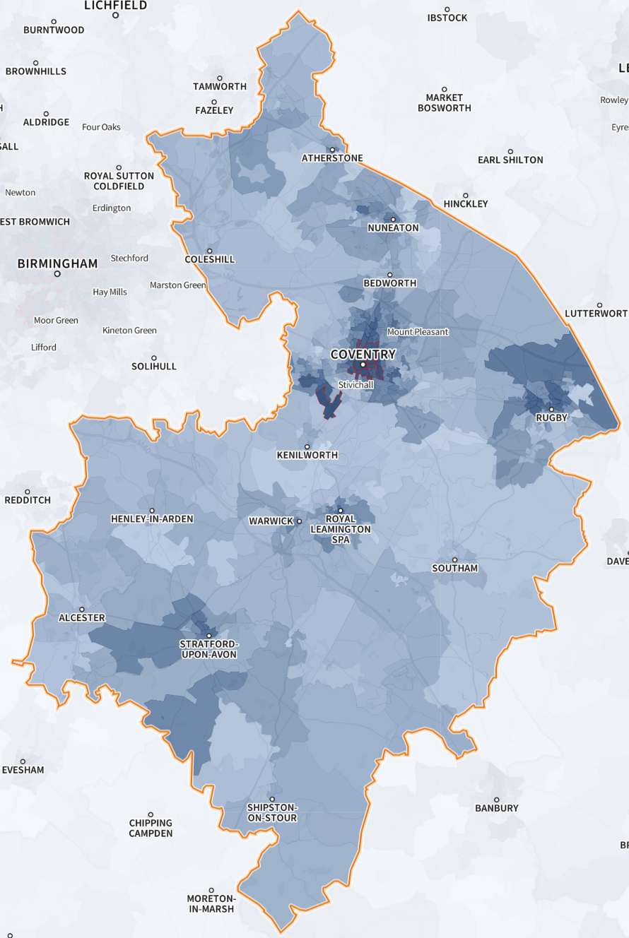
Figure 20: Count of population 16+ who have not received any doses of a COVID-19 vaccine
Source: SHAPE
Testing
In order to keep this virus under surveillance the Government supported testing and tracing. Lateral flow test kits were supplied to the public, some through pharmacies. For the majority of the pandemic positive lateral flow tests were confirmed with a polymerase chain reaction test and social isolation ensued. Positive results would be reported to the NHS Test and Trace service, which also aided in contact tracing and providing isolation advice. At the time of writing the distribution of free Lateral Flow Test kits from pharmacies has ended as the Governments leans away from mass COVID-19 testing, although some pharmacies offer to purchase.

Long COVID
The persistence of symptoms of COVID-19 for greater than four weeks after infection is referred to as long COVID, or post- COVID-19- syndrome. A few of the most common symptoms include fatigue, shortness of breath, loss of smell and loss of taste. An estimated 1.3 million people living in private households in the UK (2.1% of the population) were experiencing self-reported long COVID as of 2 January 2022. Of these people, 63% report that the symptoms have impacted their day-to-day activities in a negative manner. A recent review by UKHSA demonstrated that those who are vaccinated are less likely to report symptoms of long COVID than those who remain unvaccinated. Specialist services that support those with long COVID continue to be a focus for the NHS.
For pharmacies, COVID-19 has led to an increase in workload as there has been a significant increase in requests for healthcare advice. This has also been compounded by the decrease in workforce with the main cause being sickness from COVID-19 and self-isolation. This combination has led to increased pressure on staff and having to reduce services provided and at times opening hours. The above has caused a negative impact on pharmacy team members wellbeing. This is important to bear in mind when the public depend so heavily on community pharmacies.
It is important to note that people who have an underlying health condition are more at risk of developing long COVID. This may highlight the need for early intervention and prevention with health conditions through screening, health promotion and lifestyle campaigns.

Mental Health in COVID-19
COVID-19 has impacted mental health alongside physical health. A survey carried out by the mental health charity Mind during the months of March and May 2021 found that nearly half (46%) of adults say their mental health has got much worse since the beginning of the first national lockdown. Approximately one in six (16%) adults had accessed mental health services for the first time during the pandemic. Contributing factors to worsening of mental health include lack of personal contact with loved ones, loneliness and financial worries. Nearly half (48%) of those receiving benefits mentioned that their financial situation had worsened their mental health. There is likely to be an ongoing mental health need after the pandemic as seen with previous coronavirus outbreaks (SARS &MERS) where there was a considerable prevalence of post-traumatic stress disorder, depression, and anxiety beyond 6 months.
Increasing mental health concerns may increase pressure on pharmacies with patients accessing health and wellbeing and lifestyle opportunities, with pharmacies supporting and signposting into other relevant services.

Health inequalities and COVID-19
Health inequalities are due to unequal distribution of social determinants of health such as housing and employment that reduces the ability to prevent illness or access appropriate treatment if it were to occur. They are avoidable, unfair and systematic differences in health between different groups of people. Health inequalities have been a focus for the government and the impact of COVID-19 on certain members of society has further demonstrated that they are important to address.
The increased mortality rate in Asian and Black ethnic groups compared to the previous years where it was higher in White ethnic groups conveys the effect of COVID-19. When accounting for the effect of sex, age, deprivation, and region, people of Bangladeshi ethnicity had approximately twice the risk of death than people of White British ethnicity. It is important to note that co-morbidities and occupation were not considered in this analysis. The Black, Asian and minority ethnic account for 26.2% and 7.3% of the Coventry and Warwickshire population respectively from 2011 Census data.
People who live in more deprived areas have a higher diagnosis rate of COVID-19. The rate of death in the most deprived decile was 2.2 times the rate in the least deprived decile. This is greater than the baseline all-cause mortality rate difference between the most the deprived and least deprived from 2014-2018, demonstrating the impact of COVID-19.
Work was undertaken across Coventry and Warwickshire to ensure pharmacy provision of COVID-19 vaccinations matched need, specifically areas of low uptake/areas of deprivation.

Pharmacy Provisions and Access
In order to assess the provision of pharmaceutical services within Coventry and Warwickshire current provision from all providers has been considered. This includes providers and premises within Coventry and Warwickshire, as well as the contribution made by those providers who may lie in neighbouring Health and Wellbeing Board areas but provide services to the Coventry and Warwickshire population.

Community Pharmacy Contractual Framework
The NHS Community Pharmacy Contractual Framework requires community pharmacies to contribute to the health needs of the population they serve. All NHS pharmaceutical service providers must comply with the contractual framework that was introduced in 2005. The contractual framework is formed of the following components:
- Essential Services – these must be provided by all contractors nationwide.
- Advanced Services – services that can be provided by contractors subject to accreditation requirements.
- Locally Commissioned and Enhanced Services – services commissioned either by the NHS (enhanced services) or Local Authorities (locally commissioned services) in response to the needs of the local population.

Pharmaceutical Lists
If a person (a pharmacist, appliance contractor, or dispensing doctor) wants to provide NHS pharmaceutical services they are required to apply to the NHS to be included on a pharmaceutical list. Pharmaceutical lists are compiled and held by NHS England. This is commonly known as the NHS “market entry” system.
Under the NHS regulations, a person wishing to provide NHS pharmaceutical services must apply to the NHS England to be included on a relevant list by proving they are able to meet a pharmaceutical need as set out in the relevant PNA. There are exceptions to this, such as applications for needs not foreseen in the PNA or to provide pharmaceutical services on a distance-selling (internet or mail order only) basis.
The following are included in a pharmaceutical list. They are:
Pharmacy contractors – community pharmacies and distance selling pharmacies (DSPs). DSPs must adhere to all regulations concerning all other pharmacies, however a distance selling pharmacy must not provide Essential services onsite to a person who is present at the pharmacy, but the pharmacy must be able to provide Essential services safely and effectively without face-to-face contact. Currently there are 7 distance selling pharmacies in Coventry, 2 in Nuneaton and Bedworth Borough, 2 in Stratford-on-Avon District and 1 in Rugby Borough.
Dispensing appliance contractors (DACs) – DACs are a specific sub-set of NHS pharmaceutical contractors who supply, on prescription, appliances such as stoma and incontinence aids, dressings, bandages, etc. However, they do not dispense any medicines. There is 1 DAC in Coventry and 0 in Warwickshire.
Dispensing doctors (DD) – GP practices are allowed to dispense medicines and appliances to patients who live in an NHS England determined controlled locality (Rural Area) and live more than one mile from a community pharmacy. There are 23 dispensing GP practices within Coventry and Warwickshire, 11 in Stratford-on-Avon District, 5 in North Warwickshire Borough, 3 in Warwick District, 2 in Rugby Borough, 1 in Nuneaton and Bedworth Borough, and 1 in Coventry.

Community Pharmacy Benchmarking
Figure 21 below shows the number of pharmacies per 10,000 population in Coventry and Warwickshire against the England average. Coventry has 2.6 pharmacies per 10,000 population which is slightly higher than the England average (2.1), and Warwickshire has 1.8 per 10,000.

Figure 21: Number of pharmacies per 10,000 population
Source: https://www.nhsbsa.nhs.uk/statistical-collections/general-pharmaceutical-services-england/general-pharmaceutical-services-england-201516-202021#:~:text=Key%20Findings,%2F21%2C%20while%20451%20closed.

Access to Pharmacies in Coventry and Warwickshire
Coventry and Warwickshire have 197 community pharmacies; 91 pharmacies in Coventry, 7 of which are distance selling pharmacies, and 106 pharmacies in Warwickshire, 5 of which are distance selling pharmacies.

Geographical Location
Figure 22 shows the location of pharmacies within Coventry and Warwickshire, and figures 23 - 28 show that at the locality level. Pharmacies are not evenly distributed throughout the localities, with great concentrations of pharmacies in central areas of each locality/borough, particularly in Coventry, Nuneaton and Bedworth, Rugby, and Warwick. These central area Lower Super Output Areas (LSOAs) are the most densely populated areas in the localities, and have the greatest deprivation as described in the Local Picture chapter.
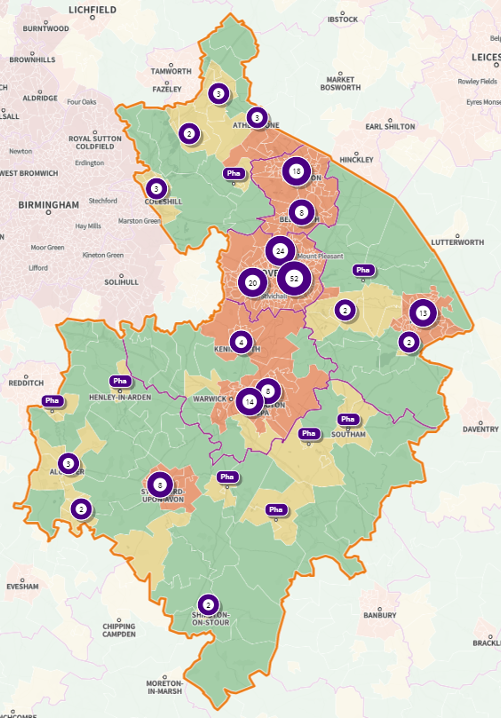
Figure 22: Location of pharmacies in Coventry and Warwickshire
Source: SHAPE

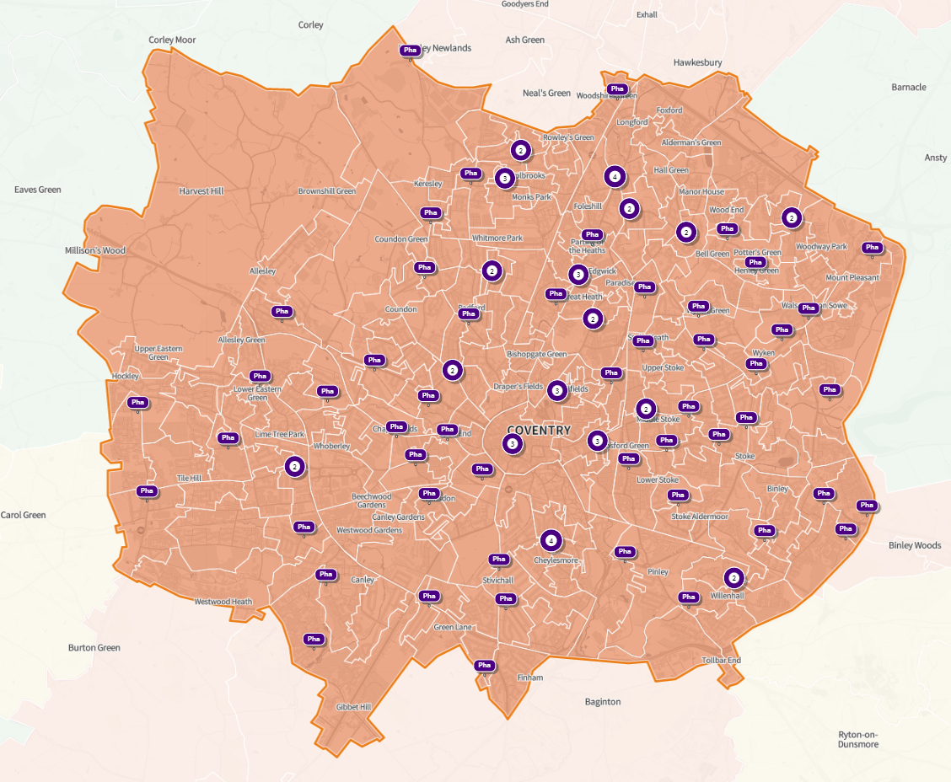
Figure 23: Location of pharmacies in Coventry
Source: SHAPE
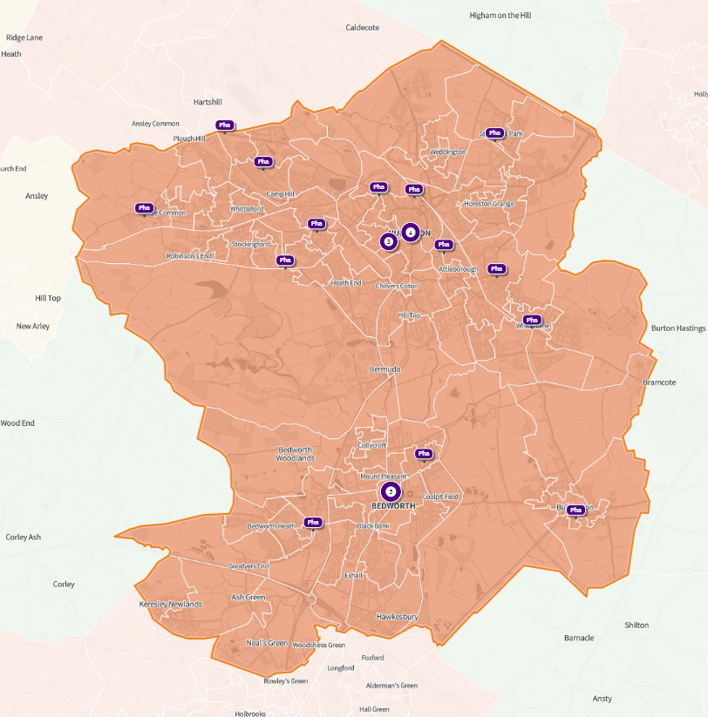
Figure 24: Location of pharmacies in Nuneaton and Bedworth Borough
Source: SHAPE
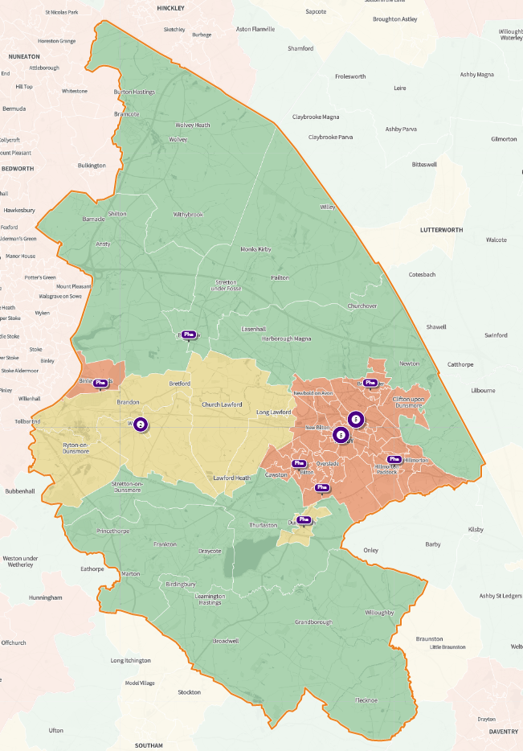
Figure 25: Location of pharmacies in Rugby Borough
Source: SHAPE

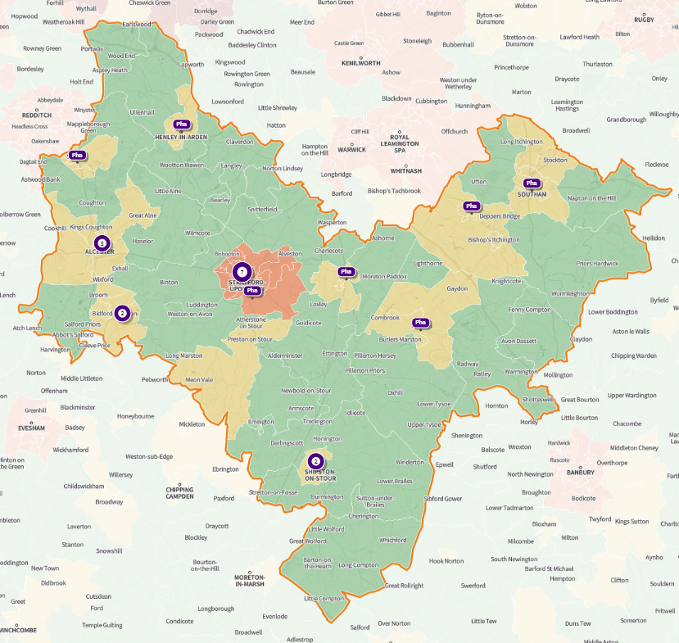
Figure 26: Location of pharmacies in Stratford-on-Avon District
Source: SHAPE

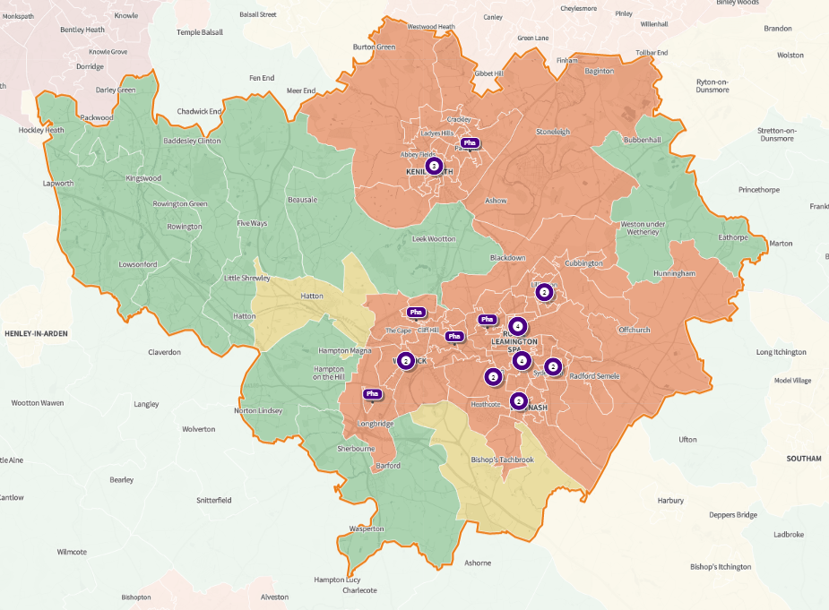
Figure 27: Location of pharmacies in Warwick District
Source: SHAPE
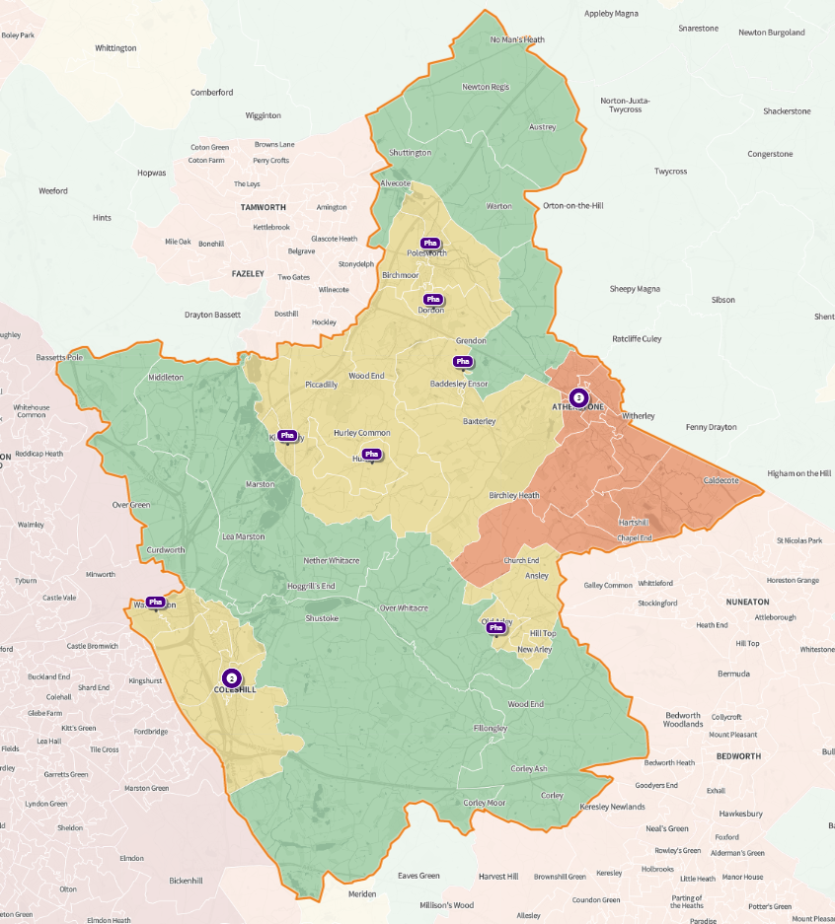
Figure 28: Location of pharmacies in North Warwickshire Borough
Source: SHAPE

Figure 29 shows access to pharmacies in relation to a 5- and 15-minute drive. The dark green areas are within a 5-minute drive to a pharmacy, and the light green are within a 15-minute drive to a pharmacy. Almost all of Warwickshire is within a 15-minute drive to a pharmacy, the exceptions being in South and Southeast of Stratford-on-Avon District, which are rural areas. The majority of Coventry is within a 5-minute drive to a pharmacy and all of Coventry is within a 15- minute drive.
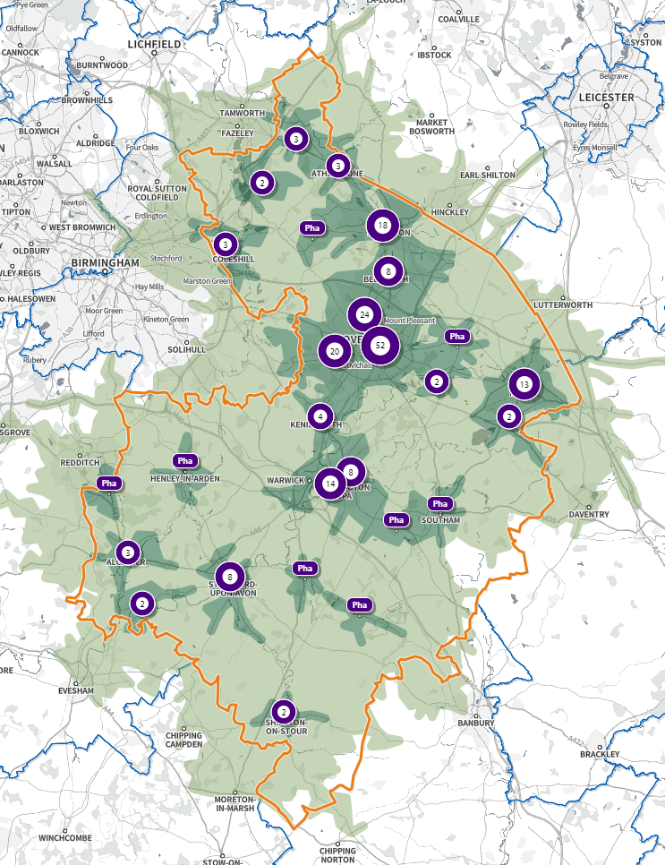
Figure 29: Location of pharmacies in relation to a 5 or 15 minute drive
Source: SHAPE
Figure 30 shows the access to pharmacies via public transport and the top 20% of IMD areas. The green areas represent a 15-minute journey via public transport to a pharmacy whilst the yellow represent a 30-minute journey. The red areas are the top 20% IMD areas. All of the lowest 20% IMD areas are within a 30-minute journey via public transport to a pharmacy. Those areas not within a 30-minute journey are predominately rural or uninhabited areas.
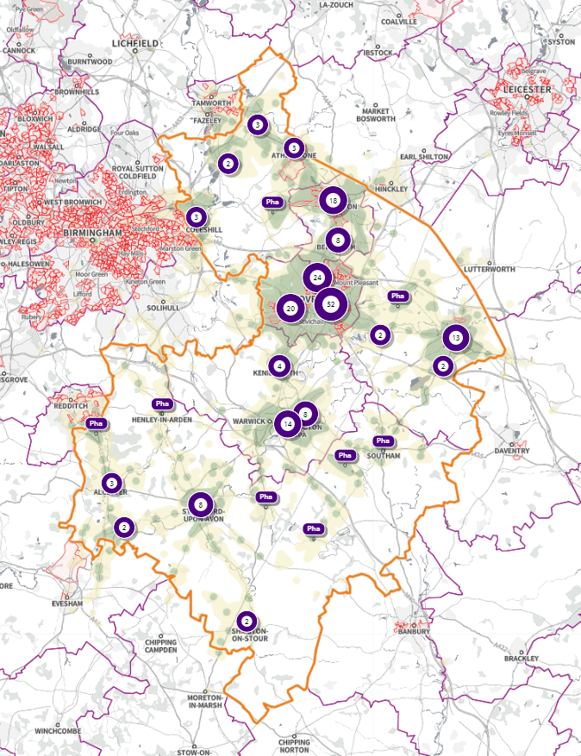
Figure 30: Location of pharmacies by public transport: 15 and 30 minutes
Source: SHAPE
Within Warwickshire there are 2 demand responsive services that provide a transport service for residents who cannot access public transport either due to mobility issues or live in an area with limited or no public transport. These services are:
- UBUS – operating in Stratford-on-Avon - https://www.stratford.gov.uk/people-communities/ubus--community-transport.cfm
- IndieGo – operating in Atherstone, Coleshill, Rugby, Hatton, and West Warwick - https://www.warwickshire.gov.uk/public-transport/indiego
From the 1,601 responses to the public survey, 46.5% of respondents said they would normally travel by car/motorbike/van to a pharmacy, and a further 42% said they would normally walk. As car ownership is lower in Coventry, it is important to note that almost all pharmacies are within a 15 minute walk, with only a small number being within a 30 minute walk. The exception is North-West Coventry but this area is much more rural with lower population. Only 1.8% said they would use public transport. When asked about how long their travel usually takes, 74% said that it takes less than 15 minutes and 19% said it takes between 15 and 30 minutes. Only 1% of respondents said it takes more than 30 minutes to travel to their pharmacy.

Cycling Access
Figure 31 shows cycling time in relation to pharmacies. The light green indicates a 16-minute journey time, and the dark green indicates an 8-minute journey time. The red areas on the map indicate the top 20% most deprived areas according to IMD. All the top 20% most deprived areas in Coventry and Warwickshire are covered within a 16-minute cycle time apart from a small area near Atherstone.
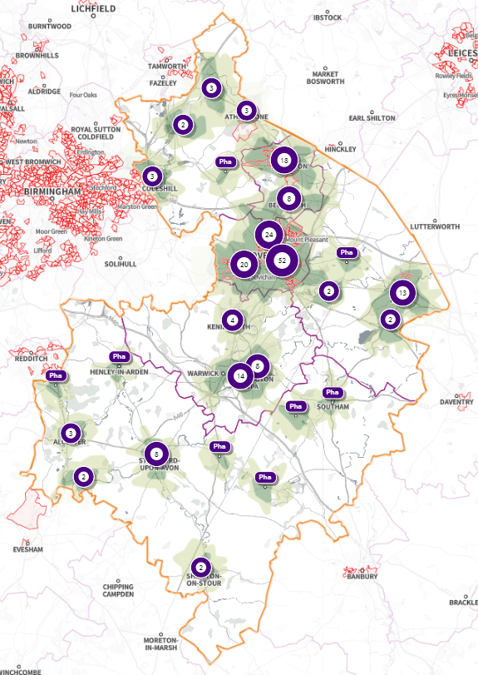
Figure 31: Location of pharmacies by 8 or 16 minute cycle
Source: SHAPE

Physical Access
The 2018 Coventry City Council PNA identified that out of the 72 responses received from the 2018 pharmacy survey, 96% of pharmacies allow parking within 50 metres of the pharmacy, and 82% within 10 metres of the pharmacy. There is a bus stop within walking distance of 99% of pharmacies. From the same survey it was analysed the 86% of pharmacies do not have any steps to climb to enter the premises, and 89% of respondents said that all areas of the pharmacy floor were accessible by wheelchair.
The 2018 Warwickshire County Council PNA identified that out of the 88 responses received from the 2018 pharmacy survey, 95.5% of pharmacies allow parking within 50 metres of the pharmacy and 88.6% within 10 metres of the pharmacy. There is a bus stop within walking distance of 98.9% of respondent’s pharmacies. From the same survey it was analysed that 77.3% of pharmacies do not have any steps to climb to enter the premises, and 95.5% of respondents said that all areas of the pharmacy floor were accessible by wheelchair.
Open text comments in the public survey for this PNA noted difficulties with access to pharmacies car parking issues especially for older people or those with disabilities, physical access to the shop, and access for hidden disabilities.

Opening Time Analysis
Pharmacies are required to open between specific times by their terms of service. Most pharmacies are required to open for 40 hours per week, and these are referred to as core opening hours, but pharmacies may choose to open for longer, and these hours are referred to as supplementary opening hours. A pharmacy’s opening hours are decided at the beginning of their contract, and it is most common for the vast majority to operate within or near regular working office hours, between 8am and 7pm, Monday to Friday.
Pharmacies wishing to amend any supplementary hours that they open additional to the core contractual hours must notify NHS England, giving at least three months’ notice of the intended change. NHS England may consent to a shorter period of notice, but as that consent may not be forthcoming, they should try to ensure that plans are made sufficiently in advance. The discretion to permit less than three months’ notice for changes to supplementary hours is most likely to be exercised where the pharmacy is seeking to align more closely, the pharmacy opening hours with the pharmaceutical needs in the neighbourhood for example, if a local surgery extends its hours. In this case, if the pharmacy intends to modify its supplementary hours to match the new hours of the surgery, NHS England may be keen to ensure this happens with minimal delay.
There is no requirement for NHS England to grant applications for changes to supplementary hours, the pharmacy has the right to amend hours, so long as three months’ notice is given.
Since the introduction of the pharmaceutical contractual framework in 2005 community pharmacies do not need to participate in rota provision to provide access for weekends or during the evening.
In the public survey, when asked the question “are you able to access a pharmacy at times that are convenient to you?” 39% responded “Yes always”, 47% responded “most of the time”, 11% responded sometimes and 2% responded “never”.
The most convenient time to visit a pharmacy as indicated in the public survey was between 9am and 1pm on Saturday (75%), followed by between 9am and 1pm on a Monday to Friday (61%), and between 1pm and 6pm on a Monday to Friday (48%). 28% said after 6pm Monday to Friday, with between 2%-4% indicating either before 9am or after 6pm on a Saturday or Sunday. 25-54-year-olds are less likely to agree that opening hours are always convenient for them whilst 75+ are more likely to say that opening hours are always convenient for them.

100 Hour Contracts and Extended Opening Hours Pharmacies
100-hour pharmacies are required in their contracts to be open and able to provide essential services for at least 100 core hours per week. In 2018 following a government review, pharmacies could no longer apply to have 100-hour contracts.
There are currently 16 100-hour pharmacies in Coventry and Warwickshire. These pharmacies are:
Coventry:
- A&M Pharmacies Ltd, CV4 9AE
- Asda Stores Ltd, CV3 4AR
- Boots UK Ltd, CV3 2SB
- Foleshill Healthcare Ltd, CV6 5JR
- Hyiris Ltd, CV6 6DX
- Tesco Stores Ltd, CV2 2SH
- Wellbeing (United Kingdom) Limited, CV4 9DR
Rugby Borough:
- Asda Stores Ltd, CV21 3EB
- Lloyds Pharmacy Ltd, CV22 6HU
- Tesco Stores Ltd, CV21 1RG
North Warwickshire Borough:
- Atherstone Pharma Ltd, CV9 1EU
- No.8 Group (Midlands) Limited, CV9 1BB
Nuneaton and Bedworth Borough:
- No 8 Pharmacy Ltd, CV12 8NF
- Pharmacyrepublic Limited, CV11 5NU
Stratford-on-Avon District:
- Avon Healthcare Ltd, CV37 6HJ
Warwick District:
- Asda Stores Ltd, CV31 1YD

These 100-hour pharmacies provide Coventry and Warwickshire with good access to pharmaceutical services on Saturdays, Sundays, and evening until late. They guarantee access to pharmaceutical services for 14/15 hours a day except on Sundays due to the Sunday Trading Act 1994.

Saturday Opening Hours
As of 1st June 2022, 137 out of the 197 community pharmacies in Coventry and Warwickshire are open on a Saturday (69.5%). 51 of these pharmacies are in Coventry, 23 in Nuneaton and Bedworth Borough, 21 in Warwick District, 18 in Stratford-on-Avon District, 15 in Rugby Borough, and 9 in North Warwickshire Borough. Of those pharmacies open on a Saturday, 64 of them are closed by 1pm. After 1pm the other 73 remain open with gradual closure over the remainder of the day.
Figure 32 shows the location of these pharmacies:
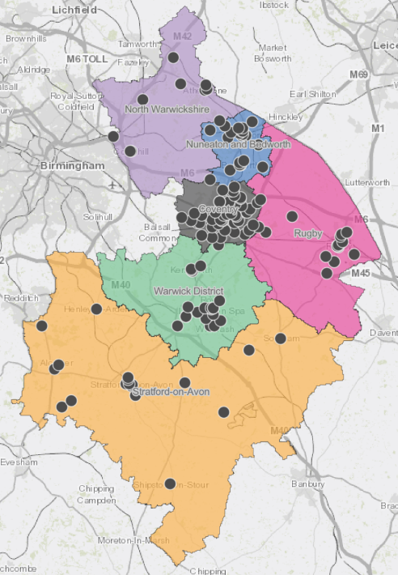
Figure 32: Location of pharmacies open on a Saturday
Source: LPS
Open text comments in the public survey noted difficulties with opening times for pharmacies including lack of weekend or ‘out-of-hours’ services locally and routine lunchtime/weekday closure for some respondents.
The survey reflected that the most popular time to visit a pharmacy was between 9am – 1pm on a Saturday (75%). `

Sunday Opening Hours
There are 14 community pharmacies in Coventry, 6 in Warwick District, 5 in Stratford-on-Avon District, 5 in Nuneaton and Bedworth Borough, 4 in Rugby Borough, and 2 in North Warwickshire Borough that are open on a Sunday, most open for 6 hours to comply with Sunday trading regulations.

Bank Holiday Provision
Some pharmacies choose to open on some bank holidays even though they are not required to do so. NHS England currently commissions rota services for main bank holidays as needed, usually for 3 hours per session. This enables patients to access pharmaceutical services on traditional bank holidays such as Christmas Day, Boxing Day, New Year’s Day, and Easter Sunday. The Bank Holiday rota is available on NHS Choices and is accessible to view by the public.

Pharmacy Premises Facilities and Consultation Areas
The provision of Advanced Services is linked to the provision of consultation areas within pharmacies. In addition, The Disability Discrimination Act 1995, replaced by the Equality Act 2010, sets out a framework that requires providers of good and services not to discriminate against persons with a disability. It is expected that the pharmacy would make reasonable adjustments, if this is what is needed in order to allow the person to access the service.
The presence of consultation areas in many pharmacies presents an opportunity to commission pharmacies in new and potentially exciting ways to deliver new services. In some respects, this is already happening through commissioning enhanced and other locally commissioned services.
From the pharmacy survey, 99% of pharmacies in both Coventry and Warwickshire said they had consultation rooms, with the remaining being distance selling pharmacies. 91% in Coventry and 88% in Warwickshire said they have hand washing facilities, and 37% in Coventry and 34% in Warwickshire said they have toilet facilities.

Pressures on Pharmacies
Community pharmacies, as the most accessible healthcare locations in England, have played a crucial role during the COVID-19 pandemic, staying open throughout, and providing face-to-face healthcare services and information/advice to the public. This has bought with it an increasing pressure, and as we continue life without COVID-19 related restrictions it is important these pressures are recognised, and work is done to adapt.
Responses to the public survey praised the response of community pharmacies during the Covid-19 pandemic:
“They were the only people you could see face-to-face during Covid”
“Their systems during the covid crisis made me feel safe when accessing their services.”
However, responses also indicated that some measures impacted on people’s ability to access the service:
“The shop is rather small, this was a problem during the pandemic”
“Because of social distancing they stayed well away from me, so I couldn’t hear properly”
The PSNC Pharmacy Advice Audit 2021 showed that 114,898 patient consultations were recorded by 5,830 community pharmacies. This indicates that 17 consultations are done per day per pharmacy, or more than 100 per week. This would give 1.1 million informal consultations in community pharmacies in England each week, 58 million per year.
Almost half of patients recorded in these consultations reported that if they were not able to attend their local pharmacy, they would have visited their GP instead. This means that these consultations save more than 2 million GP appointments every month, or 24 million every year, equating to 74 appointments for each GP practice each week across the country. 70,000 people would have gone to an A&E or NHS walk-in centre each week if they couldn’t have accessed their local pharmacy, equating to 3.3 million people per year.
The “PSNC Briefing 013/12: Summary of the results of PSNC’s 2022 Pharmacy Pressures Survey” identified several ways in which pharmacies are feeling pressure nationally. In the survey it was found that 92% of pharmacy business owners/head office representatives said that patient services were being negatively affected by the pressures on their business. Figure 33 shows a breakdown of the impacts of business pressure on patients

Figure 33: Impacts of Business Pressures on Patients
Source: https://psnc.org.uk/wp-content/uploads/2022/04/PSNC-Briefing-013.22-Summary-of-the-results-of-PSNCs-2022-Pharmacy-Pressures-Survey.pdf
Responses from pharmacy team members to the survey indicated that 67% of pharmacies are having to deal with medicine supply issues every day, 21% multiple times per week, and 9% weekly. No team members responded saying they never had an issue. The impact of medicine supply issues is shown in Figure 34:

Figure 34: Impacts of Medicine Supply Issues on Patients
Source: https://psnc.org.uk/wp-content/uploads/2022/04/PSNC-Briefing-013.22-Summary-of-the-results-of-PSNCs-2022-Pharmacy-Pressures-Survey.pdf
Responses from pharmacy business owners/head office representatives reported that 91% of pharmacies were experiencing staff shortages, the most significant drivers of staff shortages being sickness and self-isolation related to COVID-19 (81%), difficulties in finding locums (77%), and difficulties recruiting permanent staff (72%). Figure 35 shows the impacts of staff shortages:

Figure 35: Impacts of Staff Shortages on Pharmacies
Source: https://psnc.org.uk/wp-content/uploads/2022/04/PSNC-Briefing-013.22-Summary-of-the-results-of-PSNCs-2022-Pharmacy-Pressures-Survey.pdf
Significant pressures were recorded in a wide range of areas, including significant increases in patients displaced from GPs to pharmacies, and incorrect information being provided by GP practices to patients. This increased workload breakdown can be seen in Figure 36:

Figure 36: Workload Increases Experienced by Pharmacy Teams
Source: https://psnc.org.uk/wp-content/uploads/2022/04/PSNC-Briefing-013.22-Summary-of-the-results-of-PSNCs-2022-Pharmacy-Pressures-Survey.pdf
Looking ahead to the future, the pharmacy companies were asked in the survey to rate how concerned they were about a range of issues. This was done on a scale of 1 to 10, 1 being no concern, 10 being extremely concerned. Figure 37 shows the responses:

Figure 37: How concerned are pharmacies about the following issues?
Source: https://psnc.org.uk/wp-content/uploads/2022/04/PSNC-Briefing-013.22-Summary-of-the-results-of-PSNCs-2022-Pharmacy-Pressures-Survey.pdf
From analysis of the public survey undertaken for this PNA, when asked the question “When thinking about your pharmacy, what is most important to you?”, 74% of respondents said “Efficient and quick service”, 43% said “Friendly staff”, and 32% said “Know and trust the Pharmacist/Team”. The survey also indicated that respondents used the same pharmacy, with 60% saying they use the same pharmacy all the time, and 29% saying they use the same pharmacy most of the time. In the survey, pharmacies were praised for:
- Friendly, knowledgeable staff.
- The local nature of a pharmacy was helpful to some as was staff who knew them and their health.
- Continuity of staff.
- Advice about medication and wider health issues was welcomed and sometimes seen as an alternative to seeking a GP appointment.
- Good communication with GPs
“Fantastic, really friendly knowledgeable staff, I get reminders for reordering my prescriptions and notifications that they are ready to collect. When I have a new medicine prescribed the member of staff double checks with me that I understand the dosage and that the Dr has explained the reason for the new/changed medicine. They are 1st class.”
“As a disabled person, with number health issues, my local pharmacy is literally a lifeline.”
“Excellent customer service and satisfaction over a good number of years.”
“Extremely helpful and easier and quicker to access than making a GP appointment.”
“Friendly, knowledgeable and is a quick alternative to a GP. I am very happy with my pharmacist & team.”
“I prefer to go to the local pharmacy, as it is more personal, as it is more personal than a large city-centre chain store, and it is near where I live. I really value the local service.”
“I receive a very efficient and helpful service from my local pharmacy.”
“The team are lovely, helpful, efficient, caring, and the service has always been absolutely brilliant.”
“I was able to get immediate and effective advice from the Pharmacist at a time when there were no available appointments to see my GP”

However, issues were identified that match the themes from both the PSNC Audit and PSNC Survey, including:
- The length of time between ordering medicines and prescriptions being available – some respondents reported increases in more recent months.
- Prescriptions not being ready for collection leading to long queues or necessitating return visits to the pharmacy was a key issue.
- Items not stocked or missing with return visits required.
- Wrong items/out of date medication.
- System for finding prescriptions being disorganised.
- Impromptu or random pharmacy closure due to staff shortages including pharmacists.
“It can take up to 7 days from the time the pharmacy receives the script to being able to collect medication”
“Always have to wait for the prescription to be filled even when ordered 5 days before”
“Doesn’t matter how far in advance you order medications they are never ready when you go to collect”
“Long queues outside chemist, lack of supplies a big issue repeat prescriptions so we have to go back several times to collect”
“Don’t always have the tablets in stock”
“Seem to take ages finding my prescriptions (which had been sent directly to them from the GP) have a muddled system to find things”
“Recently been closed for time during day or all day as not enough staff”
“Pharmacist leaves the premises and staff are unable to give out prescriptions or sell things like lem sip”
“My pharmacy is usually very busy which can make it feel uncomfortable to ask for any additional time from the staff (with questions or for advice) as they are clearly under a lot of pressure”
“Closes randomly without notice due to lack of pharmacists. Do not answer phone.”
From the public survey, collecting a prescription was the biggest reason why respondents usually access a pharmacy (93%), followed by buying over the counter medicines (that do not need a prescription) (57%), and getting advice and information on medication (31%).

Workforce
NHS Health Education England (HEE) produce pharmacist workforce data at National, Regional, and ICS geography level. Figure 38 shows the pharmacist workforce levels in Coventry and Warwickshire ICS in Trust, Practice, and Primary Care Networks (PCN). Between March 2019 and March 2022 Trust has increased their Pharmacist Workforce from 114 to 150, Practice has increased from 4 to 11 and PCN has increased from 0 to 66. There is currently no equivalent data on community pharmacies. The increase in numbers across Trust, Practice and PCN may cause concern as these increases may have come from workforce either leaving community pharmacies, or choosing to continue their training in a Trust, Practice, or PCN rather than in community pharmacies. There are a range of factors that contribute to this choice including training packages, salary, and financial security.
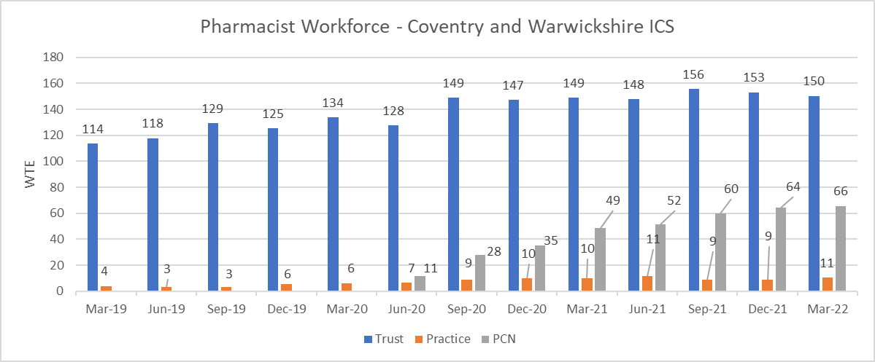
Figure 38: Pharmacist Workforce in Coventry and Warwickshire ICS
Source: HEE
HEE have undertaken a Community Pharmacy Workforce Survey in 2021, with results expected to be published in early 2022. This will form part of a Community Pharmacy dashboard that can be shared with external stakeholders via the HEE eProduct platform. The dashboard is in draft stage and has been shared within HEE for comments and recommended updates, with a view for publication in Summer 2022.
HEE are undertaking discussions to understand the possibility of undertaking an annual survey of community pharmacy workforce to support understanding of challenges and improve data completion/quality. This is at the early stage, however, there is an appetite for this to be taken forward as it has been discussed at the Midlands Pharmacy Workforce Network.

Conclusion on Access to Pharmacies
Pharmacies within Coventry and Warwickshire are well geographically distributed by population density and levels of deprivation. Opening hours indicate a good level of access during usual working hours, and on weekends and evenings across the Coventry and Warwickshire. Cross border availability of pharmaceutical services is also significant across Coventry and Warwickshire.
It will be important to monitor the pressures on pharmacies and how this may impact on the workforce, particularly with the cost-of-living crisis further impacting pressures that have built up due to the COVID-19 pandemic. Supporting surveillance through the annual HEE Community Pharmacy Workforce Survey will help to improve and understand data on this issue.
Consideration should be made to population increases and significant housing developments being built as described in the “Households & Housing Development Projections” section of the “Local Picture” chapter.

Pharmacy Services
Community pharmacies provide a wide array of services that are defined/commissioned in different ways:
- Essential Services – services which all pharmacies must provide as part of the CPCF regulations.
- Advanced Services – services the CPCF regulations allow pharmacies to opt in to providing.
- Enhanced and Locally Commissioned services – Services that are either commissioned by NHS England (enhanced services) or commissioned by a ICB or Local Authority (locally commissioned services).

Essential Services
There are 9 essential services which are summarised in the table below. All of the community pharmacies in Coventry and Warwickshire are required to provide these services as part of the CPCF regulations.
Essential Service | Description
Dispensing (Split into 2 different essential services - Medicines and Appliances) | The safe supply of medicines or appliances ordered on NHS prescriptions. Advice is given to the patient about the medicines being dispensed and information on how to use them safely and effectively. Records are kept of all medicines dispensed and maintained.
Repeat Dispensing | The management and dispensing of repeatable NHS prescriptions for up to one year, in partnership with the patient and prescriber. The patient will return to the pharmacy for repeat supplies, without first having to visit the GP surgery. Before dispensing each supply the pharmacy will ascertain the patient’s need for a repeat supply of a particular medicine and communicate any clinically significant issues to the prescriber.
Discharge Medicines Service | The Discharge Medicines Service (DMS) was added as a new Essential service within the CPCF regulations on 15th February 2021. This service allows NHS Trusts to refer patients who would benefit from extra guidance around newly prescribed medicines to the DMS service at their community pharmacy. This service aims to be a significant contributor to the safety of patients transition from care, and aims to reduce readmissions to hospital.
Promotion of Health Lifestyles (Public Health) | The provision of opportunistic one to one advice is given on healthy lifestyle topics, such as stopping smoking, to certain patient groups who present prescriptions for dispensing. These groups include diabetic patients, patients at risk of coronary heart disease, especially those with high blood pressure, patients who smoke and patients who are overweight. Pharmacies must also support up to six local campaigns a year, organised by NHS England. Campaign examples may include topics such as promotion of flu vaccination uptake, healthy living, or stop smoking.
Disposal of unwanted medicines | Community pharmacies accept unwanted medicines from households and individuals which require safe disposal. The medicines are then safely disposed of by a waste contractor engaged by NHS England. Pharmacies are not under any obligation to accept sharps under the terms of this essential service. Needle and syringe programmes are a locally commissioned service.
Signposting | The provision of information provided by pharmacists and staff to refer patients to other healthcare professionals or care providers when appropriate. The service also includes referral on to other sources of help such as local or national support groups.
Support for Self-Care | The provision of advice and support by pharmacy staff to enable people to derive maximum benefit from caring for themselves or their families. The main focus is on self-limiting illness, but support for people with long-term conditions is also a feature of the service.
Clinical Governance | Adherence with clinical governance requirements is part of the terms of service for pharmacies, as set out in Part 4 of the NHS (Pharmaceutical and Local Pharmaceutical Services) Regulations 2013. These cover a range of quality related issues as set out in the following links:  https://www.psnc.org.uk/wp-content/uploads/2013/07/Clinical_Governance_guidance_updated_final.pdf  https://www.england.nhs.uk/publication/approved-particulars/  https://www.psnc.org.uk/wp-content/uploads/2013/07/service20spec20es8202020clinical20governance20_v1201020oct2004_.pdf  https://psnc.org.uk/services-commissioning/psnc-briefings-services-and-commissioning/psnc-briefing-01514-changes-to-contractual-requirements-201415/

Dispensing
Table 6 shows the number of items dispensed in 2020/21 and 2021/22 in England and across Coventry and Warwickshire.
Area | Prescription items dispensed 2020/21 | Prescription items dispensed 2021/22
England | 1,016,445,333 | 1,042,674,399
Coventry and Warwickshire CCG | 16,701,448 | 17,195,484
Coventry Place | 6,641,168 | 6,814,810
Warwickshire (Rugby, Warwickshire North, and South Warwickshire places) | 10,060,280 | 10,380,674
Table 6: Number of items dispensed in 2020/21 and 2021/22 in England, Coventry and Warwickshire
Source: NHS BSA
Results from the 1,601 respondents of the public survey showed that out of the essential services 86% of respondents were aware they could discuss prescriptions, 70% were aware they could get new prescriptions, 87% were aware of the disposal of old medicines service, and 65% were aware that the local pharmacy team can provide healthy living advice.

Cross Border Dispensing
The cross-border pharmacies help to service some areas in Coventry and Warwickshire. As noted in the pharmacy accessibility section of this PNA, the areas not covered by 15-minute drive time are largely rural with low population density. Figure 39 shows the provision from pharmacies outside of the Warwickshire boundary (solid orange line) to a distance of 5km (dashed orange line). For more information on these pharmacies, please see the relevant PNAs.
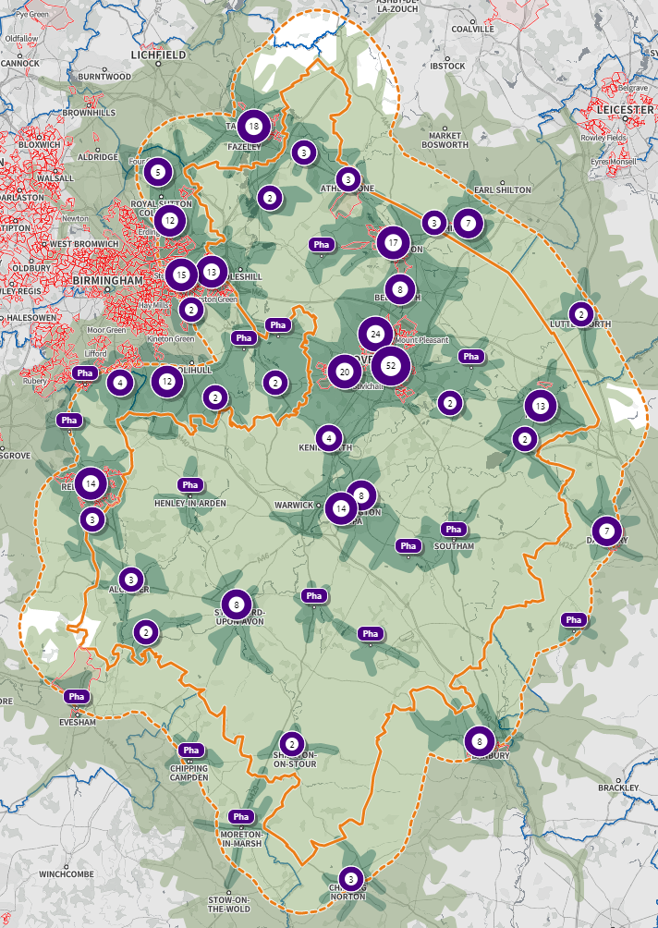
Figure 39: Location of pharmacies within Coventry and Warwickshire and within 5km outside of Coventry and Warwickshire
Source: SHAPE

Appliances
Appliances can be dispensed by any pharmacy or appliance contractor and can be broadly categorised as stoma appliances, incontinence appliances, and dressings. There is 1 dispensing appliance contractor in Coventry and 0 in Warwickshire. Results from the pharmacy survey show that of the 161 pharmacies that responded to the survey, 159 (98%) dispense appliances.

Prevention and Health Promotion
Each financial year (1st April to 31st March), pharmacies are required to participate in up to six health campaigns at the request of NHS England and NHS Improvement (NHSE&I). This generally involves the display and distribution of leaflets provided by NHSE&I.
Where requested to do so by NHSE&I, each pharmacy must record the number of people to whom information is provided as part of one of these campaigns. NHSE&I can also ask for additional information in relation to the campaign.
Any additional information to be requested will initially be discussed with PSNC. The aim of requesting additional information will be to help to evaluate the impact of the campaign and to assist with future policy development. Contractors will be notified of the additional information which needs to be collected and supplied in advance of the campaign starting.
NHSE&I can request that the information on the campaign is provided to them electronically.

Conclusion on Essential Services
Essential Services are provided by all Coventry and Warwickshire pharmacy contractors. This includes dispensing of NHS prescriptions which is a fundamental service that is commissioned nationally by the NHS. As discussed with regard to pharmacy access, essential services appear to be accessible for the majority of Coventry and Warwickshire’s population both geographically and at different times of day. Therefore, there are no gaps in the provision of essential services for Coventry and Warwickshire.

Advanced Services
In addition to essential services, the CPCF allows community pharmacies to opt to provide any of 8 advanced services to support patients with the safe use of medicine following appropriate training or accreditation by NHS England.
New Medicines Service (NMS) –
This service provides support for patients with long term conditions who have been newly prescribed a medicine to help improve patient medicine adherence. It is initially focused on particular patient groups and conditions. Specific conditions/medicines are covered by the service, they are:
Asthma and COPD | Diabetes (Type 2) | Hypertension | Hypercholesterolaemia
Osteoporosis | Gout | Glaucoma | Epilepsy
Parkinson’s disease | Urinary incontinence/retention | Heart Failure | Acute coronary syndromes
Atrial fibrillation | Long term risks of venous thromboembolism/embolism | Stroke/transient ischemic attack | Coronary heart disease
The service is split into three sections:
- Patient Engagement
- Intervention
- Follow up
Patient Engagement – After a new medicine has been prescribed for a long-term condition, patients will be recruited to the service by prescriber referral or opportunistically by community pharmacy staff. Once the new medicine has been dispensed and information given about its use a patient will be offered to use the NMS. If accepted, a method and time will be agreed for the “Intervention” stage, usually between 7 and 14 days after patient engagement.
Intervention – The pharmacist and patient will have a discussion to assess adherence to the medicine(s), identify any problems, and determine the patient’s need for further information and support. Further support and information will be provided by the pharmacist and where no problems have been identified a time for the “Follow up” stage will be agreed, usually 14 to 21 days after the “Intervention” stage. If problems are identified where the intervention of the patient’s prescriber is needed, the issue will be referred to them.
Follow up – The pharmacist and patient will again have a discussion to assess adherence to the medicine(s), identify any problems, and determine the patient’s need for further information and support. Further support and information will be provided by the pharmacist. If problems are identified where the intervention of the patient’s prescriber is needed, the issue will be referred to them.
The NMS is conducted in a private consultation area or via telephone or video consultation, which ensures patient confidentiality. Since the introduction of the NMS in October 2011, more than 90% of community pharmacies in England have provided it to their patients.
The optimal use of appropriately prescribed medicines is vital to the management of long-term conditions. The pharmacist is fundamental to this service as they can intervene and offer support and advice to patients who are newly prescribed a medicine that will be used to manage a long-term condition.
NHS BSA data shown in Table 7 shows the number of NMS interventions declared by community pharmacies between April 2021 – December 2021.
Area | Number of NMS interventions declared in the period January 2021 – December 2021 (inclusive). | Mean number per pharmacy in the period January 2021 – December 2021 (inclusive).
Coventry & Warwickshire | 24,569 | 173
Nationally | 1,640,036 | 202
Table 7: NMS interventions declared in Community Pharmacies
Source: NHS BSA
In the 2018 PNA Warwickshire had a mean number of NMS per pharmacy of 58 in 2016/17, and Coventry had 59. This therefore shows a significant increase over the past 3 years, which can also be seen nationally with the 2016/17 mean number per pharmacy being 74.
184 of the 197 community pharmacies (93%) in Coventry and Warwickshire provide an NMS service. 79 (87%) of those pharmacies who provide the NMS service are in Coventry, 105 (99%) are in Warwickshire.
Conclusion for NMS Service
A large proportion of the community pharmacies within Coventry and Warwickshire provide the NMS service. No gaps have been identified from the information available.

Appliance Use Reviews (AUR)
This service can be carried out by a pharmacist or a specialist nurse, in the pharmacy or at a patient’s home, if more convenient. AURs should serve to improve the patient’s knowledge and use of any ‘specified appliance’ by:
- Establishing the way the patient uses the appliance and the patient’s experience of such use.
- By identifying, discussing, and assisting in the resolution of poor or ineffective use of the appliance by the patient.
- Advising the patient on the safe and appropriate storage of the appliance; and
- Advising the patient on the safe and proper disposal of the appliances that are used or unwanted.
NHS BSA data shown in Table 8 shows the number of AURs conducted at community pharmacies between April 2021 – December 2021.

Area | Number of AURs conducted at community pharmacies in the period April 2021 – December 2021 (inclusive).
Coventry & Warwickshire | 171
Table 8: Number of AURs conducted at community pharmacies in Coventry and Warwickshire
Source: NHS BSA
In this time period there were no AURs conducted in user’s homes.
Of the 161 pharmacies that responded to the pharmacy survey, 25% in Coventry and 11% in Warwickshire currently provide the AUR service.
Conclusion for AUR Service
Demand for the AUR service is lower than for other advanced services due to the much smaller proportion of the population that may be targeted. No current gaps in provision have been identified based on the information available. Coventry and Warwickshire residents may be receiving AURs from other national providers of appliances/AURs. The demands of the services should be assessed continually based on service models and demographic changes.

Stoma Application Customisation (SAC)
The service involves customisation of a quantity of more than one stoma appliance, based on the patient’s measurements or template. The aim of the service is to ensure proper use and comfortable fitting of the stoma appliance and to improve the duration of usage, thereby reducing waste. In order to provide this service certain criteria must be fulfilled, one of the main being the service must be provided from an ‘acceptable locations’ meaning:
- An area within the pharmacy that is distinct from the public area
- Is clearly designated as a private area whilst the service is being provided
- Is suitable and designated for the retention of the appropriate equipment for customisation
- Is suitable and designated for modification of the appliances
- That is suitable for the volume of customisation being undertaken at any given time.
NHS BSA data shown in Table 9 shows the number of Stoma Customisation Fees by community pharmacies between April 2021 – December 2021.
Area | Number of Stoma Customisation Fees in the period April 2021 – December 2021 (inclusive).
Coventry & Warwickshire | 180
Table 9: Number of Stoma Customisation Fees by community pharmacies in Coventry and Warwickshire
Source: NHS BSA

Of the 161 pharmacies that responded to the pharmacy survey, 28% in Coventry and 8% in Warwickshire currently provide the SAC service.
Conclusion for SAC Service
Demand for the SAC service is lower than for other advanced services due to the much smaller proportion of the population that may be targeted. No current gaps in provision have been identified based on the information available. Coventry and Warwickshire residents may be receiving SACs from other national providers of stomas. The demands of the services should be assessed continually based on service models and demographic changes.

Seasonal Influenza (Flu) Vaccination
Each year the NHS runs a national seasonal flu vaccination campaign aiming to vaccinate all patients who are at risk of developing more serious complications from the virus. These include people aged 65 years and over, pregnant women and those with certain health conditions. The aims of the service are to:
- Sustain and maximise uptake of flu vaccine in at risk groups by building the capacity of community pharmacies as an alternative to general practice.
- Provide more opportunities and improve convenience for eligible patients to access flu vaccinations.
- Reduce variation and provide consistent levels of population coverage of community pharmacy flu vaccination across England by providing a national framework.
There has been a local flu vaccination scheme in place since 2012 in Warwickshire and Coventry. From 2015/16 NHS England also commissioned flu vaccination scheme from community pharmacy as a new Advanced Service. All pharmacy contractors can choose to provide the Flu vaccination service. Eligible adults have the choice of getting their flu vaccine at a pharmacy from September to March each year. This service sits alongside the nationally commissioned GP vaccination service, giving patients another choice of venue for their vaccination and helping commissioners to meet their NHS vaccination targets.
Results from the pharmacy survey (Table 10) show that 132 of the 161 pharmacies who responded to the survey currently provide a seasonal influenza vaccination service (82%). In Coventry, 91% of the respondents to the pharmacy survey provide the vaccination service and in Warwickshire 86% provide the service. The public survey showed that 84% of respondents were either aware of, or had used the service, only 10% saying they were not aware of the service.
Vaccination Service | Currently Providing | Would provide if commissioned | Would provide privately | Wouldn’t provide if commissioned
Seasonal Influenza Vaccination service | 132 | 16 | 19 | 8
Table 10: Number of pharmacies providing, would provide, or wouldn’t provide in Coventry and Warwickshire
Source: Pharmacy Survey for 2022 PNA
NHS BSA data shown in Table 11 shows the number of community pharmacy seasonal influenza vaccination advanced service fee.

Area | Number of community pharmacy seasonal influenza vaccinations in the period April 2021 – December 2021 (inclusive).
Coventry & Warwickshire | 66,570
Table 11: Number of community pharmacy seasonal influenza vassincation advanced service fees.
Source: NHS BSA
Figure 40 shows the percentage of over 65-year-olds who received the flu vaccination between 1st September to the end of February in a primary care setting. The target percentage uptake of the flu vaccine each year is 75%. Until 2020/21, Coventry and England were below that target with Warwickshire being slightly under or on the target. In 2020/21 Coventry, Warwickshire, and England all achieved over 75% coverage, with Coventry at 78% and Warwickshire at 82.9%.

Figure 40: Percentage of over 65-year-olds who received the flu vaccine between 1st September to the end of February in a primary care setting
Source: Fingertips

Conclusion for Flu Vaccination service
There is adequate provision of this service in Coventry and Warwickshire. The Flu service is also accessible from GPs and other Healthcare providers. Pharmacies in Coventry and Warwickshire should continue to be encouraged to provide the flu vaccine. Flu immunisation is a cost-effective health protection intervention, which supports the prevention of the spread of infectious disease, reducing illness, and complications of flu, which, although a mild illness in most, can be fatal.

Community Pharmacist Consultation Service (CPCS)
The Community Pharmacist Consultation Service (CPCS) was launched on 29th October 2019, allowing referrals into community pharmacies from NHS 111. On 1st November 2020 this service was extended to GP CPCS which allowed general practices to refer patients for a minor illness consultation via CPCS, once a local referral pathway has been agreed. This service replaced the NUMSAS and DMIRS pilots.
The CPCS aims to relieve pressure on the wider NHS by connecting patients to community pharmacies which can deliver a swift, convenient, and effective service to meet their needs. Since this service was launched, an average of 10,500 patients per week are being referred for a consultation with a pharmacist following a call to NHS 111. These patients may otherwise have gone to see their GP.
NHS BSA data shown in Table 12 shows the number of CPCS Fees by community pharmacies between April 2021 – December 2021.
Area | Number of CPCS Fees in the period April 2021 – December 2021 (inclusive).
Coventry & Warwickshire | 6,837
Table 12: Number of CPCS Fees by community pharmacies in Coventry and Warwickshire
Source: NHS BSA
188 of the 197 pharmacies in Coventry and Warwickshire currently provide a CPCS service.

Conclusion for CPCS Service
There is a good provision of CPCS across Coventry and Warwickshire. No current gaps have been identified based on the information available.

Hepatitis C Testing Service
The Hepatitis C testing service focuses on the provision of point of care testing for Hepatitis C (Hep C) antibodies in people who inject drugs (for example people who inject illicit drugs such as steroids or heroin) but aren’t yet accepting treatment for their substance use. Should an individual test positive for Hep C antibodies they are referred for a PCR confirmatory test and treatment. The aim of the service is to:
- Increase the number of diagnoses of HCV infection
- Permit effective interventions to lessen the burden of illness to the individual
- Decrease long-term costs of treatment
- Decrease onward transmission of HCV
This service was added to the Community Pharmacy Contractual Framework (CPCF) in 2020, starting on the 1^{st of} September. This was originally trialled in the 5-year CPCF agreement, and its planned introduction in April 2020 was delayed due to the Covid-19 pandemic. This service is currently commissioned until 31st March 2023.
NHS BSA data shown in Table 13 shows the number of Hepatitis C Antibody Testing Service Fees by community pharmacies between April 2021 – December 2021.
Area | Number of Hepatitis C Antibody Testing Service Fees in the period April 2021 – December 2021 (inclusive).
Coventry & Warwickshire | 9
Table 13: Number of Hepatitis C Antibody testing service Fees in Coventry and Warwickshire
Source: NHS BSA

Conclusion for Hepatitis C Testing Service
Pathways for referral to a confirmatory PCR test are currently under development. This should be supported to help develop the service as there is currently a limited pathway for PCR testing.

Smoking Cessation Advanced Service – Secondary Care to Community Service
NHS community pharmacies are a great place for patients to receive stop smoking advice and support. Through this service hospitals can refer patients to community pharmacy to continue the stop smoking journey they started in hospital.
The service:
- supports patients who started a stop smoking programme in hospital to continue their journey in community pharmacy upon discharge
- promotes healthy behaviours to service users
This service was commissioned in March 2022. There are currently 52 pharmacies delivering this service in Coventry (28) and Warwickshire (24).
Additional smoking cessation pharmacy services:
- NRT (nicotine replacement therapy) voucher scheme: all clients who are part of a smoking cessation scheme will receive a voucher. The client will redeem this at a community pharmacy.
- Champix/Varenicline review and provision: this provision is specific to Coventry and operates under a Patient Group Directive (PGD)
- Psychosocial interventions: includes structured counselling, motivational enhancement, case management, care-coordination, psychotherapy and relapse prevention.
Conclusion for Smoking Cessation Service
As this is a newly commissioned service pharmacies are still signing up to provide it. The number of pharmacies providing this service should be monitored whilst this initial sign-up is taking place. The referral pathway from Trusts into community smoking cessation services are being developed, this work should be supported as part of the NHS long term plan tobacco dependency work.

NHS Blood Pressure Check Service
The NHS Community Pharmacy Blood Pressure Check Service supports risk identification and prevention of cardiovascular disease (CVD). There are currently 118 community pharmacies in Coventry and Warwickshire delivering this service.
This service will:
- identify people over the age of 40 who have previously not been diagnosed with hypertension (high blood pressure) and refer those with suspected hypertension for appropriate management.
- promote healthy behaviours to service users.
- refer people identified as likely to have high blood pressure to general practice, for ongoing care to manage their blood pressure.
This service was commissioned in April 2022.
Conclusion for NHS Blood Pressure Check Service
There is a promising initial sign-up to this service as it has only been commissioned for 2 months at the time of writing this PNA. There is an opportunity to develop pathways for this from pharmacies and GPs straight through to lifestyle service for people who want support around lifestyle interventions.

Enhanced and Locally Commissioned Services
The third set of pharmaceutical services from the CPCF that can be provided from pharmacies are Enhanced Services and Locally Commissioned Services. These services can only be referred to as Enhanced Services if they are commissioned by NHS England. Local services commissioned by ICBs or Local Authorities are referred to as Locally Commissioned Services.
These services are commissioned to meet an identified need in the local population and pharmacies can choose whether to provide these services.

Substance Misuse
Coventry and Warwickshire both commission needle exchange and supervised consumption for the management of drug action services. Coventry additionally commissions the notification of missed doses.
The overall aims of pharmacy services to drug users are to assist the service user to remain healthy, reduce risk, and provide service users with regular contact with a healthcare professional and help them access further advice or assistance. These are considered necessary services and pharmacies can act as an important primary access point for these service users. The service reduces the risk of drug-related death during the induction and titration stages of treatment, but also prevents diversion of prescribed medication. This service ensures frequent (usually daily) contact between the service user and the pharmacist especially during the early and more chaotic stages of treatment. This also allows the opportunity to monitor patients closely.
Needle Exchange
Needle exchange supplies injecting drug users access to sterile needles, syringes and other equipment and their safe disposal. Needle exchange delivery is based on the philosophy of providing injecting drug users with sterile needles and associated injection equipment at no cost. The aim of these services is to reduce the damage associated with using unsterile or contaminated injecting equipment.
The objectives of the pharmacy-based needle exchange service are to:
- Reduce the spread of blood-borne viruses associated with injecting drug use through the provision of injecting equipment.
- Reduce the rates of high-risk injecting behaviours by referring on to specialist services.
- Reduce the social and physical harms associated with injecting drug use, including promoting safer injecting practices.
- Increase and facilitate access to treatment services for clients who are not already engaged in structured treatment.
- Reduce the potential for unsafe disposal of used injecting equipment and therefore reduce the risks to public health.
- Maximise the benefits of accessing community pharmacies, such as general health improvement and signposting to other services.
Supervised Consumption
Supervised consumption/medically assisted treatment is a service used to ensure that patients with substance dependence take their medication at regular intervals. The service requires the pharmacist to supervise the consumption of the prescribed medicines at the point of dispensing in the pharmacy, ensuring that the correct dose has been administered to the patient.
Frequent contact between pharmacists and patients, following on from supervised consumption, means that pharmacists are well placed to monitor patient health. In addition to providing support and advice to substance misusers, trained pharmacists can communicate any non-attendance or other non-adherence. The risk of accidental overdose is also reduced, and the rehabilitation process is enhanced by helping patients stick to their treatment plan.
The objectives of the supervised consumption service are to ensure compliance with the agreed treatment plan by:
- Dispensing prescribed medication in specified instalments
- Ensuring each supervised dose is correctly consumed by the patient for whom it was intended, with privacy and dignity.
- Encourage uptake of vaccines and testing for blood borne viruses.
- To reduce the risk to local communities arising from:
- Over usage or under usage of medicines
- Diversion of prescribed medicines onto the illicit drugs market and accidental exposure to the supervised medicines
Notification of Missed Doses
On receipt of a patient referral to the NHS Discharge Medicines Service, the community pharmacy team undertake a pharmacist clinical check within 72 hours. The pharmacy reviews the prescription and identifies what is required, depending on the patient need. The community pharmacy team must also check any previously ordered prescriptions for the patient that are in the dispensing process or awaiting collection to see if they are still appropriate. Particular attention should be paid to electronic repeatable prescriptions as these could be pulled down from the system sometime after the patient has been discharged from hospital.

In Warwickshire there has been a reduction of the number of active pharmacies providing both the needle exchange and supervised consumption service and a reduction in the number of interactions (Table 14). The initial reduction between 2019/20 was likely due to the COVID-19 pandemic. This had continued into 2021/22. National data is not available to compare for needle exchange, but supervised consumption shows an opposite trend to the national picture, which shows a slight increase in the service.
 | 2018/19 | 2019/20 | 2020/21 | 2021/22
Number of pharmacies providing needle exchange | 17 | 22 | 22 | 17
Number of needle exchange interactions | 8,335 | 11,124 | 9,265 | 7,284
Number of pharmacies providing supervised consumption | 46 | 52 | 46 | 40
Number of supervised consumption interactions | 5,946 | 8,326 | 4,253 | 3,284
Table 14: Number of pharmacies in Warwickshire providing needle exchange and supervised consumption and interactions
Source: Pharmoutcomes

In Coventry the number of pharmacies providing the needle exchange and supervised consumption service has been static, with changes happening only when pharmacies close down (Table 15).
 | 2019/20 | 2020/21 | 2021/22
Number of pharmacies providing needle exchange | 24 | 24 | 24
Number of needle exchange interactions | 18,527 | 14,423 | 12,228
Number of pharmacies providing supervised consumption | 69 | 69 | 69
Number of supervised consumption interactions | 9,432 | 3,744 | 5,802
Table 15: Number of pharmacies in Warwickshire providing needle exchange and supervised consumption and interactions
Source: Pharmoutcomes
In Coventry 69 pharmacies provide the supervised consumption service and 24 provide the needle exchange service. This is shown in Figure 41, with pharmacies providing both supervised consumption and needle exchange in green, and those providing just supervised consumption in blue.
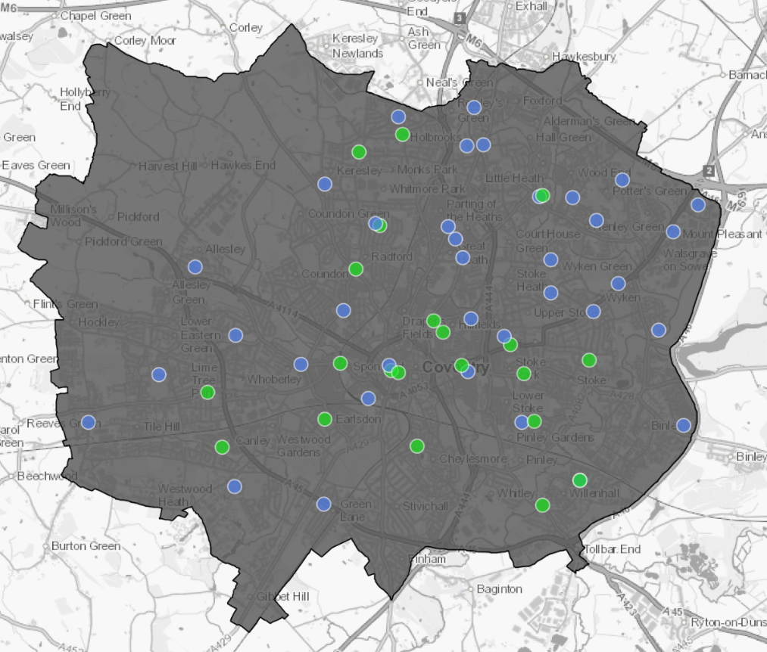
Figure 41: Pharmacies who provide the substance misuses service in Coventry
Source: Pharmoutcomes
Table 16 shows the provision of pharmacies who provide needle exchange, supervised consumption, or both services in Warwickshire. This is then mapped in figure 42, with the colours in the table corresponding to the coloured circles on the map.
 | Both | Needle Exchange | Supervised Consumption | Total
North Warwickshire | 3 | 1 | 4 | 8
Nuneaton and Bedworth | 2 | 1 | 8 | 11
Rugby | 2 |  | 6 | 8
Stratford-on-Avon | 4 | 1 | 3 | 8
Warwick | 4 |  | 7 | 11
Total | 15 | 3 | 28 | 46
Table 16: Pharmacies who provide Needle Exchange, Supervised Consumption, or Both in Warwickshire
Source: Pharmoutcomes
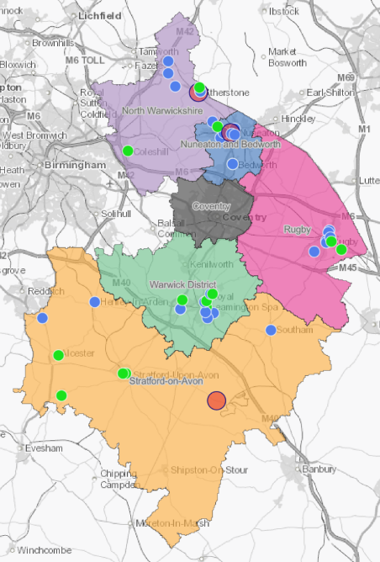
Figure 42: Pharmacies who provide Needle Exchange, Supervised Consumption, or Both in Warwickshire
Source: Pharmoutcomes
It should be noted that non-pharmacy providers throughout Warwickshire provide Substance Misuse services that include supervised consumption and needle exchange. Any planned increases in service provision should therefore take these providers into account.

Conclusion for Substance Misuse services
To achieve the national ambition outlined in the Drug Strategy 2021, more work will be required to improve the quality of services and expand the number of providers delivering supervised consumption and needle exchange programmes in Warwickshire. More work is required to map out the current provision to ensure there is fair and equitable provision countywide. Adequate provision will need to be sought in the more deprived areas and those with higher drug and alcohol prevalence. Individuals within these areas are more likely to have a range of health inequalities and poorer health outcomes.

Smoking Cessation
WCC commission community stop smoking service ‘Quit 4 Good’. Smokers can receive support to quit smoking via the GP, pharmacy or virtual offer from Everyone Health. Pharmacies providing this service can be found online - https://quit4good.warwickshire.gov.uk/

Coventry City Council commission Healthy Lifestyle Service to deliver a range of lifestyle interventions, including smoking cessation. Smokers can receive free one to one support over 12 weeks with a qualified health coach through the Healthy Lifestyle Service, as well as via their GP or local pharmacy. Information for Healthy Lifestyle Service can be found online: https://hlscoventry.org/our-services/stop-smoking/

The Stop Smoking Service is one where pharmacies provide support and advice to people who want to give up smoking. The delivery for the service helps reduce levels of smoking-related illness, disability, premature death, and health inequality.
The aims of the service are:
- Support the development of stop smoking services outside of GP surgeries.
- Enable supply of nicotine replacement therapies by appropriately trained non-physician health care professionals.
- Enable non-health care professionals who are offering intensive support to smokers to access nicotine replacement therapy as part of the support package.
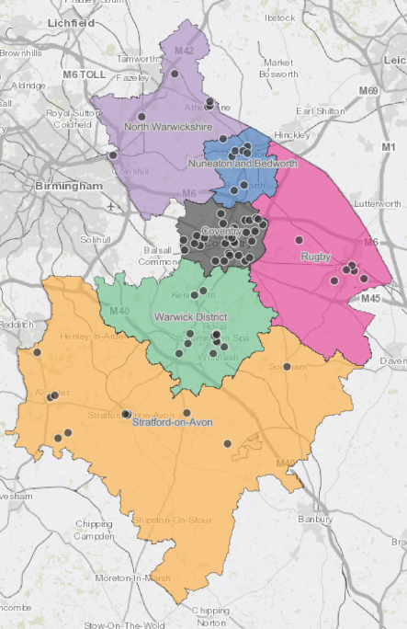
In Coventry and Warwickshire, a total of 73 pharmacies provide the smoking cessation service.
Figure 43: Pharmacies who provide the smoking cessation service in Coventry and Warwickshire
Source: Coventry City Council and Warwickshire County Council
Whilst 73 pharmacies are registered to provide the service, actual activity is an issue with many of the pharmacies.
In Warwickshire, under the contract for this service pharmacies are required to have 6 patients per year who set a quit date. An audit of services carried out showed that numbers are well below this figure for most pharmacies, and some have no activity at all.
In Coventry, there has been a significant drop in the amount of quits that pharmacies reported from 702 in 2019/20 to 261 in 2021/22. There isn’t a minimum number of patients in order for the pharmacy to offer the service. Instead, the focus is insuring a good geographic spread of pharmacies including coverage within the more deprived neighbourhoods.
Conclusion for Stop Smoking Service
Partnership work needs to be done between Commissioners of SSS/SSiP services and pharmacies to identify the actions to increase activity across those pharmacies where behavioural support and prescribing is low, with a particular focus on areas of greatest need. Consideration should be given to the role of pharmacies within the NHS long term plan tobacco dependency commitment to deliver NHS funded tobacco dependence treatment services which includes inpatient, maternity, outpatients, and community settings.

Stop Smoking in Pregnancy Service (SSiPS)
Currently, all pregnant women from the booking appointment from all 3 trusts across Coventry and Warwickshire are referred to the Stop Smoking in Pregnancy Service.
In Warwickshire this service is commissioned by WCC and provided by SWFT. In Warwickshire, a specialist team of experienced stop smoking in pregnancy advisors provide a friendly, confidential service to help pregnant smokers and their families stop smoking. If nicotine replacement therapy is required the advisor completes a letter of recommendation which needs to be redeemed and dispensed from pharmacies. It is the same pharmacies involved in the smoking cessation service who are able to dispense NRT products. It should be noted that not all pharmacies take part in this service; a patient may visit a pharmacy to redeem their voucher to be told the pharmacy does not participate in the scheme. To access the service in Warwickshire https://quit4good.warwickshire.gov.uk/quit4baby
Similar to Warwickshire, in Coventry the SSiPS is commissioned as part of the Family Health and Lifestyles Service and sits separately to the Healthy Lifestyle Service. It has been highlighted that more promotion can be done to enable more pharmacies to dispense NRT products to pregnant women.

Conclusion for Stop Smoking in Pregnancy (SSiPS)
Within Coventry and Warwickshire work can be done to strengthen the pathways around the service, especially to encourage pharmacists to redeem and dispense the letters of recommendation. The SSiPS is commissioned separately to the generic Stop Smoking service, more promotion can be done between these 2 services to increase the number of pharmacies able to dispense NRT products to pregnant women.

Sexual Health Services
Community Pharmacy sexual health services in Coventry and Warwickshire are designed to improve access to key treatments including emergency hormonal contraception (“the morning after pill”). Providers of sexual health services also encourage clients to access mainstream contraceptive services and provide education on available contraception and the prevalence of sexually transmitted diseases.
At present, pharmacies in Warwickshire are not testing or treating for STIs. Pharmacies are signposting to the Integrated Sexual Health Service (ISHS) website where users can order a testing kit for Chlamydia online.
Coventry pharmacies do offer chlamydia testing as well as C-Card (condom distribution).
Supply of emergency hormonal contraception (EHC)
The service allows a client of any age to choose to attend an accredited Warwickshire pharmacy (operating within the parameters of a service level agreement and a current EHC PGD) to obtain EHC. Client privacy is of utmost importance, and the selection of each pharmacy will have been based on the assurance that they use approved private counselling area that complies with the requirements for provision of Advance services under the National Pharmacy Contractual Framework.
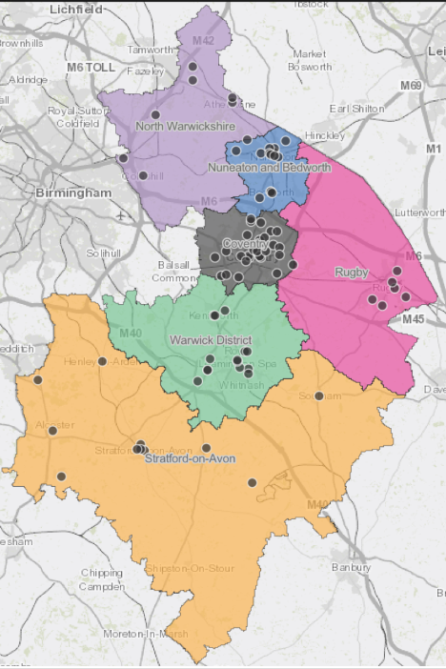
In Coventry and Warwickshire, a total of 82 pharmacies provide sexual health services.
Figure 44: Pharmacies who provide the sexual health service in Coventry and Warwickshire
Source: Coventry City Council and Warwickshire County Council
During periods of 2020, some pharmacies stopped undertaking the EHC consultation and dispensing functions due to capacity of pharmacists, but also as the requirements include the need for private consultations in rooms away from the main shop area. A number of those were not available due to the lack of ventilation, or the spaces being too small to fall in line with the 2m regulations. From 2021 onwards, the majority of the pharmacies signed up to undertake this work have reverted back to pre-pandemic activity levels.
Both Coventry and Warwickshire Integrated Sexual Health services are being renewed from 1st April 2024; it is hoped (going through final governance process ) that there will be one contract awarded to cover the whole area, this will help to ensure the offer is the same across the two areas and reduce the current confusion on what is available and to whom.
It is fair to say that pharmacies should be playing an important part of the recommissioned service. Some of the key principles which the recommissioning will embed include reducing health inequalities and focussing on ongoing service improvement.

Conclusion for Sexual Health Services
Local data shows that some Coventry residents are accessing EHC in Warwickshire, this could be as Warwickshire doesn't have an upper age limit whereas Coventry does. Bringing the Integrated Sexual Health contracts together to one contract will enable the current pharmacy offers to be aligned, this will help to reduce service user confusion as to what is offered where and to whom.

End of Life (EoL) Medicines
Community pharmacies provide advice and stock an agreed list of medicines commonly used in palliative care for patients nearing the end of their life. Pharmacies are a convenient access point for these medicines throughout Coventry and Warwickshire. There are 4 community pharmacies in Coventry and 7 community pharmacies in Warwickshire who are currently commissioned to provide this service, and therefore guarantee to hold the stock of medicines. All pharmacies can order these medicines, although they are not guaranteed to have stock. The demand of these medicines may be urgent and/or unpredictable, the pharmacy contractor will therefore:
- Stock a locally agreed range of specialist medicines and make a commitment to ensure prompt access to these medicines at all times agreed with the ICB.
- Provide information and advice to the user, carer, and clinician. They may also refer to specialist centres, support groups or other health and social care professionals where appropriate.
This service is currently due to run until 31st March 2023.

Conclusion for End of Life Medicines Services
Pharmacies provide a convenient access to these medicines throughout Coventry and Warwickshire. At present there is a limit to the number of pharmacies commissioners can commission this service to. This is currently being reviewed, and a supplementary statement to this PNA will be produced if there is any change in this service.

Sharps Disposal
The Sharps Disposal service currently collects any size of sharps container once per month which allows the disposal of 1L sharps which pharmacies are not generally contracted to take. This will soon be moving to an on-request service where pharmacies contact the service when they need a collection.
This service only operates in Warwick District at the following pharmacies:
Birk and Nagra, CV31 1NL | Birk and Nagra, CV31 3AG | Birk and Nagra, CV31 2BB
Birk and Nagra, CV31 2DT | Birk and Nagra, CV31 2LY | Birk and Nagra, CV32 6DS
Birk and Nagra, CV34 6DZ | Boots Local, CV8 1JP | Boots the Chemist, CV34 4DH
Boots the Chemist, CV34 6RH | Mellors Pharmacy, CV34 4SA | Dudley Taylor Pharmacy, CV8 1JD
Ivens Dispensing Chemist, CV31 3BH | Leyes Lane Pharmacy, CV8 2DE | Lillington Pharmacy, CV32 7AG
Lloyds Pharmacy, CV32 7SH | Lloyds Pharmacy, CV32 4PN | Stratwicks Pharmacy, CV34 5RN

Conclusion for Sharps Disposal
There are different sharps service collections in place which can be unclear to both the public and pharmacies, such as the service provided by PHS which also collects sharps. Because of this, the quantity of sharps collected by this service has been minimal. To help with this the following opportunities have been identified:
- Provide clarification on the different services to clear up confusion for pharmacies and patients, including over the size of sharps containers accepted with the different services.
- Provide better communication between pharmacies who provide a sharps disposal service and GPs so better signposting can be done.
Warwick District Council is open to additional pharmacies becoming sharps return points so that they can expand the service offered to residents to return sharps. Consideration should also be given to expanding the service to cover all of Coventry and Warwickshire to create equitable access.

HIV POC Testing
The HIV Point of Care Testing service in Coventry aims to increase the number of HIV tests taken in Coventry, especially in at-risk groups such as the black African population and Men who have Sex with Men (MSM). Pharmacy involvement means patients can access this service who may not have otherwise accessed it.
Pharmacies use the INSTI HIV-1/HIV-2 Antibody Point of Care blood spot Test (POCT) to screen for HIV antibodies. If a result is positive, patients must attend the Integrated Sexual Health Service for another blood test to have their HIV diagnosis confirmed.
There are 4 pharmacies in Coventry who provide the HIV POC Testing service. No gaps in this service have been identified.

Phlebotomy
Phlebotomy services are blood tests or blood taking. A prescriber such as a nurse or GP can issue a patient with a request to have bloods taken, and for convenience and speed this can now be done at a local pharmacy, avoiding queues at hospitals and GP surgeries. The bloods are sent off for analysis and the results are sent back to the prescriber. This provides access to phlebotomy services at a wider range of times and venues to suit the local community.
There are 17 pharmacies in Coventry who provide the Phlebotomy service. No gaps in this service have been identified.

Emergency Department (ED) to CPCS Pilot Coventry and Rugby
The ED to CPCS is an extension of the CPCS Advanced Service and is running as a pilot from 1st November 2021 to 30th September 2022. There are 21 pharmacies in Coventry and 5 pharmacies in Rugby taking part, they are:

Coventry
Acorn Chemist – CV3 3DP | Asda Pharmacy – CV2 2PN | Bannerbrook Pharmacy – CV4 9AE
Boots UK Ltd – CV3 6TA | Chemicare – CV6 2HT | Chemycare – CV2 2GG
Clay Lane Pharmacy – CV2 4LJ | General Wolfe Pharmacy – CV6 5HP | Hillfields Pharmacy – CV1 5JF
Humber Pharmacy – CV3 1AT | Imperiun Pharmacy – CV6 4HF | Jhoots Pharmacy – CV6 1HQ
Jhoots Pharmacy Torcross – CV2 3NE | Lloyds Pharmacy – CV1 4FS | Lloyds Pharmacy Sainsburys – CV6 7NS
M Hussain Chemist – CV1 5AE | Mount Nod Pharmacy – CV5 7NJ | Styvechale Pharmacy – CV3 6FQ
Superdrug – CV1 1LF | Superdrug – CV1 1DL | Village Pharmacy – CV7 8JX
Rugby
Lloyds Pharmacy in Sainsburys – CV22 6HU | Lloyds Pharmacy – CV21 3AQ | Paddox Pharmacy – CV22 5BP
Well Rugby Health & Wellbeing Centre – CV21 3HX | Rowlands – CV21 2AS

In this service pharmacies will receive referrals to the NHS CPCS from the identified additional Urgent and Emergency Care (UEC) settings in the pilot areas, for Coventry this being University Hospital Coventry and Warwickshire (UHCW) and for Warwickshire this being the Urgent Treatment Centre (UTC) at the Hospital of St Cross.
Once the referral has been received by the pharmacy it will be actioned in the same way as referrals made in the CPCS Advanced Service. This will allow patients with low acuity minor illnesses and requests for urgent repeat medication supplies to be referred to the community pharmacies in the trial.

Conclusion for ED to CPCS Pilot
There will be further decisions made depending on the outcomes of the pilot during the evaluation.

NHS England Extended Care Service
The Community Pharmacy Extended Care Service is provided in 2 Tiers, and aims to provide eligible patients who are registered with a GP contracted to NHS England & Improvement Midlands Region with access to support for the treatment of the following:
Tier 1:
- Treatment of simple Urinary Tract Infections (UTI) in females (aged 16-years up to 65-years of age)
- Treatment of Acute Bacterial Conjunctivitis (for children aged 3-months to 2-years)
Tier 2:
- Treatment of Impetigo
- Treatment of Infected Insect Bites
- Treatment of Infected Eczema
The overall aims of the service are to:
- Educate patients to seek advice and treatment from the most appropriate healthcare setting
- Improve patient’s access to advice and appropriate treatment for these ailments via community pharmacy
- Reduce GP workload for these ailments allowing greater focus on more complex and urgent medical conditions
- Educate patients with aim of reducing requests for inappropriate supplies of antibiotics
- Promote the role of the pharmacist and self-care
- Improve working relationships between doctors and pharmacists
50 pharmacies in Coventry and 61 pharmacies in Warwickshire currently provide UTI treatment under Tier 1 and 44 pharmacies in Coventry and 58 pharmacies in Warwickshire currently provide Acute Bacterial Conjunctivitis treatment under Tier 1.
33 pharmacies in Coventry and 41 pharmacies in Warwickshire currently provide Tier 2 treatments.
Conclusion for Extended Care Services
No gaps in this service have been identified from the information available.

COVID-19 Vaccination National Enhanced Service (Phase 5)
From Autumn 2022 the COVID-19 vaccination service will be commissioned as a National Enhanced Service (NES) with community pharmacy contractors being selected locally to provide the service to meet the needs of the population. The service is planned to commence on 1st September 2022 and will be supported by national Patient Group Directions and national protocols.
There are a mix of pharmacies operating from their usual location, and some operating out of temporary non-NHS sites in order to outreach into communities where there may be lower take up or a gap in provision.
Site name | Site Address | Site Postcode
Abbeygate Shopping Centre (Pharmacy2U) | Unit 17, Abbey Street, Abbeygate Shopping Centre, Nuneaton | CV11 4HL
Acorn Pharmacy - Coventry | Unit 2 Remembrance Rd, Coventry | CV3 3DP
Allesley Pharmacy | 132-134 Birmingham Rd, Allesley, Coventry | CV5 9HA
Brownsover Community Centre (Lister Chemists) | Bow Fell, Brownsover, Rugby | CV21 1JF
Coventry Community Resource Centre (Express Meds) | Red Lane, Coventry | CV6 5EE
Hb Dunn Chemists - Leamington Spa | 31-33 Oxford St, Leamington Spa | CV32 4RA
Henley Road Pharmacy | 1 Henley Rd, Bell Green, Coventry | CV2 1LQ
Imperiun Pharmacy - Coventry | 1 Wheelwright Ln, Coventry | CV6 4HF
Kasli Pharmacy | 216-218 Tomkinson Rd, Nuneaton | CV10 8BW
Knights Pharmacy - Rugby | 30-31 Sheep St, Rugby | CV21 3BX
Left Hand Grafton House (Delivermymeds) | Bulls Head Yard Alcester | B49 5BX
Monarch Pharmacy | 318 Radford Rd, Coventry CV6 3AA | CV6 3AA
Atherstone Vaccination Clinic (Village Pharmacy) | Old Bank House, South Street, Atherstone | CV9 1DE
Paddox Pharmacy | 316 Hillmorton Rd, Rugby | CV22 5BP
Ringwood Pharmacy | Ringwood Pharmacy, 200 Wigston Rd, Coventry | CV2 2RH
Rugby Indian Association (Acorn Pharmacy) | Edward St, Rugby | CV21 2EZ
Tile Hill Lane Pharmacy - Coventry | 343 Tile Hill Lane, Coventry | CV4 9DU
United Reform Church (Hillfields Pharmacy) | United Reform Church, Chapel Street, Nuneaton | CV11 5QH
Vantage Chemist - Coventry | 131-132, Far Gosford St, Coventry | CV1 5EA

Conclusion

Coventry
The PNA tells us that even though coverage of community pharmacies is adequate for our needs, all community pharmacy services could be more effectively integrated into local pathways to ensure maximum benefits for population level health and wellbeing. The pathway into community pharmacy should be clear and well communicated, allowing community pharmacies the opportunity to deliver appropriate services. Community Pharmacies can offer a suite of services commissioned locally and nationally. The direction of travel for service delivery through community pharmacies requires integration in terms of pathway design and infrastructure and for community pharmacies to be recognised as a member of the multi-disciplinary team along with other service providers in primary care.
As many community pharmacies are often located in deprived areas with high population density, they are an important first point of contact for patients seeking ad-hoc health advice alongside picking up regular prescribed medicines or purchasing over the counter medicines. It is important for pharmacies to continue to deliver healthy lifestyle campaigns to support the wider determinants of health, increasing awareness of local and national programmes which could positively impact the community’s health and wellbeing.
There are many opportunities where community pharmacies can support all workstreams of the evolving ICS and improve health, wellbeing and reducing health inequalities. Key opportunities for the ICS exist around making the most of existing commissioned services (essential, advanced and locally commissioned services) particularly in relation to medicines optimisation.
There is capacity for community pharmacy to address local priorities described in the JSNA and forthcoming ICS strategy. Community pharmacies have close links with their communities and are therefore well placed to support CHWB to deliver their priorities.
Local commissioning organisations should continue to consider pharmacies among potential providers when they are looking at the unmet pharmaceutical needs and health needs of the local population, including when considering options for delivering integrated care. Any commissioning of services or initiatives in community pharmacies should be informed by the evidence base and evaluated locally ideally using an evaluation framework that is planned before implementation.
Pressures on community pharmacies have increased due to the COVID-19 pandemic, and this pressure may increase over the next few years due to the cost-of-living crisis. This should be carefully monitored to understand how this may change community pharmacy provision, and provide support should that be needed.
There is good access for community pharmacies in Coventry, with 51 of the 97 pharmacies in Coventry being open on a Saturday and the majority of pharmacies being within a 5 minute drive, and all pharmacies within a 15 minute drive. There is opportunity to do more joined up work when it comes to signposting, both into community pharmacies (providing clear information on opening times and services offered) and out of pharmacies (best pathways for care).
It is important to emphasis prevention, early intervention, and early help to protect and maintain people’s health and independence. The Coventry Health and Wellbeing Board consider community pharmacies to be a key health and wellbeing resource and recognise that they offer potential opportunities to support health improvement initiatives and work closely with partners to promote health and wellbeing.
The public engagement process revealed a high level of satisfaction on the part of respondents.

Warwickshire
Whilst the PNA concludes that there is an adequate provision of pharmaceutical services in Warwickshire to serve the needs of the population, there is an opportunity to encourage community pharmacies to be part of service pathways. The pathway into community pharmacy should be clear and well communicated, allowing community pharmacies the opportunity to deliver appropriate services. Community Pharmacies can offer a suite of services commissioned locally and nationally. The direction of travel for service delivery through community pharmacies requires integration in terms of pathway design and infrastructure and for community pharmacies to be recognised as a member of the multi-disciplinary team along with other service providers in primary care.
Community pharmacies can serve as an important first point of contact for people seeking health advice as well as collecting prescriptions and buying over the counter medication. Many pharmacies can be found in high density, deprived areas and have important links out into the communities they serve. It is important for pharmacies to continue to deliver healthy lifestyle campaigns to support the wider determinants of health, increasing awareness of local and national programmes which could positively impact the community’s health and wellbeing.
Local commissioning organisations should therefore continue to consider pharmacies among potential providers when they are looking at the unmet pharmaceutical needs and health needs of the local population, including when considering options for delivering integrated care.
Pressures on community pharmacies have increased due to the COVID-19 pandemic, and this pressure may increase over the next few years due to the cost-of-living crisis. This should be carefully monitored to understand how this may change community pharmacy provision and provide support should that be needed.
There is good access for community pharmacies in Warwickshire, with 86 of the 106 pharmacies in the county being open on a Saturday and almost the entirety of the county being with a 15-minute drive of a pharmacy. There is opportunity to do more joined up work when it comes to signposting, both into community pharmacies (providing clear information on opening times and services offered) and out of pharmacies (such as best pathways for care).
The changing population needs for healthcare and in particular the demands of an increasing ageing population with multiple long-term conditions mean there are some significant challenges to overcome in the drive to improve health and well-being in Warwickshire. To meet these challenges, there will need to be a much greater emphasis on prevention, early intervention, and early help to protect and maintain people’s health and independence. The Warwickshire Health and Wellbeing Board consider community pharmacies to be a key health and wellbeing resource and recognise that they offer potential opportunities to support health improvement initiatives and work closely with partners to promote health and wellbeing.
There are opportunities to develop the contribution of community pharmacies across all the currently commissioned services. Any commissioning of services or initiatives in community pharmacies should be informed by the evidence base and evaluated locally ideally using an evaluation framework that is planned before implementation.
There is capacity for community pharmacy to address local priorities described in the JSNA and evolving ICS. Community pharmacies have close links with their communities and are therefore well placed to support WHWB to deliver these priorities.
The public engagement process revealed a high level of satisfaction on the part of respondents, with particular praise for the part they played in the COVID-19 pandemic.

Appendicies

Appendix 1 - Pharmacy Survey
Out of 197 pharmacies, 161 responses to the Pharmacy Professionals survey were received. Of these, Coventry had 76 responses (47%) and Warwickshire had 85 responses (53%).
Table 17: Number of responses to the Pharmacy Professionals Survey by District / Borough
District / Borough | Number of Responses
Coventry | 76
North Warwickshire | 13
Nuneaton & Bedworth | 22
Rugby | 13
Stratford-on-Avon | 15
Warwick | 22
Table 17: Number of responses to the pharmacy professionals survey by district/borough
Of the 161 pharmacies who responded to the survey, 159 had consultation rooms (98%), with the remaining being distance selling pharmacies. There were hand washing facilities at 142 of the pharmacies (88%), and toilet facilities at 54 pharmacies (34%).
Offsite consultations were available at 75 pharmacies (47%)
Almost all pharmacies dispensed appliances (159, 98%).
The number of pharmacies providing advanced services is shown in figure 45.
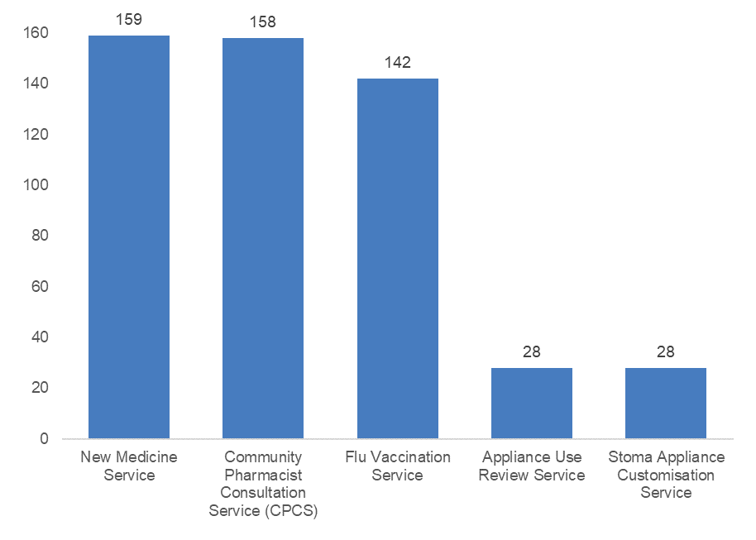
Figure 45: Number of pharmacies providing advanced services
A list of other services provided by pharmacies are shown in Table 18. Pharmacies were able to select more than one option for each service. The home delivery service was the most commonly provided service (97 pharmacies), along with supervised administration service (93 pharmacies) and emergency supply service. There were a number of services provided by fewer than 5 pharmacies, however for all of these, there were over 100 pharmacies who said they would provide the service if commissioned.

Service | Currently Providing | Would provide if commissioned | Would provide privately | Wouldn’t provide if commissioned
Home Delivery Service (not appliances) | 97 | 50 | 18 | 6
Supervised Administration Service | 93 | 43 | 6 | 15
Emergency Supply Service | 88 | 63 | 15 | 2
Emergency Contraceptive Service | 78 | 70 | 18 | 4
NRT vouchers | 78 | 69 | 18 | 7
Extended Care Tier 1 (UTI) | 74 | 60 | 12 | 9
Sharps Disposal Service | 68 | 70 | 18 | 12
Extended Care Tier 2 (Skin) | 59 | 74 | 12 | 14
Stop Smoking Service | 58 | 80 | 17 | 11
Medication Review Service | 38 | 108 | 19 | 6
Needle and Syringe Exchange service | 34 | 79 | 20 | 31
Extended Care Tier 3 (ENT) | 22 | 103 | 20 | 16
Medicines Assessment and Compliance Support Service | 20 | 109 | 21 | 16
Phlebotomy Service | 20 | 90 | 20 | 34
Pharmacy First Minor Ailment scheme | 19 | 126 | 19 | 3
Not Dispensed Scheme | 18 | 111 | 18 | 13
Care Home Service | 17 | 89 | 19 | 37
Contraceptive Service (not EHC) | 15 | 129 | 21 | 7
Obesity Management (Adults and Children) | 15 | 126 | 21 | 8
Chlamydia Testing Service | 12 | 119 | 20 | 13
Chlamydia Treatment Service | 12 | 122 | 21 | 10
Anti-viral Distribution Service | 10 | 117 | 21 | 18
Language Access Service | 10 | 101 | 21 | 29
Gluten Free Food Supply Service (not via FP10) | 9 | 115 | 20 | 18
Healthy Start Vitamins | 8 | 121 | 19 | 17
Out of Hours Service | 5 | 88 | 16 | 48
Anticoagulant Monitoring Service | 4 | 130 | 23 | 14
On Demand Availability of Specialist Drugs Service | 4 | 111 | 19 | 27
Schools Service | 4 | 103 | 20 | 33
Prescriber Support Service | 2 | 114 | 43 | 25
Vascular Risk Assessment Service | 1 | 131 | 21 | 13
Table 18: Number of Pharmacies providing other services
In terms of disease specific services, not many pharmacies were already providing these services, the highest being hypertension with 25 currently providing. However for each disease specific service, over 100 pharmacies would provide if commissioned (Figure 19).
Disease Specific Service | Currently Providing | Would provide if commissioned | Would provide privately | Wouldn’t provide if commissioned
Hypertension | 25 | 109 | 17 | 9
Allergies | 12 | 118 | 23 | 11
Asthma | 12 | 122 | 20 | 9
Diabetes Type 1 | 10 | 122 | 21 | 10
Diabetes Type 2 | 10 | 123 | 20 | 9
CHD | 9 | 121 | 20 | 10
COPD | 9 | 122 | 20 | 10
Depression | 9 | 118 | 19 | 15
Epilepsy | 8 | 119 | 19 | 14
Heart Failure | 8 | 120 | 20 | 11
Parkinson's Disease | 8 | 122 | 19 | 12
Alzheimer's / Dementia | 7 | 121 | 19 | 13
Table 19: Number of Pharmacies providing Disease Specific Services
Similarly with screening services, there are not many pharmacies currently providing these services, however the majority would provide if commissioned (Table 20)
Screening Service | Currently Providing | Would provide if commissioned | Would provide privately | Wouldn’t provide if commissioned
Diabetes | 13 | 111 | 28 | 11
Cholesterol | 5 | 117 | 26 | 15
HIV | 3 | 104 | 23 | 26
Alcohol | 2 | 116 | 23 | 18
HbA1C | 2 | 115 | 23 | 20
Gonorrhoea | 1 | 112 | 24 | 22
H. Pylori | 1 | 115 | 23 | 22
Hepatitis | 1 | 108 | 24 | 25
Table 20: Pharmacies providing Screening Services

In terms of vaccination services, the majority of pharmacies offer the seasonal influenza vaccine service (132) however only small numbers currently provide other vaccinations (Table 21)
Vaccination Service | Currently Providing | Would provide if commissioned | Would provide privately | Wouldn’t provide if commissioned
Seasonal Influenza Vaccination service | 132 | 16 | 19 | 8
Pneumococcal | 22 | 94 | 28 | 22
COVID 19 | 16 | 104 | 24 | 24
Travel Vaccinations | 10 | 99 | 39 | 20
Meningococcal | 9 | 103 | 13 | 26
Hepatitis (at risk workers or patients) | 8 | 99 | 33 | 26
HPV | 7 | 95 | 33 | 27
Childhood vaccinations | 3 | 99 | 28 | 33
Table 21: Pharmacies providing Vaccination Services
In terms of non-commissioned services, the majority of pharmacies offer collection of prescription from GP practices (137) as well as monitoring dosage systems free of charge on request (135), and many also provide delivery of dispensed medicines free of charge on request (105). For the delivery of dispensed medicines, it is worth noting that most of these pharmacies will deliver free of charge to elderly, vulnerable or housebound patients only (Table 2)
Vaccination Service | Currently Providing | Would provide if commissioned
Collection of prescription from GP practices | 137 | 21
Monitoring Dosage Systems - free of charge on request | 131 | 26
Delivery of dispensed medicines - free of charge on request | 105 | 52
Delivery of dispensed medicines - with charge | 65 | 78
Monitoring Dosage Systems - with charge | 15 | 125
Table 22: Pharmacies providing Non-commissioned services
When asked if there is a particular need for a locally commissioned service in your area, the two most common responses are minor ailments service or community Pharmacy Consultation service (17) and also a Phlebotomy service (11).

Appendix 2 - Public Survey
Background
A Pharmacy Services User Survey was conducted across Coventry and Warwickshire in March 2022. The survey was conducted on-line with access to the survey promoted via posters in all community pharmacists. Users were asked to scan a QR Code which took the respondent to the survey hosted on Coventry City Council’s Let’s Talk platform.
1,601 responses were available for analysis. The response for each of the council areas is seen below:
Which area do you live in?
 | Sample Percent | Population Percent
Coventry | 27% | 39%
Warwick District | 22% | 15%
Stratford on Avon District | 19% | 14%
Rugby Borough | 13% | 12%
Nuneaton and Bedworth Borough | 11% | 14%
North Warwickshire Borough | 7% | 7%
Other | 1%
Table 23: Responses to the public survey by area
The sample under-represents Coventry and Nuneaton and Bedworth and over-represents Warwick and Stratford Districts.
Compared to the population the sample was also non-representative by
- 25–54-year-olds were under-represented
- Older age groups were over-represented
- Only 25% of the respondents were male
- BAME groups were under-represented with 91% in the whole sample being of White British origin.

Survey Contents
The survey asked a range of questions about respondents use of pharmacy services both in-store and online. For those who mostly visited a pharmacy store – access issues were discussed and for on-line users the benefits for them of this approach was examined.
Additionally, socio-demographic information about the respondent was recorded. This allows for an analysis of responses to questions about service use across age, employment status, ethnicity, disability status etc.
This report will examine the responses to the pharmacy use questions for the whole survey and identify variations from this by location, age, ethnicity etc where they occur.

Frequency of Use
On average how frequently do you use a pharmacy?
 | Percent
More than once per week | 2%
Once per week | 8%
Once or twice a month | 39%
Once or twice every other month | 41%
Once or twice per year | 8%
I don't know | 1%
Table 24: Answers to the question “On average how frequently do you use a pharmacy?”
- Respondents from Warwick District were more likely to attend once or twice every other month (51.6%)
- Employed people were more likely to visit 1 or 2 times per year
- Retired people were less likely to visit 1 or 2 times per year
- 25–54-year-olds were more likely to visit 1 or 2 times per year
- 75+ were less likely to visit 1 or 2 times per year
- People with disability were less likely to visit 1 or 2 times per year

Travel to Pharmacy
How would you normally travel to the pharmacy you usually use?
 | Percent
Car/Motorbike/Van | 46.5%
Walk | 42.0%
I have my medicines delivered | 6.8%
Other | 1.8%
Public Transport | 1.8%
Cycle | 1.1%
Table 25: Answers to the question “How would you normally travel to the pharmacy you usually use?”
- Fewer people walk in Stratford District
- Retired people were more likely to use a car
- People with disabilities were less likely to walk and more likely to use a mobility scooter

Distance travelled to Pharmacy
How long does it usually take you to travel to your pharmacy?
 | Percent
Between 15 and 30 minutes | 19%
I have my medicines delivered | 5%
Less than 15 minutes | 74%
More than 30 minutes | 1%
Table 26: Answers to the question “How long does it usually take you to travel to your pharmacy?”
- Respondents from Coventry were less likely to travel 15-30 minutes (10.5%)
- 25–54-year-olds were less likely to travel 15-30 minutes

Pattern of Use
What best describes your use of a pharmacy?
 | Percent
I use the same community pharmacy all of the time | 60%
I use the same community pharmacy most of the time | 29%
I use several different community pharmacies | 8%
I use a combination of community pharmacies and online/internet pharmacies | 3%
I use online/internet pharmacies all of the time | 1%
Table 27: Answers to the question “What best describes your use of a pharmacy?”
- Employed respondents are more likely to use a range of pharmacies
- 25–54-year-olds are less likely to use the same pharmacy all of the time
- 75+ are more likely to use the same pharmacy

What do people use the Pharmacy for?
We gave respondents a range of pharmacy uses to choose from, and they could select as many as appropriate, hence the percentages add up to more than 100%.
For what reasons do you usually access a pharmacy? | %
To collect a prescription(s) | 93%
To buy over the counter medicines (that do not need a prescription) | 57%
To have a vaccination including flu booster/Covid vaccines | 25%
To buy over-the-counter medical devices and other health-related products e.g plasters, bandages etc. | 28%
To get advice and information on medication | 31%
To get advice and information on healthy lifestyles and disease prevention | 3%
To get Covid related advice/information | 3%
To access a NHS or public health service | 6%
Other | 6%
Table 28: Answers to the question “For what reasons do you usually access a pharmacy?”
- Rugby respondents were more likely to buy over-the-counter medical devices and other health-related products e.g., plasters, bandages etc.
- Coventry respondents were more likely to access an NHS or public health service
- Others noted were mostly Blood Tests which wasn’t offered as an option in the survey

Most important services
Respondents were asked to choose their top 3 services most important to them.
When thinking about your pharmacy, what is most important to you?
 | %
Efficient and quick service | 74%
Location of pharmacy | 45%
Friendly staff | 43%
Know and trust the Pharmacist/Team | 32%
Late opening hours | 24%
Pharmacist takes time to listen and talk to me | 19%
Services available | 13%
Availability of urgent advice | 10%
Home delivery of medication | 9%
Other (please specify) | 3%
Multiple languages spoken | 0%
Table 29: Answers to the question “When thinking about your pharmacy, what is most important to you?”
- Respondents from Coventry were more likely to value late opening
- Respondents from Stratford District were less likely to value late opening
- Employed people value late opening
- Retired people were less likely to value late opening
- 75+ were less likely to value late opening
- 75+ were more likely to value home delivery
- Disabled respondents were more likely to value home delivery

Use of Services
Respondents were asked to identify from a list of services those they are aware of, those which they have used and which they may be interested in using in the future?
 | I am aware of this service but have not used it | I have used this service | I am not aware of this service but I would be interested in using this service in the future
Disposal of old medicines | 40% | 47% | 11%
Discuss your prescription medicines | 38% | 48% | 10%
New prescription medicines | 31% | 39% | 22%
Use of medical devices e.g. blood pressure monitor | 51% | 11% | 30%
Emergency supply of medication | 38% | 21% | 34%
Advice on healthy living | 60% | 5% | 24%
Stopping smoking advice | 75% | 3% | 8%
Sexual health services | 68% | 2% | 14%
Blood tests | 31% | 18% | 42%
Vaccinations including flu/Covid | 46% | 38% | 10%
Travel vaccines | 52% | 6% | 30%
Health tests e.g. cholesterol, blood pressure check | 46% | 7% | 37%
Table 30: Percentages of people aware of certain services
- Stratford-based respondents were more likely (18%) to have not been aware of the service to discuss prescription medications but would be interested in doing this in future
- Warwick-based respondents were more likely (41%) to be aware but not used blood test services
- 25–54-year-olds were less likely to have used medicines disposal but more likely to think they might use the service
- 25–54-year-olds were less likely to be interested in smoking cessation advice
- Asian/Asian British were more likely to not be aware of medicines disposal services but would be interested in using this service in the future
- Male respondents were less likely to have used the sexual health services but more likely to have used health tests

Opening Hours

When would be the most convenient time for you to visit a pharmacy?
 | Before 9am | Between 9am and 1pm | Between 1pm and 6pm | After 6pm
Monday to Friday | 9% | 61% | 48% | 28%
Saturday | 3% | 75% | 36% | 4%
Sunday | 2% | 43% | 24% | 3%
Table 31: Answers to the question “When would be the most convenient time for you to visit a pharmacy?”
Are you able to access a pharmacy at times that are convenient to you?
 | Percent
Most of the time | 47%
Yes always | 39%
Sometimes | 11%
Never | 2%
Table 32: Answers to the question “Are you able to access a pharmacy at times that are convenient to you?”
- Employed respondents were more likely to cite opening hours as an access barrier, more likely to prefer Mon-Fri opening before 9am, less likely to prefer 9-1pm, less likely to agree that opening hours are always convenient for them favouring only sometimes
- Retired respondents were less likely to cite opening hours as an access barrier, less likely to prefer Mon-Fri opening before 9am, more likely to prefer 9-1pm, and more likely to find opening hours always convenient for them
- 25–54-year-olds face some access issues due to opening hours, are less likely to agree that opening hours are always convenient for them favouring only sometimes and use online services because of later opening hours
- 75+ are more likely to say opening hours are fine and more likely to find opening hours always convenient for them

Use of Online/Internet Pharmacy Services

Have you used or accessed online/internet pharmacy services?
 | Percent
No | 80%
Yes | 17%
Not sure | 3%
Table 33: Answers to the question “Have you used or accessed online/internet pharmacy services?”
Why do/did you chose to use online/internet pharmacy services?
 | % of those who use Online
Home delivery of medication | 51%
Efficient and quick service | 48%
Services available | 19%
Other (please specify) | 18%
Late opening hours | 8%
Availability of urgent advice | 5%
Knowledge | 5%
Table 34: Answers to the question “Why do/did you chose to use online/internet pharmacy services?”
- 25–54-year-olds were more likely to use online services because of later opening hours

Communication of advice

The advice was well communicated to you (e.g.
spoken, written down)
 | Percent
Definitely agree | 55%
Somewhat agree | 18%
Neither agree nor disagree | 9%
Somewhat disagree | 3%
Definitely disagree | 2%
Table 35: Answers to the question “The advice was well communicated to you (e.g. spoken, written down)
Did the advice offered meet your expectations?

73%
10%
18%
Figure 46: Answers to the question “Did the advice offered meet your needs?”
In total, 90% of respondents felt the advice they received from their Pharmacy met or exceeded their expectations.

Appendix 3 – Public Survey Question Feedback
Introduction

The final open ended question of the pharmacy needs assessment survey recorded 564 comments. Using Nvivo software, comments were coded and themed and are presented below. They reflect a mixture of positive, negative, and more neutral statements or suggestions made by participants. Sentiment analysis using Nvivo indicated there was a broadly similar number of comments coded as ‘positive’ to those coded ‘negative’.
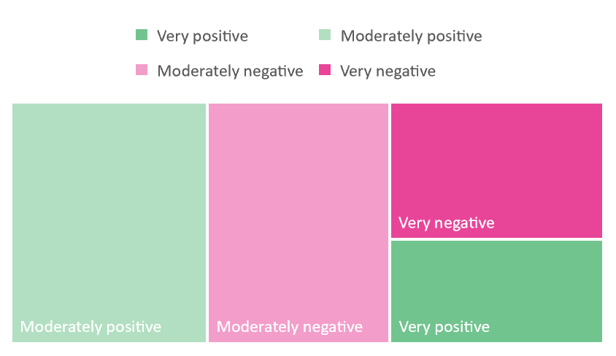
Figure 47: Sentiment analysis (using Nvivo) ‘Is there anything else you want to tell us about your recent experience of using pharmacies

Summary
In general, the things people liked and valued about their local pharmacy included;
- Good customer service – friendly and knowledgeable staff – for some this included the time to get to know customers and their needs and continuity of staff.
- Efficiency in handling prescriptions (including repeat prescription systems) was appreciated. Respondents liked systems that were streamlined and worked around their different needs e.g., prescriptions being ready to collect or a reliable delivery service if that wanted that. Easy to use repeat prescription arrangements were also valued.
- Pharmacists were for some viewed as a positive alternative to making GP appointments. They were valued for their knowledge relating to medication queries and wider health issues.
- The availability of other services like blood tests and vaccines was also helpful to some respondents.

On the flipside, it was largely when the above didn’t happen that respondents raised concerns about the service of their local pharmacy. These typically were as follows;
- Prescription handling problems – these included issues at all stages of the prescription journey from ordering repeats to collection/delivery. A frequent concern was that prescriptions were not ready for collection or had items out of stock. This caused long waits or necessitated return visits to complete the prescription which respondents found frustrating. It is important to note on this that pharmacies do not order the script or deliver it, and any stock issues are beyond pharmacy control.
- There seemed considerable variation in the way prescriptions, including repeats, were handled (e.g., some notified ‘prescription ready’ others did not, some delivered others did not). It was not always clear people were using, or aware of, the method that would best suit their needs.
- Experiencing staff as rude, dismissive, or feeling like an inconvenience to them.
- Opening times did not always meet customer needs. Respondents sometimes found routine (e.g., lunchtime) and random closures (due to staff shortages) frustrating. This is reflected within the pharmacy pressures section of the Pharmacy Provisions and Access chapter as a direct impact from increased pressures on pharmacies.
- Respondents observed how busy some of their local pharmacies were and felt there was a lack of capacity in some areas where demand from the local population had increased. Access to the pharmacist was not always possible.
- Respondents sometimes reported that when they sought additional health advice as per NHS recommended pathway to self-care, staff including pharmacists were unwilling to offer advice preferring instead to refer to GP services.

The following table provides more detailed information about the comments made in relation to this question including identified themes and sample quotations for illustration.

Theme | Explanation | Examples for illustration
Generic positive experiences | There were many positive comments relating to the general experience of pharmacies. People liked;  - Friendly, knowledgeable staff.  - The local nature of a pharmacy was helpful to some as was staff who knew them and their health.  - Continuity of staff mattered to some respondents.  - Advice about medication and wider health issues was welcomed and sometimes seen as an alternative to seeking a GP appointment.  - Efficiency in prescription handling including ready for collection and notification that it was ready e.g., text was valued.  - Good communication with GP was appreciated  Some of the above are expanded in the themes set out below. | “Fantastic, really friendly knowledgeable staff, I get reminders for reordering my prescriptions and notifications that they are ready to collect. When I have a new medicine prescribed the member of staff double checks with me that I understand the dosage and that the Dr has explained the reason for the new/ changed medicine. They are 1st class”  “As a disabled person, with numerous health issues, my local pharmacy is literally a life line”  “Excellent Customer Service and Satisfaction Over a Good Number of Years.”  “Extremely helpful and easier and quicker to access than making a GP appointment.”  “Friendly, knowledgeable and is a quick alternative to a GP  I am very happy with my pharmacist & team.”  “I prefer to go to the local pharmacy, as it is more personal than a large city-centre chain store, and it is near where I live. I really value the local service”  “I receive a very efficient and helpful service from my local pharmacy.”
Prescription handling issues | Issues identified by respondents about how the pharmacy handles prescriptions, included:  - The length of time between ordering medicines and prescription being available – some respondents reported increases in more recent months  - A key issue was prescriptions not ready for collection leading to long queues or necessitating return visits to the pharmacy.  - Items not stocked or missing – return visits required.  - Wrong items/out of date medication.  - System for finding prescriptions disorganised.  - Respondents liked measures that saved them time e.g., prescription ready notifications, good communication between GPs and pharmacies, delivery services if desired.  - Communication issues between GP and pharmacy (see repeat prescription theme). | “It can take up to 7 days from the time the pharmacy receives the script to being able to collect medication”  “Always have to wait for the prescription to be filled even when ordered 5 days before”  “Doesn’t matter how far in advance you order medications they are never ready when you go to collect”  “Long queues outside chemist ,lack of supplies a big issue repeat prescriptions so we have to go back several times to collect”  “Don’t always have the tablets in stock”  “Seem to take ages finding my prescriptions (which had been sent directly to them from the GP) have a muddled system to find things”
Repeat prescription process | There appeared to be a range of ways in which respondents and pharmacies dealt with repeat prescriptions e.g., through the GP, a pharmacy or ‘pharmacy to my door’ arrangements. There were also different methods to arrange these e.g., online/telephone/automated. Some pharmacies delivered while some did not. There was a sense some respondents didn’t always know if there were alternatives to their current arrangements that might work better for them (e.g., a delivery service)  Both positive and negative comments were made;  - As above, respondents valued more streamlined processes where the system worked on time and without errors.  - Communication differences between GP and pharmacy were highlighted but good communication was appreciated.  - Problems with the POD service were also noted by some respondents. | “I get reminders for reordering my prescriptions and notifications that they are ready to collect.”  “I really appreciate my pharmacy's arrangement for ordering repeat prescriptions online and then having them delivered within 1 or 2 days.”  “I prefer to get prescriptions delivered to my home and like this service. I would like my GP surgery to allow prescription reordering online (and more communication generally by email. Phones aren't accessible for everyone).”  “Pharmacy used to reorder prescription when needed, now have to spend 30 mins + phoning pod every month totally pointless system.”  “Endless problems between pharmacy and GP regarding repeat prescriptions, each accusing the other of failures.”  “Contradictory advise about prescriptions and when they can be on repeat and collected”
Staff capacity | Some respondents reported how busy their pharmacy always seemed to be  - Understaffing especially at busy times resulting in long queues.  - Difficult to ‘pop in’ in to pharmacy if time was limited – ended up in repeat visits.  - Some noted increases in this more recently and linked it to housing growth in the area.  - Impromptu or random pharmacy closure due to staff shortages including pharmacist.  - Unable to dispense if pharmacist is not present (e.g., lunch or absent).  - Access to confidential space was sometimes compromised. Respondents reported being less confident to ask for pharmacy advice in busy periods. | “Queues seem longer these days”  “My chemist is always very busy. For an area like Earlsdon it is not enough.”  “The Boots chemist in Shipston on Stour is inadequate in its size to support the present population and will only get worse as the population grows.”  “have noticed they have got much busier over the last few years due to increase of new estates in the area”  “Very understaffed with long wait times. Have to visit in lunch hour so sometimes takes my whole lunch break”  “Recently been closed for time during day or all day as not enough staff”  “Pharmacist leaves the premises and staff are unable to give out prescriptions or sell things like lem sip”  “My pharmacy is usually very busy which can make it feel uncomfortable to ask for any additional time from the staff (with questions or for advice) as they are clearly under a lot of pressure”
Routine opening times | Respondents reported issues relating to accessing services outside of standard week-day opening:  - Lack of week-end or ‘out of hours’ services locally  - Routine lunchtime/weekday closure was inconvenient for some respondents | “My usual and nearest pharmacy is not open at weekends.”  “Closest pharmacy closed on a Saturday and had to get prescriptions resent to another pharmacy for collection”  “Only issue is limited weekend and no late night access.”  “My local pharmacy closes for lunch every day - this can sometimes be inconvenient and results in a second journey.”  “My local Lloyds pharmacy has limited opening hours so I travel into town to collect my prescriptions from boots which is 3mile drive rather than a 5min walk.”  “The biggest issue for me is the convenience of being able to pick up prescriptions outside working hours.”
Customer service/staff attitudes/availability of pharmacist | These included both positive (as noted above) and negative experiences of staff in pharmacies;  - Many respondents valued the friendly and efficient manner of the staff with which they had contact.  - Continuity of staff was mentioned and/or time to get to know customers.  - Respondents sometimes experienced staff as rude and/or unhelpful in some outlets.  - Specifically, access to the pharmacist was valued but not always possible – they were sometimes either absent due to staffing issues or tended to remain behind the scenes.  - Where the pharmacy had a dedicated phone line, this was not always staffed, and respondents reported issues getting through causing frustration with the service. | “I am very happy with my pharmacist & team.”  “The team are lovely, helpful, efficient, caring and the service has always been absolutely brilliant.”  “Having a pharmacy that knows my family makes things so much easier. They know our needs and I trust them.”  “I have confidence in the team at my local pharmacy and that is priceless”  “Lacking in customer service skills at times.”  “I wish they were friendly like they used to be...”  “Pharmacies near to me forget they are there to provide a services, customers seem to get in their way”  “There appears to be no permanent pharmacist: the pharmacist changes from day to day.”  .  “Closes randomly without notice due to lack of pharmacists. Do not answer phone.”  “Trying to ring the pharmacy to request my prescription delivery is frustrating. They rarely answer the phone and my husband a cancer patient has to walk up to the pharmacy to order our medication. I am disabled and find it difficult to go there.”
Medication and health advice offered in pharmacies | Respondents made several points relating to medication and health advice;  - Valued dealing with medication queries including liaison with GP.  - Medication review service was helpful.  - Useful and seen as an alternative to GP and trusted source of information and advice.  However, respondents sometimes experienced an unwillingness of some pharmacists to give actual advice, or they lacked the time or were not visible to do this. | “He has been very helpful and professional about my questions and requests for guidance”  “Happy with my pharmacist especially regarding medication queries”  “I use the pharmacy more than my GP as they are more approachable.”  “I was able to get immediate and effective advice from the Pharmacist at a time when there were no available appointments to see my GP”  “Too often the advice is to go and see the doctor”  “I understand pharmacists aren't doctors but they are usually very unwilling to offer any medical advice and seem to default to making a doctor’s appointment. I get this hesitancy, but why offer advice when they are unwilling to give it.”
Additional services | Respondents highlighted several areas where they valued additional services or mentioned services they would like available;  - Blood tests where available  - Vaccine service especially flu and Covid  - Sharps drop off  Smoking cessation and weight management sessions | “Blood test service is great”  “I am disappointed that pharmacies do not offer a sharps drop off service”  “I would like to see the service of blood tests and other vaccines”  “More pharmacies should provide more NHS services like tests etc.”  “I had a flu jab at the local pharmacy for the first time a few months ago and it was so much more convenient and easier to arrange than via a GP practice. I hadn’t previously been aware of this service via a pharmacy”  “Pharmacy staff have been exceptionally helpful by setting up weekly 'weight loss' guidance & monitoring sessions.”
Access to a pharmacy | Several respondents noted difficulties getting to a pharmacy including:  - Difficulties if you didn’t have a car  - Relying on public transport meant access was more limited  - Car parking issues especially for older people or those with disabilities  - Physical access to the shop e.g., for pushchairs  - Access for hidden disabilities  - Areas that were without a pharmacy despite sizable local population | “It would be useful if I could walk to a pharmacy and not have to use public transport.”  “In my rural village the pharmacy is attached to the GP Surgery which is extremely convenient for all residents especially those who do not drive”  “Because it is based by a surgery the same parking is used. Access is usually difficult. There is no alternative parking nearby.”  “There is no pharmacy at all in Weddington, or Horeston Grange or any of the multiple new housing estates on the east side of Nuneaton: That is shocking !”  “Not friendly for pushchairs”  “Complete lack of understanding re hidden disabilities and access needs”
Young people | There were several comments both positive and negative which mentioned services for young people, particularly in relation to sexual health and emergency contraception | “some young people have been turned away from the pharmacy or there is no one available to support the young person.”  “Botterills Pharmacy, Queens Road, Nuneaton - amazing with EHC for young people”  “Emergency contraception for young people is often hard to access. Young people have been asked to pay when there is not a chemist working.”
Covid-19 response | Reference was made to the pandemic;  - Pharmacies were praised for continuing to provide a service during the pandemic and adapting to requirements.  - The small nature of some outlets was sometimes a problem  - Queues outside of shops happened because of social distancing measures  - Some measures impacted on people’s ability of access the service. | “They were the only people you could see face-to-face during Covid”  “Their systems during the covid crisis made me feel safe when accessing their services.”  “The shop is rather small, this was a problem during the pandemic”  “Because of social distancing they stayed well away from me, so I couldn't hear properly”
Specific dispensing issue – blister packs | Reference was made to the pandemic;  - Pharmacies were praised for continuing to provide a service during the pandemic and adapting to requirements.  - The small nature of some outlets was sometimes a problems  - Queues outside of shops happened because of social distancing measures  - Some measures impacted on people’s ability of access the service. | “Pharmacy services in kenilworth have withdrawn provision of blister packs. Some care agencies will not give check controlled medications unless they are in blister packs.”  “It's very difficult to get blister packs or dossett boxes filled”  “Some will prescribe in blister packs, some will not, and some will deliver, and some will not. I feel that all pharmacies should have the same approach to ensure that some in the county are not left without access to services that others have.”
Questionnaire/survey comments | A small number of comments related to the survey design  - Some questions did not offer the options required by respondents  - One comment felt questions were skewed to urban populations and did not deal with rural matters
Figure 48: Is there anything else you want to tell us about your recent experience of using pharmacies

Appendix 4 – Formal Consultation Feedback
As part of the PNA process there is a statutory provision that requires consultation of at least 60 days to take place to establish if the pharmaceutical providers and services supporting the population are accurately reflected in the final PNA document.
The regulations set out a list of bodies that must be consulted during the formal consultation. In compliance with these regulations, the following were notified on the first day of the formal consultation with an invitation to review and comment:
- Any Local Pharmaceutical Committee (LPC) for its area
- Any Local Medical Committees (LMC) for its area
- Any persons on the pharmaceutical lists and any dispensing doctors list for its area
- Any LPS chemist in its area
- Any Local Healthwatch organisation for its area
- Any NHS trust or NHS foundation trust in its area
- The National Health Service Commissioning Board (NHSCB) and any neighbouring Health and Wellbeing Boards.
The PNA went out to formal consultation on 23rd June and closed on 29th August. During this time the webpage the document was hosted on was viewed 119 times, there were 34 downloads and 5 responses. Whilst the response rate to the formal consultation was low both Health and Wellbeing Boards are happy with the sight and opportunity given during the process for all key stakeholders to comment and give thoughts. There were separate responses from the LPC that were collated during the consultation.
Of the 5 formal responses, 3 responded in a Pharmacy Role, 1 responded as a Member of the Public, and 1 responded as Other and specified Sexual Health Commissioner.
2 said the operate/live Coventry/Warwickshire wide, 1 Warwickshire wide, 1 Nuneaton and Bedworth, and 1 Warwick District.
The questions had the following responses:
Question | Reponses
Has the purpose of the pharmaceutical needs assessment been explained within this document? | 5/5 – Yes
Does the pharmaceutical needs assessment reflect the current provision of pharmaceutical services within your area? | 5/5 – Yes
Does the draft pharmaceutical needs assessment reflect the needs of your area? | 4/5 – Yes,  1/5 – No
Are there any gaps in service i.e., when, where and which services are available that have not been identified in the pharmaceutical needs assessment? | 4/5 – Yes  1/5 – No
Has the pharmaceutical needs assessment provided information to inform market entry decisions i.e., decisions on applications for new pharmacies and dispensing appliance contractor premises? | 3/5 – Yes  2/5 – Don’t know
Has the pharmaceutical needs assessment provided information to inform how pharmaceutical services may be commissioned in the future? | 5/5 – Yes
Has the pharmaceutical needs assessment provided enough information to inform future pharmaceutical services provision and plans for pharmacies and dispensing appliance contractors? | 5/5 – Yes
Are there any pharmaceutical services that could be provided in the community pharmacy setting in the future that have not been highlighted? | 4/5 – No  1/5 – Yes
Do you agree with the conclusions of the pharmaceutical needs assessment? | 4/5 – Yes  1/5 - No

Comments received from formal consultation:
Boots Opening Times
What you said:
“It is possible that since the data collection for this draft (February) the opening hours of a number of Boots pharmacies in the area covered by the PNA, may have changed. These changes, most of which came into effect on the 28th February, were notified to NHS England who should have a record of the current opening hours of our pharmacies.”

What we did:
The list used to inform pharmacy opening time information in this document was up to date as of 1st June 2022 which will therefore include the changes made to Boots opening times. This was clarified with the Coventry and Warwickshire Community Pharmacy Steering Group.

End of Life Medicines
What you said:
“Greater amount of pharmacies that are open longer with end of life provision medication stocked needs to be a priority.” – response to the question “Does the draft pharmaceutical needs assessment reflect the needs of your area?”
“Staff and patients are having to drive for miles and leave dying family member to get medications. These should be stocked closer and be available for longer hours. Rapid response are 24hrs but if they recommend or give a medication they cannot be dispensed/replaced in a timely fashion.” – response to the question “are there any gaps in service provision i.e., when, where and which services are available that have not been identified in the pharmaceutical needs assessment?”

What we did:
The Coventry and Warwickshire Community Pharmacy Steering Group was consulted on this feedback. Commissioners currently have a set number of pharmacies they commission this service to and cannot go beyond that. This is being reviewed and a supplementary statement to this PNA will be produced should this be changed. We have expanded the recommendation on this service in the document to reflect this.

Feedback received during the formal consultation period but not via the formal consultation platform:
During the consultation period feedback was received on the PNA which has resulted in changes to the document. This feedback was received without the completion of the survey. The following feedback and changes have been made in addition to the above:
- The pharmacies per 10,000 population have been included for Coventry, Warwickshire, and England average.
- The Blood Pressure Check Service Advanced Service recommendation has been expanded to include an opportunity to develop pathways from pharmacies and GPs straight through to lifestyle service for people who want support around lifestyle interventions.
- The COVID-19 Vaccination National Enhanced Service which is phase 5 of the COVID-19 vaccine rollout has been included.
- Additional clarification has been added to the Sharps Disposal Locally Commissioned Service to highlight the exact provision and it being a stand-alone service for Warwick District. The recommendation around this service was expanded to include consideration around expanding the service to Coventry and Warwickshire wide to provide equitable access.
- The Smoking Cessation Advanced Service recommendation has been expanded to include supporting the development of the referral pathway from Trusts into community smoking cessation services.
- The document has been checked for where it has incorrectly referred to CCGs instead of to the ICB.
- An additional note in the appendices that pharmacies do not order or deliver scripts so any issues relating to that are beyond their control, and additional reflection on pharmacy pressures causing unplanned closures.

https://www.warwickshire.gov.uk/joint-strategic-needs-assessments-1 (accessed May 2022)
https://www.coventry.gov.uk/facts-coventry/joint-strategic-needs-assessment-jsna (accessed May 2022)
https://www.england.nhs.uk/about/equality/equality-hub/core20plus5/ (accessed May 2022)
NHS England » NHS Five Year Forward View (accessed May 2022)
https://www.england.nhs.uk/publication/integrating-nhs-pharmacy-and-medicines-optimisation-into-sustainability-and-transformation-partnerships-and-integrated-care-systems/ (accessed May 2022)
https://www.buckslpc.org/wp-content/uploads/2020/11/IPMO_Guidance_Final.pdf (accessed May 2022)
https://news.sky.com/story/more-than-four-in-five-britons-concerned-about-rising-cost-of-living-poll-for-sky-news-suggests-12614622 Accessed June 2022
https://resoluationfoundation.org/publications/cap-off/ Accessed June 2022
https://www.bbc.co.uk/news/business-61813857 Accessed June 2022
https://www.warwickshire.gov.uk/health-improvement/smoking-tobacco-control/1#:~:text=Smoking%20is%20the%20biggest%20preventable,of%20adults%20in%20Warwickshire%20smoke. (accessed May 2022)
https://fingertips.phe.org.uk/search/2020%20definition#page/3/gid/1000042/pat/402/par/E10000031/ati/401/are/E07000218/iid/93798/age/168/sex/4/cat/-1/ctp/-1/yrr/1/cid/4/tbm/1/page-options/car-do-0 (accessed May 2022)
https://digital.nhs.uk/data-and-information/publications/statistical/statistics-on-smoking/statistics-on-smoking-england-2020 (accessed May 2022)
https://www.nhs.uk/conditions/alcohol-misuse/ (accessed May 2022)
https://www.bsmhft.nhs.uk/service-user-and-carer/service-user-information/common-mental-health-conditions/substance-misuse/ (accessed May 2022)
https://www.longtermplan.nhs.uk/areas-of-work/cancer/ (accessed May 2022)
https://api.warwickshire.gov.uk/documents/WCCC-630-1186 (accessed May 2022)
Narrowing the Gaps in Warwickshire (accessed May 2022)
https://diabetescw.co.uk/ (accessed May 2022)
https://cwrise.com/ (accessed May 2022)
https://www.england.nhs.uk/ourwork/clinical-policy/respiratory-disease/ (accessed May 2022)
https://www.euro.who.int/en/health-topics/health-emergencies/coronavirus-covid-19/novel-coronavirus-2019-ncov (accessed May 2022)
https://www.instituteforgovernment.org.uk/sites/default/files/publications/lifting-lockdown-how-approach-coronavirus-exit-strategy_1.pdf (accessed May 2022)
https://www.gov.uk/government/publications/covid-19-response-living-with-covid-19/covid-19-response-living-with-covid-19#living-with-covid-19 (accessed May 2022)
https://psnc.org.uk/wp-content/uploads/2022/04/PSNC-Briefing-013.22-Summary-of-the-results-of-PSNCs-2022-Pharmacy-Pressures-Survey.pdf (accessed May 2022)
https://www.gov.uk/government/news/uk-marks-one-year-since-deploying-worlds-first-covid-19-vaccine (accessed May 2022)
https://www.gov.uk/guidance/nhs-test-and-trace-how-it-works#how-nhs-test-and-trace-helps-fight-the-virus (accessed May 2022)
https://www.nhs.uk/conditions/coronavirus-covid-19/long-term-effects-of-coronavirus-long-covid/ (accessed May 2022)
https://www.ons.gov.uk/peoplepopulationandcommunity/healthandsocialcare/conditionsanddiseases/bulletins/prevalenceofongoingsymptomsfollowingcoronaviruscovid19infectionintheuk/3february2022 (accessed May 2022)
https://ukhsa.koha-ptfs.co.uk/cgi-bin/koha/opac-retrieve-file.pl?id=fe4f10cd3cd509fe045ad4f72ae0dfff (accessed May 2022)
https://psnc.org.uk/wp-content/uploads/2022/04/PSNC-Briefing-013.22-Summary-of-the-results-of-PSNCs-2022-Pharmacy-Pressures-Survey.pdf (accessed May 2022)
the-consequences-of-coronavirus-for-mental-health-final-report.pdf (mind.org.uk) (accessed May 2022)
https://api.warwickshire.gov.uk/documents/WCCC-1350011118-2953 (accessed May 2022)
A perfect storm - health inequalities and the impact of COVID-19 | Local Government Association (accessed May 2022)
What are health inequalities? | The King's Fund (kingsfund.org.uk) (accessed May 2022)
Disparities in the risk and outcomes of COVID-19 (publishing.service.gov.uk) (accessed May 2022)
http://archive.psnc.org.uk/pages/introduction.html (accessed May 2022)
https://psnc.org.uk/wp-content/uploads/2021/05/PSNC-Pharmacy-Advice-Audit-2021-A-summary-of-findings.pdf (accessed May 2022)
https://psnc.org.uk/wp-content/uploads/2022/04/PSNC-Briefing-013.22-Summary-of-the-results-of-PSNCs-2022-Pharmacy-Pressures-Survey.pdf (accessed May 2022)
https://psnc.org.uk/services-commissioning/essential-services/ (accessed May 2022)
https://psnc.org.uk/services-commissioning/advanced-services/community-pharmacist-consultation-service/ (accessed May 2022)
https://psnc.org.uk/contract-it/the-pharmacy-contract/cpcf-settlement-2019-20-to-2023-24/ (accessed May 2022)

