Coventry Cost of Living Training Resource (FAQs) for Frontline Workers and Volunteers

Aim of the Training Resource

At the One Coventry Cost of Living Forum, one of the actions identified and collectively agreed was to equip our workers and volunteers across the city to provide immediate help or signposting for residents with regard to cost of living support. A number of organisations volunteered to form a working group to consider how we can support the frontline and the residents of Coventry.

These organisations include Central England Law Centre, Coventry Building Society, Coventry Citizens Advice, Coventry City Council and Grapevine.

We have co-created the One Coventry frontline workers and volunteers FAQs to help our workers and volunteers across the city during conversations about the cost-of-living and what help is available.

We know helping someone isn’t easy. To make it as easy as possible to use, we’ve broken it down into key questions someone might need urgent help answering, but we appreciate that these can also be interlinked.

Anyone can be experiencing difficulties around the cost of living, but some people will experience them more acutely and may need more help. You may need to help these people access other more specialist help.

We all have a role in helping and we hope this resource can support you.

The FAQs cover:
Emergency Support - Essential items, food, fuel and energy, and internet connection 5
Financial Help - Maximising income and help with benefits, managing money and managing debt. 11
Housing Support - Help with homelessness, landlords, rent arrears and council tax. 14
Connectivity - Help with digital inclusion 18
Employment Support - Pay and entitlements, terms and conditions, and jobs. 20
Clothing and Footwear 21
Childcare Costs 22
Specialist Support for Additional Vulnerabilities 22
Mental and Physical Health - Key contacts for those in crisis 24
Contact Numbers – Local Organisations 26
National Trusted Sources of Advice 27

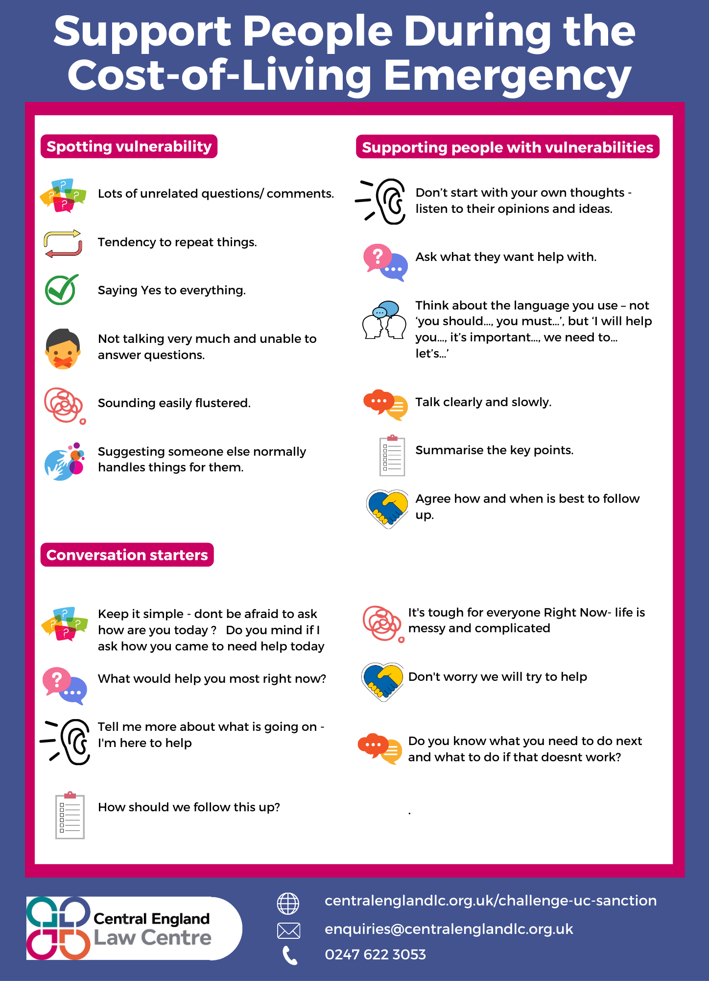

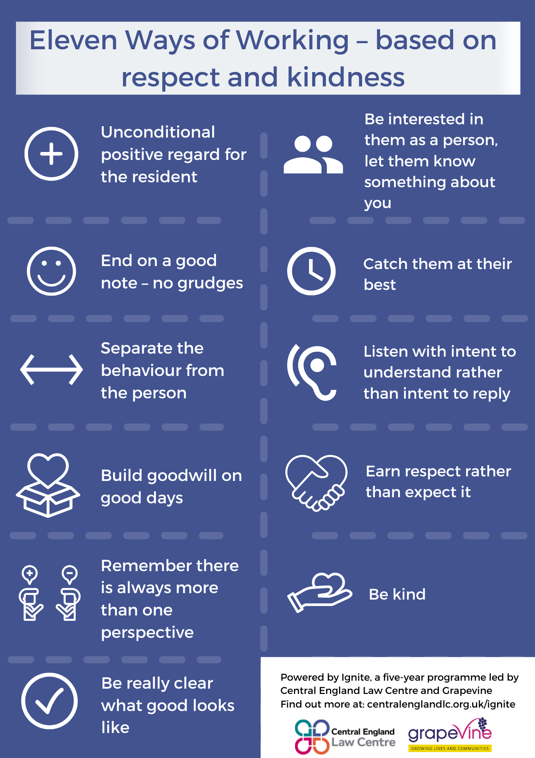

Emergency Support

Essentials

Q: Is there specific help available for people experiencing difficulties with the cost of living?

Yes, for further information about the Household Support Fund (HSF) and how to apply for it please visit https://www.coventry.gov.uk/householdsupportfund

Local and national charities can also provide emergency support for those affected by the cost-of-living crisis. For more information go to https://www.turn2us.org.uk/

Food

People who are unable to afford food, heat their homes or afford fuel bills are experiencing serious hardship.

A few quick questions can help you to understand if they are getting everything they are entitled to. These are the kinds of things that can help determine if people are getting the right money and support:

- Are they able to work?
- Are they taking care of someone?
- Are they experiencing ill health or living with a disability?

All these things change the amount of money they are entitled to.

Many people who are struggling are missing benefits that could increase their household income.

Q: If a member of the public needs emergency support with food how can I help?
Emergency food parcels are available via foodbanks through a referral system. For further information please visit https://coventry.foodbank.org.uk/

People can access food support via the Household Support Fund which also directs to Food Hubs. For further information please visit https://www.coventry.gov.uk/householdsupportfund

People can access affordable food from food hubs who operate on a membership basis and offer wrap around support.

For more information on your nearest food hub and foodbank please visit the Council’s interactive map at https://www.coventry.gov.uk/foodmap.

To access an emergency food hub parcel via the HSF, please call 08085 834333.

To access food bank food parcels, please call Coventry Foodbank on 024 7699 3770.

Q: Are there any other options?

Family Hubs - Offer free drinks and snacks. To find your nearest Family Hub visit the Council’s interactive map at https://www.coventry.gov.uk/familyhubs
Warm Welcome Spaces - The Council’s ‘warm welcome’ webpage includes further details about what food and drink options are on offer. For further details please visit https://www.coventry.gov.uk/warmwelcome

Q: Is there anything else I can check if someone is experiencing issues with food?

Free School Meals - School-age children might be entitled to free school meals.
For more information, please visit https://www.coventry.gov.uk/freeschoolmeals to find out if a child is eligible or please call 024 7683 3773. People who have no recourse to public funds can also be eligible for Free School Meals, but this process involves applying to your school.

Healthy Start Vouchers - Get help to buy food and milk
If a person is more than 10 weeks pregnant or has a child under 4, the ‘Healthy Start’ scheme may help:
- buy healthy foods like milk or fruit
- get free vitamins
Please visit https://www.healthystart.nhs.uk/how-to-apply/

Holiday Activity and Food (HAF) Programme
During the school holidays, children who are entitled to free school meals can access free food and a wide range of activities across Coventry. It’s all free for eligible children and young people.

Every HAF-funded activity includes:
- Positive activities (enriching and physical).
- A nutritional meal/food (normally hot).

For further information about eligibility and to book sessions please visit
https://www.coventry.gov.uk/haf or talk to your nearest Family Hub.

Fuel and Energy

Q: What should I do if someone is worried about heating their home and the cost of their electricity and gas?

- Talk to your landlord, especially if you are in a social tenancy (e.g. Citizen, Midland Heart, etc) and ask them what support they have available for fuel support and emergency fuel provision this winter.

- Contact your energy supplier if you are struggling to pay your energy bill as soon as you are able. Ask them about the Priority Services Register, emergency energy, changing tariffs or additional entitlements.

Q: Are there any other options for advice and support?

- Contact the Coventry Citizens Advice ‘Power Up’ project:
The Power Up project aims to help people out of fuel poverty by offering energy advice, help with managing fuel debt, energy saving and ways to reducing energy bills by switching suppliers or finding a better tariff. Please call 02476 253 190 or 0800 144 88 48, or email WPD@coventrycab.org.uk

- National Energy Action:
The Coventry HEAT team provides FREE help, support and advice on keeping your home warm and healthy. They can give you bespoke, confidential advice over the phone or visit you in your home, working holistically to help deliver solutions to the often multiple problems faced by individuals and households.
Call 0800 304 7159 for Energy Advice, Monday to Friday 10.00 am-12.00 noon, or 0800 138 8218 for benefits advice

- Scope - Disability Energy Support: Charity offering free energy advice to disabled people. For further information please visit
Website: https://www.scope.org.uk/campaigns/cost-of-living-crisis/
Contact number: 0808 800 3333
Contact email: helpline@scope.org.uk

- Energy Saving Trust: Advice on saving money in your home through energy-saving tips and home improvements.
For further information please visit https://energysavingtrust.org.uk/

People in Coventry can also apply for fuel vouchers via the Household Support Fund.
Q: What further support is available to improve the energy efficiency of my home?
Funding and Grants:

- Act on Energy: Keeping Coventry Warm provides funding for:
  - External wall insulation
  - Cavity wall insulation
  - First time gas central heating
  - Broken boiler replacement
  - Inefficient gas boiler
  - Loft insulation
  - Upgrade or repair of electric storage heaters available to households who are owner-occupiers or private renters who meet the health, income, and savings criteria.

- For advice about energy efficiency please visit Keeping Coventry Warm
https://actonenergy.org.uk/project/keeping-coventry-warm/

To access any of the support offered through Keeping Coventry Warm, please contact Act on Energy on their free advice line 0800 988 2881 or visit their website at https://actonenergy.org.uk/

Act on Energy will discuss your query over the phone and, where needed, can arrange a home visit. They will advise on the most appropriate support and will be able to check eligibility for the different sources of support available as well as supporting people to apply.

There is also information about Keeping Coventry Warm in a variety of languages
https://www.coventry.gov.uk/downloads/download/7238/keeping-coventry-warm-posters

- Act on Energy – Quick tips to save you money https://actonenergy.org.uk/resources/quick-tips-to-save-you-money/

- Warm Home West Midlands: Energy saving advice, energy saving measures, income maximisation advice. Contact number: 0808 196 8298.

- The Energy Company Obligation (ECO) is a government energy efficiency scheme in Great Britain to help reduce carbon emissions and tackle fuel poverty. It can provide funding for insulation and broken or inefficient heating systems. Available for people who claim some household benefits.

- Warm Welcome Spaces: Many venues across Coventry are providing warm welcome spaces open to everyone who may need it. For further details please visit https://www.coventry.gov.uk/warmwelcome
Q: If a member of the public needs help to reduce their fuel/water bills, manage their fuel/water debts, how can I help?

For advice about energy efficiency please visit https://actonenergy.org.uk/project/keeping-coventry-warm/

For advice on managing money effectively, please visit https://www.moneyhelper.org.uk/en
https://www.moneysavingexpert.com/

For local independent advice on how to manage debts, including fuel debts, please contact:

Coventry Citizens Advice on 0800 144 88 48 or visit www.coventrycitizensadvice.org.uk
Coventry Independent Advice Service at https://covadvice.org.uk/
Christians Against Poverty (CAP) at https://hopecoventry.org.uk/cap/

To see what support is available to help with the cost of living and how to save money with our energy saving tips, please visit the Government’s Help for Households.

The Severn Trent Water ‘Big Difference Scheme’ can offer a reduction in water bills to any Severn Trent Water customer with a low income. The Big Difference Scheme will assess the household income when someone applies. Please visit
https://www.stwater.co.uk/bigdifferencescheme for more information or call Severn Trent Water on 0345 7500 500.

Internet Connection

If someone cannot afford to connect to the internet there is help available.

Free sim cards pre-loaded with up to 6 months of data can be gifted to any adult over the age 18 who needs help staying connected to the internet.

National Databank distribution points include:
- Customer Services Centre, Broadgate House.
- Any of the 8 community family hubs.
- Central Library and community libraries at Stoke, Tile Hill, Bell Green and Foleshill.
- Moat House Community Trust.

Alternatively, residents can email the team at covconnectsdigital@coventry.gov.uk

Financial Help

Maximising income and help with benefits

Q: People on a low income of working age, whether in work or not, could be entitled to Universal Credit?

As well as paying for daily living costs, Universal Credit can help pay for additional things like paying rent or the cost of raising children. If someone is receiving Universal Credit but is still struggling, they may be missing some elements they are entitled to. On top of the standard allowance, a person might get additional allowances including child element, childcare costs element, limited capability for work-related activity component (LCWRA), carer element, and/or housing costs element.

Q: If a member of the public wants to make a claim for Universal Credit how can I help?

There is a nationally funded project – ‘Help-to-Claim’ – which helps applicants apply for Universal Credit. Call 0800 144 8 444 or visit https://www.gov.uk/universal-credit/how-to-claim
for more information.

Q: If a member of the public needs help understanding their potential benefit entitlements how can I help?

Comprehensive information on benefit entitlements, and how to claim them, can be found on the government’s website https://www.gov.uk/browse/benefits

The benefits system can be complex and confusing – anyone who seems uncertain or distressed needs to access independent specialist advice.

To seek specialist local help please contact Coventry Independent Advice Services on 02476 521101 or Coventry Citizens Advice on 0800 144 88 48.

Q: If a member of the public needs help to understand, manage or challenge decisions made about their benefits how can I help?

Local independent community-led advice providers – such as Coventry Citizens Advice and Coventry Independent Advice Service– are best placed to provide one-to-one (and in-person in some cases) advice to vulnerable service users.

Q: Who can help me with welfare benefit appeals and sanctions?
If you have been told you are not entitled to welfare benefits; have made an appeal against that decision or your benefits have been stopped or reduced because your benefit has been sanctioned; then Central England Law Centre offer specialist legal advice and can provide advocacy and representation with appeals. Please visit the below website for further information about how Central England Law Centre can help
https://www.centralenglandlc.org.uk/pages/category/challenge-universal-credit-sanction

Managing Money and Debt

Q: If a member of the public needs help with budgeting how can I help?

Basic information on budgeting effectively is available from a national independent advice provider – Moneyhelper. Call 0800 011 3797 or visit https://www.moneyhelper.org.uk/en for more information.

Local independent advice providers such as Coventry Citizens Advice https://www.coventrycitizensadvice.org.uk/ and Coventry Independent Advice Service https://covadvice.org.uk/ also deliver money management support.

Q: If a member of the public needs help with managing their debt(s) how can I help?

Providers of debt advice must be accredited by the Financial Conduct Authority (FCA). Providers of money or budgeting advice, as referenced above, do not need this accreditation.

Coventry Citizens Advice have a large dedicated Debt Advice Team providing one-to-one expert advice on debt issues. Coventry Independent Advice Service also delivers an accredited debt advice service in Coventry.

National Debtline (https://nationaldebtline.org/ - 0808 808 4000) and
Stepchange (https://www.stepchange.org/ - 0300 303 5300) are the two most well-known national providers of telephone debt advice.

Housing Support

Housing Support and Homelessness

Q: If a member of the public needs help with paying their rent how can I help?

There are lots of reasons why people can struggle to pay their rent. The person you are helping may be bedroom taxed, sanctioned, benefits capped or not managing their other bills. It is important to consider this as you explore why they are struggling with rent and how to help.

If they are in receipt of Universal Credit, they may be eligible to receive a Housing Costs element as part of their Universal Credit Award. If they can’t manage their rent payments or have fallen behind with their rent, then they can ask to have the housing costs element of their Universal Credit paid directly to their landlord.

If they are a pensioner, or are in supported, sheltered or temporary housing they may be eligible to claim Housing Benefit.
For further information and to make a claim please visit https://www.coventry.gov.uk/housingbenefit

Q. If a member of the public is already in receipt of Housing Costs in their Universal Credit or Housing Benefit, but is still struggling to pay their rent, how can I help?
If they cannot afford to pay their rent, they may be able to claim extra help from the Council. This extra help is called a Discretionary Housing Payment (DHP). A DHP may be considered for:
- Rent in advance, a bond, or a rent deposit
- A shortfall between the amount of Housing Benefit / Housing Costs received and the amount of rent they must pay
For further information and to claim a DHP visit
https://www.coventry.gov.uk/dhp

Q: If a member of the public is at risk of becoming homeless what can I do?
If someone is at risk of becoming homeless they can self-refer to the Council’s Housing Options Team and access advice on a range of housing issues by visiting
https://www.coventry.gov.uk/housingadvice

Agencies can refer a resident who is at risk of homelessness to the Council, with their consent, by using the Duty to Refer portal, for further information visit www.coventry.gov.uk/s213b

Q: What do I do if a member of the public has eviction paperwork?
If someone has been issued with court papers for eviction, the Central England’s Law Centre’s housing solicitors can provide specialist help on 024 7622 3053 or email housingenquiries@centralenglandlc.org.uk

More general advice can be provided to those threatened with homelessness by Coventry Citizens Advice and Coventry Independent Advice Service.

Q: If a member of the public has nowhere to go what can I do?
If someone is homeless and has nowhere safe to stay, please contact the Council’s Emergency Assessment Team on 024 7683 4025. For out of hours emergencies call 024 7683 2222.

Q: If someone would like to alert the Council that someone is rough sleeping what can I do?
For further information please visit https://www.coventry.gov.uk/roughsleeping
To notify the Council of someone who is rough sleeping please visit https://www.streetlink.org.uk/

Q: If a member of the public is having problems with their landlord how can I help?

To discuss issues with landlords please contact the Council’s Housing Enforcement Team via https://www.coventry.gov.uk/housingenforcement

Q: If a member of the public is moving from temporary accommodation into permanent accommodation and doesn’t have money for essential white goods and furniture how can I help?

Where a customer is re-settling into the community, usually because they are moving out of temporary accommodation, the Council can consider helping with essential household items under the Community Support Grant Scheme. Items include cooker, washing machine, fridge, beds, sofa / chair, cot, essential kitchen appliances.
For further information and to apply for a Community Support Grant, visit
https://www.coventry.gov.uk/csg

Help with paying Council Tax

Q: If a member of the public needs help with paying their Council Tax how can I help?

They may be entitled to Council Tax Support which is a means tested discount which helps low-income households with the cost of Council Tax payments.

Pension age households can receive support of up to 100% of their Council Tax Bill depending on their circumstances.

Working age households can receive support of up to 85% of their Council Tax Bill depending on their circumstances.

For further information and to claim Council Tax Support, please visit
https://www.coventry.gov.uk/counciltaxsupport

Q: Is there any other help that a member of the public can get with their Council Tax?

If a person is in a single person household then they can apply for a 25% single person discount.

There are also other exemptions and discounts available – for example, if someone in the home is a carer, an apprentice, a care home or hospital in-patient, severely mentally impaired, or a student.

To apply for a discount please visit
www.coventry.gov.uk/applycounciltaxdiscount

For further information please visit
https://www.centralenglandlc.org.uk/council-tax-discounts-and-exemptions

Q: If a member of the public is receiving all the help they are entitled to but is still struggling to pay their Council Tax how can I help?

Normally Council Tax bills are spread over 10 monthly instalments. If it would help, the Council can spread this over 12 monthly instalments. Email counciltax@coventry.gov.uk for more information about this.

In exceptional circumstances, where the customer is experiencing extreme financial difficulties, the Council may be able to reduce the amount of Council Tax that they have to pay.
For further information on our discretionary relief policy visit,
https://www.coventry.gov.uk/counciltaxdiscretionaryreliefpolicy

If the person you are helping is in debt with council tax and seems confused about next steps, it’s important they get independent advice on what to do next.

Coventry Citizens Advice have a large dedicated Debt Advice Team providing one-to-one expert advice on debt issues. Coventry Independent Advice Service also delivers an accredited debt advice service in Coventry.

Connectivity

Q: If a member of the public needs to use a phone urgently how can I help?

Members of the public can use a phone for free at any of the Family hubs in Coventry. https://www.coventry.gov.uk/familyhubs

Please note this is for UK calls only.

Q: If a member of the public hasn’t got access to the internet or needs access to the internet for work how can I help?

If someone wants to touch down there are various locations across the city with free wifi including Libraries, Family Hubs or Warm Welcome Spaces – A map of all locations is available on the Council’s website.

If they are over 18 and from a low-income household, they are also eligible to access the National Databank (please see emergency support with connecting to the internet above).

Q: If a member of the public needs to use a computer how can I help?

If a member of the public needs to use a computer there are a few options.
- Libraries – People can drop in and use one for 15 minutes or they can book a 2-hour slot up to one week in advance. The person needs to be a library member and have a library card.
A parental consent form must be completed for anyone under 16.
- Family Hubs – People can drop in and use a computer during family hub opening hours. This doesn’t need to be booked. Devices and phones may also be charged. A parental consent form is not required for anyone under 16.

Q: If a member of the public doesn’t have access to a scanner or printer how can I help?

- Libraries - Scanning, printing, photocopying and faxing facilities are also available. There are no charges for using a scanner and no printing charges for hearing or visually impaired or those claiming benefits. To see a full range of charges please visit https://www.coventry.gov.uk/libraryfees
- Family Hubs - Ask a member of staff at reception if you need to scan or print a document and they will be able to help you.

Q: If a member of the public needs help to reduce their broadband bill, how can I help?

Anyone in receipt of Universal Credit or similar benefits may be able to cut their broadband costs by asking to be placed onto a social tariff. Please see the most recent guidance from Ofcom and a list of social tariff providers available.
- Ofcom advice about social tariffs: https://www.ofcom.org.uk/phones-telecoms-and-internet/advice-for-consumers/costs-and-billing/social-tariffs
- List of providers offering social tariffs: https://www.moneysavingexpert.com/compare-broadband-deals/broadband-social-tariffs/

You can also visit https://www.citizensadvice.org.uk/consumer/phone-internet-downloads-or-tv/switch-broadband-phone-or-tv-provider/ for more information.

Q: If a member of the public needs help with their digital skills, how can I help?

Digital Drop-ins in the Community
If a member of the public needs support with basic digital skills, such as using a device for the first time, setting up an email, browsing the internet safely or accessing online services Digital Champions can help. Digital Champions are friendly volunteers who can support residents in getting online in a safe environment. To speak to a Digital Champion, people can join one of the digital drop-in sessions running in the community.
- Moat House Leisure and Neighbourhood Centre, CV2 1EA
Every Tuesday
1pm – 3pm
- WATCH Community Centre, CV1 5LZ
27th February to 27th March
10am – 12pm
Please note the sessions do not not run during school holidays.

Adult education
There is a wide range of free digital skills courses available across the city provided by the Council’s Adult Education Team. To browse the courses and sign up, access the Adult Education web page and choose ‘courses,’ then select ‘ICT’ from the drop-down menu.

For further information and support contact Adult Education on 024 7697 5200 or email: feedback@covaded.org

Employment Support

Q: If a member of the public needs help with work, support or training?

Coventry Job Shop provide a wide range of support to all Coventry residents, of all ages, who are looking for work.

Our Job Shop is situated in Coventry City Centre. For further information please visit
https://www.coventry.gov.uk/jobshop

Call 024 7678 5740 or email jobshop@coventry.gov.uk

Q. If a member of the public is struggling with their employer, facing unfair treatment or discrimination?

Central England Law Centre offer free specialist legal advice in employment law. You can be referred to us by an organisation that is already supporting you. Or visit our offices, email enquiries@centralenglandlc.org.uk or call 024 76 223 053. We will arrange an appointment for you at one of our advice clinics.

Employment and Discrimination Advice | Central England Law Centre Limited at
https://www.centralenglandlc.org.uk/

Please contact Citizens Advice at https://www.citizensadvice.org.uk/ for general employment rights information or call 0800 144 8848 for one-to-one local support.

Specialist telephone advice on employment issues is also available from the ACAS Employment Helpline at 0300 123 1100.

Clothing and Footwear

Q: If a member of the public needs help with clothing or footwear?

Coventry Clothing
Coventry’s clothing bank supports anyone in need of clothes or shoes in Coventry.

Get help with school uniform, school shoes and warm clothing for further information go to https://clothingcoventry.org
To request a clothes parcel please contact
https://clothingcoventry.org/referrals/

Baby Godiva
Coventry’s baby bank can be contacted on https://babygodiva.org/
For further information on how to make a referral, including a link to the referral form please visit https://babygodiva.org/self-referral/

Coventry Boot Fund
For further information about how to make a referral for school shoes please visit https://www.childrensbootfund.org.uk/

Childcare Costs

Q: If a member of the public needs help with childcare costs?

To find the right offer for a family please see visit Childcare Choices: https://www.childcarechoices.gov.uk/

Specialist Support for Additional Vulnerabilities

Q: If a member of the public is disabled and needs further help with the cost of living?

For specialised help and advice for disabled people please visit https://www.disabilityrightsuk.org/how-we-can-help/advice-and-information for further information and Scope at https://www.scope.org.uk/campaigns/cost-of-living-crisis/ or on the free helpline 0808 800 3333

For textphone please dial 18001 then 0808 800 3333

For further details about accessibility and different ways you can get in touch with Scope for help and advice, please visit
https://www.scope.org.uk/helpline/

Q: If a member of the public is over 50 years old and needs further help with the cost of living?

For further information for people over 50 years old, please visit https://www.ageuk.org.uk/ or
https://www.independentage.org/get-involved
Q: If a member of the public needs specific support in relation to migration?

People who are subject to immigration conditions can be very vulnerable to cost of living struggles.

If someone has no recourse to public funds it is important to remember that they can access some support - free school meals and household support fund are available to people in these circumstances and this should be explored.

Coventry has a wide range of organisations which provide support for Refugees and Newly Arrived Communities.

Support for Refugees and Newly Arrived Communities and Asylum seekers
Visit www.coventry.gov.uk/welcometocoventry

Support for Unaccompanied Asylum Seekers’ Children (UASC)
The Council’s ‘Through Care’ service deals with all referrals of UASC's to Social Care. For further information and contact details please visit
https://www.coventry.gov.uk/UASC

Coventry Refugee and Migration Centre
For further information please visit
https://www.covrefugee.org/
or call 024 7622 7254

Central England Law Centre offer specialist legal advice and representation to people seeking to regularise their immigration status and can support people to understand and access their rights visit https://www.centralenglandlc.org.uk/asylum-and-immigration-law or call 024 7622 3053

Mental and Physical Health

For further information about mental health support available across Coventry please visit https://www.coventry.gov.uk/mentalhealthsupport

Urgent Mental Health Support
If anyone is in a life-threatening situation call 999

NHS Mental Health Access Hubs
Call Freephone 08081 966798 (Hours of operation: 24 hours a day, seven days a week
For more information visit the Coventry and Warwickshire Partnership Trust's ‘Find help now’ information https://www.covwarkpt.nhs.uk/urgent-advice

Specific Information for Children and Young People
The Rise Crisis & Home Treatment Team (Coventry & Warwickshire Partnership NHS Trust) provides multi-disciplinary support to children and young people (under 18s) who present in mental health crisis on Freephone 08081 966798 (select option 2)

Voluntary and Community Sector Support Helpline provided by 'Wellbeing for Warwickshire' in Coventry and Warwickshire

Telephone Number: 0800 616 171 (Hours of Operation: 24 hours a day, seven days a week) or visit https://wellbeingforwarwickshire.org.uk/coventry-residents

Coventry City Council's domestic abuse website
https://www.safetotalk.org.uk/
If someone is in immediate danger and their life is threatened, they should dial the Police on 999; if you are unable to talk, once connected to 999 press 55 and the police will attend. If it is not an emergency but you need help from the police, please call 101. For non-emergencies you can also report a crime online: https://www.police.uk/reportcrime

For anyone in the city who may be a victim of domestic abuse and violence:
- The Safe to Talk helpline is available Monday to Friday 8.30am - 5.30pm and Saturday to Sunday, 10am - 1pm. For support call 0800 111 4998: http://www.safetotalk.org.uk/
- Hollie Guard - a personal safety app http://hollieguard.com/

Coventry Haven Women’s Aid
https://www.coventryhaven.co.uk/

Coventry Rape & Sexual Abuse Centre (CRASAC)
CRASAC 024 7627 777 https://www.crasac.org.uk/

Contact CRASAC if you are helping someone who has been impacted by sexual violence. CRASAC accept self-referrals and referrals from professionals and they provide a holistic range of support services. Full details of services are available on the website, however, if you are not sure you can call the number listed and they will talk you through the options.

Coventry Drug and Alcohol Service
Change, Grow, Live accepts referrals by people themselves or you can refer someone on their behalf, please visit https://changegrowlive.org/drug-alcohol-service-coventry for further information about alcohol and drug treatment help and advice.

For emergency advice please visit https://changegrowlive.org/advice-info/need-help-now

For information regarding under 21s specifically, please visit https://changegrowlive.org/advice-info/under-21-advice

Coventry Healthy Lifestyle Service can be accessed by over 18s to help support people with making healthy changes healthy changes such as quitting smoking, managing weight and improving physical activity. They also offer free NHS Health Checks. https://hlscoventry.org/

Contact Numbers – Local Organisations
Key Coventry City Council Contacts | Phone Numbers
All Other Cost of Living Issues Customer Service Centre  https://www.coventry.gov.uk/costofliving | 08085 834 333
Coventry Job Shop  https://www.coventry.gov.uk/jobshop | 024 7678 5740
Discretionary Grants Team  https://www.coventry.gov.uk/dhp | 024 7683 3773
Household Support Fund  https://www.coventry.gov.uk/householdsupportfund | 08085 834 333
Council Tax  https://www.coventry.gov.uk/council-tax | 024 7683 1111
Housing Benefit and Council Tax Support  https://www.coventry.gov.uk/counciltaxsupport | 024 7683 1800
Homelessness Prevention Team  https://www.coventry.gov.uk/homelessness | 024 7683 4025
Independent Advice Services | Phone Numbers
Coventry Citizens Advice  https://www.coventrycitizensadvice.org.uk/ | 0800 144 88 48
Coventry Independent Advice Service  https://covadvice.org.uk/ | 02476 521101
Central England Law Centre  https://www.centralenglandlc.org.uk/ | 02476 223 053
Coventry Refugee & Migrant Centre  https://www.covrefugee.org/ | 02476 227254
Age UK (Coventry & Warwickshire)  https://www.ageuk.org.uk/coventryandwarwickshire/ | 0800 169 6565
Coventry Food Bank (Local)  https://coventry.foodbank.org.uk | 02476 993770
Coventry Food Bank (National) | 0808 2082138

National Trusted Sources of Advice
Citizens Advice | https://www.citizensadvice.org.uk/
National Debtline | https://www.nationaldebtline.org/
Money Helper | https://maps.org.uk/moneyhelper/
Advice Now | https://www.advicenow.org.uk/help-deal-benefit-problems
GOV.UK | https://www.gov.uk/
UC EU Resource | https://www.workrightscentre.org/universal-credit
Shelter | https://england.shelter.org.uk/housing_advice
Age UK | https://www.ageuk.org.uk/
National Energy Action | https://www.nea.org.uk/member-of-the-public/
Mind | https://www.mind.org.uk/
Carers Trust | https://www.carersuk.org/
Version Control – Version 0.3
Date Last Updated 07/03/2023
Date Last Published 08/03/2023

