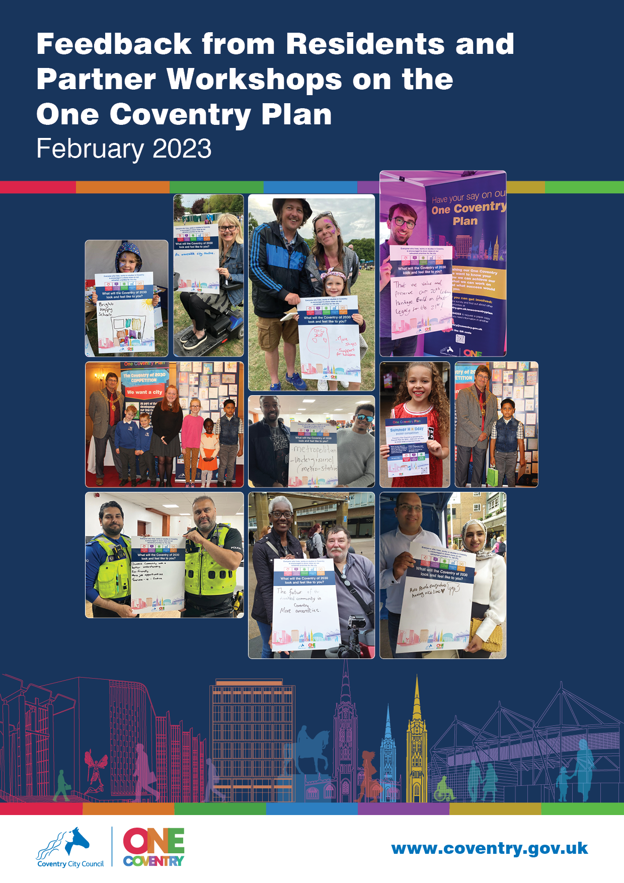

Background
This is a summary of feedback that was gained via residents and partner workshops.
This summary includes feedback from:
- 6 residents & partner workshops (a mixture of face to face and online)
- Youth Council workshop
- Parish Council workshop

Overarching Themes
All of the feedback was considered and this identified common themes (the things people told us are most important), as shown below:
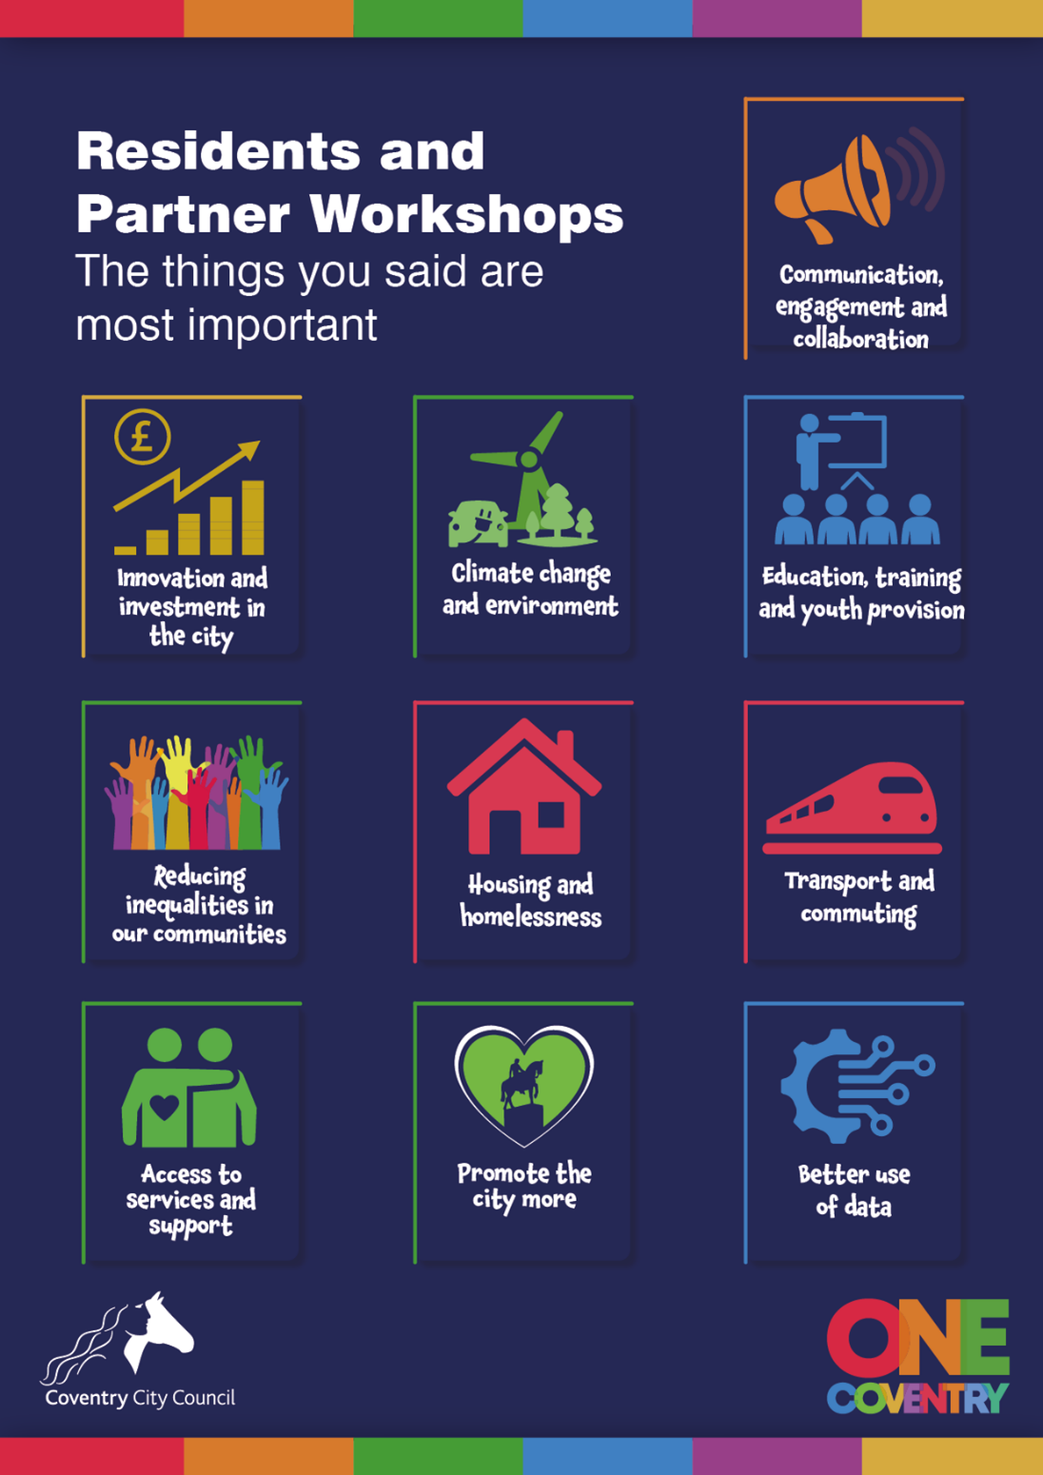
Examples of comments/suggestions relating to each theme have been provided below (pages 3-12), including a selection of quotations from the raw feedback received.

Communication, Engagement and Collaboration
Examples of comments and suggestions relating to the theme ‘Communication, Engagement and Collaboration’:
- Partnership/collaboration:
  - Continue to develop partnerships
  - Tap into residents’ expertise
  - Improved two-way engagement with partners
  - Improved engagement between City Council and Parish Councils, provide more information on what’s going on
  - Council to act as coordinator and influencer – bringing groups / partners / stakeholders and businesses together to bring change whilst sharing local knowledge/data
  - Improved communication/joined-up working between departments/elected members especially frontline services (e.g. mental health / debt management)

- Engagement:
  - Improved public engagement – especially with specific hard-to-reach groups
  - More opportunities for residents/young people to engage with decision makers
  - More face-to-face engagement/conversations, such as:
    - Ward forums
    - Pop-up shops
    - Council workers to be seen within the community
  - Digital inclusion – ensuring everyone can engage
  - More promotion of what is going on within the council
  - Coproduction-type activities – getting residents fully involved in changes/services taking ownership
  - Information to be relatable to local neighbourhoods/communities – provide maps
  - Improve the council’s “you said, we did” feedback
  - Be more open, honest, and transparent – even when mistakes are made
  - Council to become more approachable – work to be done in changing the perception that residents feel they can’t engage with the council.
  - Make use of qualitative data – share success stories and stories of when things don’t go to plan
  - More opportunities for resident voice – Citizen panels
  - Ask residents how the One Coventry Plan will make a difference to their lives
  - Ask what services do they actually need?
  - Meaningful consultation before any decisions have been made

A selection of quotations received from raw feedback relating to the theme ‘Communication, Engagement and Collaboration’:
“Not everyone is online - community based events need to give everyone the opportunity”
“Citivision a good tool - need hard copies - Covid highlighted the digital divide, recognition that we shouldn’t exclude people”
“Identify where all the groups are happening and disseminating this information widely and support in what ways the LA (Local Authority) can - Council not always best placed to understand need - could be a coordination role for the Council”
“Council can't take accountability for partners but can influence their objectives by taking the messages from all the feedback to them”
“People always encouraged when we read you said this, we did this, and this is the difference from your input”
“Beware of talking just to a select few”
“Pop up shops in foodbanks, etc so people in the community can see council workers visibly engaging with the community”
“Really conscious that residents’ expertise is not always tapped into - can respond to some of the things that are being raised - some people have lived experiences - very passionate - look to where you might learn - will take specific bits of feedback to the people that may be able to help”
“Qualitative not just quantitative – stories – share the success stories and also the things that didn’t work and apologise and take the learning forward – the facts don’t mean much it’s the stories – success has to be the stories for local people – all the money spent in the city that’s the social value”
“Having regular meetings with residents on a monthly basis – residents going in with ideas and suggestions for improvements coming out of that”
“More opportunities for young people to meet and talk to decision makers”
“Explanations and feedback even if the decision was not the one which was hoped for by the Parishes to get an understanding of why decisions are made”

Innovation and Investment in the City
Examples of comments and suggestions received for the theme ‘Innovation and Investment in the City’:
- Innovation:
  - Promote and showcase Coventry’s inventions/patents
  - Promote young and future entrepreneurs
  - Improve infrastructure with council parishes
- Invest in:
  - Work opportunities in the city centre
  - More main attractions to draw people in
  - Repurposing empty shops
  - Business to help reinvent the city centre
  - Council housing
  - Creating favourable opportunities for independent businesses
  - The night-time economy (recreation/activities)
  - Coventry assets becoming accessible
  - Developing/changing the ring road
  - Offering grants/sustainable funding opportunities for voluntary sector/businesses
  - Repurposing libraries
  - Spending more to improve rural areas, not just the city centre
  - Local suppliers/businesses

A selection of quotations received from raw feedback relating to the theme ‘Innovation and Investment in the City’:
“It seems it would be great to know that if you work and live in Coventry you can walk into town - but currently there are not many opportunities to work in the city centre?
“Retail has died - without business there is nothing to reinvent the city centre”
“Independent businesses in city arcade should have been offered favourable rates to continue to operate”
“Drop the ring-road down - can be done - takes a vision”
“Encourage the growth of ‘nightlife economy’ e.g., clubs and other venues. Too many local people travel to other towns for a ‘good night out”
“Encourage investment opportunities for small business owners to help them progress during financial hardship”
“Devise a programme, (possibly with the local universities, to encourage young entrepreneurs”
“More money spent in the rural areas as opposed to the City Centre”
“Promote and use local supplies/businesses”

Climate Change and Environment
Examples of comments and suggestions received for the theme ‘Climate Change and the Environment’:
- More greenery:
  - Tree planting / reduce tree felling
  - Increase green spaces across the city
  - Inner ring road as a garden
  - Changing driveways to gardens
- Transport/Commuting:
  - Measures to reduce traffic/cars in the city
  - Improved public transport
    - EV’s (Electric Vehicles)
    - VLR (Very Light Rail)
  - More cycling/pedestrian paths
  - Active travel initiatives
- Street cleanliness:
  - Improve street cleanliness
  - More bins/bins emptied
  - Address fly-tipping
  - Improve drain clearing
- More information about Climate Change Board
- Improve air quality in the city
- Improved energy-efficient homes
- More partnerships/collaboration with climate groups/initiatives

A selection of quotations received from raw feedback relating to the theme ‘Climate Change and the Environment’:
“Should have a northern relief road to avoid traffic going in and out of the city centre”
“Ensure services provided by the council are appropriate and timely - street cleaning needed”
“You have plans for buses/tram network - very light rail - hub at Walsgrave but will that help local residents? What's coming next electric buses are good but need the next step”
“Need to focus on green spaces/active space for children how do we encourage play outside”
“The Council is aiming to reduce the number of car journeys by 50% Why build car parks in the centre of the city …Why not have car parks at the edge of the city and have a rail/tram system”
“Get people out of cars walking/improve air quality”
“Climate Change - if the city would be more attractive we would have more people cycling”
“Inner ring road as a garden - - would be a great idea”
“Something about us all being responsible for keeping things green - modern trends to change gardens to driveways”
“Better homes structure ie insulate houses to contain heat help with carbon emissions”

Education, Training and Youth Provision
Examples of comments and suggestions received for the theme ‘Education, Training and Youth Provision’:
- Education / training
  - Work more closely with schools/colleges/universities to educate young people on the priorities
  - Litter-picking initiatives through the schools
  - Provide transition skills for young people aged between 16-24 – from youth to adulthood (budgeting, your rights, etc)
  - Digital training in libraries for residents
  - Upskilling opportunities for residents
- Jobs for young people:
  - Growing our own talent in Coventry and ensuring good terms of employment for young people by reducing zero-hour contracts and temporary contracts
  - Initiatives to retain students and young people to live and work in Coventry
- Youth provision:
  - Support partners to run youth groups
  - Invest in more youth clubs/groups
  - Improved engagement and building trust with young people – more visibility within the community to bring a sense of security
  - More activities to support physical/mental health in young people
  - Children’s health initiatives – social prescribing opportunities
  - More initiatives linking up young people with the police/tackling crime (Safety/Crime education)
  - More youth infrastructure in rural areas of Coventry

A selection of quotations received from raw feedback relating to the theme ‘Education, Training and Youth Provision’:
“How do we attract talent and ensure they stay and spend money? And grow our own talent - Coventry built on industry and apprenticeships.”
“Young People need more provision to avoid creating Anti-Social Behaviour.”
“Older people – lack of skills as well as lack of access to equipment – not just an age issue – access issue resulting in in equality – expand the free Wi-Fi out of the city centre”
“Need to provide choices – no cost / low-cost activities for young people to help physical/mental well health – need more significant impact – reach more deprived areas and get access to other activities”
“Work together on child health – population health management”
“Skills not just for young people, for older people as well – 50 + - success get people back into employment – proper jobs”
“How many students stay in Coventry and Warwick after going to university here … Coventry businesses are unable to retain people with talents and skills”
“Provide safe spaces for young people to meet e.g., youth centres”
“Not everything should be about ‘reaction/fire-fighting’ try prevention activities, involve schools, groups etc.”
“To decrease the crime rate, we do not need more police, instead build safer environments, provide safety education as outreach by youth workers, get specialist support from the voluntary sector.”
“More support for 18–25-year-olds transitioning into adulthood, this starts in schools by teaching real life skills e.g., budgeting, your rights”

Reducing Inequalities in our Communities
Examples of comments and suggestions relating to the theme ‘Reducing Inequalities in our Communities’:
- Disabilities:
  - Improve the accessibility within the city centre
  - More car parking spaces for the disabled
  - Improved transport to accommodate disabled people
  - More specialist services e.g. ‘Hydrotherapy pool’
- Older People:
  - Services to become more accessible to older people
  - Digital/card-only transactions can become a barrier for older people
- Ethnic / Minority communities
  - Need to work on how to get communities more involved in sharing what’s important to them
  - Break down barriers – ethnic minorities sometimes view the council as authoritarian which can create barriers of trust within those communities
  - Provide opportunities for young ethnic minorities
- Cost of Living:
  - Need to respond to the cost of living crisis
  - Provide more support for those living on low income
  - Provide low-cost opportunities to access services which improve health and wellbeing
  - Need more foodbanks and social supermarkets
  - Affordable housing
- Digital exclusion:
  - Provide free Wi-Fi access across the city
  - Make all services accessible to those who cannot access digitally
- Support networks for single men

A selection of quotations received from raw feedback relating to the theme ‘Reducing Inequalities in our Communities’:
“Transport big issue for disabled people - only allow one wheelchair on a bus - taxis are expensive”
“Take stock of where we’re at and consider the tsunami of hardship which is on its way – how will we get through the next 18 months?”
“Regarding reducing inequalities what can be done to counter hardship as there will be a higher impact on some people more than others – it’s most likely women will make decisions to skip meals, use sanitary products, etc”
“New café at the Memorial Park card only – negatively affecting older people”
“Wi-Fi – the 4th utility – needs to be recognised with the cost of living crisis coming”
“Social supermarkets – if we are able to alleviate the need for these – people not having to rely on foodbanks”

Housing and Homelessness
Examples of comments and suggestions relating to the theme ‘Housing and Homelessness’:
- Address the increase in HMOs (House in Multiple Occupation) and overcrowded properties – better enforcement
- Improved provision for homelessness:
  - More accommodation
  - Improve support for the homeless:
    - Substance issues
    - Support and guidance to get back to permanent residency
- Social housing
  - Improve the quality of social housing
  - Work with private sector rentals to increase housing
  - Provide more safe and stable housing
  - Availability of larger properties for families
- Get lived experience as part of the decision process – e.g. those with experience to have a say

A selection of quotations received from raw feedback relating to the theme ‘Housing and Homelessness’:
“Homeless provided places to stay over Covid, now what provision is there? Proper outreach work needed”
“How we can work together on this? Galvanise people, national issue not a local issue.”
“What can be sponsored by businesses? The Council can't do it all - need to give back to the community”
“Work with housing and homelessness – need more voices/more diverse”
“Improvement in housing – safe and stable housing”
“The Local Plan - affects housing - hopefully the census will show that there is still a need for a large amount of houses that need to be built. Where will we put them? Have to have a balance”
“Homeless families need bigger homes”

Transport and Commuting
Examples of comments and suggestions received for the theme ‘Transport and Commuting’:
- Public transport
  - Improve access for disabled people
  - Improve transport links linking up rural and urban areas
- Behaviour change:
  - Move people away from cars to active travel methods
- Roads:
  - Roadwork equipment and signs are left on streets even when roadworks have been finished
  - Improve pressure on parking
  - Change access routes on roads/open natural routes which have been closed off
  - Remove/change the ring-road
- Pathways:
  - Change walking routes away from unsafe areas such as under subways
  - Increase cycling opportunities

A selection of quotations received from raw feedback relating to the theme ‘Transport and Commuting’:
“Get people out of cars walking/improve air quality”
“Pressure on parking and complete change of community feel and vision”
“Shouldn’t be walking under subways … it is archaic and ridiculous - don’t mind day light but wouldn’t walk in the dark”
“Ring road is a concrete collar with negative connotations - open up natural routes”
“Reduce reliance on cars by supporting a better distribution of buses e.g., buses that circle the town and buses that can get you across the city without having to come into town to go back out.”
“Better transport facilities, rural areas have one bus into town and one out per day, no small services to next villages often mean older people feel trapped”

Access to Services
Examples of comments and suggestions received for the theme ‘Access to Services’:
- Council services to be appropriate and timely, especially during periods of change such as the cost of living crisis
- Health:
  - Invest in, and enable, access to socially prescribed events/activities
  - Healthcare hubs providing support for adults and children such as speech/therapy
- Planning department:
  - Improve the planning portal
  - Increase transparency of planning department approvals/process
- Invest in community centres
- Invest in adult and children’s social care services

A selection of quotations received from raw feedback relating to the theme ‘Access to Services’:
“Ensure services provided by the council are appropriate and timely - street cleaning needed”
“Situation very grim for 20% of the population”
“Planning portal - not fit for purpose, not easy to use”
“Re-emergence of community centres”
“There needs to be more transparency re: planning process”
“Hub for health care and children - central space for families to come eg: speech therapy; etc”
“Increase adult and children social care”

Promote the City More
Examples of comments and suggestions received for the theme ‘Promote the City More’:
- Behaviour change – Need to develop more pride and care for the city
- City of culture activities were a great way of promoting a sense of pride locally whilst bringing communities together in Coventry
- Important to get children involved in changes taking place within the city so that the future generation takes ownership of their city/community
- Council to do more in making the city’s environment a nicer place to live and work
- Need to ensure that the right resources are in place to address the needs of the city
- Coventry needs to build a better identity
- Private developers should be influenced by the Council to make changes which brings benefit to residents and the environment
- Repurpose the city centre to become an attractive and welcoming place to visit

A selection of quotations received from raw feedback relating to the theme ‘Promote the City More’:
“Need pride and care in our city”
“Found via City of Culture that people have ventured out into organised activities - sense of pride for local people. Encourage more localised events - don’t want to lose the buzz”
“Celebrating the creative people of our city and give them a platform”
“Make the spaces in which we live nicer places and have joy”
“Repurposing the City Centre - accessible and central, attractive and welcoming”
“Artists in the city need support - to showcase and create their work”
“Assembly Gardens been absolutely fantastic - come together with local businesses and entertainment in a safe environment”

Better Use of Data
Examples of comments and suggestions relating to the theme ‘Better use of Data’:
- Set deliverables / KPIs (Key Performance Indicators)
- Measure success by finding out if the priorities are making a difference in people’s lives
- Priorities should be interlinked and equal – not ranked by order of importance
- Share more success stories, making better use of qualitative data, not just quantitative data
- Measure on how many students stay to live and work in Coventry upon completion of their studies within the universities
- Setting benchmarks and performance reports
- Social care / homeless data to be used to measure the difference the council are making to inequality

A selection of quotations received from raw feedback relating to the theme ‘Better Use of Data’:
“Get people's opinions about the factors that make up the One Coventry Plan - find out if you are making a difference in people's lives”
“Tackling inequalities – social care/homeless – which data should we be measuring to show the whole picture of inequality – there are statutory indicators and other indicators to measure the difference we are making”
“Need to look at stories and sharing stories to show we have improved lives for the citizens of Coventry.”

Next Steps

The engagement has been really valuable and will influence and play a vital role in defining how we deliver the One Coventry Plan going forward. All the feedback has been shared with relevant service areas and partners to inform future strategies and service delivery.

To find out more about how we are responding to your views see the Cabinet report for One Coventry Plan 2022-2030. Further updates will also be shared on Let’s Talk Coventry and on the Council’s website.



