



Children’s Services Complaints and Representations Annual Report 2022-23

1
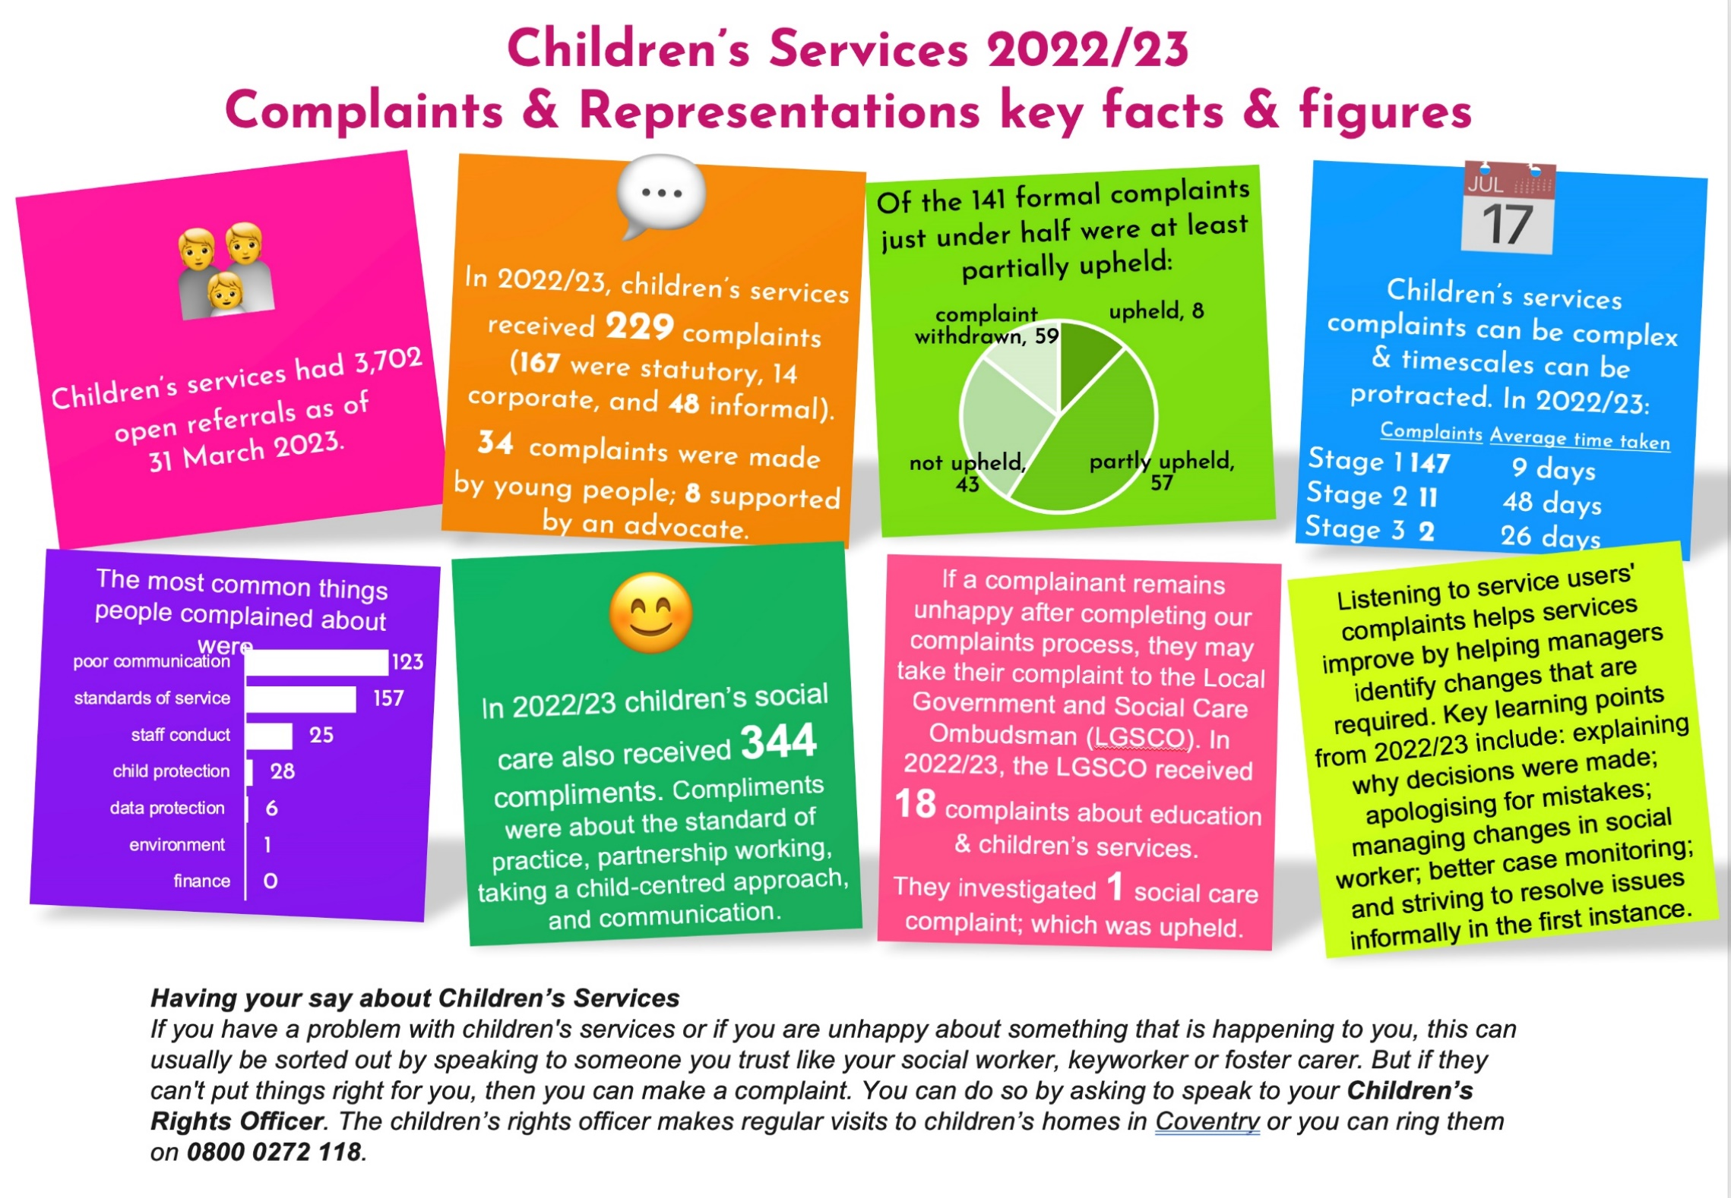

Table of contents
Infographic 2
Welcome 3
Background 3
Summary 4
Feedback 5
Advocacy 6
Complaints 6
Statutory complaints 6
Resolution of complaints 8
Timescales 9
Equality 10
Ombudsman 12
Comments 12
Compliments 13
Service improvements and learning points 16
Further information 26

Welcome
Welcome to the 2022/23 complaints and representations annual report. As part of the Council’s commitment to openness, quality assurance, service development and listening and learning from service users, this report provides summary information from comments, compliments and complaints received under the statutory procedures in relation to children’s services provided by or commissioned by Coventry City Council for the year 1 April 2022 to 31 March 2023.

Background
Local Authorities are required by law (Children Act 1989, plus subsequent changes including the Local Authority Social Services Complaints Regulations (1990) as a result of the Adoption and Children Act 2002 and the Health and Social Care (Community Health and Standards) Act 2003) to have a system for receiving representations made by or on behalf of children who use the Children’s Services they provide or commission. These include social work services, residential care, fostering, adoption and the provision of support to families, children with disabilities and young people in trouble with the law. Representations are defined as comments, compliments and complaints. Local Authorities are required by law to appoint a complaints officer to oversee all aspects of the procedure.

Some complaints received do not meet the criteria to be dealt with under the statutory procedure. When this is the case, these are registered under the Council's corporate complaints procedure. The arrangements for handling these complaints are different from the statutory process in terms of timescales and the independence of the people who investigate and review the complaints. Children Services has a nominated officer assigned to the management of representations from children and others who present feedback on children’s services.
The purpose of the comments, compliments and complaints system is to ensure that: the views and experiences of people who use services are heard; positive feedback is used to develop services and acknowledge good practice; things that have gone wrong are put right; the organisation learns from both positive and negative feedback; and the organisation sustains its focus on service users / customers / citizens.

Reference is made to the range of representations received and responses to them, and specific trends and issues that emerged in the reporting period.

Summary
In 2022/23 children’s services completed 26,677 contacts and received 4,912 referrals. This compares to 28,103 and 4,987 in 2021/22. As of 31 March 2023, there were 3,702 referrals open to children’s services, compared to 3,307 a year ago.
The total number of statutory and informal complaints received about children’s services in 2022/23 was 229, compared to 235 received in 2021/22. The 229 complaints received consist of 167 statutory complaints, 14 corporate complaints and 48 informal complaints.
The number of complaints under the statutory process has decreased to 167 received in 2022/23, compared to 177 in 2021/22 ,141 received in 2020/21 and,63 received in 2019/20.
21 complaints were made by children and young people themselves or from an advocate complaining on behalf of a child; the remainder were from adults. There has been an increase in the number of children or young people using an advocate to make a complaint – 19 complaints received during 2022/23 compared to 14 complaints in 2021/22, 8 in 2020/21, 13 in 2019/20 and 11 in 2018/19

Two main themes could be identified as arising from the complaints by and on behalf of users in 2022/23: issues regarding poor communication with users; and concerns about the standards of service provided.

Themes from compliments were predominantly around the good standard of practice received from individual social workers and the overall standard of service received from teams.

Description of Complaint Types

Coventry City Council’s complaints policy sets out how individual members of the public can complain to the Council, as well as how the Council handle compliments, comments and complaints.

Informal

Where possible, complaints should be resolved informally. The complaint is usually sent to a Team Manager to make contact with the individual to discuss their concerns to ensure a resolve can be actioned as soon as possible.

If this is not possible, complainants can formally complain to the Council. Informal matters can also be related to concerns that require resolution or follow up investigation outside of the formal process.

Statutory

Complaints about Children’s Services follow the statutory process if they are not able to be resolved informally. Complaints that fall under the Statutory complaints process are complaints made by children, young people, parents and carers.

All other complaints relating to Council services are dealt with by the corporate complaints policy.

Corporate

A Corporate complaint example would be as follows: When a member of the public who is not a service user or a holder of parental responsibility for a young person request that their concerns are investigated formally.

Feedback
Promoting feedback
Comments, compliments and complaints can tell the Council a great deal about the service users' experiences of service delivery, professional practice and the outcome of management decisions. Children’s services welcome this feedback and encourages children, their advocates and anyone who uses the service or who is affected by it, to make their views known.

Where possible, issues/complaints should be handled at the point of delivery. It is when a person feels that they are still not satisfied, then it is recorded as a formal complaint and investigated as such. The length of time to investigate and resolve complaints depends on their complexity. Where there are particular complexities that will require an elongated period of investigation, a timescale is agreed with the complainant.
Providing feedback
People can provide feedback directly to the service or team; to customer services; or to the Complaints Officer. Further information about how to make a complaint, access advocacy or support, and the complaints process is available on the Council’s website at www.coventry.gov.uk/comments.It is vitally important that the comments, complaints and compliments system is easily accessible. This maximises the opportunities for individuals to make their views known. Complaints can be accepted through the contact centre via a visit to the centre, by letter, by an online form or by telephone. Complaints may also be made directly to the team that is providing them with a service. Sometimes, complaints are also made via elected members (Councillors), the Chief Executive, or directly to senior managers. Complaints can also be referred to the Council from the Local Government and Social Care Ombudsman (LGSCO). Complainants who contact the complaints team directly are encouraged to use the contact centre to ensure that their complaint can be processed efficiently.

In 2022/23, the majority of complainants chose to make a complaint via email or through the contact centre.

Advocacy
Of particular importance is the need to inform children of their opportunity to make representations and to find methods they can easily use. There have been 21 complaints from children and young people themselves this year, compared to 23 last year. Work has taken place with Barnardo’s advocacy service to ensure that more feedback is received from children and young people.

Since 1st April 2004, the Advocacy Services and Representations Regulations 2004, have required councils to make arrangements for the provision of advocacy to children and young people making representations under the Children Act 1989. Of the 21 children and young people making complaints during the year, 19 used an advocate to support them in making their complaint. Since April 2006, the Council has commissioned Barnardo’s to provide an advocacy service.

Complaints
The Council received 167 statutory children’s services complaints. It also dealt with 14 corporate complaints and 48 informal.

The table below indicates how the complaint was received:

Method | Number of Complaints
Email | 115
Online form / Contact Centre | 51
Letter | 1
Total | 167

Note: table above includes non-statutory and informal issues. Not knowns excluded.

Statutory complaints
167 statutory complaints were received about children’s services in 2022/23. This compares to 177 in 2021/22.
Statutory complaints overtime

Listening to service users' complaints helps services improve by helping managers identify changes that are required. When complaints are received, they are reviewed to see if the concerns can be resolved informally in the first instance. The statutory procedures offer a three-stage process, and the corporate procedures offer a two-stage process, both of which aim to provide a satisfactory resolution to any complaint, preferably as quickly as possible.

The table below sets out the number of complaints in 2022/23 by resolution. The majority of complaints were either Partially Upheld or Withdrawn by the complainant or include concerns relating to ongoing court cases.
Statutory complaints by upheld status

Status | Number of complaints | %
Upheld | 8 | 5%
Partly upheld | 57 | 34%
Not upheld | 43 | 26%
Complaints withdrawn | 59 | 35%
Still Open | 0 | 0%
Total | 167 | 100%
Statutory complaints by team

The below table shows a breakdown figure of number of complaints received per team in 2022/23.

Team | Complaints
Through Care | 32
Team West | 40
Children’s Disability Team | 3
Looked After Children | 29
Team South | 11
Team East | 17
Team Central | 15

Team | Complaints
Fostering & adoption | 2
MASH | 6
Quality & Assurance | 1
Social Work Academy | 5
Early Help (Team West) | 1
Early Help (Team East) | 1
Placements | 1
Safeguarding | 3
Total | 167

Resolution of complaints
Local resolution (Stage 1)
The service aims to resolve concerns, whenever possible informally or at Stage 1. At this stage, the allocated manager (usually the manager responsible for the service being complained about) will identify what is needed so that the complainant feels able to continue to work with the service. Examples of the types of resolutions offered can be found later in this report.

There were 167 statutory complaints, of which 149 were resolved at Stage 1. 89% of complaints were resolved at Stage 1 of the complaints process, compared to 92% during 2021/22. Considering that there was a decrease of statutory complaints by 3% compared to 2021/22, this shows an improvement on last year of the number of statutory complaints resolved at Stage 1. Our Internal Investigation Outcome Form in 2021/22, helps us to gather more learning internally to help to keep the percentage of complaints resolved at stage one of the process at a high level.

Formal investigation (Stage 2)
In certain circumstances a formal investigation of the circumstances leading to a complaint is a more appropriate response, although this tends to be a lengthier process. This may be required when complainants remain dissatisfied with the conclusion reached at Stage 1 or when the complaint is particularly complex or involves a number of service areas. These investigations are always conducted by someone outside the direct line management of the service and the person about whom the complaint is being made.

In 2022/23, there were 11 Statutory Stage 2 complaints and 2 Corporate Stage 2 investigations, compared with 13 Statutory Stage 2 complaints and 3 Corporate Stage 2 investigations in 2021/22.

The investigations for the Statutory Stage 2 complaints were undertaken by external commissioned investigators. At the conclusion of these Stage 2 investigations the investigating officers/persons' reports are read by senior manager who acts as an Adjudicating Officer for them to consider and act upon before a response is sent to the complainant. The Corporate Stage 2 complaint were investigating by Senior Managers and not reviewed by commissioned investigating officers.
Review panel (Stage 3)
Within the statutory complaint’s procedure, where complainants are dissatisfied with the outcome of a formal investigation at Stage 2, they can request that a review panel of three independent people be convened to examine the investigation. Review panels can make recommendations to the Director of Children’s Services if they conclude that the complaint is justified, or that more could be done to resolve the matter, or if they feel the Council should take action to prevent similar situations arising in the future.

There were 7 Stage 3 complaints received and 2 of these were reviewed by an independent panel during 2022/23. The other 5 stage 3 complaints were withdrawn. This was higher compared to 2021/22 where 1 Stage 3 complaint was received. The majority number of complaints are resolved during Stage 1 of the complaints process and the number of Stage 3 complaints received is relatively very low in comparison to how many complaints have been received in 2022/23.

Timescales
The statutory legislation and corporate procedures set out timescales for dealing with complaints at each stage of the process. The timescales are as follows:

Stage | Statutory complaints | Corporate complaints
1 | 10 working days (can be extended to 20 working | 10 working days
2 | 25 working days (can be extended to 65 working | 20 working days
3 | Within 50 working days of complainant's request | Not applicable

The complexity of Children’s Services issues means that complaint resolution can sometimes be protracted, and achievement of the timescales can suffer as a result. Not all potential delays are due to delays within the Council, they are also due to the complainant submitting additional complaints or the complainant providing further information. The complaints officer/team undertakes rigorous monitoring of progress in relation to responding to complaints via a weekly RAG report which is shared with senior management.
Statutory complaints by stage and timescales

Stage | Timescales | Number of
1 | Within 10 working days | 99
1 | Over 10 working days | 50
2 | Within 25 – 65 working days | 6
2 | Over 25 - 65 working days | 5
3 | Within 50 working days | 2
3 | Withdrawn | 5
Total |  | 167
Average timescales investigated by stage in working days

Stage | Number of complaints | Average timescales
1 | 149 | 9
2 | 11 | 48
3 | 2 | 26
Not including 5 stage 3 complaints that were withdrawn.
The average time in days to complete Stage 1 complaints is 9 working days in 2022/23, compared to
7 days in 2021/22. This is an increase of 2 days. Weekly meetings with senior managers have ensured that complaint timescales were maintained on a regular basis despite an increase in the number of complaints.

Investigations of Stage 2 complaints under the statutory procedure often need to be extended beyond the 25 working days timescale up to 65 working days due to the complexity of the issues being considered. In these situations, the importance of keeping the complainant informed and securing their agreement to an extension of the timescales, is recognised and addressed. Stage 2 complaints were resolved within an average of 48 working days in 2022/23 compared to an average of 34 working days in 2021/22. 2022/23 has seen an increase in investigation times for Stage 2 complaints from the previous year by 14 days. All Stage 2 complaints were responded to within the maximum 65 working days response timeframe, except for one complaint which was delayed due to exceptional circumstances with the Independent Investigating Officer. This was beyond the control of the Local Authority.

The two Stage 3 complaints were resolved within 26 working days compared 35 working days in 2021/22. 2022/23 has shown on average, that Children’s Services has achieved resolving complaints within the statutory timescale guideline of 10 working days for Stage 1 complaints. The data shows that complaints at Stage 2 were also resolved on average within the statutory timescale guidelines of 20-65 working days. Further data shows that the Stage 3 complaints received were investigated within the statutory timeline of 50 working days.

Equality
During 2022-23, we captured Equality Data to obtain further information and a characteristic insight on the complainants and service users who made complaints within Children’s Services. The below graphs illustrate the data captured but this does not include complaints submitted for the SEN service area as we were unable to obtain those details, due to equality data not being required when SEN complaints are registered.

The below graph shows out of 229 complaints received during 2022-23 (excluding SEN), 103 were from male complainant’s/service users, 94 were from female complainant’s/service users and 32 were non- applicable (N/A) as they were made by the public and not service users, therefore those details were not captured.

The below graph shows the age range of the complainant or service user. 164 (72%) of the complaints received in 2020-21 (excluding SEN) were from or submitted on behalf of young people under the age of 16, 34 (14%) of complaints received were from or submitted on behalf of young people between the ages of 16-24. Age 25-34 both received 1 complaint (1%). 30 (13%) were non-applicable (N/A).

Out of the 229 complaints received in 2022-23, 135 (60%) of the complainant’s/service users were White British, followed by White and Black Caribbean with 13 (6%). 8 complaints were received from an African background (4%). 6 complaints were from a White and Asian background (3%) and Indian (3%).Other White Background, and Any other Asian background both received 5 complaints (2%) each. Any Other Black/African/Caribbean Background, Any other ethnic group and Any Other Mixed Background received 3 complaints (1%) each. White and Black African received 2 complaints (0.8%). Gypsy or Irish Traveller, Pakistani and Caribbean all received 1 complaint (0.4%) each. 35 complaints (15%) were unable to be captured.

The data captured during 2022-23 showed that 8 (4%) of complainants had a disability and that 186 (81%) did not, with 35 (15%) as non-applicable (N/A) due to this information not being able to be captured.

Ombudsman
If the complainant remains unhappy following the outcome of the Council’s complaints process, they have the option of taking their complaint to the Local Government and Social Care Ombudsman (LGSCO).

In 2022/23, the LGSCO received 18 complaints or enquiries relating to the category of education and children’s services for Coventry City Council. The LGSCO does not separate Education and Children’s Services and do not necessarily inform the Local Authority of every complaint or enquiry received, so it is unclear how many of these related specifically to children’s services.

Please note that this figure is an estimate, as on occasion when the annual letter is received in July, the LGSCO include some other decisions as full investigations- currently, only decisions that were either held or not upheld have been included.

The LGSCO undertook full investigations for 1 Children’s Services case. The decision/outcome of this case was Upheld.

Mr H complained the Council did not tell him about a child protection investigation concerning his son. The Council accepted it acted with fault and offered Mr H a suitable remedy. The Council offered to apologise to Mr H and pay him £500 to recognise the distress its actions caused. The LGSCO confirmed the Council’s offer to be a suitable remedy and was completed and satisfied.

Comments
People may also express disappointment, disagreement or observations about services without necessarily wanting to complain. Feedback of this nature will be recorded as a comment on the Council’s central customer relationship management and forwarded to the relevant service area for consideration and action.

No comments were recorded in 2022/23.

Compliments

Compliments tell the Council what people appreciate about services and the way they are provided. Positive feedback also encourages and motivates staff and enables them to celebrate their good performance. Every compliment received is shared with the individual or team to whom it refers and copied to the relevant managers.

363 compliments were received during 2022/23, compared to 502 received in 2021/22 and 445 received in 2020/21.

The majority of compliments reflected satisfaction about the standard of practice in social work; and the standard of service provided by a social worker and/or child and family worker. Other compliments received and categorised were about good partnership working; child-centred practice; and the quality of communication.

Compliments recorded include those from other professionals and partner organisations, for instance, advocates, police officers, judges, schools; as well as compliments from foster carers and service users, for instance, parents/carers, children and young people, and other family members.
It is not currently possible to distinguish between compliments from children and young people themselves, or carers, or staff without manually going through every compliment.

Below is a selection of compliments from children/young people and parents/carers to Children Services Teams.
:
[Name] is always timely in providing me with information and always returns calls and keeps me in the loop with any developments. I also think that [Name] has a positive relationship with the carer, who feels comfortable with [Name] visiting her home etc.

What a breath of fresh air Early Help have been! The clarity and knowledge from you lot has been invaluable to me as a Mum who is feeling wobbly with trying to do the best I can. I can't thank you enough, now on to the next bits. Wish me luck!

I just wanted to take this time to thank you and your team for being so lovely to me yesterday and making me feel so welcome. The team really are a credit to you [Name] and are all obviously so passionate about the jobs they do! I was totally impressed and blown away during the team meeting regarding how forward thinking the team are and are embedding contextual safeguarding in to so many of their approaches to tackle child exploitation.

I am writing to let you know how [Name] has been an excellent link worker to me for the whole of last year. Every year he gives 100% and goes over and beyond in his practice, totally dedicated, non-judgemental and knowledgeable in his field. His ability to empathise with needs, circumstances in placement is a quality that I find very helpful. His communication is top-notch, His people skills , ability to built a good working relationship even with the children in my care is something which I find very recommendable. He is always on top of things and he takes prompt professional actions. He is an outstanding Social worker.
I just wanted to say a big big thank you for everything you did for us all I won't ever forget it you changed my life around. And you are brilliant at your JOB. I WON'T MESS UP PROMISE THANK YOU

I felt very comfortable speaking to [Name] compare to other professionals because she spoke to me in a way that made me feel like a peer rather than like a kid like a lot of professionals have which makes me feel quite awkward. And we have lots of common interests which I think helped. [Name] has been amazing throughout. She has been available for any concerns/question and help in anyway possible.

I wanted to say thanks to the social worker [Name], [Name] and [Name] for supporting my family and I through this difficult time. Also, extra thanks to [Name] as from my previous experience I did not like working with social worker but talking to [Name] made me feel more comfortable, i felt less pressured and more willing to work with everyone on this case.

[Name] is fair, honest, down to earth and really listened to [Name]. What I liked is she didn't judge our past and always knew I could turn to her. It was hard at first because [Name] was there when nasty things happened to me and has seen me suffer. Then she started spending more time upstairs in her bedroom, I just thought that's what she wanted but when [Name] started to work with us I was upset to hear that [Name] said 'my mum doesn't spend time with me'. This is where things have changed, thanks to [Name] we go out, bake and play games. All my life people have told me what to do – [Name] was different and helped me to find ways to make my own decisions and encouraged to belief in me. The early help meetings were good and I looked forward to them because people around the table were genueine and wanted [Name] to succeed. [Name] is no longer hurting herself and has elastic bands to help with any thoughts she may have - thanks to [Name] this hasn't happened. We needed the 'third party' to come in and help. I know I have said ten to the other questions - can I change this to 100. We are closer than ever and needed the help with our relationship.

Compliments recorded by year
The below graph shows the year-by-year compliments figures received and 2021/22 shows the highest number of compliments received in 14 years.

Compliments by category in 2022/23
The below table shows the compliment themes. A compliment can have more than one theme.

Category | Compliments received
Standard of Service | 165
Good communication | 36
Standard of practice (social work) | 119
Good child focus | 45
Good partnership working | 19
Note: totals may not add up because numbers may fall under more than one category.

Compliments by category received in 2022/23
The below table shows the breakdown of compliment received from.

Compliment from | Compliments received
Professionals | 143
Parent/Carers | 60
Young Person/Child | 12
Police/Judge/Legal | 17
School/Education | 19
Foster Carers | 16
Adopters | 1
Other | 76

Compliments by team

The below table shows a breakdown figure of number of compliments received per team in 2021/22.

Team | Compliments
Team Central | 34
Team East | 38
Team South | 66
Team West | 28
Responsive Services | 8
Social Work Academy | 5
Youth Offending | 49
Total | 228

Team | Compliments
Through Care | 49
Edge of Care | 3
LAC & Permanency | 17
Fostering and Adoption | 12
Placements | 6
Children’s Disability Team | 15
Total | 102

Team | Compliments
Safeguarding | 3
Quality Assurance | 8
Children’s Champion | 3
Total | 14

Service improvements and learning points
Children’s Services are committed to learning from customer feedback. When complaints highlight where things have gone wrong, managers must identify any remedial and developmental action required to improve service delivery.

When complaints are received, they are recorded on a database and each concern raised within the complaint is logged under a ‘reason of complaint code’. These codes include main categories and subcategory subjects. An example of this would be Standard of Service which has the subcategory reason codes service level/care plan dispute, lack of/access to/eligibility for service and delay in receiving service. It is not unusual for a complainant to raise more than one concern in the same complaint. For example, a complainant may submit a complaint about communication and finance issues experienced during the same incident, and both concerns along with any additional subcategories within the complaint codes would be recorded accordingly under that complaint.

From the 167 formal complaints received, the table below highlights the different types of concerns raised within the complaints received in 2022/23 under the main category. This does not show the actual number of complaints received but only the main reasons of complaints data. Currently our system does not capture an individual complaint code breakdown of the outcome of each concern – so the figures below reflect the alleged complaint, rather than whether a complaint was upheld or not within those specific categories.

Complaint issue/category

Category of concern raised | Number of times raised
Communication | 123
Standards of service | 157
Alleged Staff conduct | 25
Child protection issues | 28
Breach of Confidentiality | 6
Standard of environment | 1
Finance | 0
Resolutions
All staff dealing with complaints are encouraged to make any reasonable effort to ensure that the complaint is resolved. Common resolutions this year mirror the previous years. These are: a full explanation of why decisions were made; apologies for mistakes made and any distress caused; a change in practitioner, where this could be managed in the best interests of the child; the opportunity for complainants to ensure their view is recorded on the social care file; additional monitoring of the case through the usual supervision route; provision of advocacy to ensure child’s voice could be heard; and to aim to deal with complaints informally in the first instance – this often achieves a positive resolution in many cases, which in turn decreases complaint escalation.
Compensation/Remedy
The key principle for any financial remedies paid is that a remedy should, as far as possible, put the complainant back in the position they would have been in but for the fault identified. Typically, compensation will be considered if a service user has had to use their own finances due to the delay in offering a service or if their belongings have been damaged or lost through no fault of their own. In 2022/23 there was one Statutory Complaint which offered a remedy payment of £200.00 that was accepted.
Service Improvements
Upon completion of the complaint investigation, officers are asked to identify specific service improvements as a result of the complaint. On the completion of Stage 2 upheld complaints these are regularly monitored by the Complaints Officer and Operational/Strategic Leads of the service areas and discussed within the senior leadership meetings for regular review and improvements.
Examples of some of these improvements include:

- To ensure any reports or assessments are concise and accurate with all information detailed in the appropriate depth and these are completed within allocated deadlines.
- Making certain complaint responses cover all points that have been raised and these are addressed in a clear and precise way so complainants can see all points have been considered.
- Ensure all information sharing adheres to the Data Protection Act and all training around Data Protection is continued to be completed and up to date.
- Ensuring complaints are not being investigated by anyone named or implicated in the complaint.
- Clear information being provided about entitlements and appeals process for decision which are made
Progression Actions
A number of actions were identified in the 2021/22 report. Progress on these actions is as follows.
Complaint Leaflets/External Webpages
In 2022/23 The complaints information webpages were updated which includes an online and downloadable Children’s Complaints Leaflet which outlines the complaints process and stages. In 2024 the Complaints Team will relaunch a new complaints leaflet which will be available online is due course.
Ongoing revision of the Stage 1 process
All Stage 1 complaints are monitored and managed more effectively. For the quarters of 2022/2023 the average time in days to complete Stage 1 complaints was 6 in Q1, 7 in Q2, 7 in Q3 and 8 working days in Q4. Further work has continued in 2022/23 to streamline the process and a more informal approach to investigate complaints has been undertaken to ensure that, where possible, complaints are not escalated within the complaints process, and are resolved, if possible, informally in the first instance. A complaints report is provided to the senior management teams on a quarterly basis outlining the themes and average days taken to investigate Stage 1 complaints.

Internal Complaints Investigation Form
An Internal Investigation Form was launched in 2020/21 to capture additional learning and understanding of complaint concerns to ensure service areas and teams consistently improve their services and implement any learning necessary.
Complaints Monitoring Dashboard
A Complaints monitoring dashboard- was launched in 2021/22 for senior management within Children’s Services, to be able to monitor complaints on a daily basis This will ensure timeframe are met and any further learning captured.
Further revision of the Stage 2 process
There was an increase in completing Stage 2 complaints in 2022/23 with the average time in days to completion being 48 working days, compared to 34 working days in 2021/22 however this remained within the maximum of 65 working days. The Service Recovery Officers meet managers on a regular basis to monitor and manage the Stage 2 complaints to ensure they are completed in a timely manner. The quarterly reports include Stage 2 complaints, the timeframe and the themes and any on-going learning themes will be shared with service area to implement any learning.
Investigating Officers External Web Pages
A step-by-step guide for investigating officers has been in launched in 2022 on our external website. The guide is to provide support and guidance for investigating officers on statutory, corporate, and informal complaints and this will be updated and refreshed on a yearly basis.

Complaints RAG Report
A RAG reports provided to teams to ensure managers are able to have an overview of complaints in their area. It enabled current complaints to be monitored weekly and discussed at Management Team Meetings on a regular basis, allowing joint working and responses. This process has continued into 2022/23 as it has been effective in monitoring complaints and any issues arising.

Training for Children’s Services and Managers on Complaint Process
All officers who deal with complaints have recently attended a complaints overview training session delivered by the Ombudsman. The course focused on the complaints journey and how best to maximise the contact made with the complainant, e.g., understanding the motivators for complaints and the types of outcomes people hope to achieve by complaining. The course also looked to share best practice when responding to complaints so that we take an empathetic and supportive approach to complaint resolution.
Specific service area improvements/learning which have been identified
Children’s Disability Team
There have been three complaints made in respect of the Children with Disabilities Team in the last 12 months. In all three complaints, another Team Manager or Senior Practitioner investigated the complaint and whilst two were not upheld and one partially upheld there were clear resolutions provided in the best interests of children.

For two of the complaints made it was evident that some families requested a greater level of support and provision than what had been agreed and one of the resolutions was to review this within Short Breaks Panel. This also relates to the importance of ensuring that there is information available and easily accessible to families about the amount of short break hours that they may be entitled to, and that this information is shared with families at the outset of involvement.

In terms of actions to be taken forwards there will be an outcome letter developed to ensure that there is improved communication around the outcome of short-breaks panel and the rationale behind decision-making as we strive to achieve a consistently good service for all children and families.

Fostering
There were 2 complaints related to the fostering service in 2022-23. One related to foster carer supervision; not having records of supervision in timescales and supervisory visits not being scheduled in a planned way. In response to this, the service has reminded all supervising social workers of the fostering recording guidance and reinforced the expectations that records are shared with foster carers within 5 working days of the visit taking place. The second related to arrangements surrounding a foster carer and special guardian’s event. The attendee had a negative experience of the event. In response to this, joining instructions for events have been made more clear ensuring that carers know whether the event is a drop in or there is an expected arrival time.

Looked After Children (LAC) and Permanency
During 2022-2023, complaints that were upheld or partially upheld were about a range of different issues. The
themes which were reoccurring within a small number of the complaints.
- Families of children in care wanting more family time with children in care
- Delays in securing funding for carers of children who have care plans of Special Guardianship/ Adoption
Overall, the complaints reached solutions that families were satisfied with. The learning has identified the need to ensure that social workers consider the family time arrangements at each Looked After Children’s Review (on a 6 monthly basis), being mindful that the needs of children and families change over time. Coventry Children’s Services has a clear policy and process for requesting and approving financial support for prospective adopters and special guardians. The learning from these complaints has highlighted the need to ensure that a refresher session about this process is undertaken with staff and that this information is included as part of induction for new starters.
The Looked After Children and Permanence Service holds monthly service meetings, with a focus on best practice. The learning themes identified from the 2022-2023 complaints will be shared at a service meeting during the next quarter.
Multi-agency safeguarding hub (MASH) and responsive services.

Responsive Services are committed to learning from complaints. From the three complaints received between 2022 and 2023, there were no identifiable themes. The findings of these complaints have been considered to support in the continuous improvement of services for children, families and professionals. It is anticipated that this approach will support in a reduction of the complaints we receive year on year.
We are working restoratively and welcome challenge, to inform practice changes to better support the families we work with. It is important to understand the impact of the way in which we communicate with families and if there are points of learning we will take these on board to seek to improve families' experiences.

Responsive Services are seeking to understand the experiences of families and to encourage greater engagement with parents and children making sure they feel involved, are listened to and views are clearly recorded in all contacts and referrals.
Quality and Assurance (Child Protection Conference Chair Service and Participation Service) / Child Protection Conference Chair Service

Child Protection (CP) Conference Chair Service

There were two complaints received in respect of this service area over the 22/23 period. These were both received from the same parent of a child subject to a CP Plan. The first raised concern around the alleged behaviour of a CP Conference Chair, allegedly witnessed outside of the workplace and in non-working hours. The complainant was informed that the matter could not be investigated within the council’s Complaints Procedure and contact details for the Ombudsman were provided as part of the outcome letter.

A further complaint was raised and investigated under stage 1 of the council’s Complaints Procedure, by the CP Conference Service Manager. This related to concern about the manner and competence of the CP Chair. The complaint was broken down into 20 separate sections and each were responded to individually. After a thorough investigation, the CP Conference Service Manager found the complaint to not be upheld. The family’s experience however was acknowledged, and it was shared that as an outcome, the service would continue to reflect on how this can be improved, including by ensuring that the language used is engaging and relational.

The complainant was not satisfied with the outcome, and it was agreed that the matter would be escalated to stage 2. The stage 2 process, however, did not progress as the complainant wanted the investigation to be undertaken by a solicitor, rather than an independent investigating officer.

The CP Chair Service has been committed to development over the last year, particularly regarding how children, young people and family members are welcomed and included in CP Conferences. There have been significant changes made to CP Conference practice, both from a physical environment perspective, and a relational and restorative interaction perspective. This is in accordance with the Coventry Children’s Services Family Valued practice principles, and the overall shared view that working in partnership with families, leads to better outcomes for children and young people.

During 2022/23, the CP Conference Service Manager was also asked to consider a historical complaint raised by an individual in relation to their experience as a child, during the 1970s and 1980s. The Service Manager was able to explain that it would not be possible to investigate the issues via the Children’s Services complaints procedure, due to the time that had lapsed. He was however able to support the complainant by:

- Clarifying the Children’s Services records they had been provided with access to regarding their childhood,
- Enquiring with the Coventry and Warwickshire Partnership Trust Community Mental Health Team, the Police, and the Education Service, as to how the complainant could access any records regarding their childhood held by these organisations.
The CP Conference Service Manager acknowledged the complainant’s frustrations regarding the limitation regarding investigating historic complaints and sought assurances that the complainant had appropriate support in place to help them manage the impact of their experiences.

There was no specific learning forward from this complaint.

Local Authority Designated Officer (LADO) Service
There were 2 complaints in relation to this service area raised over 2022/23, both of which progressed to stage 2.
The first was raised by parents who were dissatisfied with the process of investigation, and outcome reached, for a childcare organisation they had concerns about. The complaint was investigated by the Risk Management Coordinator, responsible for the LADO Service, and was found to not be upheld. The following learning for the LADO Service was identified:

- Response to concerns about threshold decisions to be prompt and to include signposting to appropriate services,
- The need for language to be clear and well understood,
- Timely communications and recording within the Children’s Services electronic recording system.
The complainant requested that the matter be escalated to stage 2, where 4 issues were reviewed by an Independent Investigating Officer. The Adjudicating Officer agreed with the outcome whereby 2 of the 4 elements of the stage 2 complaint were not upheld, 1 resulted in there being no finding made, and 1 was upheld. The learning is incorporated above.

A formal apology was issued on behalf of Coventry City Council to the complainant in relation to improvements that had since been made to LADO recording systems and on-going quality assurance activity taking place to inform continuous learning and development.

The second complaint raised to the LADO Service during 2022/23, related to concerns regarding allegedly poor manner of communication from the LADO, towards a vulnerable adult and their support worker.

The complaint was investigated by the Risk Management Coordinator, responsible for the LADO Service, and the 5 separate elements of the complaint were concluded to either be not upheld, or no findings made.

The matter was reviewed further at Stage 2 at the request of the complainant, in relation to 3 further issues around communication. The elements of the stage 2 complaint were upheld, and an apology was issued on behalf of the LADO Service. It was also shared that learning for the LADO, and the LADO Service, around communication had been progressed, to ensure that this accorded with the Coventry Family Valued principles of relational and restorative practice.

The LADO Service takes all complaints seriously. Learning is carefully considered by the responsible managers and translated into actions plans for improvement.

Independent Reviewing Officer (IRO) Service
There were no complaints received regarding the IRO Service received over the reporting period.

Social Work Academy
The operational teams in the social work academy support cohorts of Newly Qualified Social Workers into the service (NQSWs). The Academy develops NQSWs through their continuous professional development journey, particularly as new social workers stepping into professional and accountable practice. Effectively, new staff consistently join and pass through the service. The learning relates to this stage in the Social Worker career. The learning feeds into the Coventry Family Valued program, and the development of relational, restorative practices and value base when working with families. The evolved practice methodology “The Coventry Way” will significantly update the Academy offer and connect the underpinning theories and principles to practice delivery and will shape the future career of NQSWs as they grow and develop further in Coventry. Relational and restorative practice connect this to “a way of being” and will build the foundations as learning is taken forward. The team managers will connect and align closely to this work to enable this transition
Team Central
Team Central Between 2022 and 2023 complaints have continued to reduce as restorative practice is embedded.
From the complaints either upheld or partially upheld there are 2 common themes:
- Communication
- Conduct of the Social Worker
Social Workers are encouraged to respond to families and professionals in a timely way. Social workers have been trained in Family Valued Relational Practice which should ensure that families feel included valued and respected throughout the process of our interventions. Guidance around expectations of Social Workers is now embedded in the form of Practice Standards and recording guidance so the team are clear on what constitutes best practice. Any complaints are personally addressed with individuals at the time by the Team Manager. Furthermore, learning from complaints remain on the agenda of supervision sessions, team meetings and whole team meetings. Central have embedded a system where we routinely seek service user feedback every month and, we discuss the feedback in the team and the learning themes.
Team East
During this year, there have been 8 less complaints from children and families who we work with in comparison to the last year. This supports the East area’s commitment to improving our service delivery and engagement with children and families and use of restorative practice.
The themes which are present in the complaints from children and families, includes the following:
- Communication
- Conduct of the Social Worker
- Parents feeling unclear of process.
To support positive practice the East area has challenged poor practice where it has been identified through individual supervision or team meetings with bespoke short sessions run by the Team Managers. All new and agency staff are trained in line with Family Valued and guidance around expectation of staff is embedded in the form of practice standards and recording guidance, so all are clear what constitutes best practice. The Restorative Practice leads are utilised weekly which is strengthening practice across the service. The Team Managers are becoming leaders, leading by example and complaints are addressed promptly with attempts made by the Team Managers to locally resolve.

Team South
- The main findings from complaints about the social work provided by the South area that have been upheld or partially upheld relates to ensuring records are professional and parents are provided with these in a timely way.
- for one family a lack of clarity about expectations of the father and the plan for his children; and,
- for another family, the need to avoid being biased towards one parent over another.
The South area is focusing on ensuring more timely support, with records being more professional and is utilising support from Restorative Practice Leads to ensure that families are supported in a restorative way.

Team West
During this year, there have been a number of complaints from children and families that we work with in relation to communication, escalation of children’s plans and conduct of social workers. Social Workers in the West have all received Restorative Practice training within service meetings to consider how best to work with families. In respect of learning from complaints, we have embedded a system whereby a peer Team Manager investigates any complaint to ensure that our families feel that there is an independent person considering their complaint and meeting with all individuals involved. This has prevented complaints from escalating further and families have reported feeling happy about the remedial actions that have been put in place. The West area pride themselves on working with families in a restorative manner and ensuring that families are at the centre of all that we do. All learning from complaints is feedback to practitioners to ensure that we continue to improve upon the service that we deliver to children and families.
Through Care
A review of the complaints received by the Through Care service has identified that communication is the main theme and reason why complaints are partially upheld. The communication issue is what leads to matters ending in complaints and could be resolved much earlier. As a result of the review a targeted group supervision session in respect of communication and Coventry Family Valued principles will be held. Communication that is timely has been a priority within the service and learning is disseminated within manager meetings and developmental sessions.
The feedback from complaints continues to be an agenda item on a weekly basis within the management team and key themes are shared within team meetings to ensure we have a continued focus on any areas for improvement.

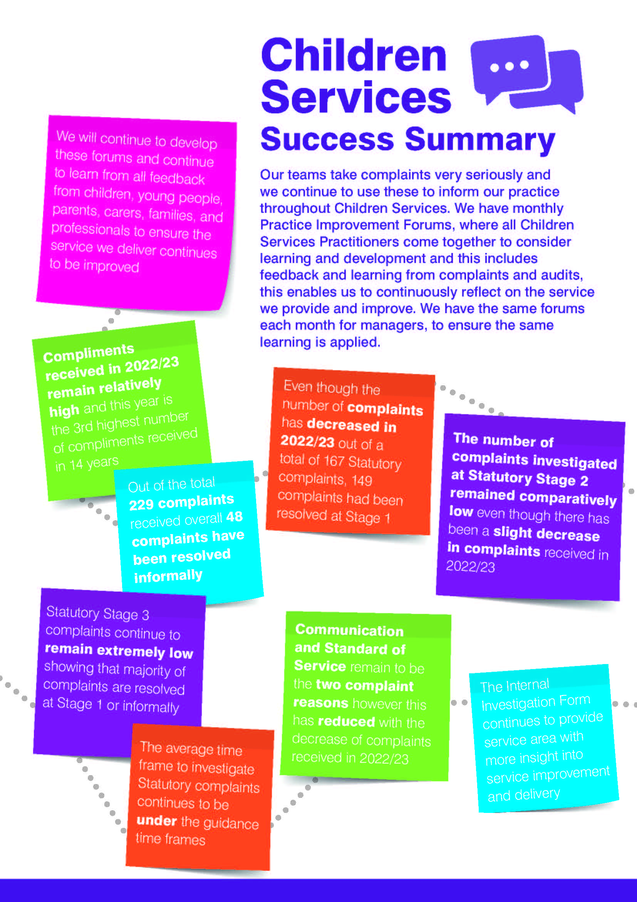

Further information
Further information about complaints and representations and a copy of the Council’s complaints policy and complaints handling guidance is available at www.coventry.gov.uk/complaints/.

Ilius Ahmed
Service Recovery Officer
Customer Services – Improvement & Development
April 2024

Kelly Boyce
Service Recovery Officer
Customer Services – Improvement & Development
April 2024

Steve Paterson
Service Recovery Officer
Customer Services – Improvement & Development
April 2024

Ombudsman Liaison Officer
Service Recovery Officer
Customer Services – Improvement & Development
April 2024

