It’s OK not to be OK

NEW Coventry Children and Young People Mental Health Services Directory

Scan the QR code to visit the NEW website where you can find services based on presenting need.

The website also has self-help resources and other useful information on the children’s mental health system.

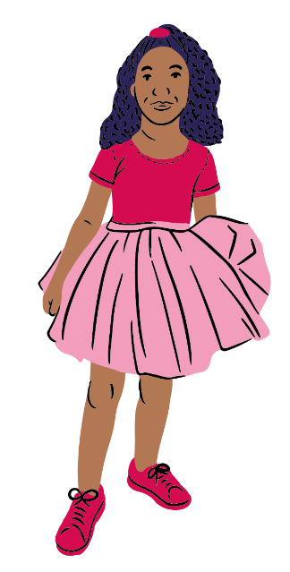
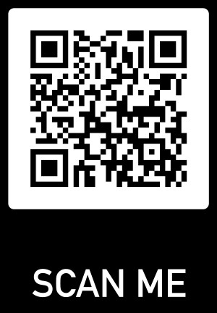



www.coventry.gov.uk/childrens-mental-health

