**Coventry Better Start Guidance**



Guidance for Early Years Foundation Stage Practitioners

**The purpose of Better Start**

In order to have a clear overview of children’s progress in your setting, you need to bring together the wealth of information you will have gathered for the individual child into a manageable summary of progress. The purpose of Better Start is to help you record that summary.

The summary of the child’s learning and development should be based on a holistic view of the child. It will be a **best-fit** judgement that you make based on all the information you have gathered and know about the child.

Better Start is used to summarise the development of the child in relation to their chronological age band. This

will be defined within the seventeen aspects in each of the seven areas of Learning and Development. The seven areas of learning should be used for guidance. Practitioners need to be very familiar with the Early Learning Goals and child development milestones in order to support the process of continuous assessment.

Better Start gives you the opportunity to enter summative assessment data four times throughout the year: Baseline, Autumn term, Spring term and Summer term.

As indicated in the Early Years Foundation Stage Statutory Framework 2024, when assessing whether an individual child is at the expected level of development, practitioners should draw on their knowledge of the child and their own expert professional judgement.

# 2

**When are the tasks open?**

The first task will be the Baseline assessment. This task will open at the beginning of September, at the start of each academic year and close in October. This will provide a baseline to identify where each child is within their learning and development in each of the seventeen aspects of learning. This can then be used to measure progress throughout each term and across the academic year.

If a child joins the provision after this task has closed, then the first task completed for that child will become their Baseline. Key workers should continue to closely observe any children joining the provision throughout the year, to ensure a baseline is established and recorded in order to accurately indicate progress.

The second task will be at the end of the Autumn term and will be open between November and December.

The third and fourth tasks are the Spring and Summer assessments and will open at the start of each term, closing towards the end of term.

# 3



Guidance for specific dates will be given in advance

of the task opening.

**What information should be used to form a best-fit judgement?**

A best-fit judgement should be made using a wide range of information about a child’s

learning and development. This information may include:

* Observations of the child across different areas of learning and in a range of situations, both indoors and outdoors
* Day to day interactions between the adult and child and the child with their peers
* Photographs / videos / children’s work
* Discussions with and information shared by parents and carers
* Discussions with other professionals involved with the child or family

The format in which this information is kept will vary from provider to provider.

**Making a best-fit judgement**

From this wealth of information, you will use your professional judgement to decide if the child is on track or not on track for each aspect of learning. As early learning is not linear, some children may be on track in some aspects of learning and not on track in others.

When forming a judgement about whether an individual child is at the expected level of development (on track), practitioners should use the information outlined above and draw on their knowledge of the child and their own expert professional judgement to come to a holistic best-fit judgement.

# 4

**How to record and submit data**

Better Start is located on the Coventry Early Years Provider Portal.

Over the academic year, there will be 4 summative data tasks to complete on the Better Start portal.

The following guidance demonstrates how to complete a task and download reports based on the summative data inputted.

1. Task One - Start of the Autumn term. This information will form a baseline for new children.
2. Task Two - End of the Autumn term.
3. Task Three - End of the Spring term.
4. Task Four - End of the Summer term.
   1. Please note - for Reception classes, the data submitted for Task Four will be used for the EYFSP.

Information gathered on the Better Start portal will allow you to track children’s progress over time.

Ensure that this type of data is covered within your privacy notice. If it is not currently, review and update your privacy notice as appropriate. Further, ensure that parents and carers provide their written consent for their child’s assessment data, this could, for example, be included within your induction information.

Once the Coventry Data Team open a task, the provider will receive an email notification.

This is when practitioners will be required to start entering children’s summative data. Therefore, it is advised to continually gather formative data on children’s learning and development during the term, in preparation for each task opening.

**5**

The first step is to log into the Coventry Early Years Provider Portal and go to the

home page.

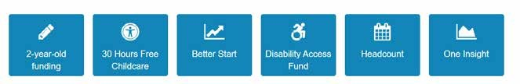

Once on the home page scroll down and click the Better Start icon, this will take you to the Better Start page where you can access the open tasks.

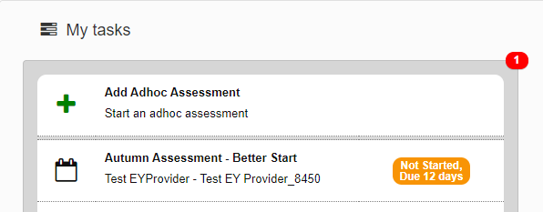

On the left-hand side are the open tasks for completion. Click on the open task to access it.

This part of the task will already be populated with any child who was on your last headcount submission.

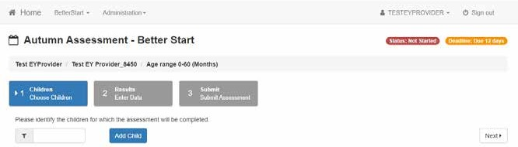

To add a new child who isn’t already on the list, press the ‘add child’ button and enter the

required fields.

# 6

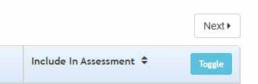

Now you need to choose which children you will be completing an assessment for. Click

this toggle box to choose all children on the list or select them one by one.

Once you have selected the children you will be completing an assessment for, press the ‘next’ button which will take you to the following screen.

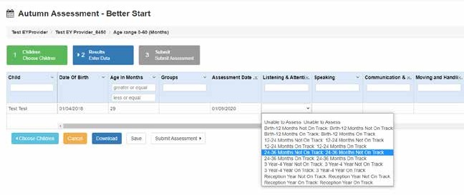

On this screen are the aspects at the top from left to right. Children’s names are listed from top to bottom. The Better Start portal will automatically calculate the age of each child in months.

Select the child’s name and select one of the drop-down options for each aspect of learning. There are 5 drop-down options:

* **Birth – 12 Months**
* **12 – 24 Months**
* **24 – 36 Months**
* **3 – 4 Years**
* **Children in the Reception Year**

Each drop-down option above is listed twice. Once with ‘Not on Track’ and once with ‘On

Track’. Ensure you select the correct option according to your best-fit judgement.

# 7

After you have entered the best-fit judgements for all children in all aspects of learning,

scroll to the bottom to review the following options.

* **Choose Children** – this will take you to the previous screen where you can add or remove children from the assessment page.
* **Cancel** – this will cancel your progress and take you back to the Better Start home page.
* **Download** – this will export your assessment data into an excel spreadsheet.
* **Save** – this will save your progress. You can save your progress at any time and come back to it any time before the task deadline date.
* **Submit Assessment** – this will submit your assessment data to the Better Start portal.

You can make changes after submitting the summative data onto the Better Start portal and resubmit your task if necessary. However, changes cannot be made or resubmitted after the deadline has passed.

**How to run a report**

Once you have submitted the summative data assessments, there are several reports which can be run to analyse the data.

Log into the Coventry Early Years Provider Portal and go to the Better Start page.

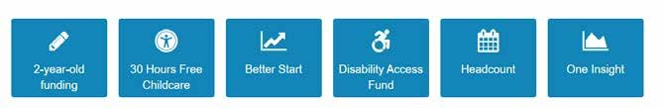

On the right-hand side click the ‘My Reports’ tab.

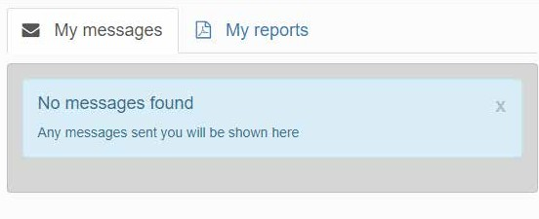

# 8

Press ‘Run A Report’.

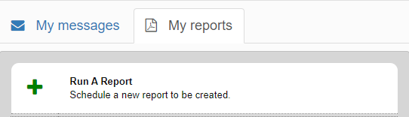

Here you will have a drop-down list of all reports available.

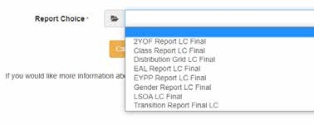Once you have selected a report to run, complete the information required.



Firstly, give your new report a title.

All the reports will require the academic year date. It’s important to remember that the academic year starts in the Autumn and therefore the following two terms have the

same academic year. For example, if you are running a report for Spring or Summer 2022, you must enter 2021 in the academic year.

After you have completed the information, click ‘next’.

**9**

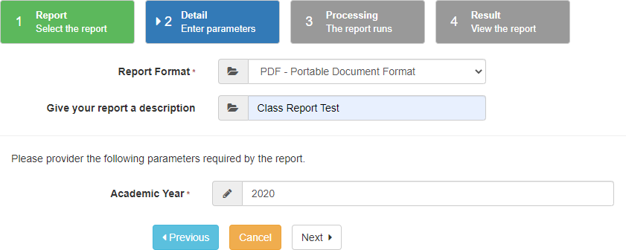

If the report has been successful, there will be a green tick under the processing status.

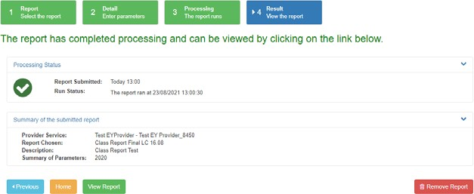

Now the report can be viewed.

# 10

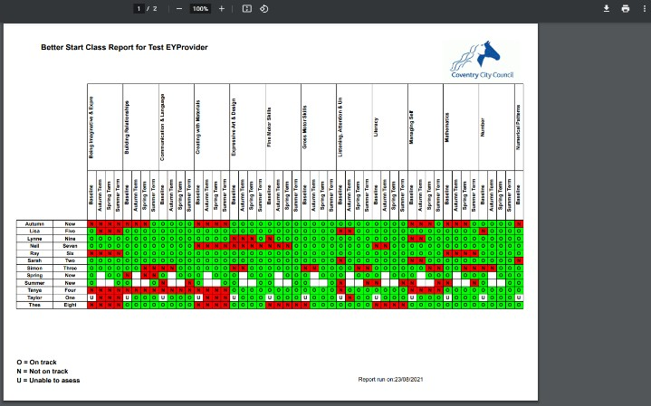

There is an option to download or print the report using the options highlighted by the arrow.



# 11

Once a report has been run it is stored on the Better Start home page and it can be viewed at any time. There is also the option to download and delete the stored reports.

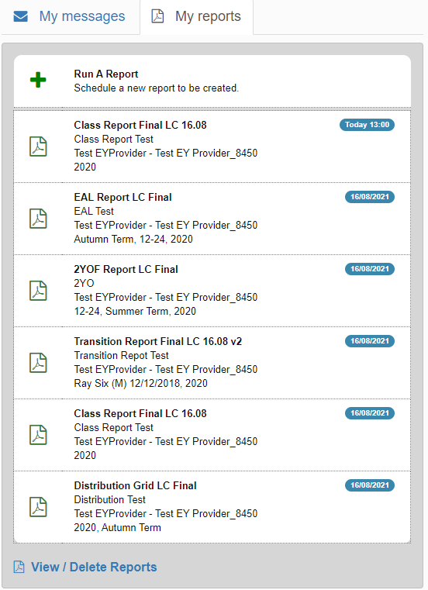

Press View / Delete Reports

# 12



**13**

This page stores all the reports that have been previously run on the portal. There is the

ability to search for specific reports and view them from this area.

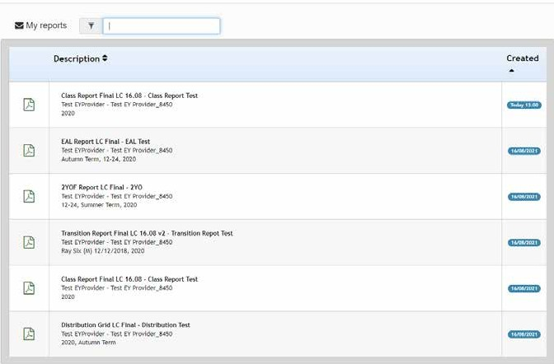

**Updated August 2024**

Please email [**betterstart@coventry.gov.uk**](mailto:betterstart@coventry.gov.uk)if you have any queries