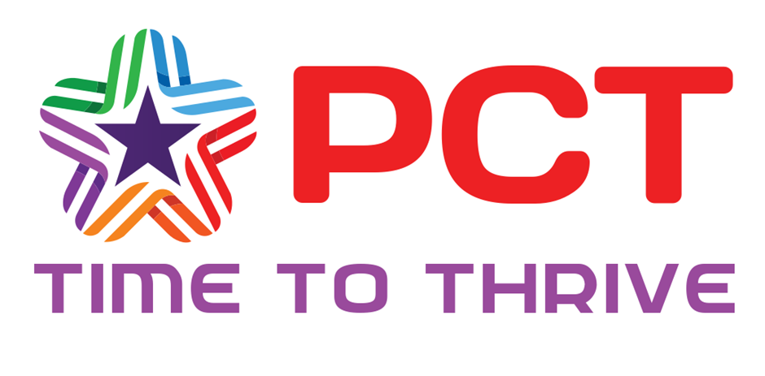PCT Personal Learning Programme

PCTs Personal Learning Programme run every day (students may be registered for one day or for as many as your student needs). It is specifically designed as an approach to addressing children’s needs, specifically those with SEMH needs, anxiety, trauma, ADHD and autism, through enrichment activities, developing their independence. This all goes alongside addressing some of the gaps they may have in their literacy and numeracy. Each session will be adapted based on the specific needs and dynamics of the participants.

We promote inclusivity by acknowledging and celebrating the diversity of the children in the course. Incorporate materials, stories, and examples that reflect different cultures, backgrounds, and experiences to ensure that all children feel represented and valued.

The course is facilitated by professionals who have expertise in child development, music therapy, play therapy as well as all areas of the curriculum. With our New Thrive Practitioner, we can work together to support your child’s development and learning, thus creating a safe and supportive environment for children to participate and engage in the activities effectively.

We know that each student is unique, and their needs may vary. We regularly assess and adapt the course to meet the specific needs of the children involved.

We believe our course will provide each young person with a unique opportunity to return to school with a toolkit to be able to manage and regulate their emotions and behaviour more effectively. They will be more independent and confident and will have closed some of the gaps they may have in their learning, so will be more able to participate alongside their peers.

The price per day is £190

